1. Copy all the required files in their own folder, separate from everything else (use basic linux commands to do this. It’s quite easy to learn if you don’t know already):

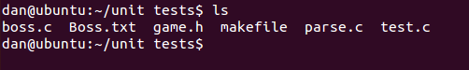

1. Run the makefile, and run the executable. If everything goes well, it should look something like this (with that output):

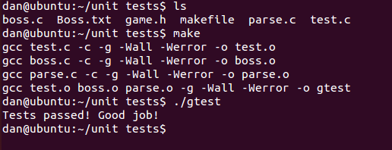

1. If your tests fail, you will see something like this:

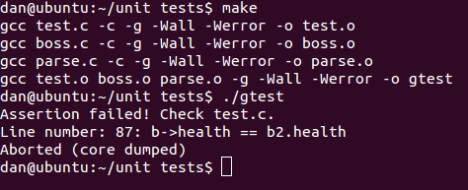

This will tell you what test failed, so you can analyze the test file and see what should’ve happened. GDB also will be your friend on this one:

(next page)

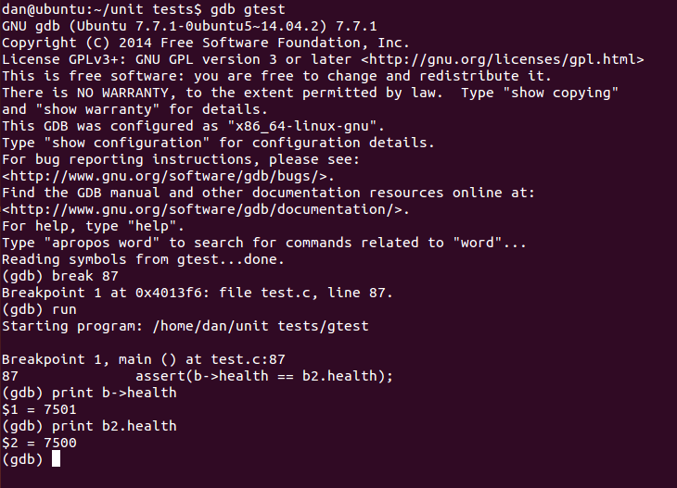

So you can see exactly what happened.