UNIVERSITY OF VICTORIA

Department of Electrical and Computer Engineering

ELEC 380 – Electronic Circuits II

Laboratory Report

Experiment No: 9

Title: Design of a low-pass filter

Date of Experiment: November 28, 2013

Report Submitted on: December 5, 2013

To: Mohammadreza Sanadgol Nezami

Laboratory Group No: 6

Names: Sean Rumsby, V00708825
Vincent Stupka, V00728559
First confirm design of 3 dB bandwidth of 10 kHz:
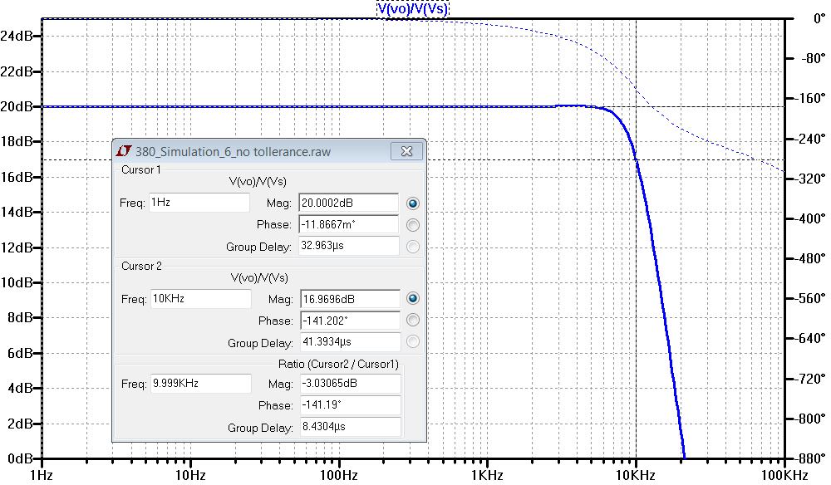
Then perform 50 runs with randomly varying parameters:
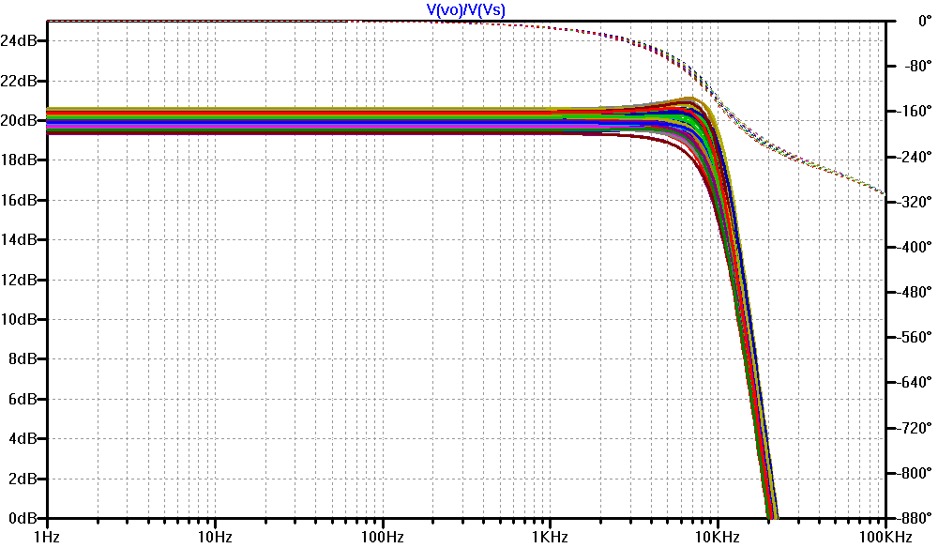

Square wave transient response:
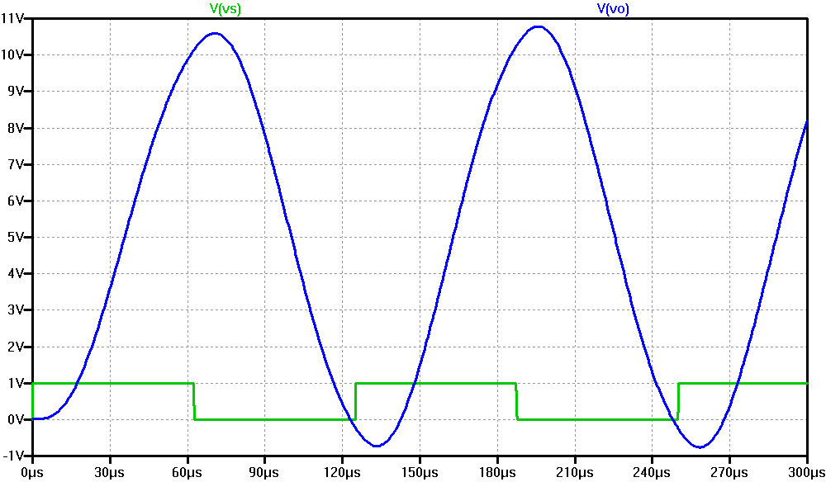
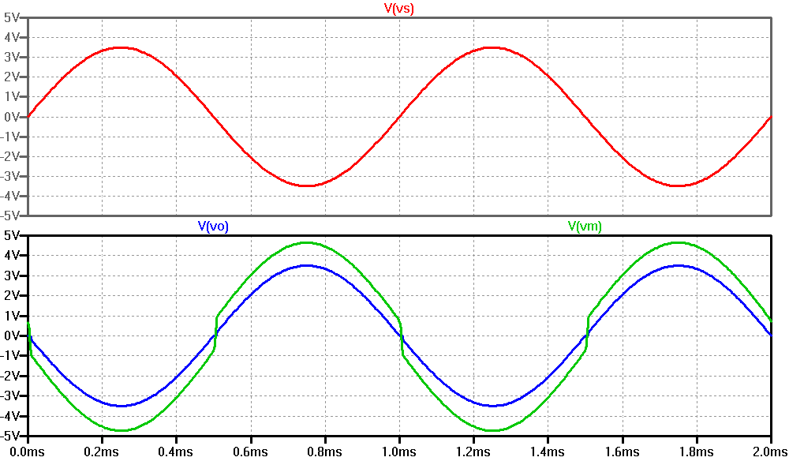
Elimination of crossover distortion:

