**Quick Users Guide to the NFSEG Automated Water-Use Permit Simulation Tool:**

**Step-by-Step Procedures**

*TO BE UPDATED - Disclaimer and Tool Maintainer Information goes here*

*Paul Bremner –* [*pbremner@sjrwmd.com*](mailto:pbremner@sjrwmd.com)

*Doug Durden –* [*Douglas.Durden@srwmd.org*](mailto:Douglas.Durden@srwmd.org)

**Software Requirements:**

ArcGIS Desktop, version 10.0 or later, installed on your local machine (or a computer that you connect with remotely that has ArcGIS installed on it).

**Overview of Steps:**

Note to the User: If this is the first time running the tool or an update, please read the more detailed instructions (below) first.

1. Navigate to the top-level tool directory
2. Create a formatted User input csv file. Name is flexible, but no spaces are allowed in the name.
3. Double-click on the batch file “sim_cup_current.bat” to open the tool console
4. Fill-in the User input filename and select a projection as prompted
5. Monitor the output in the console to ensure no errors occur, process takes about 10-20 minutes for each well depending on the size of withdrawal/injection.
6. Once complete, the console pauses to allow inspection of the output. If no errors occurred, press any key to close the console. If an error occurred, then copy and paste console output to a logfile.
7. If successful, a map is updated and two output csv files are created in the top-level tool directory that summarize the results.

**NOTE:** Before clicking on the batch file to start the tool, close all related Excel and ArcMap files that are used to setup the Permitting Tool. Any open files could cause program errors. Also, it is sometimes necessary to save Excel csv files in MSDOS csv format.

**NOTE:** This tool is setup to run the NFSEG v1.1 groundwater model. Using a different model will cause unpredictable errors.

**NOTE:** The Suwanee River Water Management District (SRWMD) and St Johns River Water Management District (SJRWMD) utilize two different map projections in GIS. X,Y coordinates must correspond to the correct projection. Input the selection in all capital letters.

**SRWMD is used for State Plane North**

**SJRWMD is used for UTM Zone 17N meters**

**Detailed Instructions:**

Initial Setup / Installation of the Tool *(this section will be updated)*

**NOTE:** This process only needs to be done once per tool update.

**NOTE:** This tool uses the Python that is bundled with ArcMap 10.0 or newer. The tool automatically searches for the location of this Python. If that is unsuccessful, then ERRORs will occur. Ensure that ArcMap’s Python is able to be found before running the tool (see steps below).

1. Download and unzip the tool in a new directory on the local machine’s hard drive.
2. The folder produced from unzipping the file is the *top-level tool directory*. Enter this directory.
3. Check that the top-level tool directory includes (at a minimum) the following:

* this Quick Users’ Guide
* docs *(folder)*
* gis *(folder)*
* misc *(folder)*
* model_update *(folder)*
* postproc *(folder)*
* preproc *(folder)*
* wellpkg_update.gbd *(looks like a folder)*
* check_Python_version.bat
* read_PY_PATH_autogen.bat
* sim_cup_current.bat
* print_date_and_time.py
* and various example csv files

1. Next, check that an appropriate version of Python is available to use:
   1. Double click on the batch script “check_Python_version.bat” in the top-level directory. The script will search for Python.
   2. If successful, then a “Success” message will appear along with the PATH to the version of Python found. Additionally, an auto-generated file called “PY_PATH_autogen.txt” will be created to store the PATH for use by the simulation tool. Though the simulation tool does not require the auto-generated file (the tool auto searches for Python when the file is not present), having this file available will decrease the tool runtime significantly.
   3. If Python could not be found, then a “Failure” message will appear.
   4. If Python was not found, or the version is not the one desired by the User, it will be necessary to manually set Python in the tool to resolve the issue. Please contact the tool maintainers for help.
   5. *Optional* – If the User needs or desires to see the Python PATH that was detected and stored in “PY_PATH_autogen.txt”, then the User may either open and view the file, or double click on the batch script “read_PY_PATH_autogen.bat”. This batch script will pop-up a Command Prompt console and display the detected PATH. The displayed PATH is what will be read by the simulation tool.
2. If all items are present, and Python was found, the tool is ready to use!

How to setup the User Input File

The User input file is a comma-separated-value (.csv) file created in MS Excel, or equivalent, that lists all the wells needing to be processed for a permit. Table 1 shows an example of the Excel file format, and an example csv file is also provided in the top-level directory of the tool. The name given to the file is not important, but the name must NOT contain spaces. Instead, use underscores in place of spaces. A descriptive filename of the permit simulation is recommended. Two csv files are output summarizing the results of the simulation, both of which will be prepended with the base of the User input filename.

Example, if the input filename is:

“sim_cup_input_example_srwmd.csv”

then the two output files will be named:

“sim_cup_input_example_srwmd_delta_q_summary.csv”

“sim_cup_input_example_srwmd_global_budget_change.csv”.

The Rows of the User input file are as follows:

*Row 1* contains the Permit ID and Name.

*Row 2* contains a set of header field names describing what information needs to be filled out by the User. The field names MUST be in the order and spelling shown in the example.

*Rows 3+* contain all the need-to-be-processed wells, one well per row.

The Columns of the well data portion (rows 3+) of the User input file are as follows:

*Col A – WellKey –* an integer counter for each well

*Col B – WellId –* an identifier for each well

*Col C/D – Xcoord/Ycoord –* Cartesian coordinate representation of the Lon/Lat well coordinates. For each well, use a GIS program such as ArcMap, to obtain the X,Y coordinates within the NFSEG model.

**IMPORTANT:** The Suwanee River Water Management District (SRWMD) and St Johns River Water Management District (SJRWMD) utilize two different map projections in GIS. Make note of which projection was used in GIS, and input the selection in all capital letters.

**SRWMD is used for State Plane North**

**SJRWMD is used for UTM Zone 17N meters**

*Col E – layer –* model layer the well will interact with

*Col F – Q_mgd –* amount of water flowing through the well [units = million-gallons-per-day].

**NOTE:** Use a positive Q_mgd value for withdrawal, and a negative value for injection.

Table 1 User input file example. File should be created in MS Excel, or equivalent, and be saved as a .csv file.

|  |  |  |  |  |  |  |
| --- | --- | --- | --- | --- | --- | --- |
|  | A | B | C | D | E | F |
| 1 | 9999999 | TrailRidge |  |  |  |  |
| 2 | WellKey | WellId | XCoord | YCoord | layer | Q_mgd |
| 3 | 1 | Brooks Sink Phase 1 | 2675475.579 | 330157.6487 | 3 | 5.1 |
| 4 | 2 | Brooks Sink Phase 2 | 2675475.61 | 330157.6491 | 3 | 1.23 |

Running the Water-Use Simulation Permit Simulation

The Automated Water-Use Permit Simulation Tool runs a batch script within a Windows Command Prompt console. The following are the steps to activate and run the tool:

1. Navigate to the top-level directory of the tool
2. Double click on the batch file “sim_cup_current.bat”. A console will pop-up on the screen.

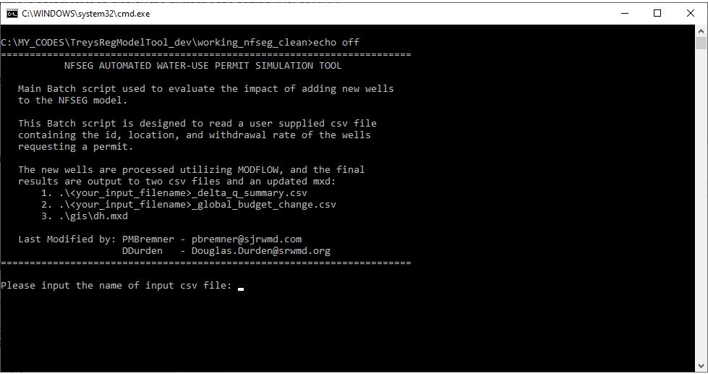

1. Follow the prompts to input both the User input csv filename, as well as the map projection that corresponds to what was used in GIS to obtain the X,Y coordinates of each well. Push Enter after each prompted input.

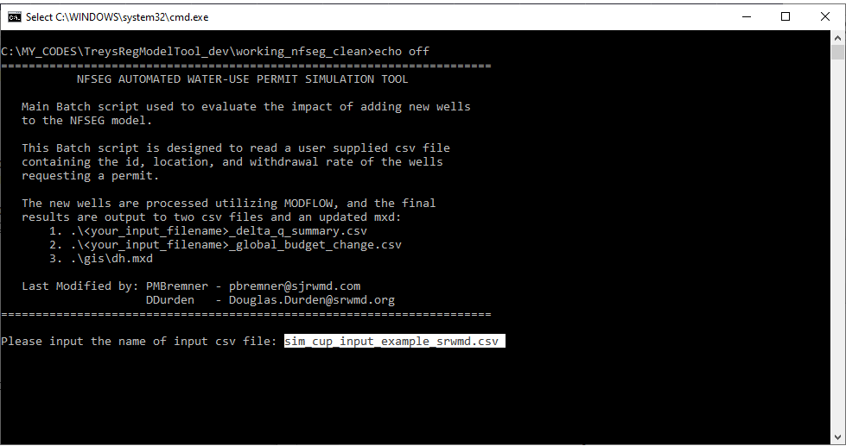

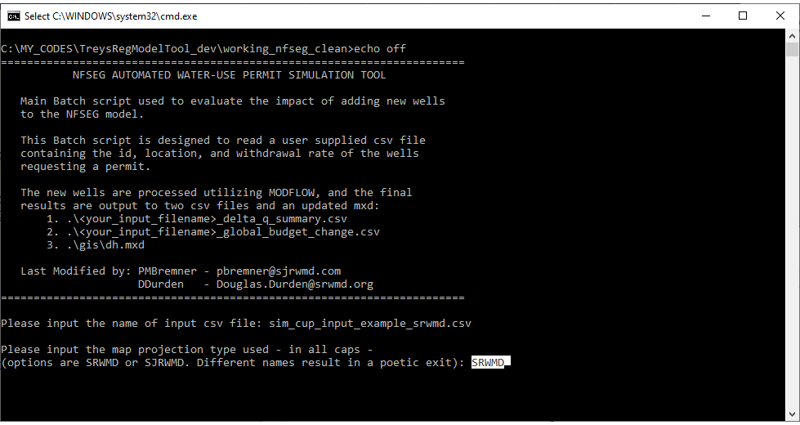

1. The simulation proceeds to run. Monitor the output to ensure no error messages appear. Log the output for evaluation if any errors do occur that are not related to User input errors (see next section for details). If the simulation was successful, then the output files will be written to the top-level tool directory, and a completion message will appear in the console. The output files will be prepended with the User input filename.

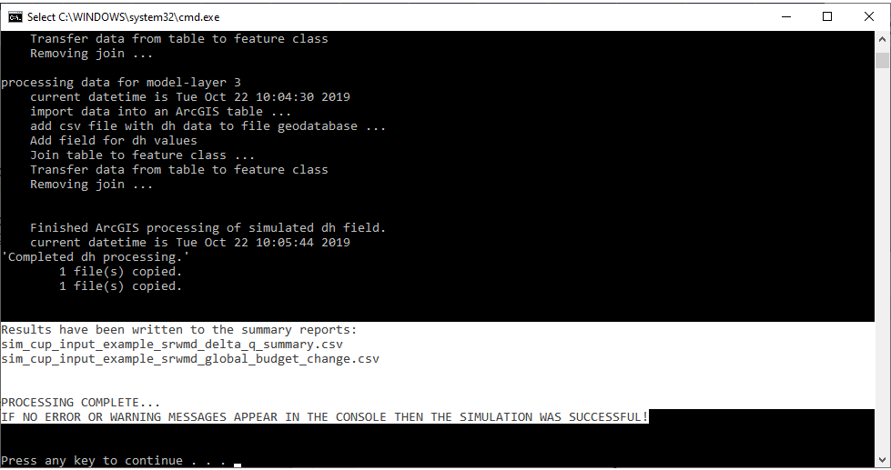

When an Error occurs, log the output from the Water-Use Simulation Permit Simulation

If an error occurs, and it is not obvious why the error occurred, then all the output from the console (along with the error message) can be put into a log file to be examined by the tool maintainers. Error messages and warning messages usually start with one of the following terms: “ERROR”, “Warning”, or “Traceback”. Create the log file as follows:

1. With the mouse, click on the small icon at the top left corner of the console pop-up. A drop-down menu will appear.
2. Hover over “Edit” to expose a sub-menu. Click on “Select All”. This highlights all the lines of output on the console.

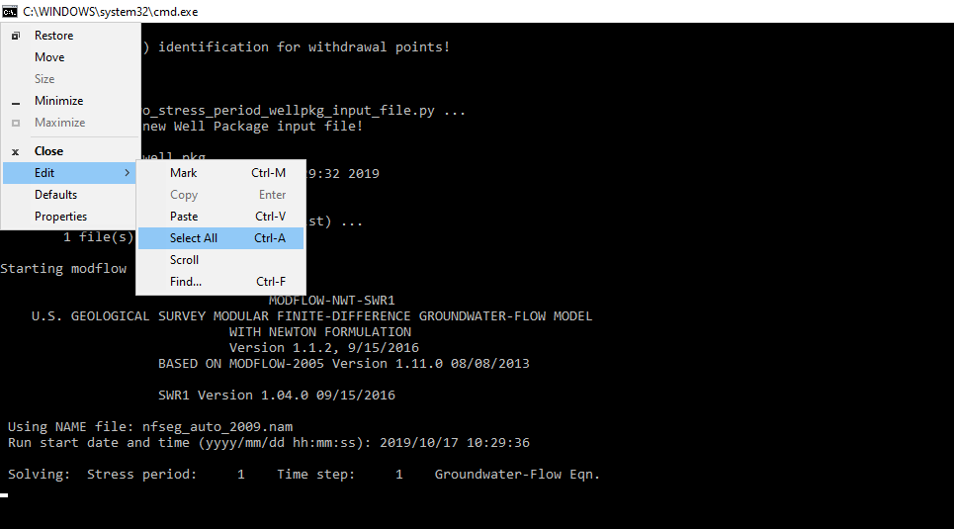

1. Use Ctrl-C to copy all the highlighted console output
2. Open a new file in NotePad++, or equivalent, and use Ctrl-V to paste the console output into the new file. Save the log file as *<your_filename>*.log, and email the log file and a description of the issue to the tool maintainers.