**Quick Users Guide to the NFSEG Automated Water-Use Permit Simulation Tool:**

**Step-by-Step Procedures**

*Disclaimer and Tool Maintainer Information goes here*

**Software Requirements:**

ArcGIS Desktop, version 10.0 or later, installed on your local machine (or a computer that you connect with remotely that has ArcGIS installed on it).

**Overview of Steps:**

1. Navigate to the top-level tool directory
2. Create the User input csv file. Name is flexible, but no spaces are allowed in the name.
3. Double-click on the “sim_cup_current.bat” batch file to open the tool console
4. Fill-in the User input filename and select a projection as prompted
5. Monitor the output in the console to ensure no errors occur, process takes about 10-20 minutes for each well depending on the size of withdrawal/injection.
6. Once complete, the console pauses to allow inspection of the output. If no errors occurred, press any key to close the console. If an error occurred, then copy and paste console output to a logfile.
7. If successful, two output csv files are created in the top-level tool directory that summarize the results.

**NOTE:** Before clicking on the batch file to start the tool, close all related Excel and ArcMap files that are used to setup the Permitting Tool. Any open files will cause program errors. Also, it is sometimes necessary to save Excel csv files in MSDOS csv format.

**NOTE:** This tool is setup to run the NFSEG v1.1 groundwater model. Using a different model will cause unpredictable errors.

**NOTE:** The Suwanee River Water Management District (SRWMD) and St Johns River Water Management District (SJRWMD) utilize two different map projections in GIS.

**SRWMD = State Plane North**

**SJRWMD = UTM Zone 17N meters**

**Detailed Instructions:**

How to setup the User Input File

The User input file is a comma-separated-value (.csv) file created in MS Excel, or equivalent, that lists all the wells needing to be processed for a permit. Table 1 shows an example of the Excel file format, and an example csv file is also provided in the top-level directory of the tool. The name given to the file is not important, but the name must NOT contain spaces. Instead, use underscores in place of spaces. A descriptive filename of the permit simulation is recommended. Two csv files are output summarizing the results of the simulation, both of which will be prepended with the base of the User input filename. Example: if the input filename is “sim_cup_input_example_srwmd.csv”, then the two output files will be named “sim_cup_input_example_srwmd_delta_q_summary.csv” and “sim_cup_input_example_srwmd_global_budget_change.csv”.

The Rows of the User input file are as follows:

*Row 1* contains the Permit ID and Name.

*Row 2* contains a set of header field names describing what information needs to be filled out by the User. The field names MUST be in the order and spelling shown in the example.

*Rows 3+* contain all the need-to-be-processed wells, one well per row.

The Columns of the well data portion of the User input file are as follows:

*Col A – WellKey –* an integer counter for each well

*Col B – WellId –* an identifier for each well

*Col C/D – Xcoord/Ycoord –* Cartesian coordinate representation of the Lon/Lat well coordinates. For each well, use a GIS program such as ArcMap, to obtain the X,Y coordinates within the NFSEG model.

IMPORTANT: Make note of which projection was used in GIS: SRWMD or SJRWMD (*spell out projections)

*Col E – layer –* model layer the well will interact with

*Col F – Q_mgd –* amount of water flowing through the well [units = million-gallons-per-day].

**NOTE:** Use a positive Q_mgd value for withdrawal, and a negative value for injection.

Table 1 User input file example. File should be created in MS Excel, or equivalent, and be saved as a .csv file.

|  |  |  |  |  |  |  |
| --- | --- | --- | --- | --- | --- | --- |
|  | A | B | C | D | E | F |
| 1 | 9999999 | TrailRidge |  |  |  |  |
| 2 | WellKey | WellId | XCoord | YCoord | layer | Q_mgd |
| 3 | 1 | Brooks Sink Phase 1 | 2675475.579 | 330157.6487 | 3 | 5.1 |
| 4 | 2 | Brooks Sink Phase 2 | 2675475.61 | 330157.6491 | 3 | 1.23 |

Running the Water-Use Simulation Permit Simulation

The Automated Water-Use Permit Simulation Tool runs a batch script within a Windows Command Prompt console. The following are the steps to activate and run the tool:

1. Navigate to the top-level directory of the tool
2. Double click on the “sim_cup_current.bat” script file. A console will pop-up on the screen.

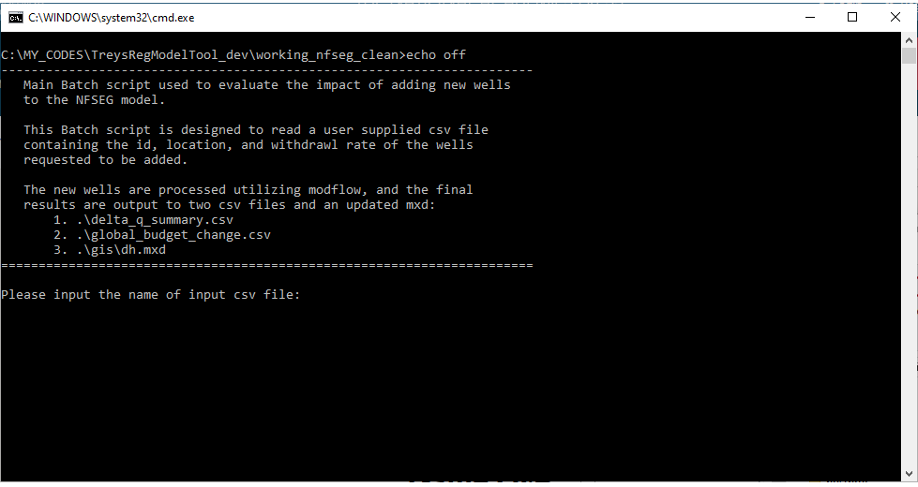

1. Follow the prompts to input both the User input csv filename, as well as the map projection that corresponds to what was used in GIS to obtain the X,Y coordinates of each well. Push Enter after each prompted input.

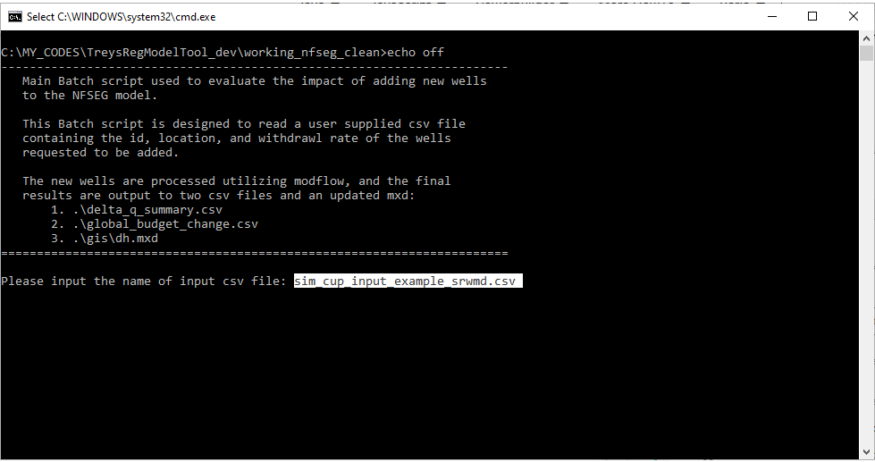

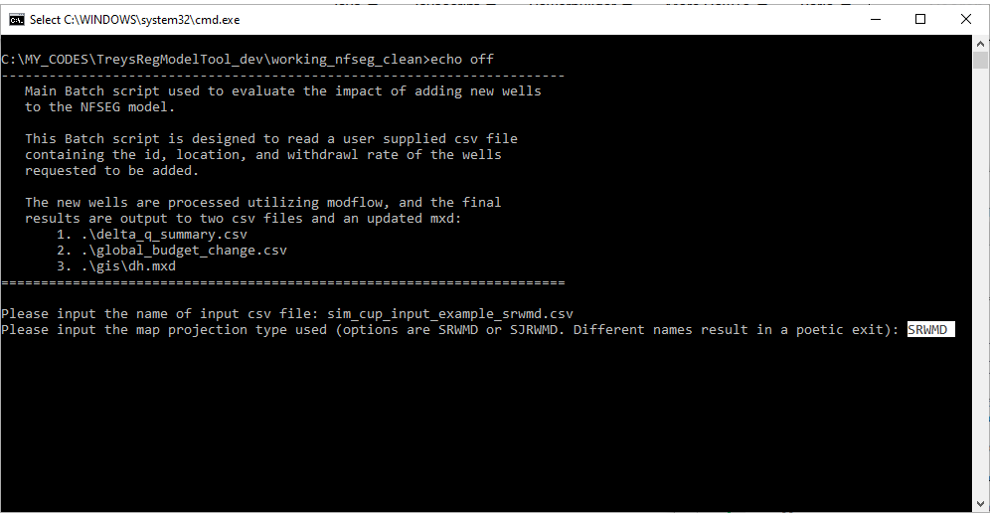

1. The simulation proceeds to run. Monitor the output to ensure no error messages appear. Log the output for evaluation if any errors do occur that are not related to User input errors (see next section for details). If the simulation was successful, then the output files will be written to the top-level tool directory, and a completion message will appear in the console. The output files will be prepended with the User input filename.

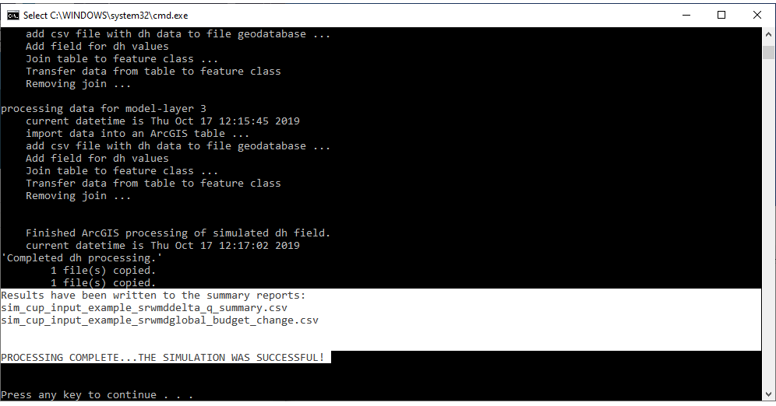

Figure 1 The text seen in this figure has been modified. The figure will be updated.

When an Error occurs, log the output from the Water-Use Simulation Permit Simulation

If an error occurs, and it is not obvious why the error occurred, then all the output from the console (along with the error message) can be put into a log file to be examined by the tool maintainers. Create the log file as follows:

1. With the mouse, click on the small icon at the top left corner of the console pop-up. A drop-down menu will appear.
2. Hover over “Edit” to expose a sub-menu. Click on “Select All”. This highlights all the lines of output on the console.

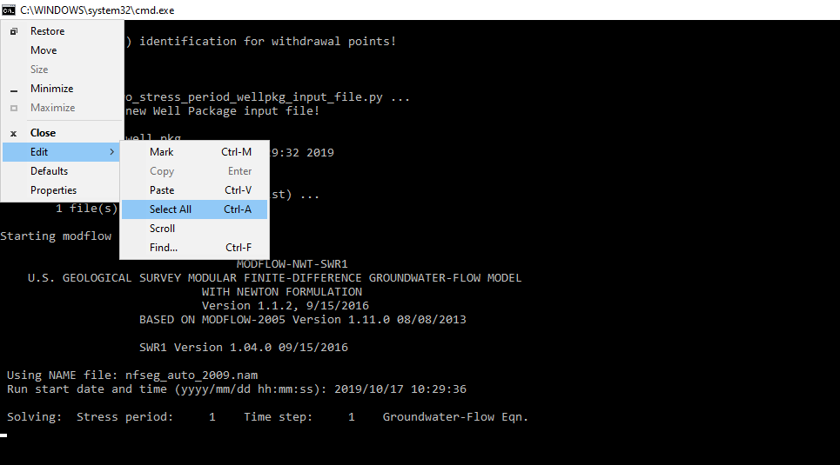

1. Use Ctrl-C to copy all the highlighted console output
2. Open a new file in NotePad++, or equivalent, and use Ctrl-V to paste the console output into the new file. Save the log file as *<your_filename>*.log, and email the log file and a description of the issue to the tool maintainers.