Technical Publication SJ20XX-X

(Communications assigns the number at the end of the editing process.)

**NFSEG GROUNDWATER FLOW MODEL V1.1 POST-PROCESSING TOOLS**

By:

Paul Bremner, Ph.D.

Tim Desmarais, P.E.

Doug Durden, P.E.

Wei Jin, P.E.

St. Johns River Water Management District

Palatka, Florida

2021

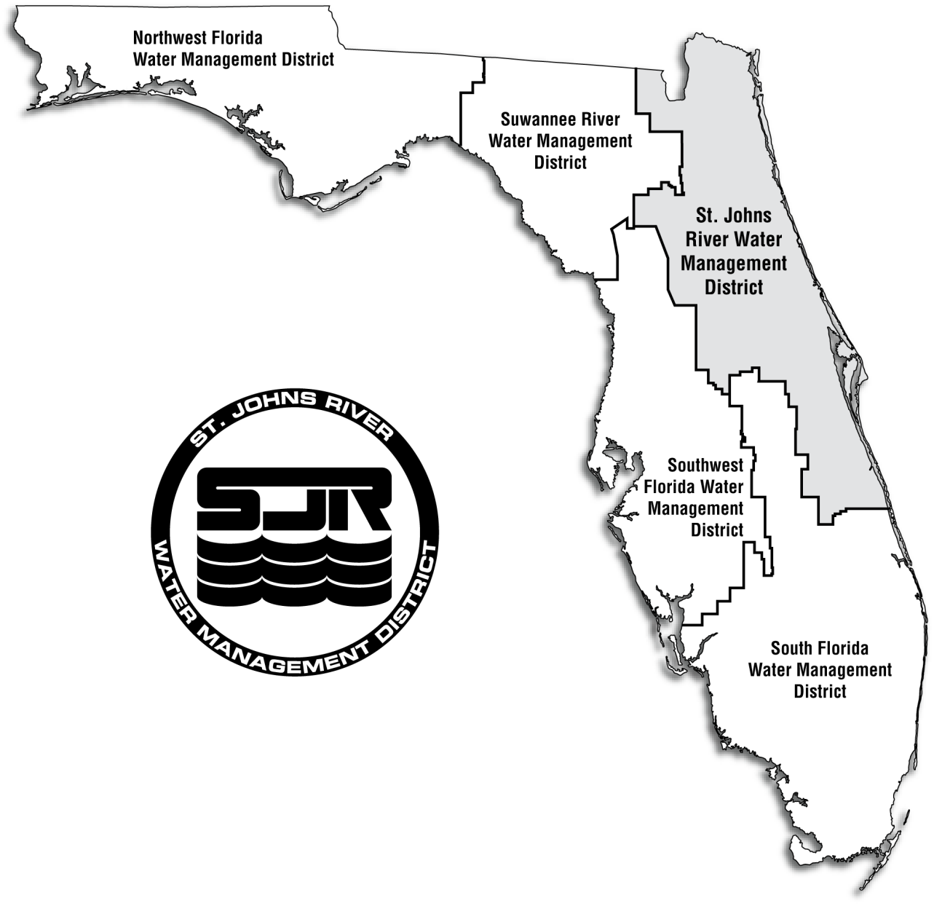

Communications will insert the approved, standard map and disclaimer information on this page.

PLACEHOLDER

# Executive Summary

…

# Contents

Executive Summary iii

Contents v

List of Figures vi

List of Tables vii

Chapter 1. Introduction 1

Chapter 2. Methodology 3

Recalibration Targets 3

Chapter 3. Recalibration Results 4

Chapter 4. Extended Long-Term (XLT) Simulation 5

Chapter 5. Conclusions 6

Evaluation of KTHM v2.0 Model Prediction Performance 6

Chapter 6. Conclusions and Recommendations 6

Literature Cited 7

Appendix A—Extension of the Keystone Heights Long-Term Simulation Model 8

Introduction 8

Conclusion 8

References 8

Appendix B—Annual Lake Water Budget Tables in Cubic Feet Per Day (cfd) (1957-2018) 9

# List of Figures

**Figure 1**. Simulated lake level at Lake Brooklyn during the calibration period for KHTM v1.0 (green) and KHTM v1.1 (black) compared to measured values (red). 1

# List of Tables

**Table 1**. Calibration metric goals for the four main calibration target groups. 1

**Table B-2**. Lake Lowry annual water budget. All rates are in units of cubic feet per day and 1957 results reflect July - December only. 9

# Chapter 1. Introduction

…..

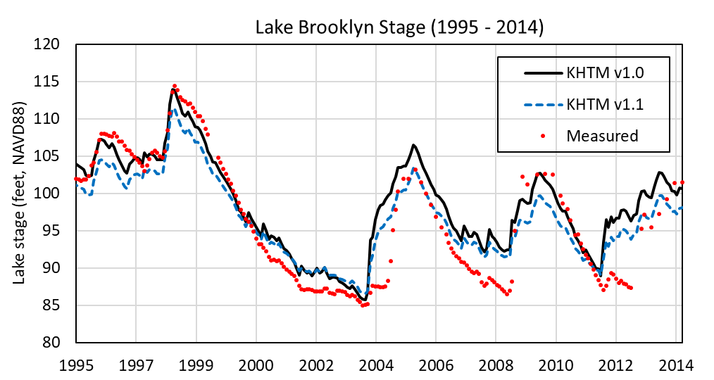

**Figure 1**. Simulated lake level at Lake Brooklyn during the calibration period for KHTM v1.0 (green) and KHTM v1.1 (black) compared to measured values (red).

…

**Table 1**. Calibration metric goals for the four main calibration target groups.

|  |  |  |
| --- | --- | --- |
| **Target Type** | **Calibration Metric** | **Metric Goal** |
| Groundwater Levels | Mean Absolute Error | **≤ 5 feet** |
| Lake Water Levels | Mean Absolute Error | **≤ 2 feet** |
| Monthly Average Streamflow | (Mean Absolute Error) ÷ Range | **≤ 10%** |
| Vertical Head Differences | (Mean Absolute Error) ÷ Range | **≤ 10%** |

# Chapter 2. Methodology

## Script Descriptions

* C104_RUNALL.bat
  + Main script. Run by the User via a call to or double-clicking the batch file
* my_utilities_NFSEG.py
  + Collection of functions that are called in each of the Post-processing scripts
* a1__NFSEG_res_to_gdb_2.0.py
  + Create new GIS geodatabase and populate with PEST target residuals from the *.res
  + The new GDB will carry the PEST filename, from here on reffered to as *newGDB*
  + Use PEST_Baselayers.gdb as template, located in the templates directory
* a3__NFSEG_optparams_to_gdb_2.0.py
  + Populate *newGDB* with PEST target optimal parameters from the *.pst file
  + Use PEST_Baselayers.gdb as template, located in the templates directory
* a5__NFSEG_propscal_2.0.py
  + Populate *newGDB* with parameters from the MODFLOW discretization, recharge, ET, and heads files
  + Use PEST_Baselayers.gdb as template, located in the templates directory
* a5b__NFSEG_propscal_PUMPSOFF_2.0.py
  + Populate newGDB with parameters from the MODFLOW discretization and Pumps-off heads files
  + Use PEST_Baselayers.gdb as template, located in the templates directory
* a6__NFSEG_lst_RIVDRN_flow_2.0.py
  + Extract the River and Drain boundaries from the list file
  + Generate maps of River and Drain flux
* a7__NFSEG_XS_2.0.py
  + Generate cross-sections
* b1__SetupReRun_files_2.0.py
  + Setup a new model directory to rerun the NFSEG model with CBB output
  + Copy all necessary model files to the new model directory
  + Modify model package files to indicate CBB output as needed
* Process to rerun NFSEG and extract results from CBB
  + Call to initiate MODFLOW
  + Call to extract results from CBB -- Fortran routine
  + Call to calculate springflow -- Fortran routine
  + Call populate table used in Water Budget calculation
    - Fortran routine
    - Excel macro (uses Visual Basic embedded code)
* c1__NFSEG_cbb_fc_2.0.py
  + Create the ZB geodatabase and add CBB parameters
* c1a__cbbpropscalcs_2.0.py
  + Add MODFLOW parameters to the ZB GDB
* d1_IBR_mxds2jpeg_2.0.py
  + Export jpeg maps related to Introductory Background Information Related(IBR): Active bnd, Grid Detail
  + Creates mxds from template mxds
  + Save mxd as jpeg
* d2_HSR_mxds2jpeg_2.0.py
  + Export jpeg maps related to Hydrostratigraphic Related(HSR): L1 thru L7 Elevations and Thickness, Elevation FWSW TDS 10,000ppm
  + Creates mxds from template mxds
  + Save mxd as jpeg
* d3_BCR_mxds2jpeg_2.0.py
  + Export jpeg maps related to Boundary Condition Related (BCR): Active model boundary L3 thru 7, Recharge Rates, ET, Extinction Depths, Withdraws_Ag_PSCII_DSS
  + Creates mxds from template mxds
  + Save mxd as jpeg
* d4_OGR_mxds2jpeg_2.0.py
  + Export jpeg maps related to Special PEST Targets (OGR): Springsflows, baseflow, VHD/HHDs
  + Creates mxds from template mxds
  + Save mxd as jpeg
* d5_CPR_mxds2jpeg_2.0.py
  + Export mxd and jpeg maps related to Calibration Parameter Related (CPR): Horizontal Heads, Vertical Heads and Head Multipliers for L2, L3 and L5
  + Creates mxds from template mxds
  + Save mxd as jpeg
* d6_CRH_mxds2jpeg_2.0.py
  + Export mxd and jpeg maps related to Calibration Results Heads (CRH): Contour POT maps, Residual Heads and Water Table above Land Surface
  + Creates mxds from template mxds
  + Save mxd as jpeg
* d7_CRF_mxds2jpeg_2.0.py
  + Export jpeg maps related to Calibration_Results_Flows(CRF): Spring Flows, 1st Mag Springs, Baseflow Pickups, Net Recharge and Upward/Downward Flows L2 L4
  + Creates mxds from template mxds
  + Save mxd as jpeg
* d8_CRP_mxds2jpeg_2.0.py
  + Exporting jpeg maps related to Calibration Results Parameters(CRP): Transmissivity, Leakance and Hydraulic Conductivity
  + Creates mxds from template mxds
  + Save mxd as jpeg
* e1__NFSEG_Zonebudget_2.0.py
* e2__NFSEG_Zonebudget_Figures_2.0.py
* e2b__NFSEG_Zonebudget_Figures_full_2.0.py

## Recalibration Targets

All calibration targets included in KHTM v1.0 were retained for this recalibration effort. Adjustments that were made to the weights of calibration targets to improve the ability to match lower water levels at Lake Brooklyn in KHTM v1.1 were retained for this recalibration effort. The reweighting approach included modifications to the weights of a small number of Lake Brooklyn water level targets to emphasize extreme observed levels, lows and highs, within the calibration period (Tetra Tech, 2019).

|  |  |
| --- | --- |
| $$H\left(x\right)≈\frac{1}{2}+\frac{1}{2}\tanh{kx}$$ | (1) |

# Chapter 3. Recalibration Results

# Chapter 4. Extended Long-Term (XLT) Simulation

# Chapter 5. Conclusions

To evaluate KHTM v2.0 model prediction performance, model results were compared to available estimates, pre-defined metric goals (**Table 1**), and available hydrogeologic information. In addition, to determine if the goals of the recalibration effort were achieved, KHTM v2.0 results were compared to those reported for KHTM v1.0 and v1.1.

## Evaluation of KTHM v2.0 Model Prediction Performance

# Chapter 6. Conclusions and Recommendations

…

# Literature Cited

Doherty, J, 2016. PEST: Model-Independent Parameter Estimation User Manual, 6th Edition, Watermark Numerical Computing, 390 p.

Subsurface Detection Investigations, Inc.(SDI), 1992. High Resolution Seismic Reflection Profiling in Selected Lakes in the St. Johns River Water Management District, Special publication SJ92-SP13. Final report prepared for St. Johns Water Management District.

Tetra Tech, Inc., 2017. Keystone Heights Transient Groundwater Flow Modeling for Evaluation of Minimum Flows and Levels. Final report prepared in conjunction with Jones Edmunds & Associates, Inc. for St. Johns Water Management District.

Tetra Tech, Inc., 2019. Keystone Heights Transient Groundwater Model Updates (Final). Technical memorandum prepared in conjunction with Jones Edmunds & Associates, Inc. for St. Johns Water Management District.

# Appendix A—Extension of the Keystone Heights Long-Term Simulation Model

## Introduction

## Conclusion

The District performed an update to the MODFLOW input files and additional files required to extend and run the existing KHTM long-term simulation out to the end of December 2018. In updating all required files, the District followed the methodology established in previous documentation of the KHTM development (Tetra Tech, 2017) and as described by Tetra Tech in a technical memorandum delivered to the District (Tetra Tech, 2019).

## References

Tetra Tech, Inc., 2017. *Keystone Heights Transient Groundwater Flow Modeling for Evaluation of Minimum Flows and Levels.* Final report prepared in conjunction with Jones Edmunds & Associates, Inc. for St. Johns Water Management District. September.

Tetra Tech, Inc., 2019. *Keystone Heights Long-Term Simulation Input Update Summary (Final).* Technical memorandum prepared in conjunction with Jones Edmunds & Associates, Inc. for St. Johns Water Management District. October.

# Appendix B—Annual Lake Water Budget Tables in Cubic Feet Per Day (cfd) (1957-2018)

**Table B-2**. Lake Lowry annual water budget. All rates are in units of cubic feet per day and 1957 results reflect July - December only.

|  | **INFLOW** | | | **OUTFLOW** | | |
| --- | --- | --- | --- | --- | --- | --- |
| **Year** | **Rainfall** | **From Alligator Creek, Runoff & Spring** | **From Groundwater** | **Evaporation** | **To  Groundwater** | **To Alligator Creek** |
| 1957* | 7.67E+05 | 6.62E+05 | 2.62E+04 | 5.84E+05 | 3.24E+05 | 2.70E+05 |
| 1958 | 7.62E+05 | 6.66E+05 | 2.65E+04 | 6.02E+05 | 3.29E+05 | 4.79E+05 |
| 1959 | 7.79E+05 | 6.96E+05 | 2.85E+04 | 6.06E+05 | 3.29E+05 | 5.98E+05 |
| 1960 | 8.00E+05 | 6.82E+05 | 2.99E+04 | 6.17E+05 | 3.26E+05 | 5.51E+05 |
| 1961 | 6.07E+05 | 6.52E+05 | 3.29E+04 | 6.30E+05 | 3.15E+05 | 3.81E+05 |
| 1962 | 6.08E+05 | 5.99E+05 | 3.14E+04 | 6.42E+05 | 3.18E+05 | 2.57E+05 |
| 1963 | 4.72E+05 | 5.71E+05 | 3.08E+04 | 6.26E+05 | 3.27E+05 | 1.50E+05 |
| 1964 | 9.78E+05 | 9.00E+05 | 2.62E+04 | 6.11E+05 | 3.52E+05 | 8.11E+05 |
| 1965 | 8.16E+05 | 6.98E+05 | 3.32E+04 | 6.11E+05 | 3.39E+05 | 6.66E+05 |
| 1966 | 6.96E+05 | 6.74E+05 | 3.69E+04 | 5.91E+05 | 3.25E+05 | 5.30E+05 |
| 1967 | 6.68E+05 | 6.57E+05 | 3.73E+04 | 6.20E+05 | 3.18E+05 | 4.05E+05 |
| 1968 | 6.32E+05 | 6.62E+05 | 3.64E+04 | 6.17E+05 | 3.30E+05 | 3.84E+05 |
| 1969 | 6.81E+05 | 6.84E+05 | 3.77E+04 | 5.95E+05 | 3.43E+05 | 4.01E+05 |
| 1970 | 7.71E+05 | 6.89E+05 | 3.93E+04 | 6.19E+05 | 3.43E+05 | 6.42E+05 |
| 1971 | 6.39E+05 | 6.47E+05 | 3.78E+04 | 6.25E+05 | 3.31E+05 | 3.10E+05 |
| 1972 | 8.62E+05 | 9.54E+05 | 3.93E+04 | 6.23E+05 | 3.44E+05 | 8.43E+05 |
| 1973 | 6.44E+05 | 6.63E+05 | 4.29E+04 | 6.18E+05 | 3.26E+05 | 4.71E+05 |
| 1974 | 6.42E+05 | 6.02E+05 | 3.98E+04 | 6.30E+05 | 3.24E+05 | 3.30E+05 |
| 1975 | 6.56E+05 | 6.63E+05 | 4.03E+04 | 6.21E+05 | 3.36E+05 | 3.85E+05 |
| 1976 | 6.10E+05 | 7.64E+05 | 4.01E+04 | 6.18E+05 | 3.48E+05 | 4.29E+05 |
| 1977 | 4.25E+05 | 6.04E+05 | 4.15E+04 | 6.42E+05 | 3.47E+05 | 1.74E+05 |
| 1978 | 6.25E+05 | 6.57E+05 | 3.60E+04 | 6.24E+05 | 3.71E+05 | 2.88E+05 |
| 1979 | 7.61E+05 | 6.45E+05 | 3.51E+04 | 6.18E+05 | 3.75E+05 | 4.04E+05 |
| 1980 | 5.27E+05 | 6.51E+05 | 3.48E+04 | 6.26E+05 | 3.72E+05 | 3.01E+05 |
| 1981 | 4.46E+05 | 5.56E+05 | 3.40E+04 | 6.45E+05 | 3.63E+05 | 7.21E+04 |
| 1982 | 7.77E+05 | 7.25E+05 | 2.84E+04 | 6.24E+05 | 3.90E+05 | 4.38E+05 |
| 1983 | 8.32E+05 | 7.51E+05 | 3.03E+04 | 6.09E+05 | 3.82E+05 | 5.33E+05 |
| 1984 | 4.97E+05 | 5.88E+05 | 3.26E+04 | 6.24E+05 | 3.59E+05 | 2.63E+05 |
| 1985 | 6.33E+05 | 6.90E+05 | 2.85E+04 | 6.21E+05 | 3.65E+05 | 2.98E+05 |
| 1986 | 6.64E+05 | 6.51E+05 | 2.99E+04 | 6.39E+05 | 3.71E+05 | 3.09E+05 |
| 1987 | 5.97E+05 | 6.28E+05 | 3.15E+04 | 6.13E+05 | 3.73E+05 | 3.44E+05 |
| 1988 | 7.77E+05 | 7.08E+05 | 2.92E+04 | 6.08E+05 | 3.81E+05 | 4.78E+05 |
| 1989 | 4.78E+05 | 5.59E+05 | 3.17E+04 | 6.45E+05 | 3.70E+05 | 9.56E+04 |
| 1990 | 4.90E+05 | 5.82E+05 | 2.85E+04 | 6.57E+05 | 3.80E+05 | 9.89E+04 |
| 1991 | 7.17E+05 | 6.66E+05 | 2.59E+04 | 6.13E+05 | 4.08E+05 | 3.70E+05 |
| 1992 | 5.46E+05 | 6.09E+05 | 2.51E+04 | 6.08E+05 | 4.04E+05 | 1.45E+05 |
| 1993 | 6.56E+05 | 5.82E+05 | 2.31E+04 | 6.31E+05 | 4.10E+05 | 1.98E+05 |
| 1994 | 7.65E+05 | 8.49E+05 | 2.02E+04 | 6.16E+05 | 4.26E+05 | 5.44E+05 |
| 1995 | 6.45E+05 | 8.51E+05 | 2.09E+04 | 5.76E+05 | 4.18E+05 | 5.58E+05 |
| 1996 | 6.58E+05 | 6.69E+05 | 2.15E+04 | 5.89E+05 | 4.02E+05 | 3.19E+05 |
| 1997 | 6.65E+05 | 7.77E+05 | 2.05E+04 | 5.75E+05 | 4.08E+05 | 4.02E+05 |
| 1998 | 6.16E+05 | 1.02E+06 | 2.08E+04 | 6.41E+05 | 4.05E+05 | 7.58E+05 |
| 1999 | 5.18E+05 | 3.62E+05 | 2.26E+04 | 6.20E+05 | 3.77E+05 | 5.97E+04 |
| 2000 | 5.00E+05 | 3.33E+05 | 2.35E+04 | 6.38E+05 | 3.64E+05 | 0.00E+00 |
| 2001 | 5.64E+05 | 3.26E+05 | 2.27E+04 | 5.78E+05 | 3.65E+05 | 0.00E+00 |
| 2002 | 7.21E+05 | 3.04E+05 | 2.09E+04 | 5.62E+05 | 3.72E+05 | 0.00E+00 |
| 2003 | 7.04E+05 | 6.96E+05 | 1.54E+04 | 5.73E+05 | 4.35E+05 | 2.05E+05 |
| 2004 | 7.43E+05 | 6.34E+05 | 1.64E+04 | 6.04E+05 | 4.25E+05 | 2.70E+05 |
| 2005 | 7.42E+05 | 8.79E+05 | 1.64E+04 | 5.84E+05 | 4.35E+05 | 5.88E+05 |
| 2006 | 4.93E+05 | 4.33E+05 | 1.93E+04 | 6.52E+05 | 3.97E+05 | 2.08E+05 |
| 2007 | 5.42E+05 | 3.12E+05 | 2.17E+04 | 6.19E+05 | 3.63E+05 | 0.00E+00 |
| 2008 | 6.64E+05 | 7.10E+05 | 1.59E+04 | 5.90E+05 | 4.10E+05 | 8.20E+04 |
| 2009 | 6.93E+05 | 9.18E+05 | 1.30E+04 | 6.90E+05 | 4.38E+05 | 4.52E+05 |
| 2010 | 5.51E+05 | 7.29E+05 | 1.38E+04 | 6.25E+05 | 4.28E+05 | 3.82E+05 |
| 2011 | 5.81E+05 | 3.51E+05 | 1.55E+04 | 7.04E+05 | 3.96E+05 | 1.12E+04 |
| 2012 | 7.65E+05 | 8.74E+05 | 1.31E+04 | 6.39E+05 | 4.18E+05 | 2.69E+05 |
| 2013 | 6.11E+05 | 7.37E+05 | 1.14E+04 | 6.05E+05 | 4.40E+05 | 3.53E+05 |
| 2014 | 6.68E+05 | 7.67E+05 | 1.24E+04 | 6.55E+05 | 4.25E+05 | 3.57E+05 |
| 2015 | 6.22E+05 | 7.78E+05 | 1.15E+04 | 6.00E+05 | 4.14E+05 | 3.80E+05 |
| 2016 | 6.52E+05 | 6.69E+05 | 2.63E+04 | 6.19E+05 | 3.75E+05 | 3.49E+05 |
| 2017 | 7.73E+05 | 1.09E+06 | 7.37E+03 | 6.27E+05 | 4.16E+05 | 6.52E+05 |
| 2018 | 6.41E+05 | 8.79E+05 | 6.30E+03 | 5.97E+05 | 4.20E+05 | 5.05E+05 |
| **AVG** | **6.52E+05** | **6.69E+05** | **2.63E+04** | **6.19E+05** | **3.75E+05** | **3.49E+05** |