
UNIVERSITY OF IDAHO



CS 504/404
Python for Machine Learning
Spring 2020

FAKE NEWS DETECTION USING NATURAL LANGUAGE PROCESSING

Submitted by
KEVIN SAPTEL

Department of Computer Science

SAMARTH SUBRAMANYA

Department of Computer Science




REPORT

Section 1.

1.1 Task Description:

Kevin Saptel | Samarth Subramanya
- Topic Discussion | - Topic Discussion
- Algorithm Implementation | - Data Collection
- Presentation Preparation | - Experiment Design
- Final Report | - Algorithm Implementation

1.2 Core Problem:

As the news will not be verified on social media, a news updated by a fake account will be shared throughout social media and spreads a wrong message in the society, to overcome this problem, we can enforce machine learning algorithm and train the model from trusted source of news and classify if the news being shared is false or true which gives clarity to the user/reader.
Weblink: https://www.kaggle.com/c/nlp-getting-started/data

1.3 Final Contributions:
In this project as per our plan everything was well organized and as mentioned above in the table the planned duties were fulfilled in a decent amount of time. The whole process to complete this project went smooth which made the final contribution of each member as per decided according to the plan and few minor difficulties which were faced were successfully solved with the effort of both of us.

Section 2.

2.1 Method:
The required packages to import the dataset and preprocess is installed, the imported dataset is preprocessed, the stop words in the dataset is removed, data is transformed using ‘nltk.corpus’ package. The features are extracted from the dataset.

The location column is being explored and the number of tweets from that specific location is calculated, the words are converted to numbers, the word frequency is calculated, the classification model is built using Logistic Regression.

Loading the |  | Model |  | Model
Data |  | Training |  | Evaluation
Exploratory |  | Data |  | Predicted
Data Analysis |  | Modeling |  | Output
Pre- |  | Text
Processing |  | Processing

Model Architecture

- Import the libraries.

- Import the data.

- Exploratory Data Analysis.

- Remove the stop words and unwanted words from the data.

- Analyze the word frequency.

- Data modeling to split the data and getting prepared to train.

- Using machine learning algorithm (Logistic Regression) classify the news being shared is false or true and from which location is it being shared.

- Evaluate the model.

- Implement the model on test set

- Output Predictions and its accuracy.

Started with Exploratory Data Analysis, found missing values in the ‘Keyword’ column. Analyzed how is it correlated to the dataset and how many percent of the values are missing. Found out just 1% of the values in the keyword column was missing, which is why we eliminated those observations from the dataset.

After EDA, started with Basic NLP techniques. I created a ‘corpus’ of text after removing stop words, unwanted words, and transforming words to lower case. The data was ready to train by implementing the desired algorithm.

We used Logistic Regression algorithm to classify the text because it is discriminative algorithm, it easily separates the text into fake and true news. Logistic Regression is one of the simplest algorithms in Machine Learning, and easy to understand. By giving different parameters and trained the best model and evaluated the accuracy of the trained model. The final model was tested by giving test set as input and calculated the accuracy on the test set, further compared the accuracy on the train set and test set.

We also used Artificial Neural Network which we used for classification. For ANN it is important to have an activation function to learn. So, the type of activation function we used is sigmoid activation function (logistic function). Since the sigmoid function ranges between 0-1 it especially helped our model to predict the probability as output. With ANN we have more better results as compared to the Logistic Regression model.

2.2 Implementation:

Imported the required libraries which are used to perform regular expressions, natural language toolkit to process the text data, matplotlib to plot and analyze graph images, sklearn library to calculate the model efficiency, accuracy and performance.

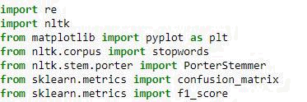
Further we performed basic analysis like checking the columns in the dataset, total number of observations in the dataset, is there any missing values in the dataset, and the target variable in the dataset. This was printed using ‘head()’ which prints the top 5 rows of the dataset.



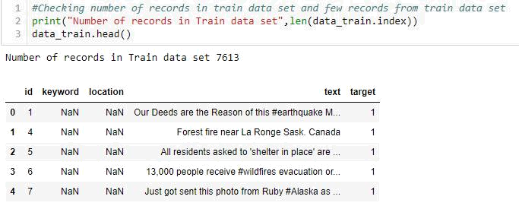

Once the dataset is analyzed, I tried to plot a graph to see the word frequency using ‘matplotlib’. We can observe that ‘fatalities’ word as repeated most number of times in the data and ‘radiation’ has been repeated least number of times in the data. Further I tries to plot ‘fake vs true news’ depending on the geographical location. We can observe that USA has the greatest number of tweets, in which 35% of them are fake tweets and rest of them are true news. We can even see few states and countries having no fake news at all. After analyzing I found out location data is not generated, but it is user entered values.

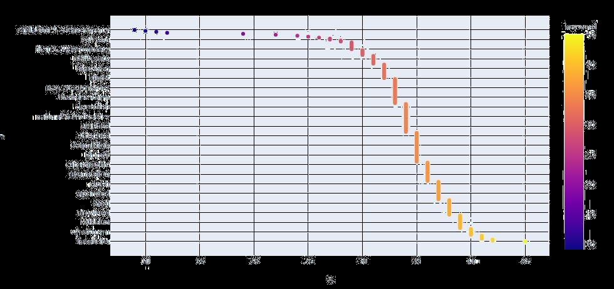
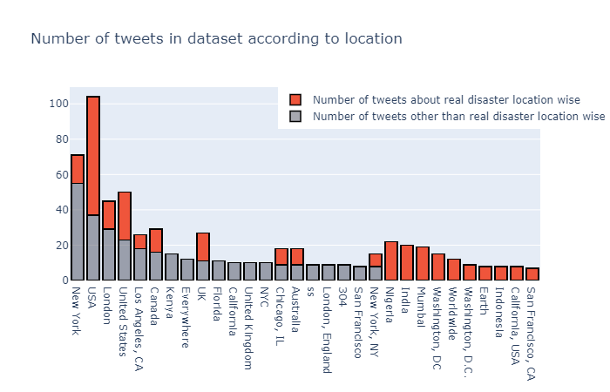


After analyzing the location and keyword data, we found out lots of interesting facts about the frequency of words in keywords, impact of location on the keywords and the news tweeted. To check the keyword repeated the greatest number of times, we plotted a word cloud using the library which has a cluster of all the repeated words.

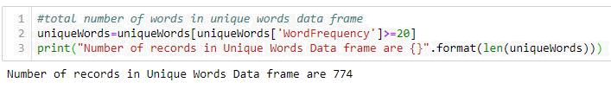

The words which have occurred minimum number of times can be neglected from the data so that the dimension of the ‘Bag of Words’ model can be decreased.

Further, we started processing the text and removing all the unwanted data, words, from the text and converted to its numerical form to train the machine learning model and apply the algorithm.


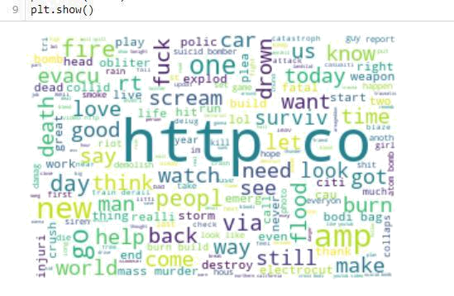

Section 3.

3.1 Experimental Results:
The Logistic regression algorithm gave out a good result. The training accuracy on the training set was 86% and the test accuracy was 82%, finally the F1 score was reported as 78.12%. We tried implementing Artificial Neural Network as well, it gave us an accuracy of 89% which is slightly better than Logistic Model.
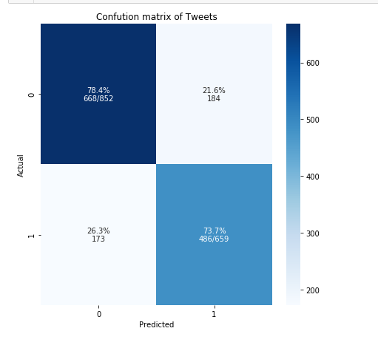

Section 4.
Conclusion:
Finally, Logistic Regression Classification model gave an average result. The results can be improved if trained on a large data with more accurate location and keywords. The model did a great job on classifying fake and true news.

Section 5.
References:
- A Fake News Detection on Social Media: A Data Mining Perspective https://dl.acm.org/doi/pdf/10.1145/3137597.3137600?download=true
- Creating TF-IDF Model from Scratch https://www.kaggle.com/yassinehamdaoui1/creating-tf-idf-model-from-scratch
- Real or Not? NLP with Disaster Tweets https://www.kaggle.com/c/nlp-getting-started/data

