2주차

라즈베리파이 alias설정
nano ~/.bashrc
alias sb="source ~/.bashrc; echo \"bashrc is reloaded\""
alias si="source install/local_setup.bash; echo \"local_setup,bash is loaded\""
alias jazzy="source /opt/ros/jazzy/setup.bash; ros_domain; echo \"ROS2 humble is activated!\""
alias ros_domain="export ROS_DOMAIN_ID=82"
export ROS_LOCLAHOST_ONLY=1

turtlesim pkg 사용
자율주행 로봇을 만들기 전에 turtlesim으로 ros2 연습
/turtle1/cmd_vel 발행
/turtle1/pose 구독
/turtle1_goal_pose 구독

ros2 run turtlesim turtlesim_node
turtle_go 파이썬파일 실행
터미널에서 직접 토픽 발
ros2 topic pub --once /turtle_goal_pose turtlesim/msg/Pose "{x: 3, y: 3}"

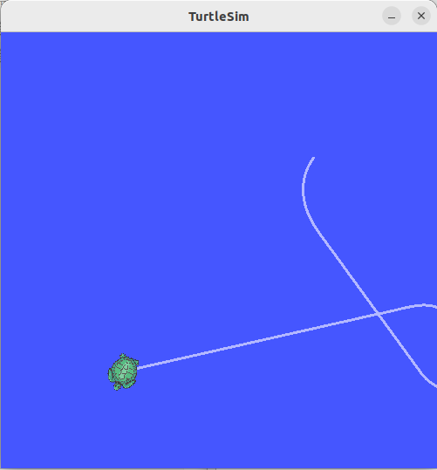
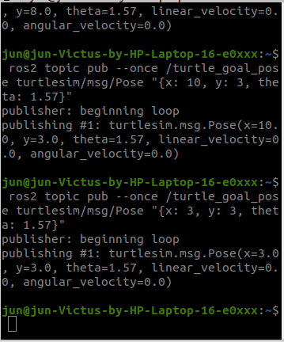

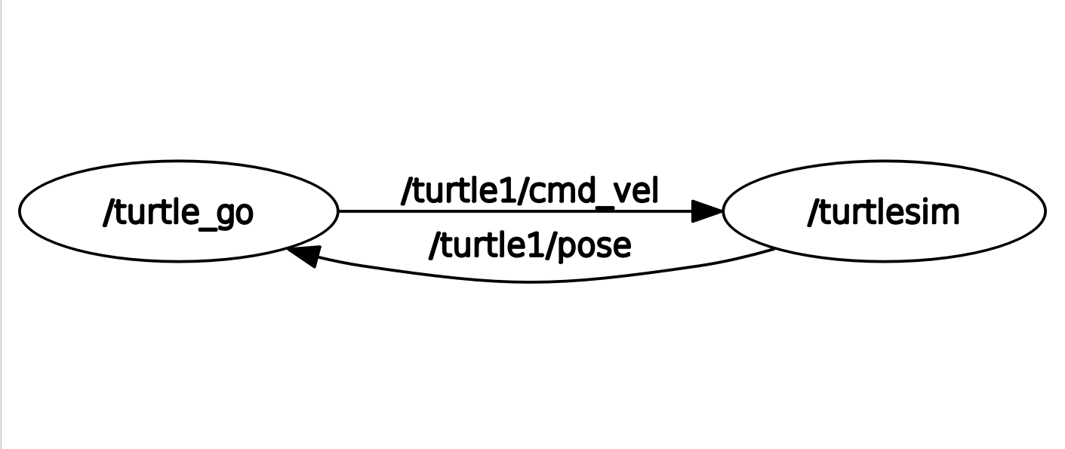

import rclpy
from rclpy.node import Node
from rclpy.qos import QoSProfile
from turtlesim.msg import Pose
from geometry_msgs.msg import Twist
import numpy as np

class TurtleGo(Node):
def __init__(self):
super().__init__('turtle_go')
qos_profile = QoSProfile(depth=200)
self.turtle_cmd_pub = self.create_publisher(Twist, 'turtle1/cmd_vel', qos_profile)
timer_period = 0.5 # seconds
self.timer = self.create_timer(timer_period, self.timer_callback)
self.turtle_pose_sub = self.create_subscription(Pose, '/turtle1/pose', self.turtle_pose, qos_profile)
self.turtle_goal_pose_sub = self.create_subscription(Pose, 'turtle_goal_pose', self.turtle_goal_pose, qos_profile)
self.present_x = None
self.present_y = None
self.present_theta = None
self.goal_x = None
self.goal_y = None
self.goal_theta = None

self.step_1 = False
self.step_2 = False

def turtle_pose(self, msg):
self.present_x = msg.x
self.present_y = msg.y
self.present_theta = msg.theta
#self.get_logger().info(f'present x : {msg.x}, y : {msg.y}, theta : {msg.theta}')

def turtle_goal_pose(self, msg):
self.goal_x = msg.x
self.goal_y = msg.y
self.goal_theta = msg.theta
self.step_1 = False
self.step_2 = False
self.dx = self.goal_x - self.present_x
self.dy = self.goal_y - self.present_y
self.init_distance = (self.dx ** 2 + self.dy ** 2) ** 0.5
#self.get_logger().info(f'goal x : {msg.x}, y : {msg.y}, theta : {msg.theta}')

def timer_callback(self):
if self.goal_x is not None:
msg = Twist()
self.dx = self.goal_x - self.present_x
self.dy = self.goal_y - self.present_y
self.dtheta = np.arctan2(self.dy, self.dx)
self.distance = (self.dx ** 2 + self.dy ** 2) ** 0.5
msg.linear.x = 1.
if self.step_1 is False:
self.auto_drive()

def auto_drive(self):
msg = Twist()
self.init_theta = np.arctan2(self.goal_y - self.present_y, self.goal_x - self.present_x)
self.calib_theta = self.init_theta - self.present_theta
if self.calib_theta < -3.14:
self.calib_theta = 6.28 - (self.init_theta - self.present_theta)
msg.linear.x = self.distance / (self.distance + 0.3)
msg.angular.z = self.calib_theta / (self.calib_theta + 0.3)
self.turtle_cmd_pub.publish(msg)
print(self.dx, self.dy, self.distance)
if self.distance < 0.05:
msg.linear.x = 0.
msg.angular.z = 0.
self.step_1 = True

def main(args=None):
rclpy.init(args=args)
turtle_go = TurtleGo()
try:
rclpy.spin(turtle_go)
except KeyboardInterrupt:
turtle_go.get_logger().info('Keyboard Interrupt (SIGINT)')
finally:
turtle_go.destroy_node()
rclpy.shutdown()

if __name__ == '__main__':
main()

