Solution Architecture Document

Version 1.0

Table OF Content
- Intorduction
- Architectural Representation
- Architectural Goal and Contraint
- Use CaseView
- Logical View
- Process View
- Deployment View

Introduction :-
Purpose :- This document provides a architectural overview of the product Store system,

Architectural Representation :-
This document presents the architecture as a series of views; use case view, logical view, process view and deployment view.

Architectural Goals and Constraints :-
- This is client server system.
- This is designed as monolith application follwing MVC eisgn pattern.

Use Case View :-
The Product store use case :-
- Login Page
- Register Page
- Admin Page (for Product excel Upload)
- User Page (For product Add/ Remove)

Logical View :-
The Application has 3 layers.
- Ui Layer (Application Layer MVC)
- Service Layer
- Dao Layers

Processes

Technical Process FLow

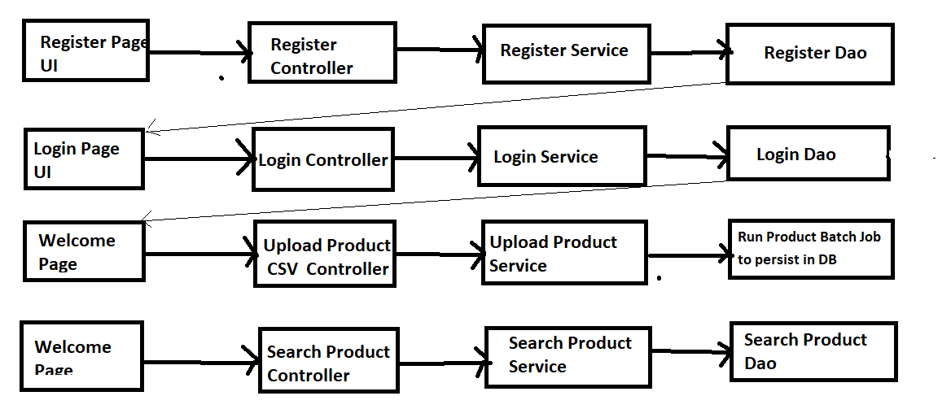

- User Login in Application from login Page
- After login User is presented with Welocme screen to upload the CSV file into database from Spring Batch.
- User will be redirected other page after job run
- User can go to search for product from elcom screen also.

Deployment View

- External Desktop PC
User registered for product store using external desktop PCs which are connected to the Server via internet .
- This is Monolith application can be done web servers like tomcat / jetty or weblogic.

