Exercise 1: Implementing the Singleton Pattern

Code:

public class SingletonPatternExample {

static class Logger {

//Creating static instance for the logger class

private static Logger instance;

private Logger() {

System.out.println("A Logger instance has been created");

}

public static Logger getInstance() {

if (instance == null) instance = new Logger();

return instance;

}

public void log(String message) {

System.out.println("Log: " + message);

}

}

public static void main(String[] args) {

Logger log1 = Logger.getInstance();

log1.log("This is the first log message.");

Logger log2 = Logger.getInstance();

log2.log("This is the second log message.");

if (log1 == log2) {

System.out.println("Only one instance exists in the application");

} else {

System.out.println("Different instances exists in the application");

}

}

}

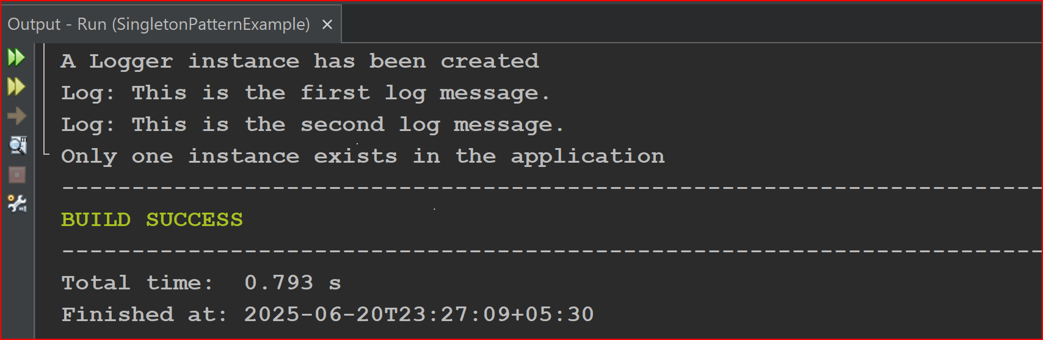Output:

Exercise 2: Implementing the Factory Method Pattern

Code:

public abstract class WordDocument {

public abstract void open();

}

public abstract class PdfDocument {

public abstract void open();

}

public abstract class ExcelDocument {

public abstract void open();

}

public class MyWordDocument extends WordDocument {

@Override

public void open() {

System.out.println("Opening Word document...");

}

}

public class MyPdfDocument extends PdfDocument {

@Override

public void open() {

System.out.println("Opening PDF document...");

}

}

public class MyExcelDocument extends ExcelDocument {

@Override

public void open() {

System.out.println("Opening Excel document...");

}

}

public abstract class DocumentFactory {

public abstract Object createDocument();

}

public class WordDocumentFactory extends DocumentFactory {

@Override

public WordDocument createDocument() {

return new MyWordDocument();

}

}

public class PdfDocumentFactory extends DocumentFactory {

@Override

public PdfDocument createDocument() {

return new MyPdfDocument();

}

}

public class ExcelDocumentFactory extends DocumentFactory {

@Override

public ExcelDocument createDocument() {

return new MyExcelDocument();

}

}

public class Test {

public static void main(String[] args) {

WordDocumentFactory wordFactory = new WordDocumentFactory();

WordDocument word = wordFactory.createDocument();

word.open();

PdfDocumentFactory pdfFactory = new PdfDocumentFactory();

PdfDocument pdf = pdfFactory.createDocument();

pdf.open();

ExcelDocumentFactory excelFactory = new ExcelDocumentFactory();

ExcelDocument excel = excelFactory.createDocument();

excel.open();

}

}

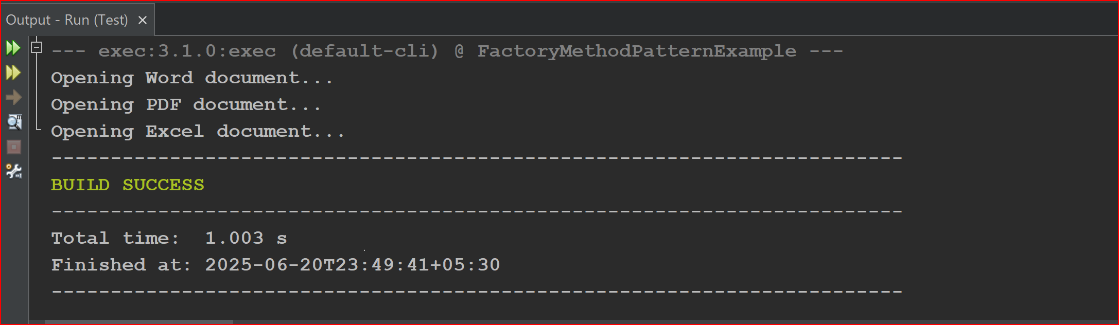Output: