**JUNIT TESTING EXERCISES**

**Exercise 1: Setting Up Junit**

**Scenario: You need to set up JUnit in your Java project to start writing unit tests.**

**Steps:**

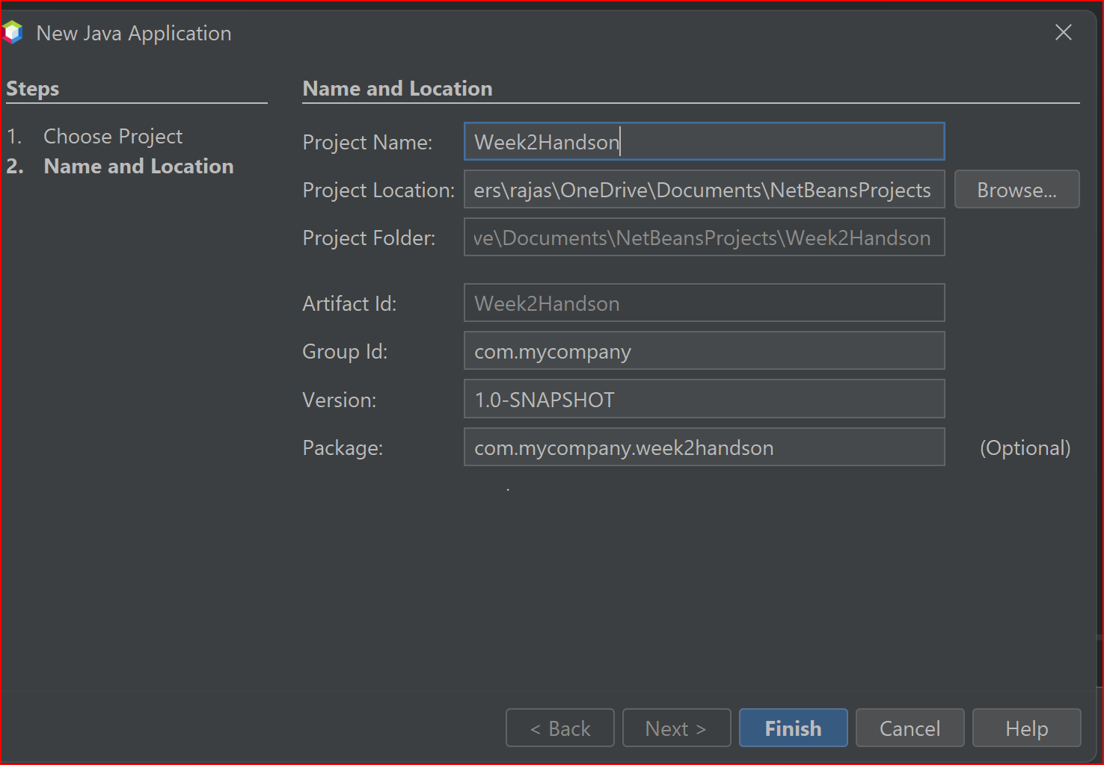1. Create a new Java project in your IDE (e.g., IntelliJ IDEA, Eclipse).

2. Add JUnit dependency to your project. If you are using Maven, add the following to your pom.xml:

<dependency>

<groupId>junit</groupId>

<artifactId>junit</artifactId>

<version>4.13.2</version>

<scope>test</scope>

</dependency>

3. Create a new test class in your project.

**TestGreet.java:**

import org.junit.Test;

import static org.junit.Assert.assertEquals;

public class TestGreet {

@Test

public void Testmsg(){

assertEquals("Actual and observed values differed",(4+3) ,multiply(4,3));

}

public int multiply(int a,int b){

return a*b;

}

}

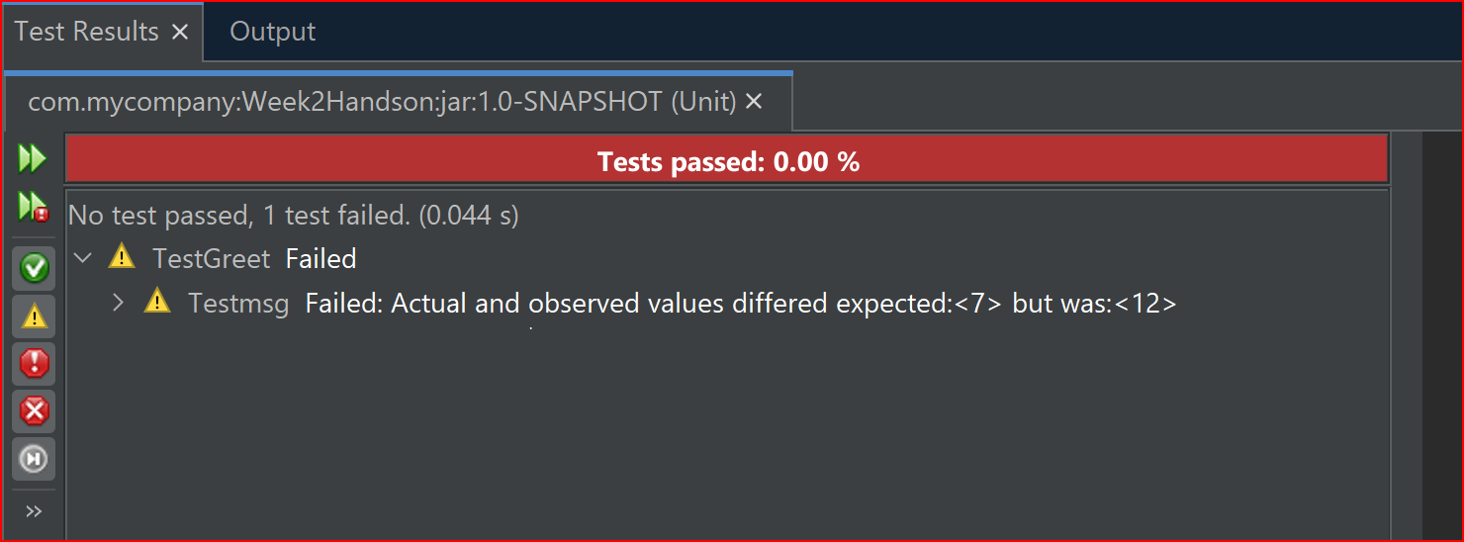**Output:**

**Exercise 3: Assertions in Junit**

**Scenario: You need to use different assertions in JUnit to validate your test results.**

**Steps:**

1. Write tests using various JUnit assertions.

**Solution Code:**

public class AssertionsTest {

@Test

public void testAssertions() {

// Assert equals

assertEquals(5, 2 + 3);

// Assert true

assertTrue(5 > 3);

// Assert false

assertFalse(5 < 3);

// Assert null

assertNull(null);

// Assert not null

assertNotNull(new Object());

}

}

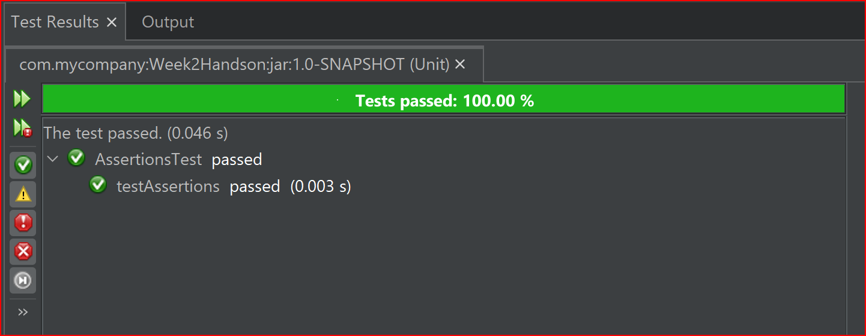**Output:**

**Exercise 4: Arrange-Act-Assert (AAA) Pattern, Test Fixtures, Setup and Teardown Methods in JUnit**

**Scenario: You need to organize your tests using the Arrange-Act-Assert (AAA) pattern and use setup and teardown methods.**

**Steps:**

1. Write tests using the AAA pattern.

2. Use @Before and @After annotations for setup and teardown methods.

**Source Code:**

import org.junit.After;

import org.junit.Assert;

import org.junit.Before;

import org.junit.Test;

import static org.junit.Assert.*;

public class AAA {

private int a,b;

@Before

public void setUp() {

a=5;

b=2;

System.out.println("Setting values for variables 'a' & 'b'");

}

@Test

public void TestAdd(){

System.out.println("Testing in process....");

Assert.assertEquals("Error in add Method", a+b, add());

}

@After

public void tearDown() {

System.out.println("Clearing values for a & b");

a=0;

b=0;

}

public int add(){

return a+b;

}

}

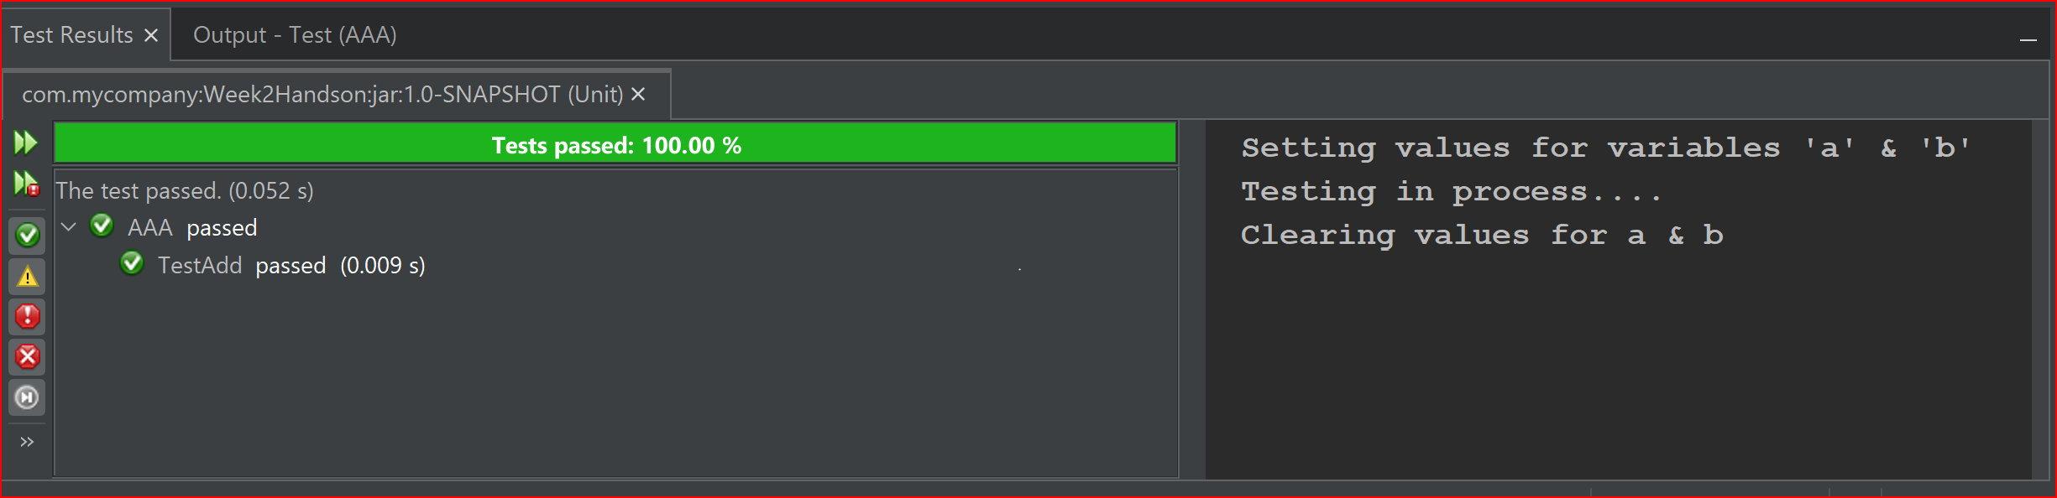**Output:**