Create a new React Application with the name “myfirstreact”, Run the application to print “welcome to the first session of React” as heading of that page.

1. To create a new React app, Install Nodejs and Npm from the following link:





1. To create a React Application with the name of “myfirstreact”, type the following command:

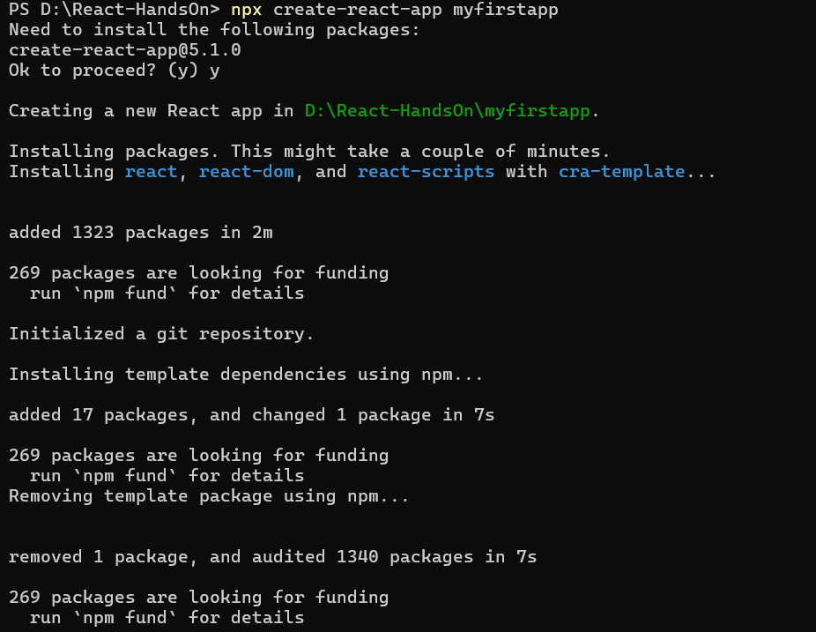

1. Once the App is created, navigate into the folder of myfirstreact by typing the following command:
2. Open the folder of myfirstreact in Visual Studio Code
3. Open the App.js file in Src Folder of myfirstreact
4. Remove the current content of “App.js”
5. Replace it with the following
6. Run the following command to execute the React application:
7. Open a new browser window and type “localhost:3000” in the address bar

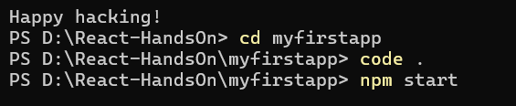

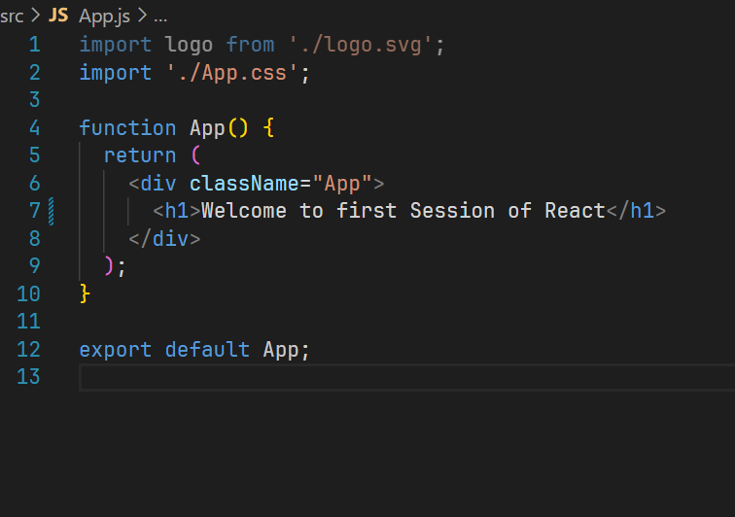

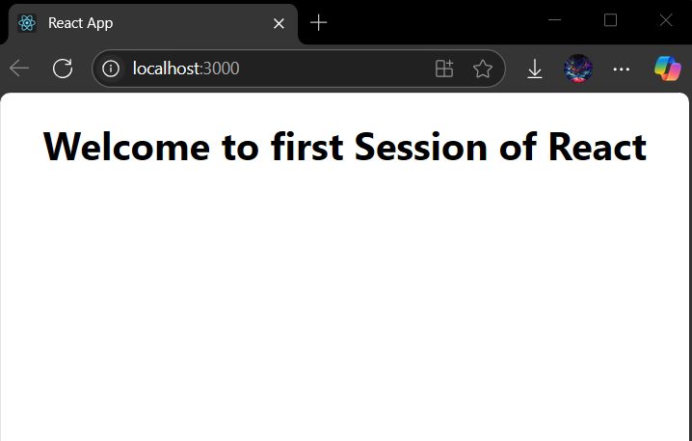

Create a react app for Student Management Portal named StudentApp and create a component named Home which will display the Message “Welcome to the Home page of Student Management Portal”. Create another component named About and display the Message “Welcome to the About page of the Student Management Portal”. Create a third component named Contact and display the Message “Welcome to the Contact page of the Student Management Portal”. Call all the three components.

1. Create a React project named “StudentApp” type the following command in terminal of Visual studio:

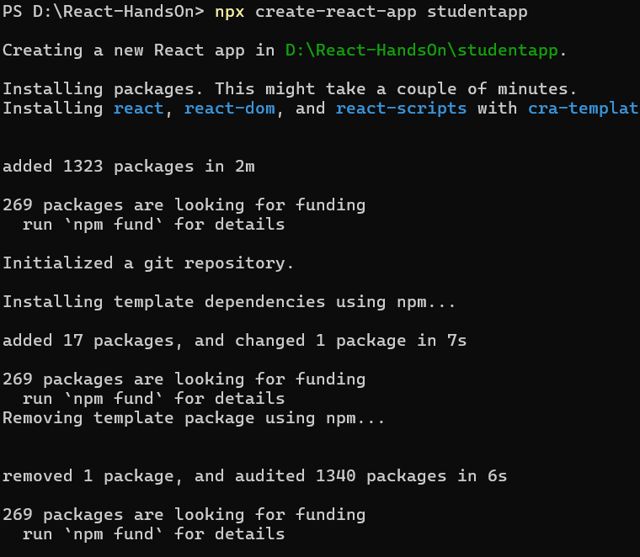

1. Create a new folder under Src folder with the name “Components”. Add a new file named “Home.js”

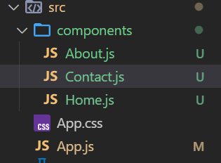

1. Type the following code in Home.js

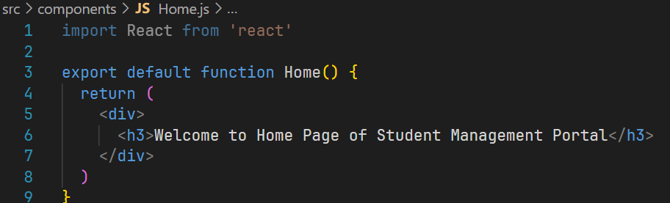

1. Under Src folder add another file named “About.js”

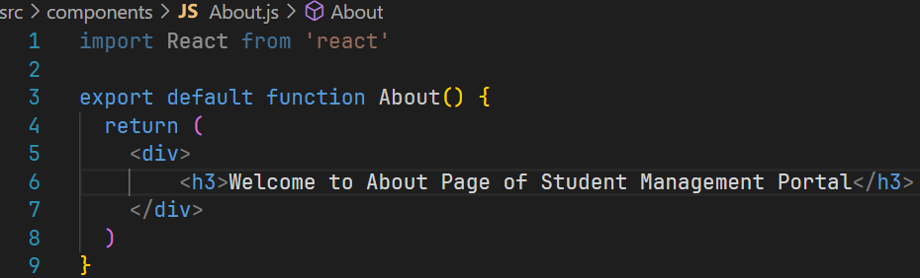

1. Repeat the same steps for Creating “About” and “Contact” component by adding a new file as ”About.js”, “Contact.js” under “Src” folder and edit the code as mentioned for “Home” Component.

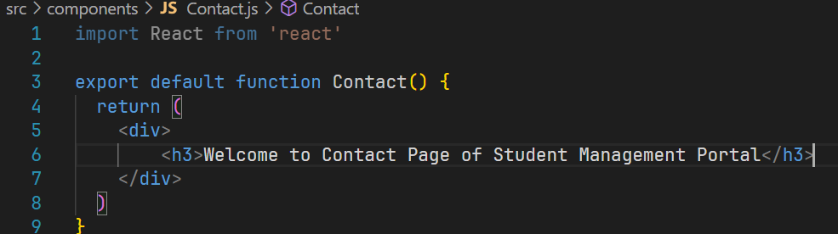

1. Edit the App.js to invoke the Home, About and Contact component as follows:

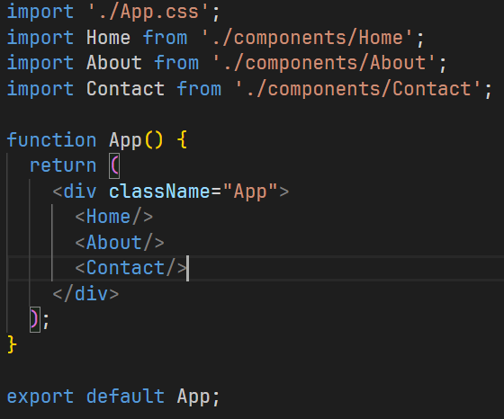

1. In command Prompt, navigate into StudentApp and execute the code by typing the following command:

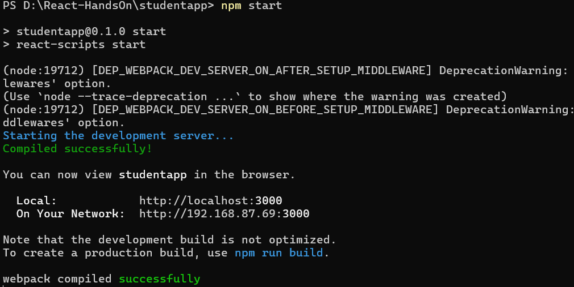

1. Open browser and type “localhost:3000” in the address bar:

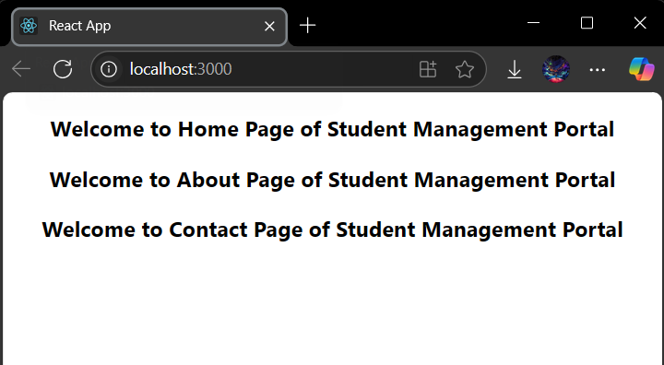

Create a react app for Student Management Portal named scorecalculatorapp and create a function component named “CalculateScore” which will accept Name, School, Total and goal in order to calculate the average score of a student and display the same.

1. Create a React project named “scorecalculatorapp” type the following command in terminal of Visual studio:
2. Create a new folder under Src folder with the name “Components”. Add a new file named “CalculateScore.js”
3. Type the following code in CalculateScore.js
4. Create a Folder named Stylesheets and add a file named “mystyle.css” in order to add some styles to the components.
5. Edit the App.js to invoke the CalculateScore functional component as follows:
6. In command Prompt, navigate into scorecalculatorapp and execute the code by typing the following command:
7. Open browser and type “localhost:3000” in the address bar:

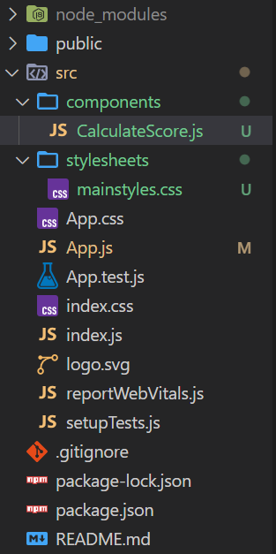

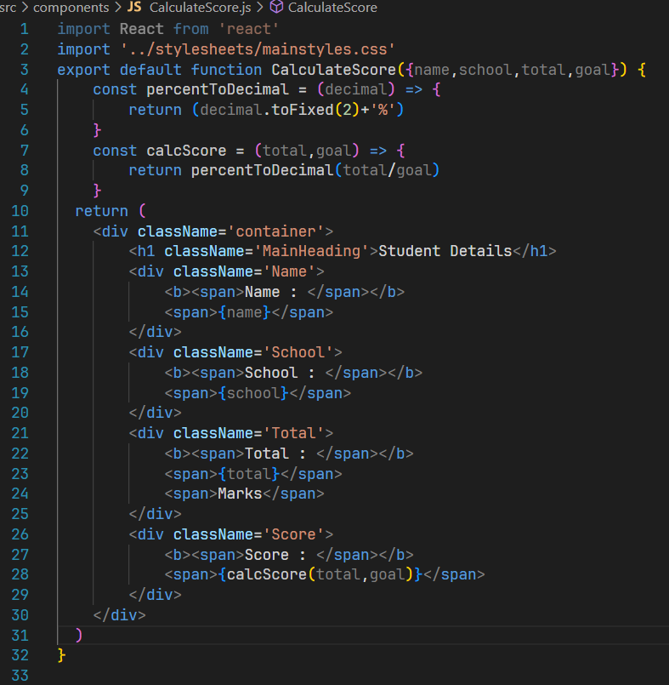

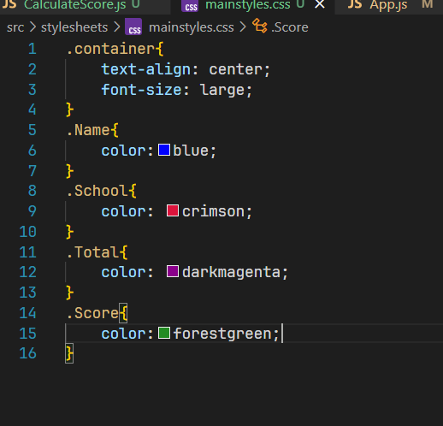

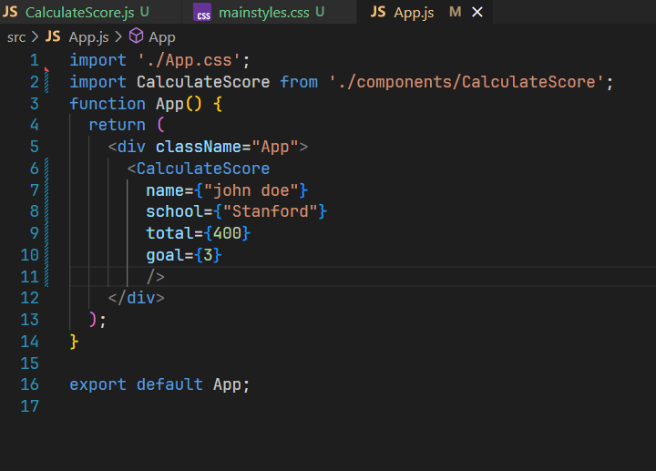

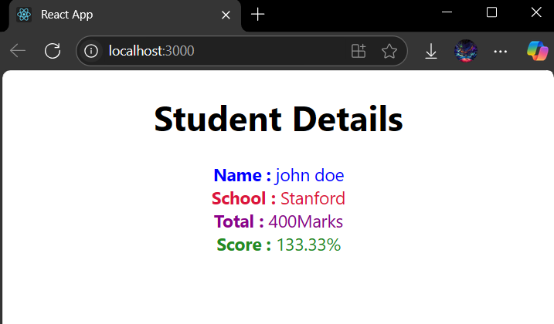

Create a React Application named “cricketapp” with the following components:

1. ListofPlayers

* Declare an array with 11 players and store details of their names and scores using the map feature of ES6
* Filter the players with scores below 70 using arrow functions of ES6.

1. IndianPlayers
   1. Display the Odd Team Player and Even Team players using the Destructuring features of ES6
   2. Declare two arrays T20players and RanjiTrophy players and merge the two arrays and display them using the Merge feature of ES6

Display these two components in the same home page using a simple if else in the flag variable.

**Code:**

**App.js**

import React, { useState } from 'react'

import ListOfPlayers from './components/ListOfPlayers'

import FilteredPlayers from './components/FilteredPlayers'

import OddPlayers from './components/OddPlayers'

import EvenPlayers from './components/EvenPlayers'

import IndianPlayers from './components/IndianPlayers'

const App = () => {

  const players = [

    { name: "zack", score: 49 }, { name: "ben", score: 89 }, { name: "pope", score: 59 },

    { name: "root", score: 119 }, { name: "brook", score: 234 }, { name: "stokes", score: 150 },

    { name: "smith", score: 180 }, { name: "woakes", score: 34 }, { name: "carse", score: 102 },

    { name: "dawson", score: 49 }, { name: "archer", score: 12 }

  ];

  const t20players = ["fist player", "second player", "third player"];

  const ranjiplayers = ["fourth player", "fifth player", "sixth player"];

  const indianPlayers = [...t20players, ...ranjiplayers];

  const indianteam = ["sachin1", "dhoni2", 'kapil3', "rohit4", "virat5", "nitish6"];

  const [flag, setFlag] = useState(true);

  const HandleChange = (event) => {

    setFlag(event.target.value === "true");

  };

  let content;

  if (flag === true) {

    content = (

      <>

        <ListOfPlayers players={players} />

        <FilteredPlayers players={players} />

      </>

    );

  } else {

    content = (

      <>

        <OddPlayers indianteam={indianteam} />

        <EvenPlayers indianteam={indianteam} />

        <IndianPlayers indianplayers={indianPlayers} />

      </>

    );

  }

  return (

    <div>

      <h1>Cricket App</h1>

      <div className='input-div'>

        <label htmlFor="flag-dropdown"> Set Flag Value : </label>

        <select id="flag-dropdown" onChange={HandleChange}>

          <option value={false}>False</option>

          <option value={true}>True</option>

        </select>

      </div>

      <h1>{`Your Flag Value is : ${flag}`}</h1>

      {content}

    </div>

  );

};

export default App;

**ListOfPlayers.js**

import React from 'react'

const ListOfPlayers = ({players}) => {

  return (

    <div>

    <h1>List Of Players</h1>

      <ul>{

        players.map((player) => {

            return <li>Mr. {player.name} {player.score}</li>

        })

      }</ul>

    </div>

  )

}

export default ListOfPlayers

import React from 'react'

**FilteredPlayers.js**

const FilteredPlayers = ({players}) => {

  return (

    <div>

    <h1>List Of Players Having Score Less than 70</h1>

      <ul>

        {

        players.filter((player) => player.score<70).map(

            (player) => {

                return <li>Mr. {player.name} {player.score}</li>

            }

        )

      }

      </ul>

    </div>

  )

}

export default FilteredPlayers

import React from 'react'

**OddPlayers.js**

const OddPlayers = ({indianteam}) => {

  return (

    <div>

      <h1>List of Odd Players </h1>

        <ul>

            {

                indianteam.map((player,i) => {

                    if(i%2!==0){

                    return <li>Mr. {player}</li>

                    }

                })

            }

        </ul>

    </div>

  )

}

export default OddPlayers

**EvenPlayes.js**

import React from 'react'

const EvenPlayes = ({indianteam}) => {

  return (

    <div>

      <h1>List of Even Players </h1>

        <ul>

            {

                indianteam.map((player,i) => {

                    if(i%2===0){

                    return <li>Mr. {player}</li>

                    }

                })

            }

        </ul>

    </div>

  )

}

export default EvenPlayes

**IndianPlayers.js**

import React from 'react'

const IndianPlayers = ({indianplayers}) => {

  return (

    <div>

        <h1>List of Indian Players </h1>

        <ul>

            {

                indianplayers.map((player) => {

                    return <li>Mr. {player}</li>

                })

            }

        </ul>

    </div>

  )

}

export default IndianPlayers

**Output:**

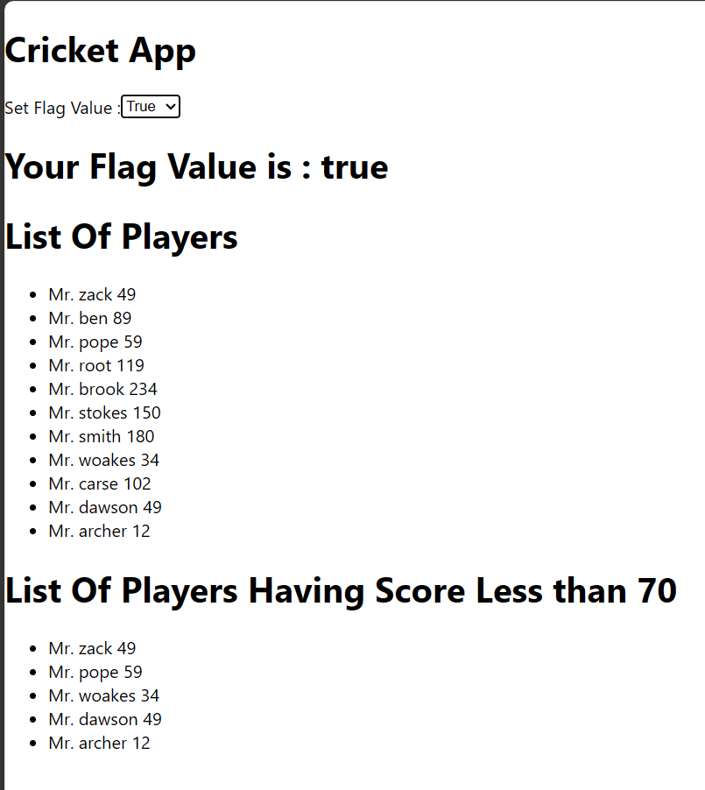

When Flag=false

