PHPIDS integration into MODX
Author: Stefanie Janine Stölting
Contact: mail@stefanie-stoelting.de
Version: 0.6.5 alpha 5
Table of contents
Description 2
Instructions 2
Download 2
Upload 2
Secure the PHPIDS directory 2
Installation and configuration of the module 3
Installation 3
Configuration 4
Parameter description 6
Installation and configuration of the plugin 8
Installation 8
Configuration 9
Configuration of the module to use the module configuration in the plugin 10
Allow the plugin to use the module settings 10
Use the parameters of the module in the plugin 11
Using the module 12
The Log Data tab 12
The Blocked Data tab 13
The Extended Options tab 15
Checking filter updates 15
Download the intrusion data as CSV file 15
Empty log table 15
Used tools and libraries 16
PHPIDS 16
jQuery 16
jQueryUI 16
jqGrid 16
jQuery blockUI plugin 16

Description
PHPIDS is a PHP based intrusion detection, to find out at a very early step about attacks to your website. This plugin is based on an article published by Heise Verlag: Getting started with the PHPIDS intrusion detection system http://www.h-online.com/security/Getting-started-with-the-PHPIDS-intrusion-detection-system--/features/113163.You can find more information about PHPIDS at the project site at www.phpids.org.
The current PHPIDS version is included in the download file, you don't need to download it from PHPIDS. The version number of the plugin refers to the version number of PHPIDS, the letters at the end are showing the version changes of the package.

Instructions

Download
First you need to download the package and unpack the zip file. You will find the current version at https://code.google.com/p/phpids-for-modx/downloads/list.

Upload
Upload the folders lib and modules in the assets directory of your existing MODX installation with a FTP client program.
Change the access rights of assets/lib/phpids/lib/IDS/tmp to 777.

Secure the PHPIDS directory
The folder assets/lib/phpids and the sub-folder is secured with a .htaccess file, that denies all possible access from the web. If you use a Microsoft Windows OS with IIS, you should secure the folder with IIS properties, because IIS does not understand .htaccess files.

Installation and configuration of the module

Installation
Open the file assets/module/phpids/module.phpids.inc.php.tpl and copy the content.
Go to your MODX backend, click on the tab "Modules" -> "Manage Modules" -> New Module".
Name the module PHPIDS and paste the copied code into "Module code (php)".
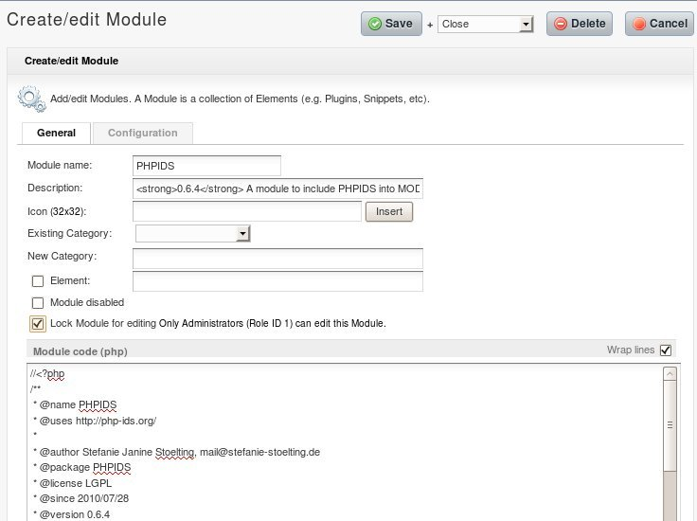

Configuration
Now click on "Configuration", there you have to enable parameter sharing by clicking on “Enable parameter charing” and to paste the following line into "Module configuration" and click "Update parameter display".
&useMODxBasePath=Use MODX base path?;list;true,false;true &basePath=PHPIDS path?;string;assets/lib/phpids/lib &useLogFile=Use log file?;list;true,false;false &useEmail=Use email?;list;true,false;true &useDatabase=Use database?;list;true,false;true &useMODxTablePrefix=Use MODX table prefix?;list;true,false;true &useMODxLog=Use MODX Log?;list;true,false;true &logFromImpact=Start logging from impact?;int;5 &sendMailFromImpact=Start sending mails from impact, high (around 15) or very high (around 25-50) impact?;int;15 &idsRecipients=Mail resipients (separated by comma);text; &idsSubject=Mail subject
(keep empty to use default);text; &SMTPServer=SMPT server;text; &SMTPPort=SMPT port
(default is 25, leave empty to use default);text; &SMTPAccount=SMPT account;text; &SMTPPassword=SMPT password;text; &mailFrom=E-Mail From Name
Only used with SMTP;text;PHPIDS;&useExeptions=Exceptions separated with pipes (|);text;&blockedDocumentID=ID of the MODX document, that blocked IPs would see, default is root;text&defaultTableEntries=Default table entries on start;text;20 &redirectIntrusionLevel=Redirect intrusions from a level (50 is hight);text;50 &redirectIntrusionID=Redirect intrusion to the document ID (0 means no redirection);text;0 &csvDelimiter=CSV delimiter (only one character);text;, &csvEnclosure=CSF enclosure (only one character);text;#

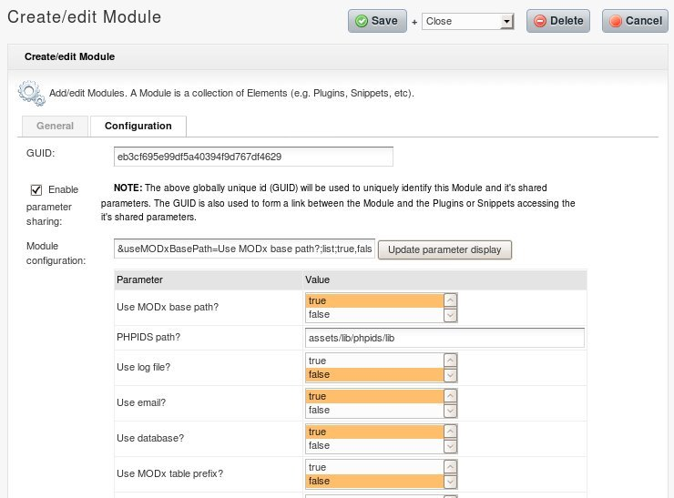
Now you can change the configuration of the plugin and the module. All parameters, that are not personally as the e-mail address, where the impacts should be reported, are filled with default values.
Click on "Save" and the first module step is done.

Parameter description
Use MODX base path | Use the base path of the current MODX installation.
PHPIDS path? | Path to the PHPIDS files. You may want to use only one PHPIDS for different MODX installations, then you have to configure the path.
Use log file? | Weather to use a log file, or not.
Use email? | Weather to send alarm mails, or not.
Use database? | Weather to write logs to the database, or not.
Use MODx table prefix? | If you use database logs, you may decide to use the MODX tabel prefix, or not.
Use MODx Log? | Weather you want to use the MODX log, or not.
Start logging from impact? | Define the lower limit for impacts where the logging starts.
Start sending mails from impact, high (around 15) or very high (around 25-50) impact? | Define the level of impacts,at which mail sending starts.
Mail recipients (separated by comma) | Enter the mail recipients, that you want to inform about possible attacks.
Mail subject  (keep empty to use default) | Write your own subject text, or leave it empty to use the default text.
SMPT server | If you want to use a SMTP server for sending mails, enter the address to the server here.
SMPT port  (default is 25, leave empty to use default) | The port of the SMTP Server, leave it empty if your server uses the default SMTP port.
SMPT account | The SMTP account name.
SMPT password | The password for the SMTP account.
E-Mail From Name  Only used with SMTP | The name, that will be used as from text on SMTP mails.
Exceptions separated with pipes (|) | Here you can define exceptions for PHPIDS, for example to avoid alarms of Google Analytics.
ID of the MODX document, where blocked IPs are send to | Here you can enter an MODX document identifier, where blocked IP addresses are forwarded to. For example you may setup a static HTML page and forward the attacker to the static page.
Default table entries on start | The number of table entries, that are used inside the module, when you open the module. You can change the the table entries also in the table.
Redirect intrusions from a level (50 is very high) | The level of intrusions to redirect possible attackers automatically to a document.
Redirect intrusion to the document ID (0 means no redirection) | If you want to redirect possible attackers with a high impact rate automatically, you can enter an MODX document identifier, where blocked IP addresses are forwarded to. For example you may setup a static HTML page and forward the attacker to the static page.
CSV delimiter (only one character) | The delimiter for the CSV cells. Only one character is allowed.
CSF enclosure (only one character) | The enclosure for CSV text cells. Only one character is allowed.

Installation and configuration of the plugin

Installation
Open the file assets/plugins/phpids/plugin.phpids.inc.php.tpl and copy the content.
In your MODX backend click on "Elements" -> "Manage Elements" -> "Plugins" -> "New Plugin".
Name the plugin PHPIDS and paste the copied content into "Plugin code (php)".
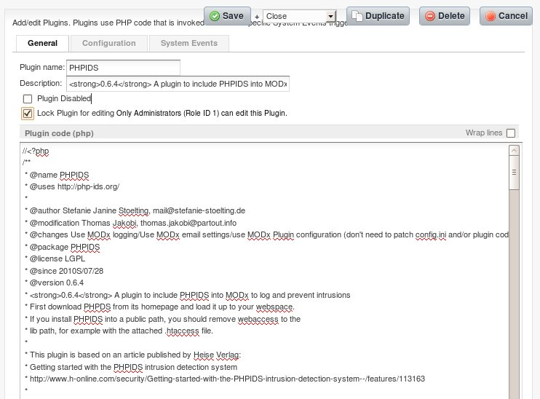

Configuration
Then go to "System Events" and under "Template Service Events" choose "OnWebPageInit", then click on save.
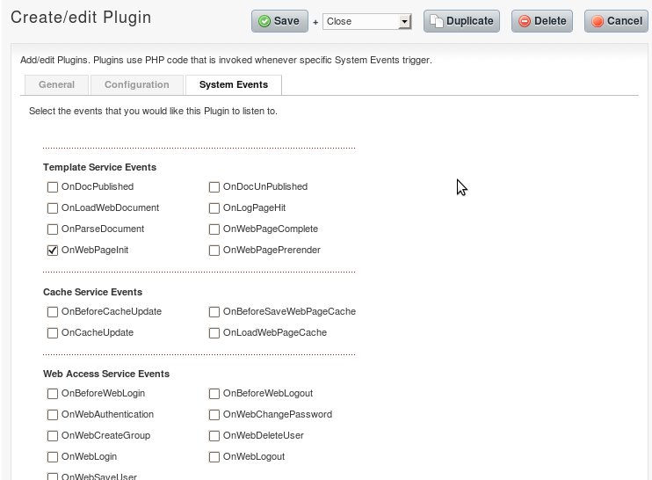

Configuration of the module to use the module configuration in the plugin

Allow the plugin to use the module settings
Go back the module by "Modules" -> "Manage Modules" -> "PHPIDS" and then on the tab "Dependencies". Now click "Manage Dependencies" and there on "Add Plugin".
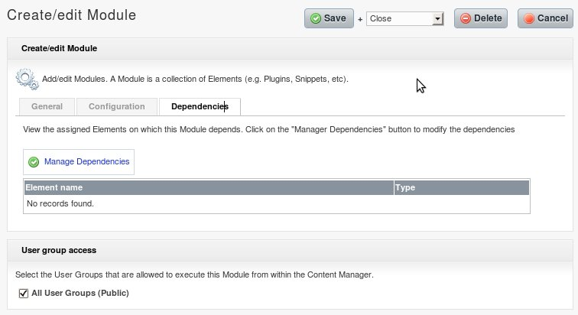
Here you only have to click on "Insert" and then on "Close".
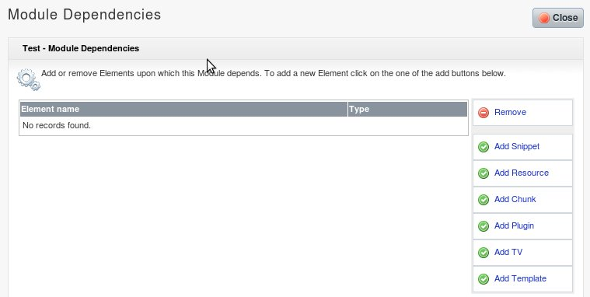
No go back to "Elements" -> "Manage Elements" -> "Plugins" and edit "PHPIDS". Open tab "Configuration" and choose "PHPIDS" in the drop down box "Import Module shared parameters".
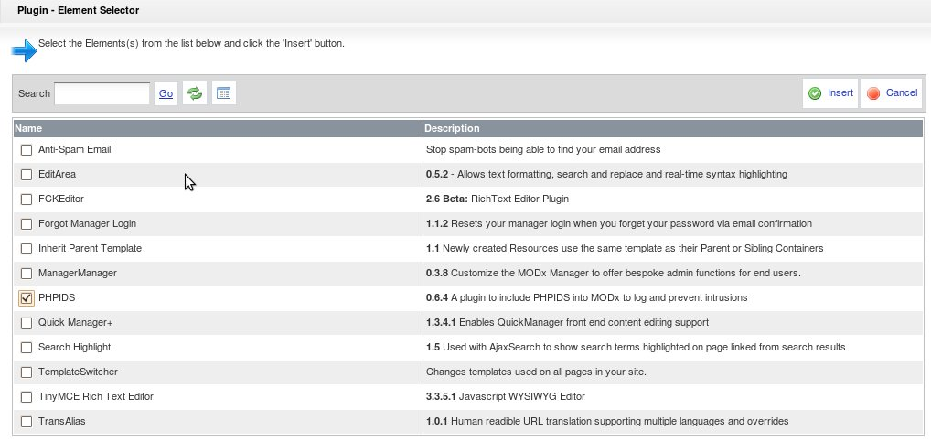

Use the parameters of the module in the plugin
Open the plugin again and click on the configuration. On “Import Module shared parameters” choose PHPIDS.
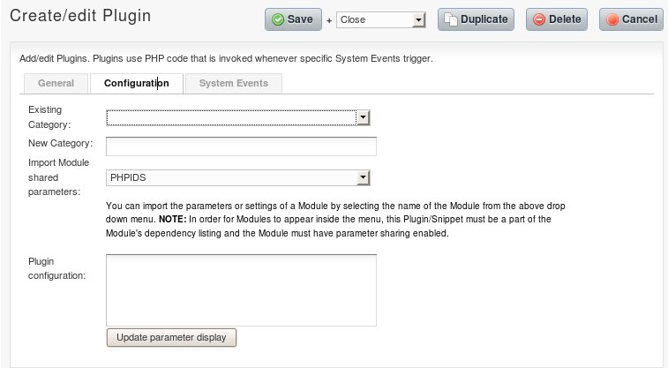

Using the module
To see possible attacks, that are logged to the database, click on “Modules” → “PHPIDS”. This does only work, if you have configured the module with Use database? = True.
There are two tab-sheets, one shows the list of possible attacks, and the other one shows a list of blocked IP addresses.
The table are both completely sortable by clicking on the header of a column.

The Log Data tab
The Log Data tab shows you possible impacts:
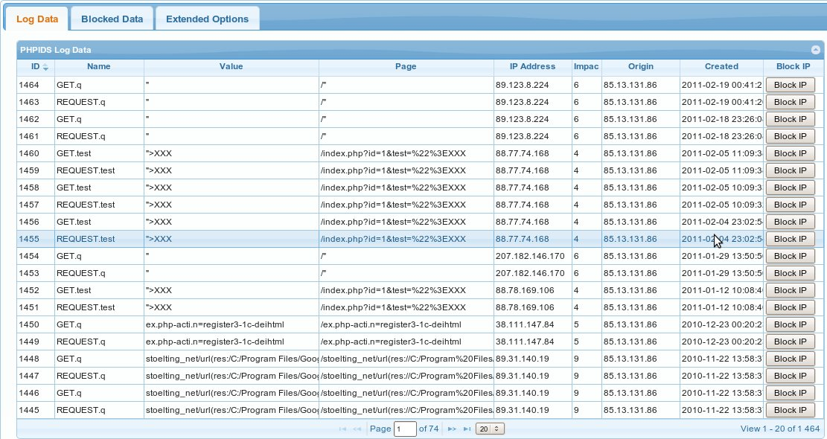
The column “IP address” of the attacker is a link, that shows further information in the RIPE database in a new window/tab.
To get location information, the column “Origin” is linked to www.infosniper.net with the IP address of the attacker. Infosniper tries to geolocate the IP address and shows several information about the provider.
You may also test the attack on PHPIDS demo page. The column “Impact” is linked to the PHPIDS demo page with the complete attack as shown in value. The content of the column itself is now URL-encoded, if you want to see the content without URL-encoding, just click on the button “Block IP”. You see the complete possible attack in that window.
If you want to block an attacker by his IP address, you have to click on the button “Block IP”. After you've confirmed, that you want to block the shown IP Address, all users with this IP address are forwarded as defined in Redirect intrusion to the document ID (0 means no redirection). For example use a static HTML page, where an attacker can do no harm to your server.
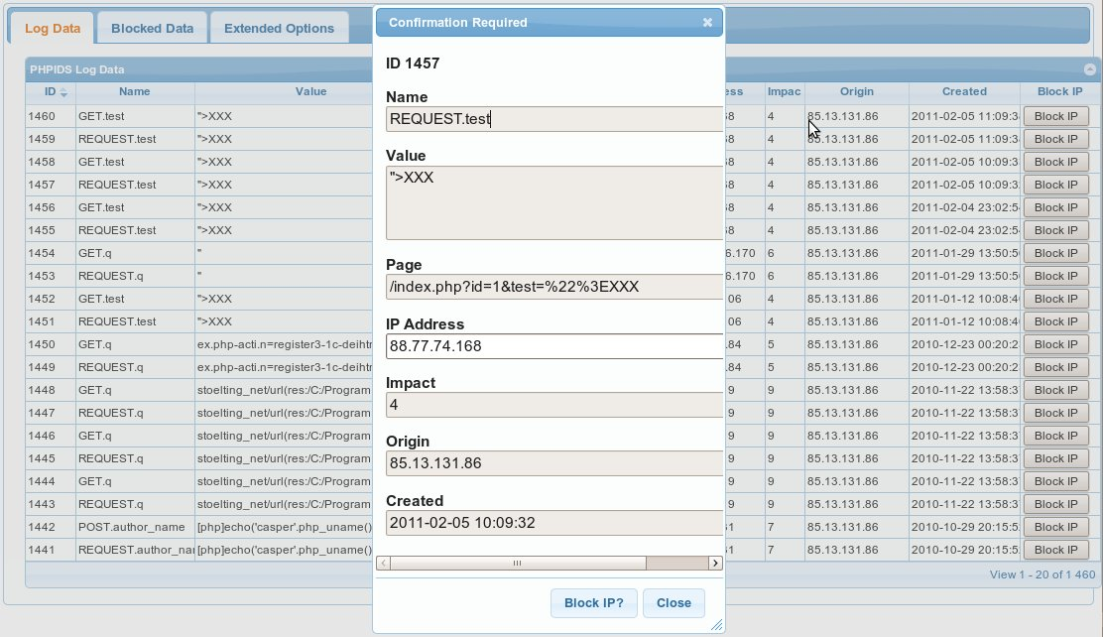

The Blocked Data tab
On the Blocked Data tab you see the currently blocked IP addresses, that are redirected.
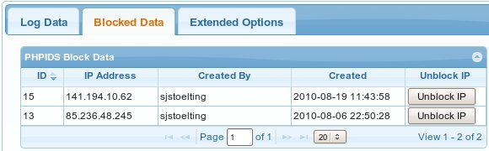
The IP address of the attacker is a link, that shows further information in the RIPE database.
To unblock a blocked IP Address, just click on the button “Unblock IP” and confirm the dialog:
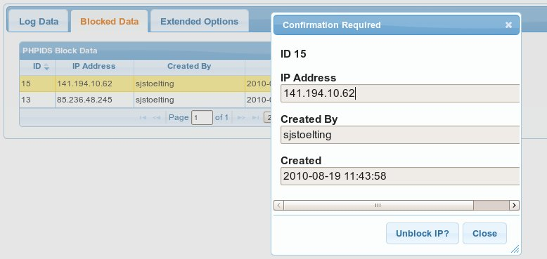

The Extended Options tab

Checking filter updates
With the change of the domain to phpids.org, the news protocol was changed from RSS to ATOM. That means, that is has to be changed here to. Until this work isn't done, filter updates are not checked.
This checks, whether there is a filter update available at phpids.org, or not. Currently there are three possible messages:
- There is no filter update available.
- There is a filter update from {update file date} available
- PHPIDS Filter URI is not available.
No filter update available means, that everything is OK. If there is a filter update available, then there are two possible options:
If you have full rights on the filter file, located in the root directory of your PHPIDS lib folder, then you only have to push the button “Update Filter”. Than the new filter data will be read from phpids.org and written to your filter.
The second option is to download the filter from phpids.org and upload it manually to your system.
“PHPIDS Filter URI is not available” means, that the module can't connect to the filter. This may be for example, that there is a problem at phpids.org.

Download the intrusion data as CSV file
With the link “Download intrusions as CSC” file, you get the complete data of the intrusion table. The delimiter and the enclosure for the CSV files are configurable at the module configuration.

Empty log table
It is now possible, to empty the log table, but afterward all entries about previous possible attacks are lost.
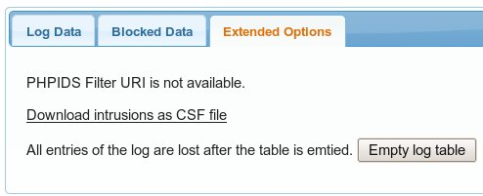

Used tools and libraries
All tools and libraries, that are mentioned, are part of this package.

PHPIDS
The package is based on PHPIDS, available at http://phpids.org/. PHPIDS is a PHP intrusion detection system. The inspiration for this package is based on an article by Daniel Bachfeld, published on 1th. May 2009 at http://www.h-online.com/security/features/Getting-started-with-the-PHPIDS-intrusion-detection-system-746233.html.
This article is also a god start for understanding PHPIDS.
PHPIDS is part of this package since version 0.6.4. The version number of this plugin refers to the version number of PHPIDS. This means, that 0.6.5 is the current version of PHPIDS in this packet.

jQuery
The module rendering is based an jQuery, which is available at www.jquery.com. The current version used in this package is 1.5.1.

jQueryUI
The jQuery package is needed for the layout and some functionality of the module. The current version used in this package is 1.8.10. jQueryUI is available at http://jqueryui.com/.

jqGrid
The grid component used for listings is the jQuery and jQueryUI based jqGrid. The current version used in this package is 3.8.1. You may find more information about jqGrid at http://www.trirand.com/blog/.

jQuery blockUI plugin
The blockUI plugin is used, while AJAX functions are called. The current version used in this package is 2.37. This jQuery plugin is available at http://malsup.com/jquery/block/.

