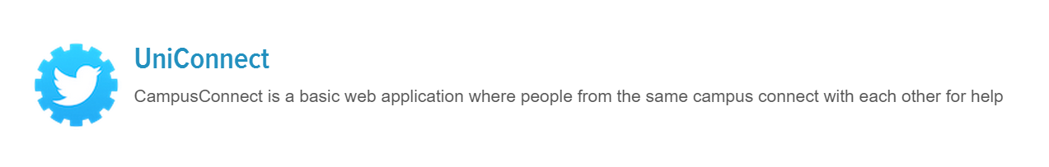

Software Engineering Department

**Course Name:** CMPE-272 Sec 97 – Ent. SW Platforms

**Instructor:** Andrew Bond, Professor

# HW #4: Group Programming Assignment

**Semester:** Fall, 2015

**Group Name:** DevAtWork

GitHub: <https://github.com/sjsu-cmpe272/DevAtWork.git>

Group Members:

* Sheeban Shaikh
* Rohit Deshmukh
* Mithra Desingruaj
* Athitha M. Anantharamu

**Abstract:**

In this trending world, being socially connected helps increase our horizon. Getting connected with the followers from the same University with similar interests and finding them in the nearby location is tedious. Twitter is one of the most popular social networking sites used by majority of the population. Twitter can ease the process of gathering the information of the people. We built application which deals with determining the profiles of Twitter users using Twitter REST API who study in the same university and stay in the same or nearby locality and prioritizing the leaderboard in their respective field based on number of followers. This will in turn enable the users to get connected with their followers/friends grouped by their interest. Furthermore the user has the ease of posting a Tweet and updating their status/Bio through our application.

**UniConnect – Features**

* Twitter id and university name
* Searching based on university name and Location.
* Sort based on followers and display it by using charts
* Contact the profile
* Post a Tweet to the user account
* Update Status/Bio of the user account

**Design Pattern Used:**

We have used the Model-View-Controller (MVC) Design Pattern in our project and the framework used is the Spring Framework. The MVC pattern consists of three inter-connected modules.

**Model:**

* Twitter **User** is the model along with attributes in the applications. It responds to events and stores the responses.

**View:**

* View Layer consists of UI components in the form of .jsp files

**Controller:**

* Controller at the UI level deals with the data to and from client.
* The controller receives user input and makes calls to model objects and the view to perform appropriate services/actions.
* The project follows the creational pattern: **Builder pattern** to a complex object using simple objects and using a step-by-step approach.

**Frameworks/API Used:**

* Spring MVC Framework
* Twitter REST API
* JQuery
* Google Charts
* Java JSON API

**Use Cases:**

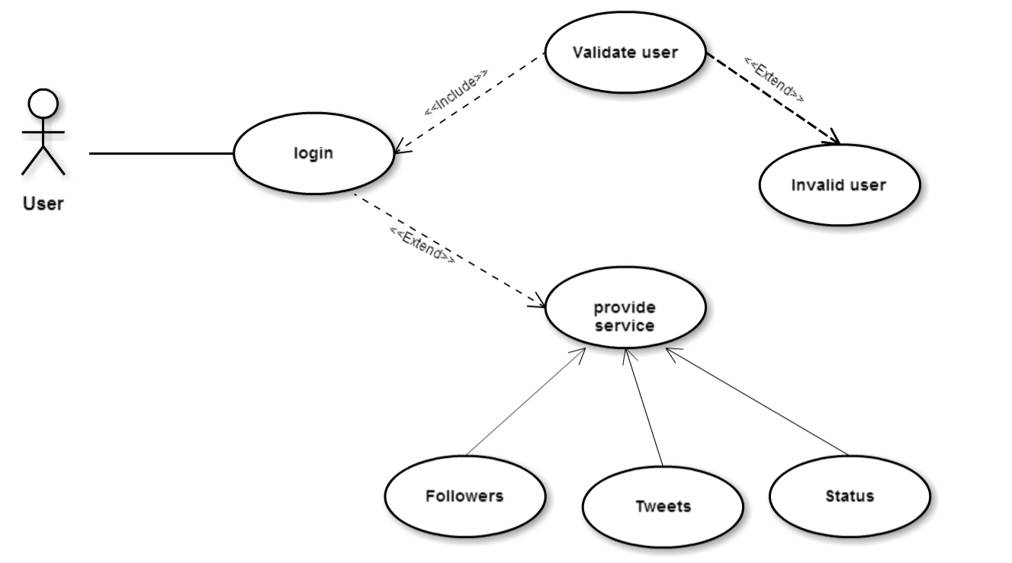

*Use Case 1: shows the process of login and redirecting to services*

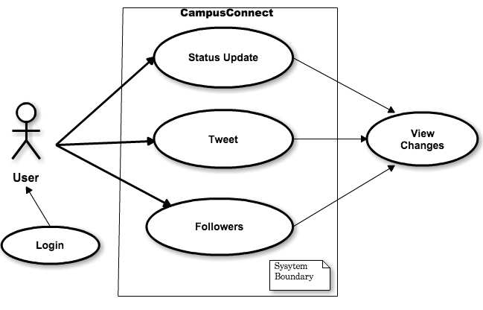

*Use Case 2: shows the process of updating profile*

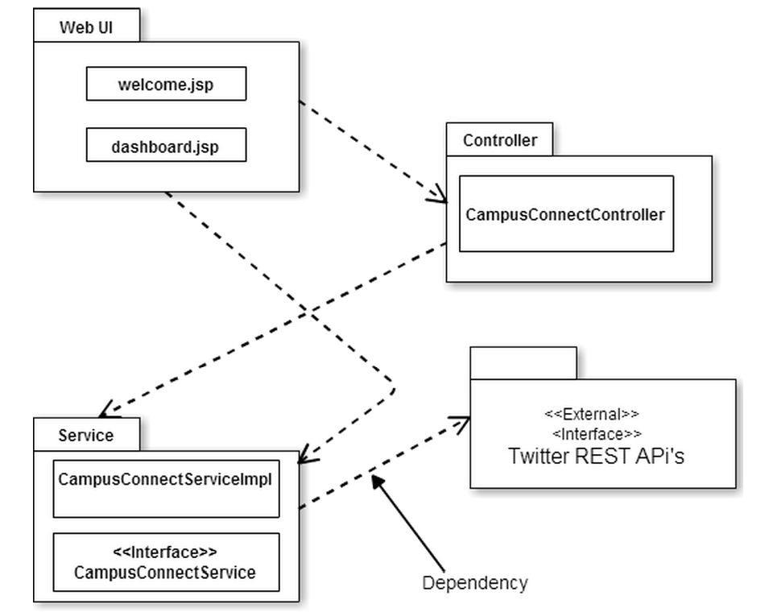

*Fig 1: Overview of the system is being represented by package UML diagram*

|  |  |
| --- | --- |
|  | |
|  | |
| **Test Cases:** | |
| **Test Case ID:** 1 |  |
| **Test Priority (Low/Medium/High):** Med |  |
| **Module Name:** Login Screen |  |
| **Test Title:** Verify login with valid Twitter ID |  |
| **Description:** Test the login page |  |
|  |  |
| **Pre-conditions:** User has valid Twitter ID | |
| **Dependencies:** | |

|  |  |  |  |  |  |
| --- | --- | --- | --- | --- | --- |
| **Step** | **Action** | **Test Data** | **Expected Result** | **Actual Result** | **Status -Pass/Fail** |
| 1 | Navigate to login page | Twitter ID: ShaikhSheeban | User should be able to login | User is navigated to | Pass |
| 2 | Provide valid username and click on submit button |  |  | dashboard successfully |  |
| 3 | User name is not specified |  | Appropriate Error should be thrown | “Please enter a string” message is displayed | Pass |

|  |  |
| --- | --- |
|  | |
| **Test Case ID:** 2 |  |
| **Test Priority (Low/Medium/High):** Med |  |
| **Module Name:** Posting Tweet |  |
| **Test Title:** Posting Tweet |  |
| **Description:** Test the Tweet section |  |

|  |
| --- |
| **Pre-conditions:** User has to check the tweet button and enter String input to Tweet |
| **Dependencies:** |

|  |  |  |  |  |  |
| --- | --- | --- | --- | --- | --- |
| **Step** | **Test Steps** | **Test Data** | **Expected Result** | **Actual Result** | **Status (Pass/Fail)** |
| 1 | Check the post a Tweet checkbox |  | User should be able to get a text field and a submit button | User gets a text field and a submit button | Pass |
| 2 | Post a tweet | “Hello World” | Posting the tweet in the users profile on submitting it | Tweet is posted in the users profile on submitting it | Pass |
| 3 | Null string entered in textbox while submitting | “” | Appropriate Error should be thrown | “Please enter a string” message is displayed | Pass |

|  |  |
| --- | --- |
| **Test Case ID:** 3 |  |
| **Test Priority (Low/Medium/High):** Med |  |
| **Module Name:** Updating Bio |  |
| **Test Title:** Updating Bio |  |
| **Description:** Test the Update status section |  |

|  |
| --- |
| **Pre-conditions:** User has to check the Update Status button and enter the bio details of them to update it in their profile. |
| **Dependencies:** |

|  |  |  |  |  |  |
| --- | --- | --- | --- | --- | --- |
| **Step** | **Action** | **Test Data** | **Expected Result** | **Actual Result** | **Status -Pass/Fail** |
|  |  |  |  |  |  |
| 1 | Check the Update Status checkbox |  | User should be able to get a text field and a submit button | User gets a text field and a submit button | Pass |
| 2 | Update Status/bio | “Student at SJSU” | Updating Status/bio in the users profile on submitting it | Status/bio is updated in the users profile on submitting it | Pass |
| 3 | Null string entered in textbox while submitting | “” | Appropriate Error should be thrown | “Please enter a string” message is displayed | Pass |

|  |  |
| --- | --- |
| **Test Case ID:** 4 |  |
| **Test Priority (Low/Medium/High):** Med |  |
| **Module Name:** Leader board1 |  |
| **Test Title:** Leader board1 |  |
| **Description:** Test the charts section |  |

|  |
| --- |
| **Pre-conditions:** User has to login with the valid user name |
| **Dependencies:** |
|  |

|  |  |  |  |  |  |
| --- | --- | --- | --- | --- | --- |
| **Step** | **Action** | **Test Data** | **Expected Result** | **Actual Result** | **Status Pass/Fail** |
| 1 | Redirecting to the next page after validating the user | Bar Chart | User should be able to get a Bar chart on the redirected page where n the bar’s of the chart represent the follower’s | User is able to view the Bar chart on the redirected page where n the bar’s of the chart represent the follower’s | Pass |
| 2 | The chart should represent the user’s followers in an ascending order depending on their followers count | Bar Chart | Bar Chart displaying the user’s followers in an ascending order depending on their followers count should be seen | Bar Chart displaying the user’s followers in an ascending order depending on their followers count is seen | Pass |
| 3 | On hovering on the bars on the chart | Bar Chart | It should show the Twitter handle name and Name of the user respectively | shows the Twitter handle name and Name of the user respectively on hovering the bar’ | Pass |

**Snapshots:**

