**CMPE272 – Enterprise Software Platforms**

**HW#8 – Build a Hello World Application on MuleSoft Anypoint Studio**

**Instructor:** Andrew Bond

**Semester**: Fall, 2015

**From:** Carlos Martinez

**Date:** October 29, 2015

**Summary:**

On this document I documented the steps I performed to create a Hello World application using Mulesoft Anypoint Studio.

1. Create an account in MuleSoft and download Anypoint Studio.
2. Read the Anypoint Studio Essentials at https://docs.mulesoft.com/mule-fundamentals/v/3.7/anypoint-studio-essentials.
3. Follow instructions on how to build a Hello World Application at https://docs.mulesoft.com/mule-fundamentals/v/3.7/build-a-hello-world-application

**Detailed Steps:**

1. Once the Anypoint Studio was installed, I created a new project called ‘My First Project’.

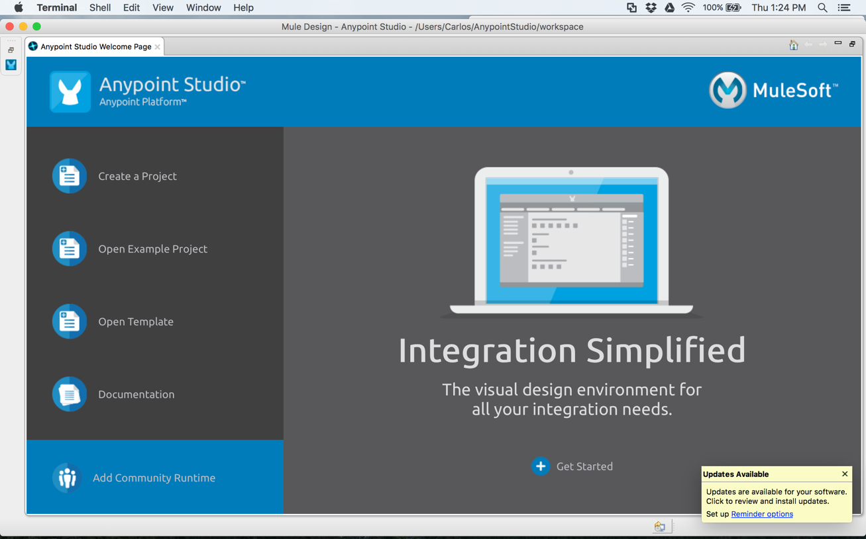

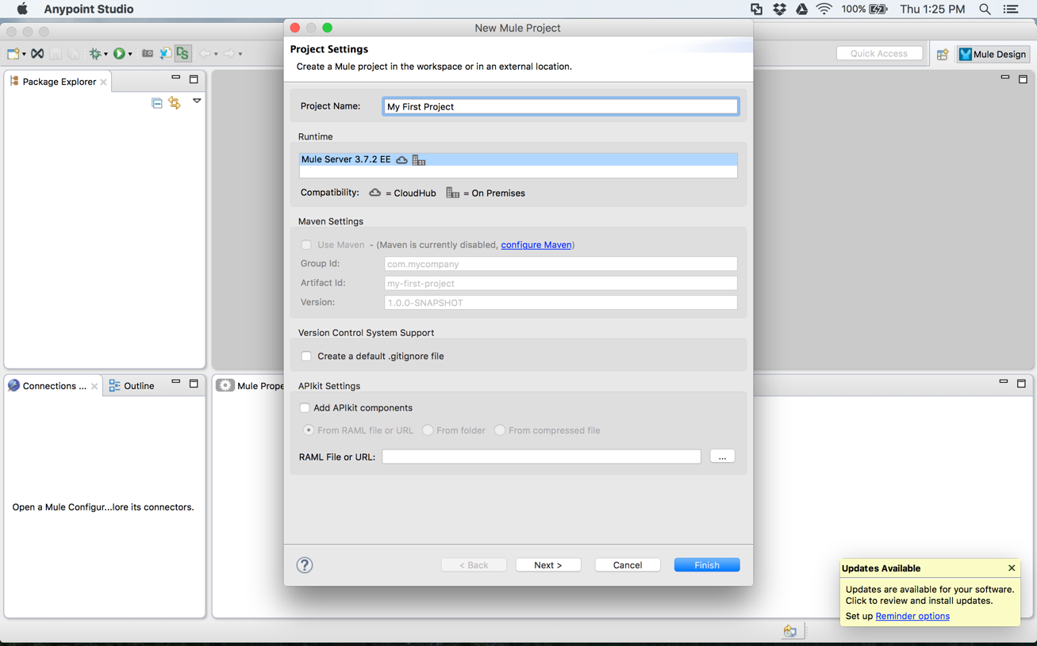

1. Then I dragged the first component “HTTP Connector” from the palette to the canvas:

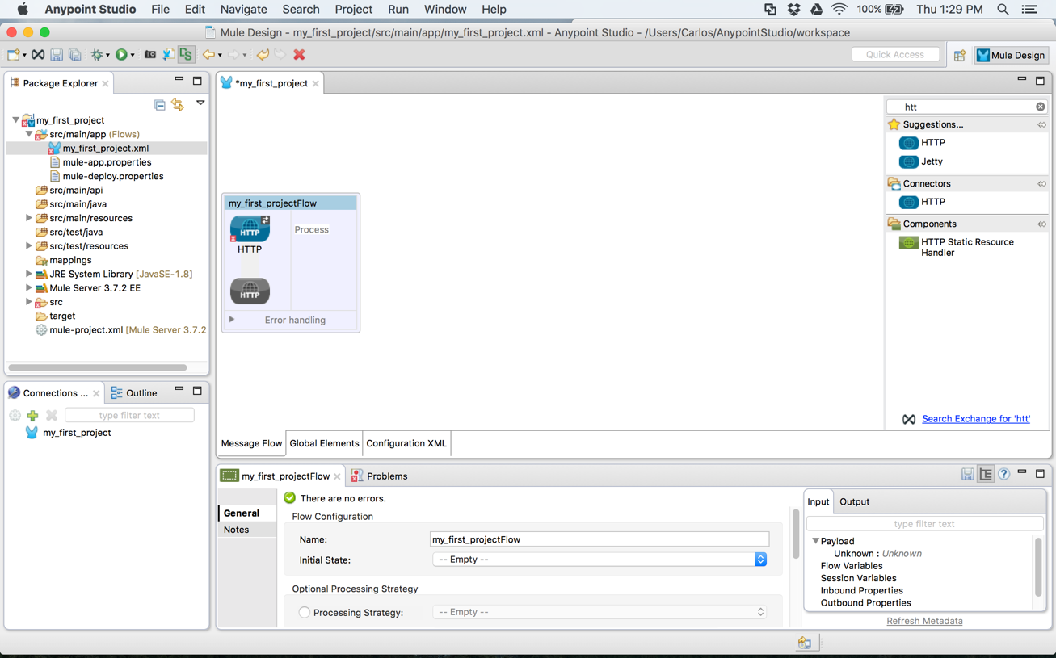

1. Then I set a ‘Payload Component’ to the flow and next to the ‘HTTP connector’

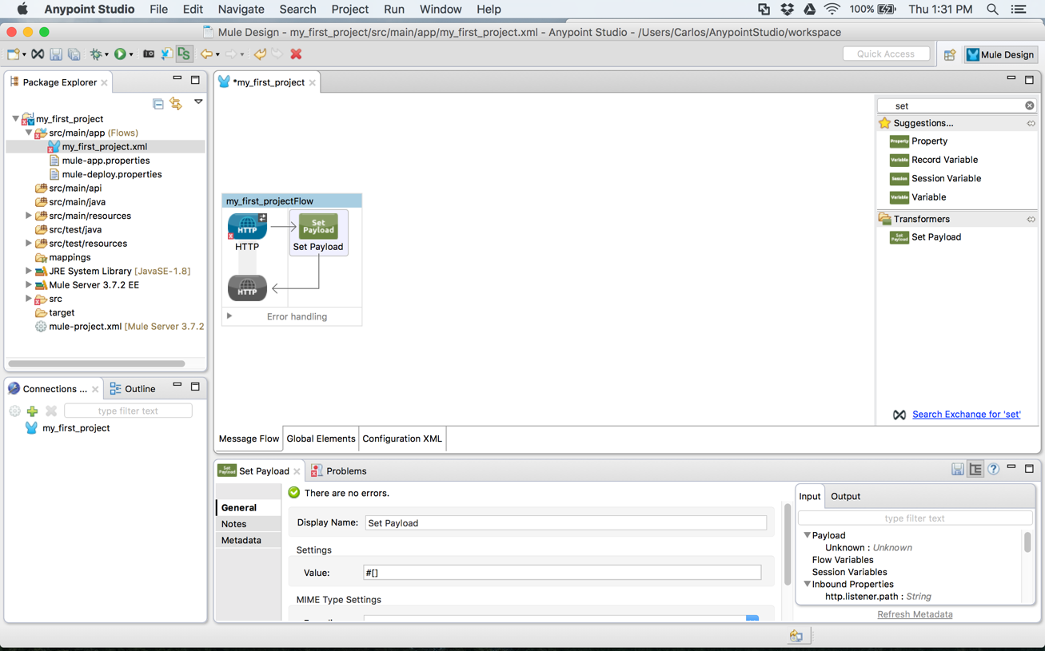

1. After that I’m ready to configure each element of the project. I started with the ‘HTTP connector’ and created and used the default configuration

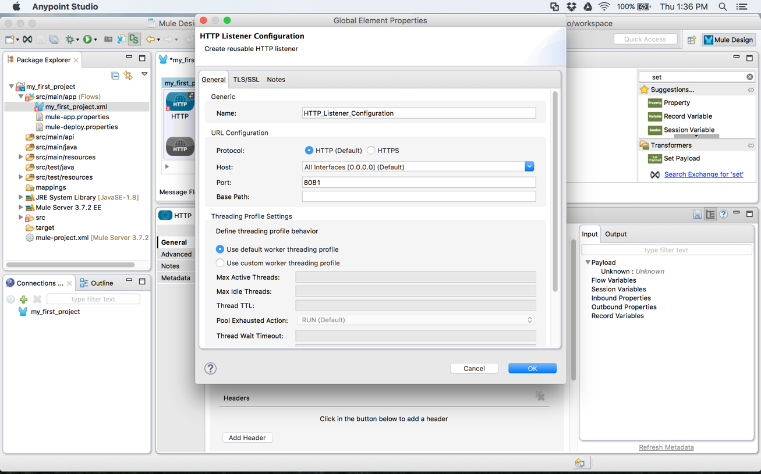

1. Then I selected the ‘Set Payload’ component and on the Value setting I entered: ‘Hello World!’

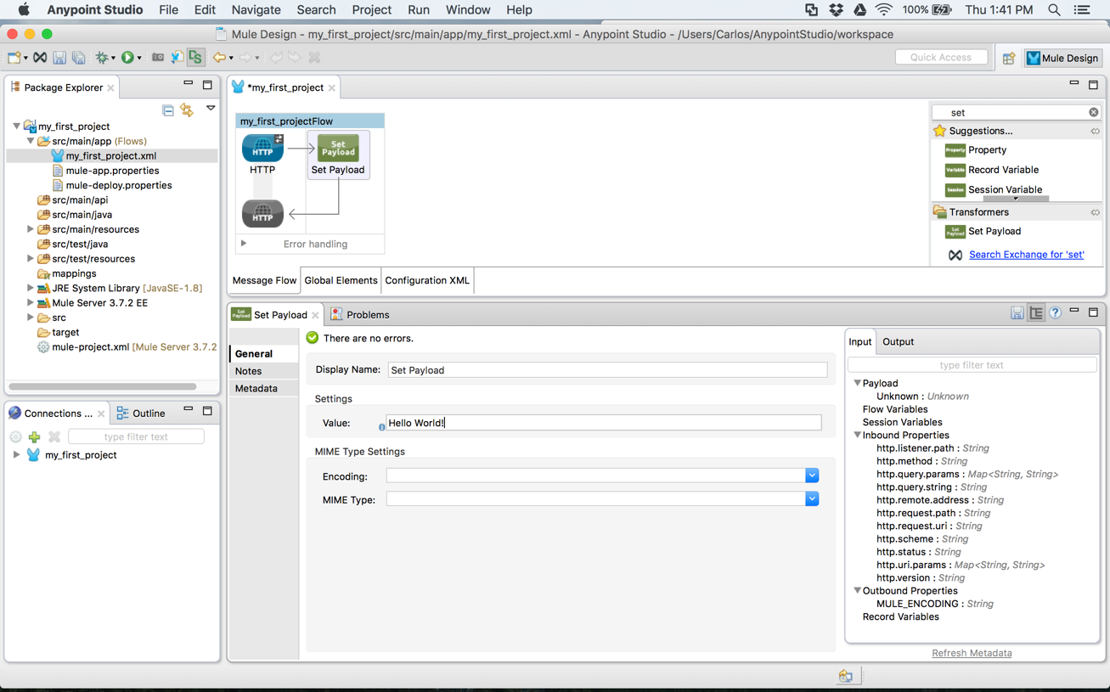

1. Then I proceeded to test the project by going to ‘Package Explorer -> Run As -> Mule Application’

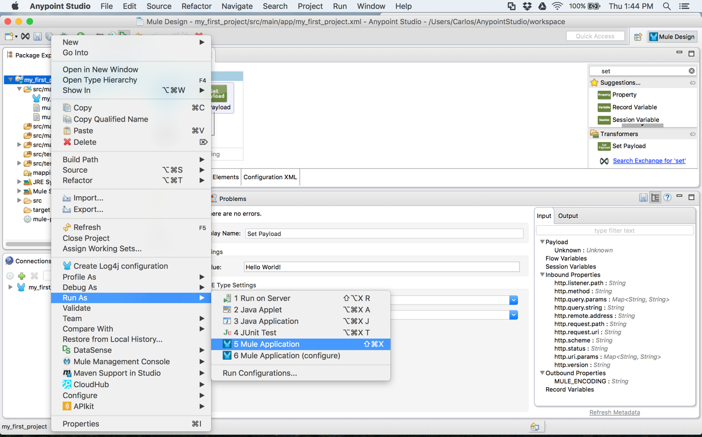

1. The application executed and was deployed:

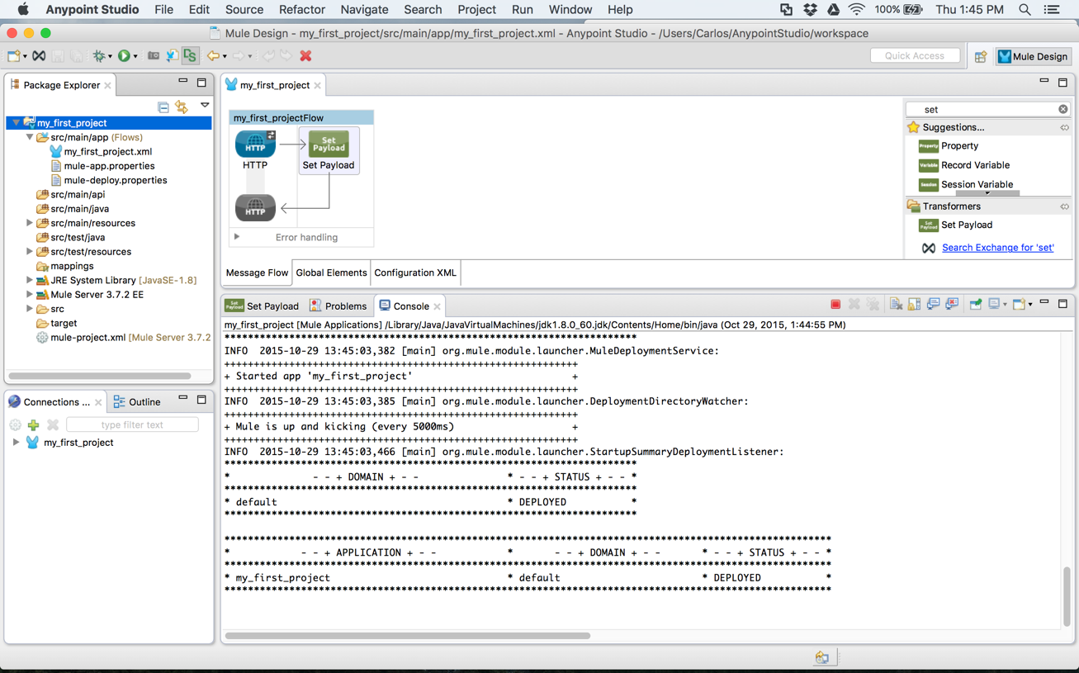

1. After that, I navigated in a browser to ‘Localhost:8081’ and was able to see the message: ‘Hello World!’.

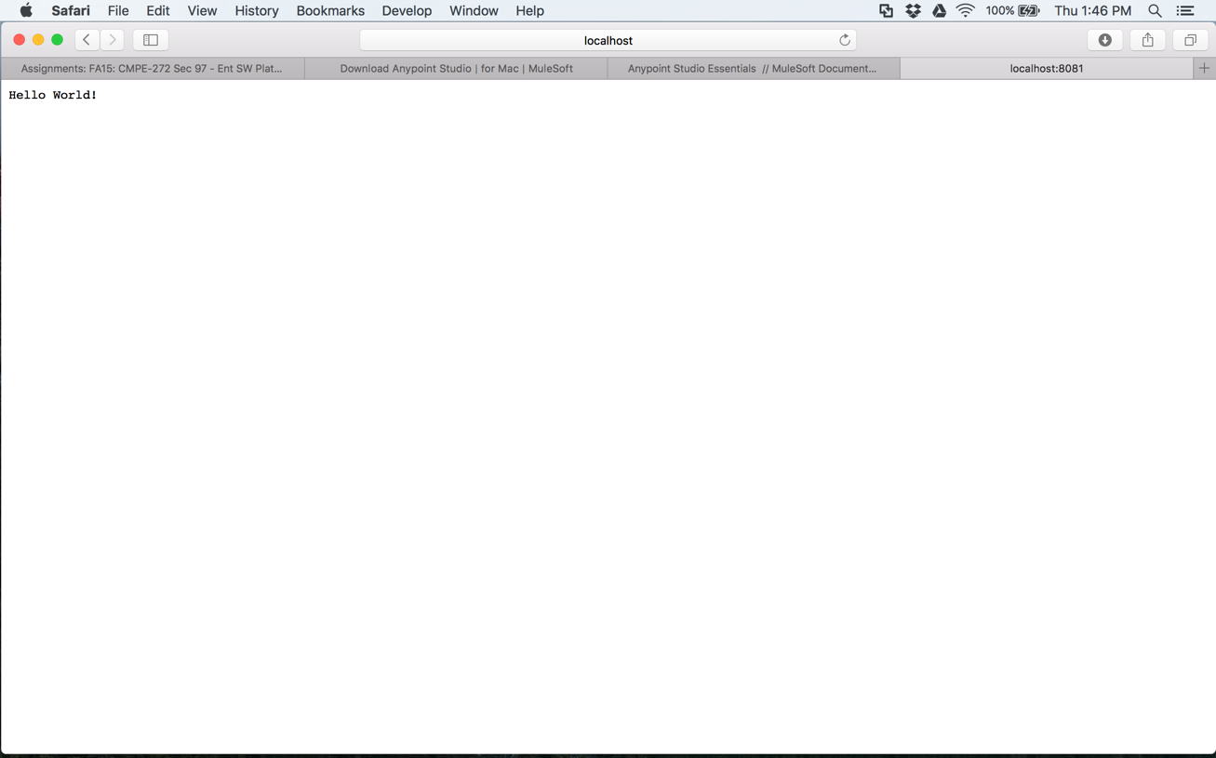

1. Finally, I stopped the application by pressing the ‘Stop’ button:

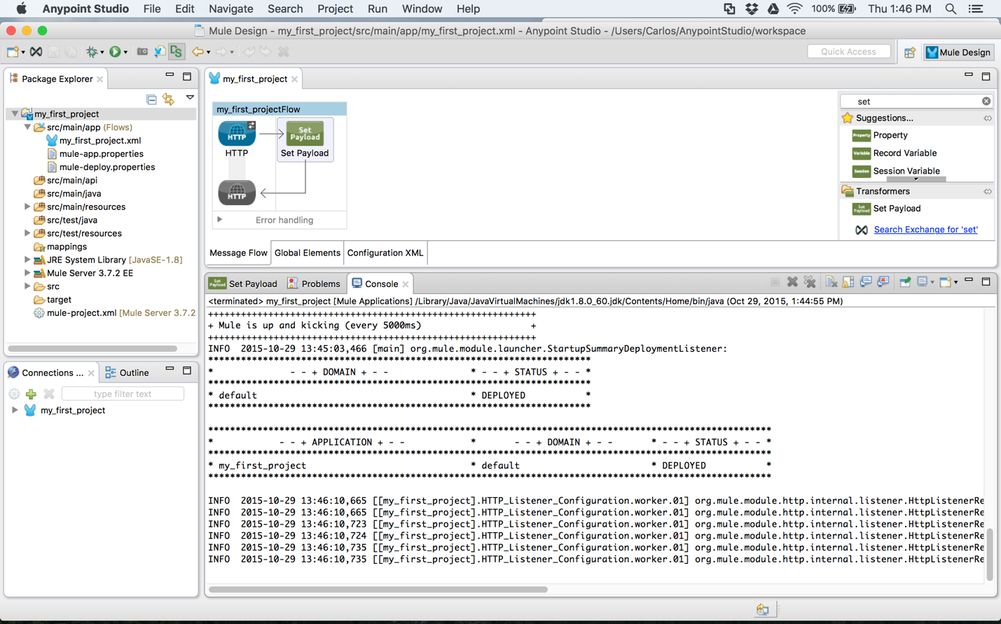

1. As a last step, I pushed the app to github using the mac terminal:

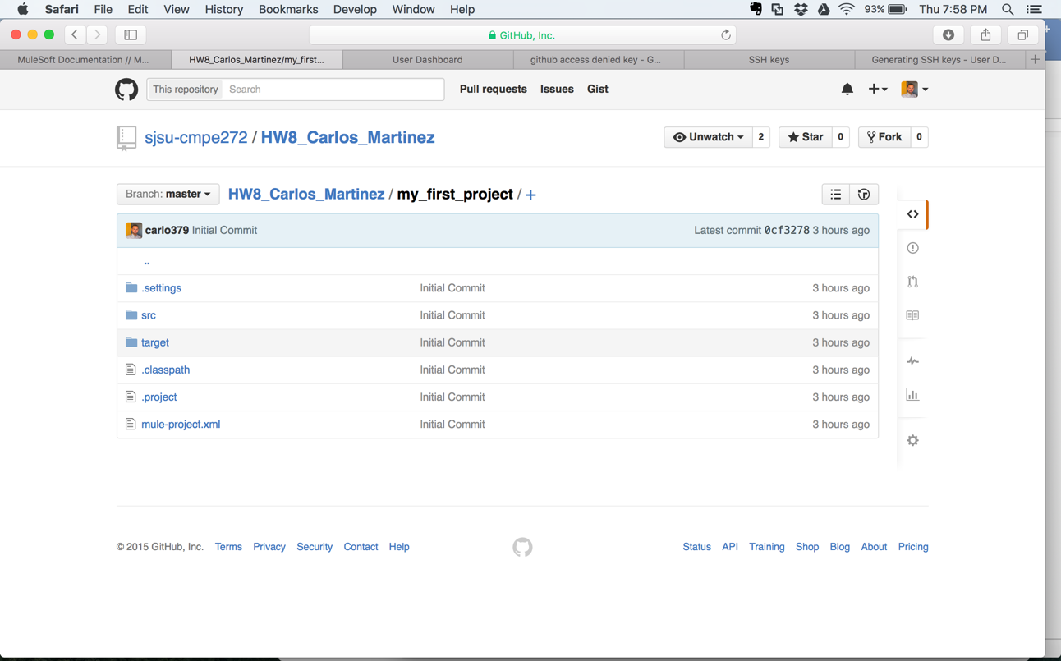

**References**

Anypoint Studio Essentials. (n.d.). Retrieved October 29, 2015, from <https://docs.mulesoft.com/mule-fundamentals/v/3.7/anypoint-studio-essentials>

Build a Hello World Application. (n.d.). Retrieved October 29, 2015, from <https://docs.mulesoft.com/mule-fundamentals/v/3.7/build-a-hello-world-application>