**Being Connected**

Assignment on “Usage of Twitter Api’s”

**By**

**Tech-Team**

**Course :** CMPE-272 Enterprise SW Platforms

**Team :** TECH TEAM

**Date :** September 24, 2015

**Prepared by :** Carlos Martinez

Khine Oo

Monisha Dash

Shalini Negi

Snehal Golhar

**Abstract**

Social media is rapidly delivering a new standard of interacting means by connecting people irrespective of different profile status.Twitter is an online social networking service that enables users to send and read short 140-character messages called "tweets". Registered users can read and post tweets. The phenomenal growth of these online giants ultimately reflects our compelling desire to connect with each other around common interests. People can tweet their thought on any topic, also one also can see what other thinks about various things going around the world.

TechTeam has tried to use Twitter Rest Api’s in a UI friendly manner. We developed a responsive website for user meeting his social network in the shortest path. With the help of “Being Connected” Application, User can connect to society, and join community and also can share his thought with everyone.

To develop the application, Tech-team is implementing the following Twitter REST APIs, for users to Tweet, see their Friend list, see their Followers list and search for Tweets.

**About the website:**

We are planning to include the following Twitter Api’s in the “Being Connected”:

1. **Get Friend list :** User can see friend list of his Twitter account.
2. **Post followers list :** User can see Followers list of his account.
3. T**weet :** User can tweet his thought or ideas.
4. **Search Tweet :** User can search tweets he wants to read.
5. **Get Friends Ids :** Return all the user Ids of the specified user.
6. **Get Followers Ids :** Return all the user Ids following the specified user
7. **Get Users Suggestion :** Return the user with the suggested user list.
8. **Unfollow Friends :** User can unfollow his/her friends on Twitter account.
9. **Get Statuses/user_timeline :** Returns a collection of 5 most recent Tweets posted by the user indicated by the screen_name.
10. **Post Friendships/create :** Allows the authenticating users to follow the user specified in the ID parameter.

**Technology Specifications:**

**Front End (UI):**

**UI Frameworks :** jQuery, jQuery Validation Engine, HTML, CSS, EJS

**Scripting languages :** JavaScript, HTML5, CSS3

**Responsive design :** Bootstrap Framework

This will provide a user friendly interface to perform the application services.

**Back End:**

**Modules :** Express, Underscore, Ejs, Async, oAuth, Http, Serve-favicon, path

**Technology :** NodeJS

**Scripting languages :** JavaScript

**Requirements**:

The Tech-team tried to develop a “Being connected” Website using AWS Cloud technologies and the integration of other technologies as HTML, CSS, JavaScript (Frontend) and NodeJS (Backend). The team will also use available APIs Twitter.

**Equipment**:

The most important setup required to accomplish this assignments are:

1. Personal computers to connect via SSH to a EC2 (t2.micro / AWS) to deploy the code.
2. Code will be stored in a Github repository.

**Application workflow :**

|  |
| --- |
| Screen Shot 2015-09-24 at 2.32.56 PM.png |
| Diagram :Protocol Flow of  Application |

**Use Cases with the UML diagrams:**

1. GET Friend List:

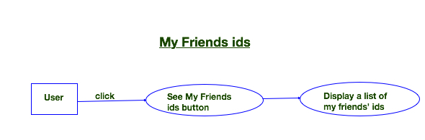

|  |  |
| --- | --- |
| **Use Case ID:** | 1 |
| **Use Case Name:** | Get friends ids |
| **Created By:** | Shalini Negi |
| **Date Created:** | Sept 24,2015 |
| **Actors:** | Common user who have minor idea about Twitter. |
| **Description:** | When one clicks the submit button, all the friends ids |
|
| **Preconditions:** | User needs to login the application with valid login |
|
| **Normal Flow:** | Process in detail steps |
|  | 1.   Click on the "Submit" Button |
| 2. If the username is present, the application will display all friends ids |
| 3. If invalid username is provided, that doesn't exist in  twitter , then it will display error. |
| 4.  The application displays "Error". |

1. GET follower’s id:

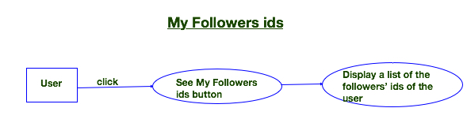

|  |  |
| --- | --- |
| **Use Case ID:** | 2 |
| **Use Case Name:** | Get Follower ids |
| **Created By:** | Shalini Negi |
| **Date Created:** | Sept 24,2015 |
| **Actors:** | Common user who have minor idea about Twitter. |
| **Description:** | When one clicks the submit button, all the followers |
|
| **Preconditions:** | User needs to login the application with valid login |
|
| **Normal Flow:** | Process in detail steps |
|  | 1. Click on the "Submit" Button |
| 2. If the username is present, the application will display all followers ids |
| 3. If invalid username is provided, that doesn't exist in  twitter , then it will display error. |
| 4.  The application displays "Error". |

1. GET friend list:

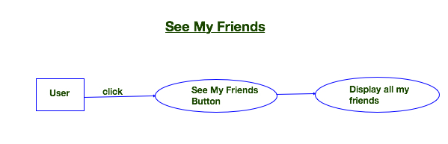

|  |  |
| --- | --- |
| **Use Case ID:** | 3 |
| **Use Case Name:** | Get FriendList |
| **Created By:** | Carlos Martinez |
| **Date Created:** | Sept 24,2015 |
| **Actors:** | Common user who have minor idea about Twitter. |
| **Description:** | When one clicks the “See My friends” button, friends list with that user account should be displayed |
|
| **Preconditions:** | User needs to login the application with valid login credential. |
|
| **Normal Flow:** | Process in detail steps |
|  | 1. Click on the "See My Friends" Button |
| 2. IIf the username is present, the application will display all friends list related to that user account |
| 3. If invalid username is provided, that doesn't exist in twitter , then it will display error. |

1. GET Follower list:

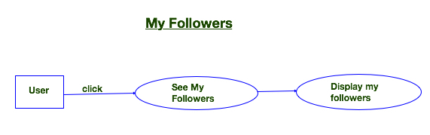

|  |  |
| --- | --- |
| **Use Case ID:** | 4 |
| **Use Case Name:** | Get FolllowerList |
| **Created By:** | Snehal Golhar |
| **Date Created:** | Sept 24,2015 |
| **Actors:** | Common user who have minor idea about Twitter. |
| **Description:** | When one clicks the “ See My Followers ” button, followers list with that user account should be displayed |
|
| **Preconditions:** | User needs to login the application with valid login credential. |
|
| **Normal Flow:** | Process in detail steps |
|  | 1. Click on the "See My Followers" Button |
| 2. If the username is present, the application will display all friends list related to that user account |
| 3. If invalid username is provided, that doesn't exist in  twitter , then it will display error. |

1. Search Tweet:

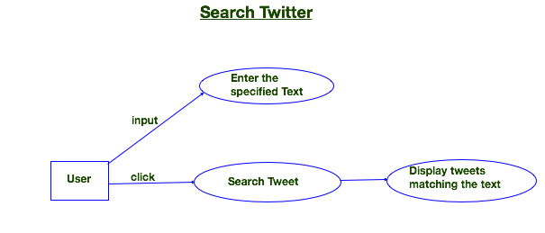

|  |  |
| --- | --- |
| **Use Case ID:** | 5 |
| **Use Case Name:** | Search Tweet |
| **Created By:** | Snehal Golhar |
| **Date Created:** | Sept 24,2015 |
| **Actors:** | Common user who have minor idea about Twitter. |
| **Description:** | When one clicks the “ search Tweet" button, tweets related to that search keyword will be displayed in list |
|
| **Preconditions:** | User needs to login the application with valid login credential. |
|
| **Normal Flow:** | Process in detail steps |
|  | 1.Enter keyword user wants to search |
| 2.Click on the "Search Tweet" button. |
| 3. If Present , then application will display error conditions. |

1. Tweet to your account:

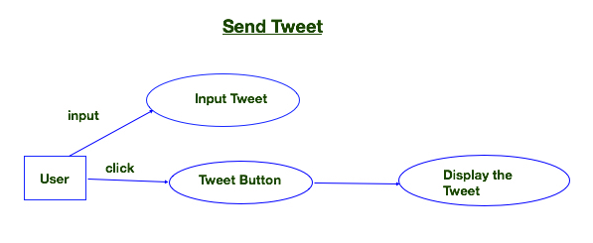

|  |  |
| --- | --- |
| **Use Case ID:** | 6 |
| **Use Case Name:** | Tweet to your account |
| **Created By:** | Carlos Martinez |
| **Date Created:** | Sept 24,2015 |
| **Actors:** | Common user who have minor idea about Twitter. |
| **Description:** | When user clicks the submit button, Tweets related to that    search keyword should displayed in the list. |
|
| **Preconditions:** | User needs to login the application with valid login credential. |
|
| **Normal Flow:** | Process in detail steps |
|  | 1.Enter Tweet  user wants  to tweet in his account |
| 2.Click on the "Tweet" Button. |
| 3.  If string is proper format ,User tweet will be Posted on his twitter account . |
|  |  |

1. Get statuses user-timeline:

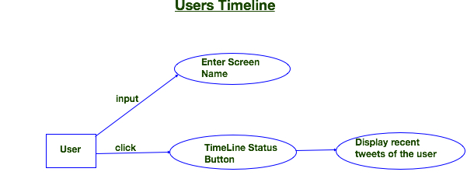

|  |  |
| --- | --- |
| Use Case ID: | 7 |
| Use Case Name: | Get statuses/user_timeline |
| Created By: | Monisha Dash |
| Date Created: | Sept 24,2015 |
| Actors: | Common user who have minor idea about Twitter. |
| Description: | When one provides the valid twitter username,  5 recent   status if present for the same username get  displayed. |
|
| Preconditions: | Us User needs to login the application with valid login     credential. |
|
| Normal Flow: | Process in detail steps |
|  | 1.   Provide a twitter valid username |
| 2.   Click on the "Submit" Button |
| 3.   If the username is present, the application will  display five recent status with that username |
|  |  |
|  |  |

1. Post Create friendship:

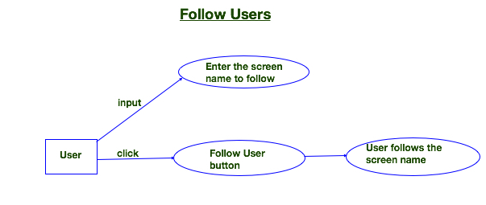

|  |  |
| --- | --- |
| **Use Case ID:** | 8 |
| **Use Case Name:** | Post Frienships/create |
| **Created By:** | Monisha Dash |
| **Date Created:** | Sept 24,2015 |
| **Actors:** | Common user who have minor idea about Twitter. |
| **Description:** | When one clicks the “ Follow User" button, the user starts following the screenname provided |
|
| **Preconditions:** | User needs to login the application with valid login credential. |
|
| **Normal Flow:** | Process in detail steps |
|  | 1.Enter keyword valid twitter username want to follow |
| 2.Click on the "Follow User" button. |
| 3. The user starts following the screenname user. |

9.User Suggestions:

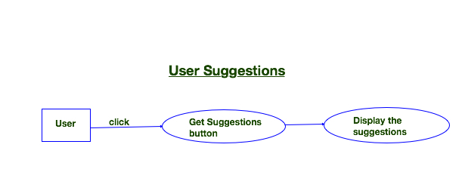

|  |  |
| --- | --- |
| Use Case ID: | 9 |
| Use Case Name: | Get User Suggestion Lists |
| Created By: | Khine Oo (Clara) |
| Date Created: | Sept 24,2015 |
| Actors: | Common user who have minor idea about Twitter. |
| Description: | When one clicks the submit button, the user suggestion lists should be displayed. |
|
| Preconditions: | User needs to login the application with valid login credential. |
|
| Normal Flow: | Process in detail steps |
|  | 1. Click on the "Submit" Button |
| 2. The application will display a list of user  suggestion |
|  |  |

10. Unfollow Friend:

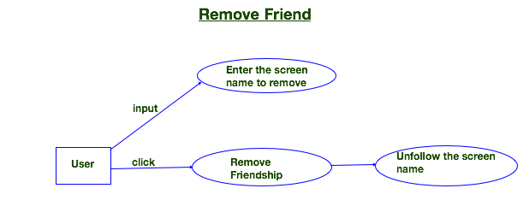

|  |  |
| --- | --- |
| **Use Case ID:** | 10 |
| **Use Case Name:** | Unfollow Friends |
| **Created By:** | Kline Oo (Clara) |
| **Date Created:** | Sept 24,2015 |
| **Actors:** | Common user who have minor idea about Twitter. |
| **Description:** | When one clicks the “ Follow User" button, the user starts following the screenname provided |
|
| **Preconditions:** | User needs to login the application with valid login credential. |
|
| **Normal Flow:** | Process in detail steps |
|  | 1. Click on the "Submit" Button |
| 2. If the username is present, the application will display the friend’s screen name that was removed or unfollowed. |
| 3. The user starts unfollowing the screenname, and if invalid name is given it throws error. |

**Test Cases:**

|  |  |  |  |  |  |
| --- | --- | --- | --- | --- | --- |
| **Case Description** | **Action** | **Expected Results** | **Actual Results** | **Pass/Fail** | **Comments** |
| Send Tweet | 1.Enter Tweet Status on Input Box  2. Click “Tweet” Button | - Update and upload Tweet Status on the user Twitter account  -Show the successfully uploaded tweet on the Application page | Successfully updated user Tweet Status on the Twitter account and the result also show on the Application page. | Pass | meet Expectation |
| Get Friends Lists | 1.Click “See My Friend” Button | - Show a list of user friends’ screen name on Twitter | - Successfully show a list of user friends’ screen name | Pass | meet Expectation |
| Get Follower Lists | 1.Click “See My Followers” Button | -Show a list of the screen name who are following the user on Twitter | - Successfully show a list of the screen name who are following the user on Twitter | - Pass | -meet Expectation |
| Search Tweets by a Screen Name | 1.Enter a Twitter Screen Name  2. Click”Search Tweets” Button | - Show a list of the recent 15 Tweets on the Application page | -Successfully show a list of the recent 15 Tweets on the Application page | -Pass | -meet Expectation |
| Get Friends ids | 1.Click “See My Friends ids” Button | -Show a list of the user’s friends’ ids on the Application page | -Successfully show a list of the user’s friends’ ids on the Application page | -Pass | -meet Expectation |
| Get Followers ids | 1.Click “See Followers ids” button | -Show a list of the ids of the users’ followers on the Application page | -Successfully show a list of the ids of the users’ followers on the Application page | -Pass | -meet Expectation |
| Get Timeline Status by a Screen Name | 1.In the textbox,Enter a Twitter screen name that the user want to check timeline status of  2.Click “Timeline Status” | -Show a list of the timeline Status of the screen name on the Application | -Successfully show a list of the timeline Status of the screen name on the Application | -Pass | - meet Expectation |
| Follow User | 1.In the Textbox, Enter the screen name that the user want to follow  2.Click “Follow User” Button | -the user’s Twitter account will follow the Twitter account of  the screen name  that the user entered. | -if the screen name isn’t followed, the user will start following the screen name | -Pass | - meet Expectation |
| Remove Friendship | 1.In the Textbox,  Enter the screen name that  the user want to unfollow  2.Click “Remove Friendship” Button | - the Application will remove the screen name from the list of following of the user’s twitter account | -the Application remove the screen name from the list of following of the user account successfully | -Pass | - meet Expectation |
| Get Users Suggestion | 1.Click “Get Suggestion” Button | -a list of User Suggestion will be displayed on the Application page. | -Successfully display the list of the categories suggestion | -Pass | - meet Expectation |

**Link to Running Website:**

[http://ec2-52-88-237-253.us-west-2.compute.amazonaws.com:8080](http://ec2-52-88-237-253.us-west-2.compute.amazonaws.com:8080/)

**Screenshots**

**1.Website :**

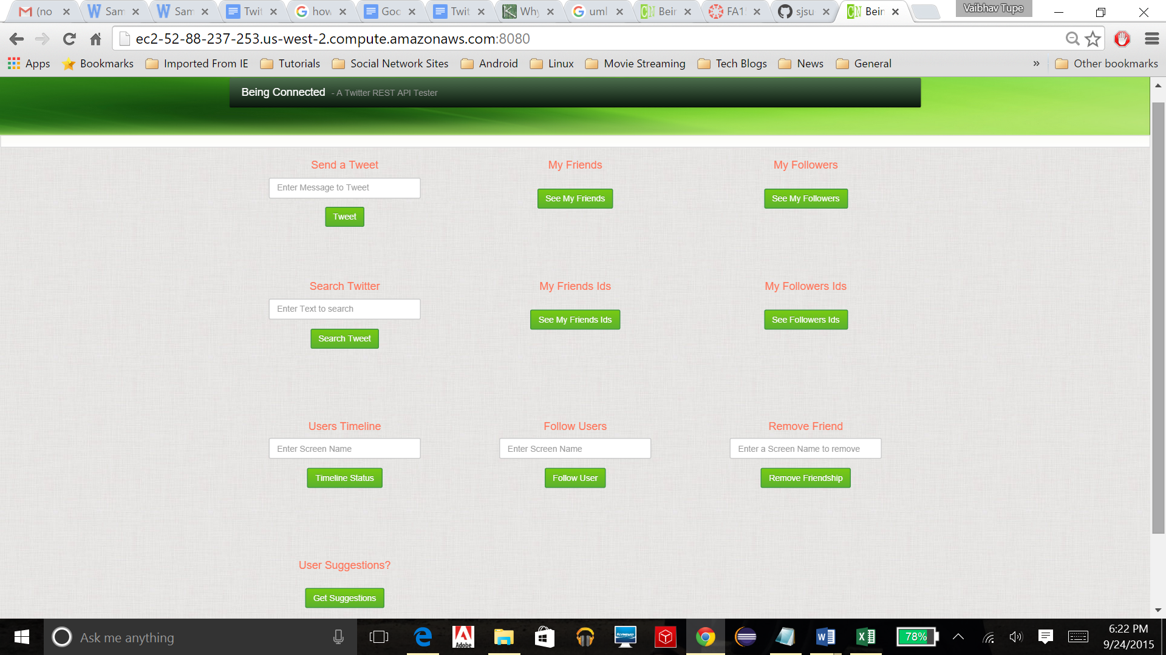

**2.Output of different request:**

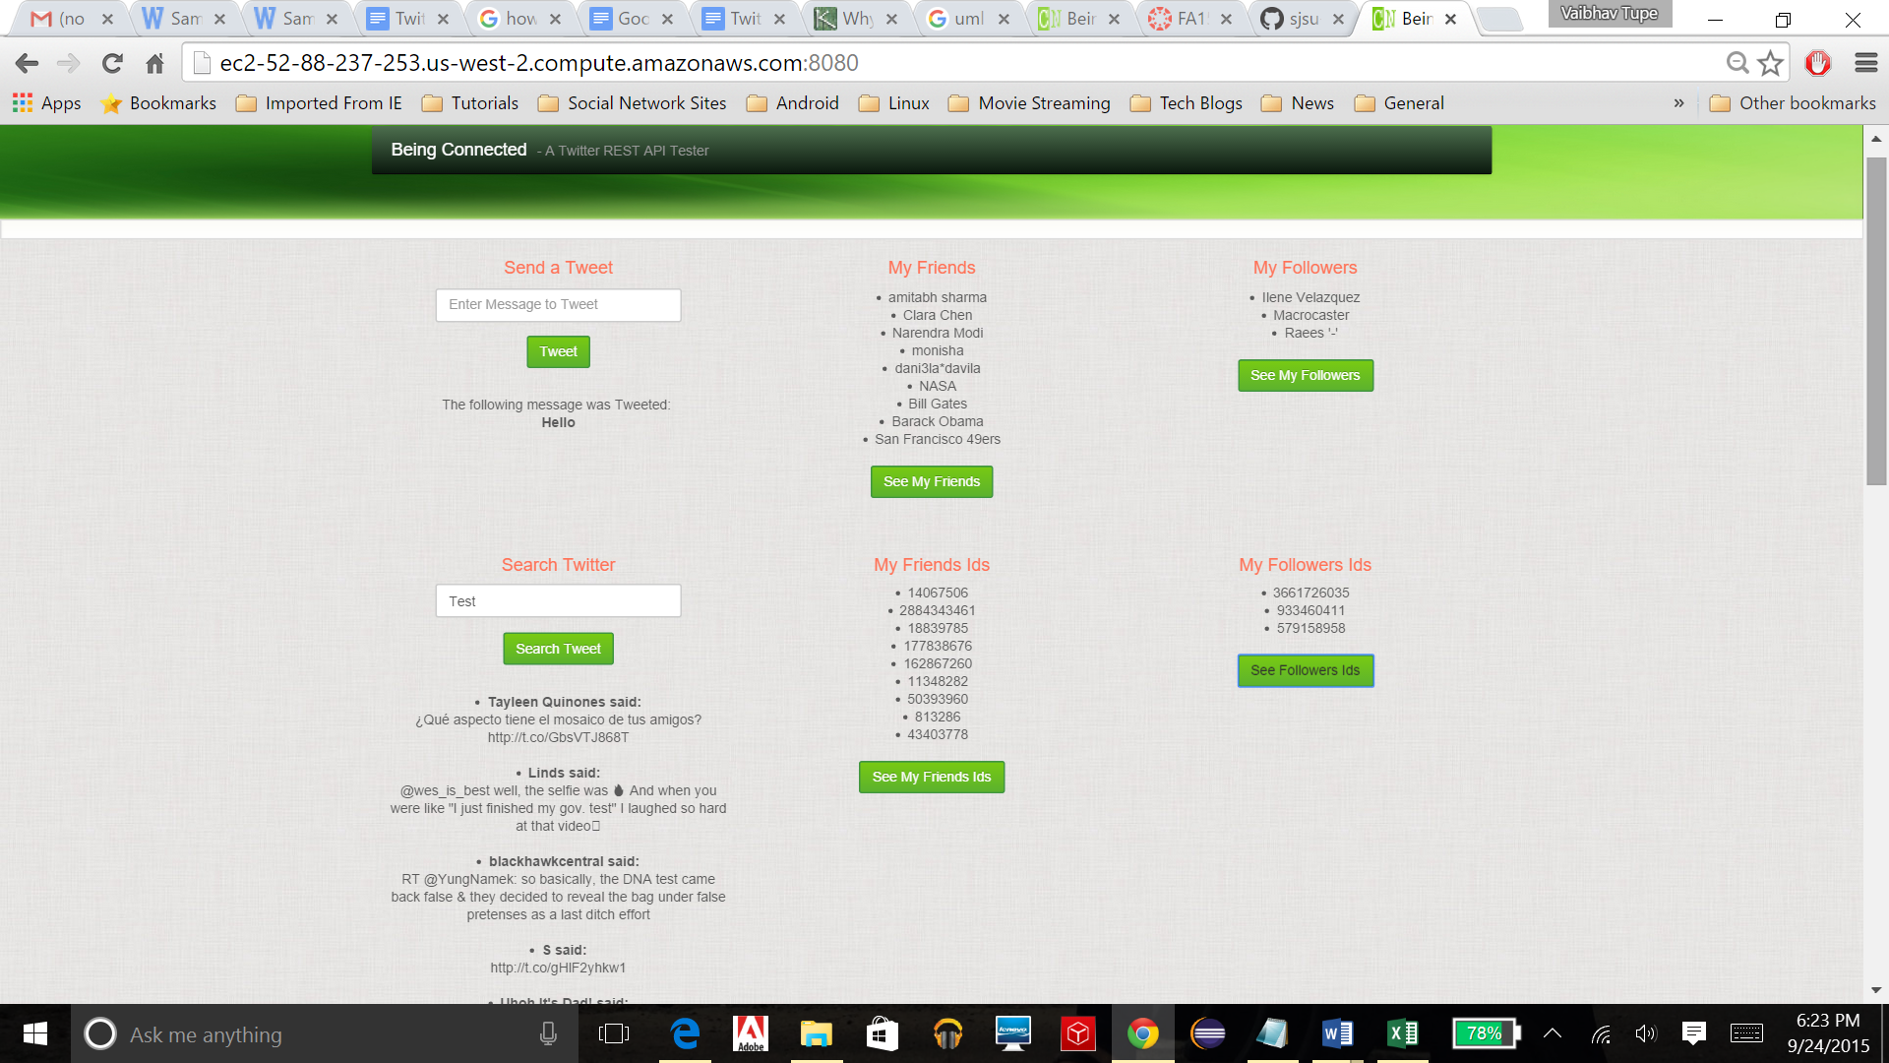

**3.Output of Users timeline ,Follow Users, Remove friend and User Suggestion**

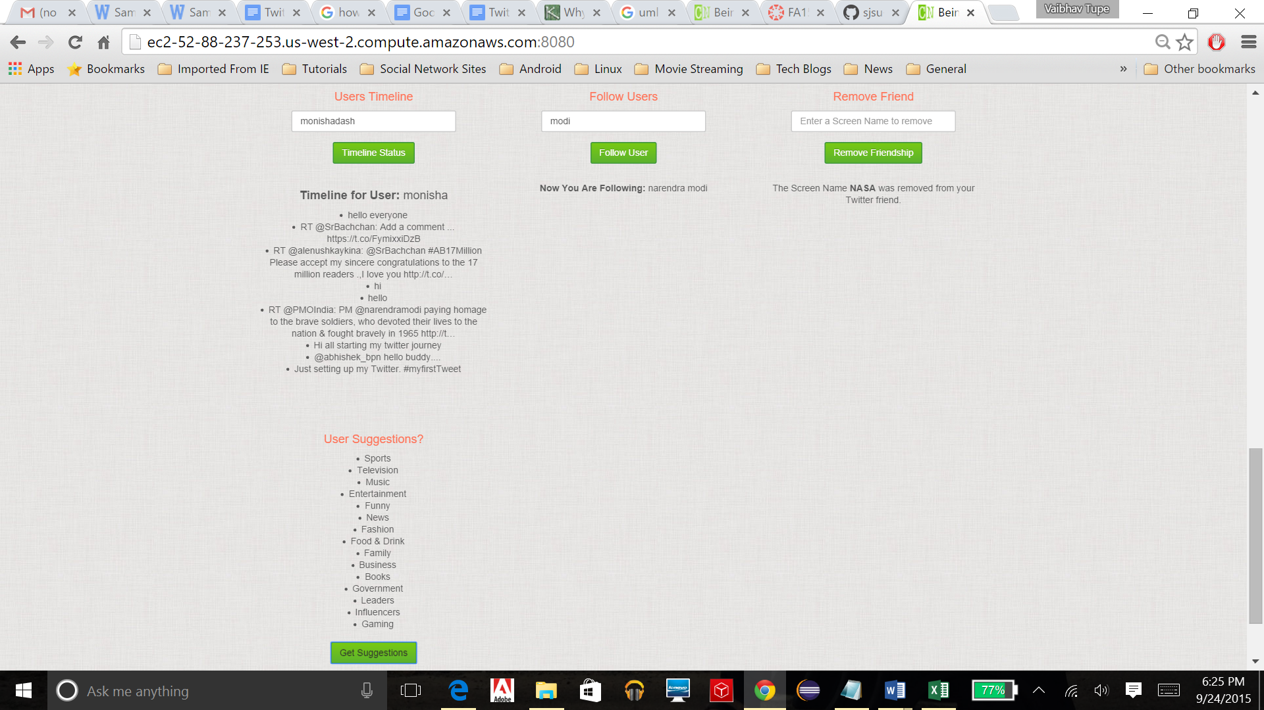

**4.After removing NASA from Friend ,check “See my friend”**

