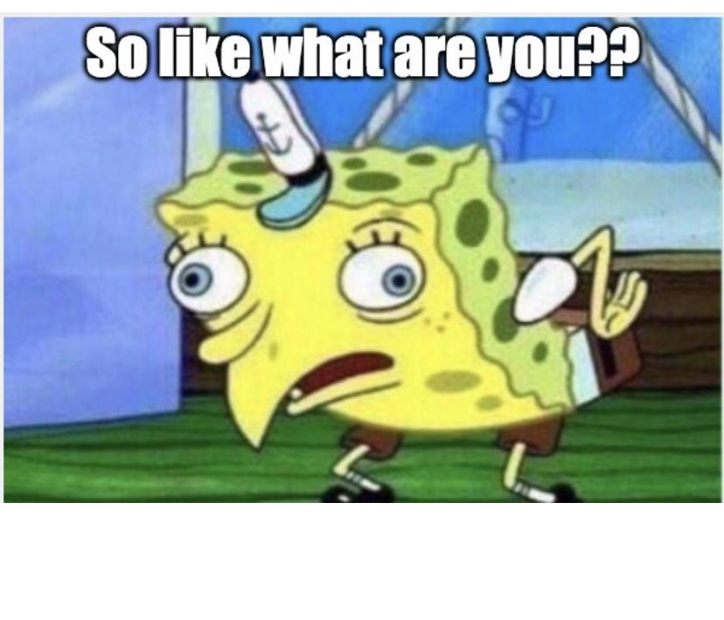

**Just a Little Rant:)**

The question of the hour, or you like gay or something. How do you have sex, how about you dont worry about it! No I don’t identify as a lesbian or bisexual women but I’m tired of these assumptions and genderfuck questions. My lovely unicorns of the LGBTQ+ community are strong as stone wall and will not bow down to society’s fenced in mindset. Don't be afraid to taste the rainbow we have all flavors hi femme, lo femme, transgender, you NAME IT! I know this wide spectrum of self expression makes you shiver in your boots. People are so worried about if Tom is fucking Greg and God forbid they fall in love and actually want to be HAPPY, when we have some crazy shit in this world going on. Immigrant children ripped from families, poverty, and the continuation of the oppression of the Black Community. Here are some words of wisdom get yourself some business it's literally free to mind yours and just make the world a better place PERIOD!