Team 31 – PhisherMan

CMPE 272

Fall 2021

Kafka Assignment

1. *Spin up dockerized containers for Kafka and Zookeeper using Kafka on Docker*
   * Run the provided Docker Compose based Kafka cluster (kafka/docker-compose.yml):

1. *Install kafkacat*
   * Install Kafkacat via “apt install kafkacat” and check version:

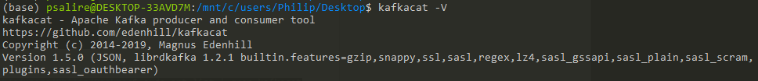

* + Verify that it can connect to our Kafka cluster:

1. *Create a topic in the Kafka cluster using kafkacat*
   * Create a new topic:



* + Verify that the topic was created by consuming the topic:



1. *Produce to and consume from the topic using kafkacat*
   * Run a Producer and Consumer simultaneously with Kafkacat:

1. *Write a Java application to produce and consume from the Kafka topic using the kafka-clients directory in the repo*