**Vendiman (Smart Vending Machines Network)**

Mu-Te Shen, Sai Krishna Dosapati, Teja Ramisetty and Wenhao Tseng

Department of Software Engineering, San Jose State University

San Jose, CA.

**Abstract -**Through this project we are building an application which makes our existing vending machines smarter. In this project vending machines can communicate among themselves if needed and provides better services to the customer. It serves better insights to the owners through which stock refilling complexity is reduced and it also provides better stock predictions through which we can generate more revenue.

1. **INTRODUCTION**

There are more than 7 million vending machines serving people in the U.S. every day, and these add up to a market more than 8 billion dollars. However, seeing the desired item being out-of-stock is one of the most disappointing moment. In fact, vending machines being out-of-stock are estimated to be at least 3% in lost sales. Therefore, having an interactive web app that helps tracking the stock information becomes crucial to improve the business.

1. **ARCHITECTURE**

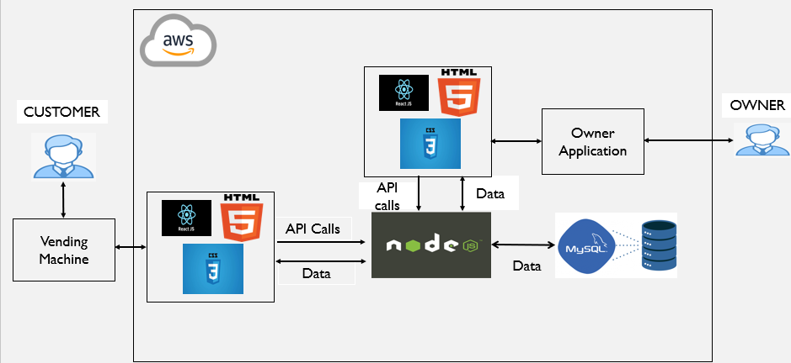

Important components components are: MySql, Nodejs, Reactjs, html, css.

1. MySql: In this project we used Mysql database which stores all the vending machine details their current stock details, product details, payment details and owner details.
2. Nodejs: In this project we used Nodejs as a back-end tool which consists of all API for customer and owner actions.
3. Reactjs: In this project we used HTML, CSS for providing a customer interface and reactjs as our front-end tool which generated API calls ,pushes data into the UI from DB and viceversa.

1. **PROCESS FLOW**

Below are few use case scenarios which can illustrate working of vendiman.

Scenario1: John is a software engineer, in his office cafeteria, he found a vending machine and from the listed products he selects shrimp cup noodles, in this scenario, this product is available on that machine so he’ll be directed to the payment option and after a successful payment he’ll get his product from the machine’s outlet and stock count will be updated in that machine.

Scenario2: On the other day John feels thirsty and goes to the nearby vending machine and selects a water bottle, but in that machine, there will be no water bottles now that machine display “Item out of stock” message and nearest 3 machines details which has water bottles.

Scenario3: Thomson is an owner who installed 10 vending machines at John’s office. He refills stocks periodically. On refill day instead of going to every machine for checking its stock and refill he’ll just login to our application, go through all his machines stock details and identify only those machines which need a refill. Through this he saves lots of time and manpower.

Scenarios4: Thomson found that few machines run out of stock regularly now he wants to increase stock quantity of every machine’s highly demanded stock. In his application he can find the sales statistics for every machine through which he can increase or decrease a product’s stock in a machine while refilling.

**IV. FUTURE ENHANCEMENTS**

1. We can inculcate email automation into this project, which can send stock alerts to the owners.
2. Using machine learning concepts, we can suggest customers a relevant product which they might buy.
3. Using machine learning concepts, we can suggest new products to the owner which can increase hi revenue.
4. We can increase the scalability of this project by increasing number of items in the vending machines and a number of owners.

**V. CONCLUSION**

This application serves best for both the customers and the owners. Using this application, a customer can buy a product from a vending machine or an adjacent machine based on the availability.

An owner can have a clear insight on his stocks and he can easily refill his vending machines.

1. **ACKNOWLEDGEMENT**

We are thankful to our professor Rakseh Ranjan (Innovation Leader, Director of Emerging Technologies at IBM) for guiding us throughout this project. His inputs on machine learning and database concepts helped us a lot in achieving our motto.

1. **GIT REPOSITORY**
2. FRONT END:
3. BACK END:
4. PRESENTATION:
5. **REFERENCES**