Installation of Conda and Geopandas

1. Download Miniconda
2. Install Minicoda by running the exe
3. Run the App for Anaconda
4. In the terminal (base) run conda list .
5. Create virtual environment
6. <https://conda.io/projects/conda/en/latest/user-guide/tasks/manage-environments.html>
7. Environment milestone_pyenv created on VMHighmemory
8. 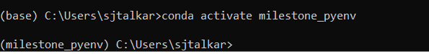
9. <https://towardsdatascience.com/how-to-set-up-anaconda-and-jupyter-notebook-the-right-way-de3b7623ea4a>
10. <https://conda.io/projects/conda/en/latest/user-guide/tasks/manage-environments.html#activating-an-environment>



1. Installing geopandas
2. conda install – c conda-forge geopandas
3. conda install geoplot -c conda-forge
4. conda install -c conda-forge altair vega_datasets
5. <https://github.com/geopandas/geopandas/issues/1812>
6. Remove rtree
7. Install pygeos

After installing Miniconda and an environment- install geopandas first

On VMHighMemory

C:\ProgramData\Miniconda3\envs\milestone_pyenv

To access the notebook, open this file in a browser:

<file:///C:/Users/sjtalkar/AppData/Roaming/jupyter/runtime/nbserver-6916-open.html>

<https://jcutrer.com/python/learn-geopandas-plotting-usmaps>

https://dataverse.scholarsportal.info/guides/en/4.8.6/api/intro.html