TenForce Hiring – Developer – Test and Taste

Exercise 1

Overview

For caluclation Purpose few propertirs added into entities, like gravity, PlanetId, Name.

I assumed arethmetic average for planet moons average gravity calculation.

CalAverageMoonGravity() function is added in class Planet, and AverageMoonGravity is modified as read write. CalAverageMoonGravity() function is called inside constructor to set property value.

Exercise 2

Propose in less than 5 lines an alternative solution to this problem (if possible) and explain a benefit and a drawback versus the solution that you have chosen.

Using LinqQuery and Bodies entiry, we can calculate PlanetMoon Average Gravity value.

Here I group by planet id and Average of moon.gravity is taken.

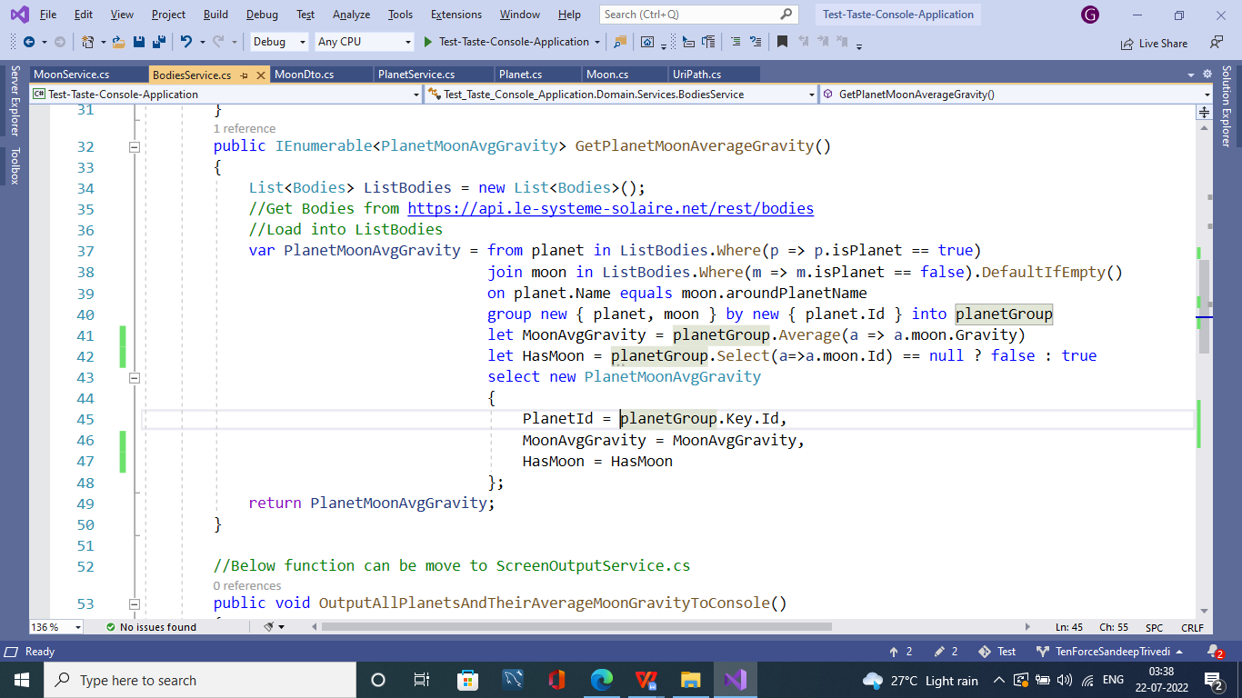

Advantage of above methos is that it is simple, easily and not for loop is used for caluclation.

It can read all data at a one time from URL : <https://api.le-systeme-solaire.net/rest/bodies>

So there will be no repetative call to read moonResponse (from URL UriPath.GetMoonByIdQueryParameters + moon.URLId) at line 56 of PlanetServie.cs

Henace My Methos above is saving server call and will give good performance, spcecially for large data set.

I don’t see any drwaback in code except it will requred new entiry Bodies and PlanetMoonAvgGravity.