

Project and Professionalism

(6CS007)

A2: Project Report

FINANCE (Artefact)

Student Id : 2050089

Student Name : Sajat Prasad Shrestha

Group : L6CG5

Supervisor : Bhanu Aryal

Reader : Rupak Koirala

Cohort : 5

Submitted on : 13-11-2021

Contents

1. Functional Decomposition Diagram 1

1.1 User Management System (US) 2

1.2 Money Management System (MS) 4

1.3 Detailed Analytics System (MS) 5

2. Use Case 6

3. Wireframe 7

3.1 Home Screen 8

3.2 Transaction Screen 8

3.3 Category Screen 9

3.4 Analysis Screen 9

3.5 Setting Screen 10

3.6 Lock Screen 10

4. Sequence Diagram 11

5. Entity Relationship Diagram 12

Figure 1:Functional Decomposition Diagram 1

Figure 2: Functional Overview 6

Figure 3: Connections in wireframe 7

Figure 4: Home Screen 8

Figure 5: Transaction Screen 8

Figure 6: Category Screen 9

Figure 7: Analysis Screen 9

Figure 8: Setting Screen 10

Figure 9: Lock Screen 10

Figure 10: Interaction between objects 11

Figure 11: Entity Relationship Diagram 12

# Functional Decomposition Diagram

The finance system when broke down into smaller systems comprises of five systems. First one is the token auth system in which basis a user will be given their unique user ID. Using Facebook and google for user credentials will require firebase dependencies for this project. Secondly, money management will be about keeping track of all the transaction added by the user and having it tracked according to date for other systems.

Expense Prediction System will have a linear regression algorithm built from the past data of the user which will predict expenses for the next month according to the target saving set by the user. Auto categorization system will be an unsupervised machine learning model which will predict which category might the transaction fall into and determine whether the category is income or an expense. Lastly a detailed analysis will be provided so the user can take an informed decision.

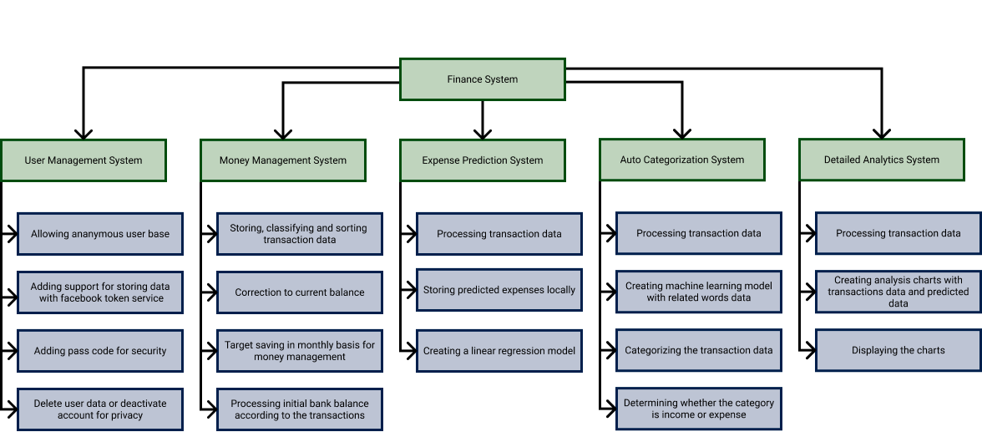

Figure 1:Functional Decomposition Diagram

A more detailed analysis for the system is given on the next page.

## 1.1 User Management System (US)

|  |  |  |  |
| --- | --- | --- | --- |
| **Req. Code** | **Requirement Description** | **Use Case** | **MoSCoW Prioritization** |
| **US-F-1.0** | Allowing anonymous user base to use the application without logging in | Anonymous user base | Must Have |
| **US-NF-1.1** | App to auto create an anonymous account to store anonymous user data right after the launch of the application | Auto Sign Up | Should Have |
| **US-F-2.0** | Support for storing data with O-Auth from Facebook or Google | Add Token Service | Must Have |
| **US-NF-2.1** | User can choose avatar that best represents themselves to recognize their min age estimation, max age estimation and gender | Add Avatar Selection | Should Have |
| **US-NF-2.2** | The User can log out of their account if they want to sign in from another account | Add log out option | Must Have |
| **US-NF-2.3** | The session id is stored locally so they don’t have to sign in again unless they log out | Add session ID | Should Have |
| **US-UR-2.1** | The User can view their user data in the system from their profile page | Add profile Screen | Should Have |
| **US-F-3.0** | 4-digit passcode for app security when opening the application | Passcode | Must Have |
| **US-NF-3.1** | User can change their passcode if they want to | Change Pin Code | Must Have |
| **US-NF-3.2** | User needs to retype their pin code in order to confirm their pin code while changing the password | Confirm pin code | Should Have |
| **US-NF-3.3** | User needs to type their current pin code to confirm that they are the valid user | Ask for their current password | Should Have |
| **US-UR-3.1** | The typed pin code is obscure for better security while entering the pin code | Add obscure text | Must Have |
| **US-F-4.0** | The User can delete their personal data from the server for better privacy | Add Clear data option | Must Have |
| **US-UR-4.1** | A dialog box is provided in order to confirm if they want to clear their data | Add confirm dialog box | Should Have |
| **US-F-5.0** | The User can deactivate their account if they don’t want their data to be used while the account is deactivated | Add deactivate account function | Should Have |
| **US-UR-5.1** | A dialog box is provided in order to confirm if they want to deactivate their account | Add confirm dialog box | Should Have |

## 1.2 Money Management System (MS)

|  |  |  |  |
| --- | --- | --- | --- |
| **Req. Code** | **Requirement Description** | **Use Case** | **MoSCoW Prioritization** |
| **MS-F-1.0** | The user can store, update or delete their transaction data in the system | Add transaction | Must Have |
| **MS-NF-1.1** | The transaction amount is subtracted from the initial bank balance to gain new initial bank balance | Calculate new bank balance | Must Have |
| **MS-NF-1.2** | The transactions can be sorted by date or by amount for better analysis | Add sort transactions | Must Have |
| **MS-UR-1.1** | The transactions are denoted by red if it is an expense and by green if it is an income | Add notation | Should Have |
| **MS-F-2.0** | User can add correction to the current balance if the user misses to input transactions. Similarly, the user can update and delete corrections. | Add correction functionality | Should Have |
| **MS-NF-2.1** | The correction is subtracted from the current bank balance on the application to obtain the actual bank balance | Calculate the actual bank balance | Should Have |
| **MS-F-3.0** | User can set a target monthly saving with which the system can analyse its goals better | Set target monthly saving | Must Have |
| **MS-NF-3.1** | The User is notified if the threshold is breached and the target saving for the month is crossed | Set threshold and notify | Must Have |
| **MS-UR-3.1** | The notification is easily dismissible | Use dismissible dialog box | Must Have |
| **MS-F-4.0** | The transactions can be categorized into groups | Add categorization | Must Have |
| **MS-NF-4.1** | Categories can be added, edited and deleted | Add, edit and delete category | Must Have |
| **MS-NF-4.2** | When deleting a category, the user is asked to categorize the transactions that falls under the category | Add recategorize transactions from deleted category | Must Have |
| **MS-UR-4.1** | The add category navigation can be found in the add transaction screen | Add category function in add transaction | Should Have |

## 1.3 Detailed Analytics System (MS)

|  |  |  |  |
| --- | --- | --- | --- |
| **Req. Code** | **Requirement Description** | **Use Case** | **MoSCoW Prioritization** |
| **DS-F-1.0** | The User can view the detailed analysis for the transactions made in pie chart with respect to their category | Add Pie chart view | Must Have |
| **DS-NF-1.1** | The amount of expense for specific categories are calculated for the month or year | Calculate the category wise expense | Must Have |
| **DS-UR-1.1** | The indexing is provided for colours with respect to the category | Add indexing | Must Have |

# Use Case

The app is defined with two roles in order to define the functional requirements of the application constituting the user and a database. The user is visualized to be a singular person but can be further developed for a family or even an organization. The second role played is rather a database which would constitute both local storage and a server in order to constitute the functional capabilities to store user data.

The sole functionality for the mobile application will lie upon the financial tracking of the user with correspondence to the data that is fed. Furthermore, along with keeping the data intact and categorized, the data will also be analyzed for a better perception and comparison of the user’s personal incomes, savings and expenses featured with predictions and warnings in case of a potential overhead.

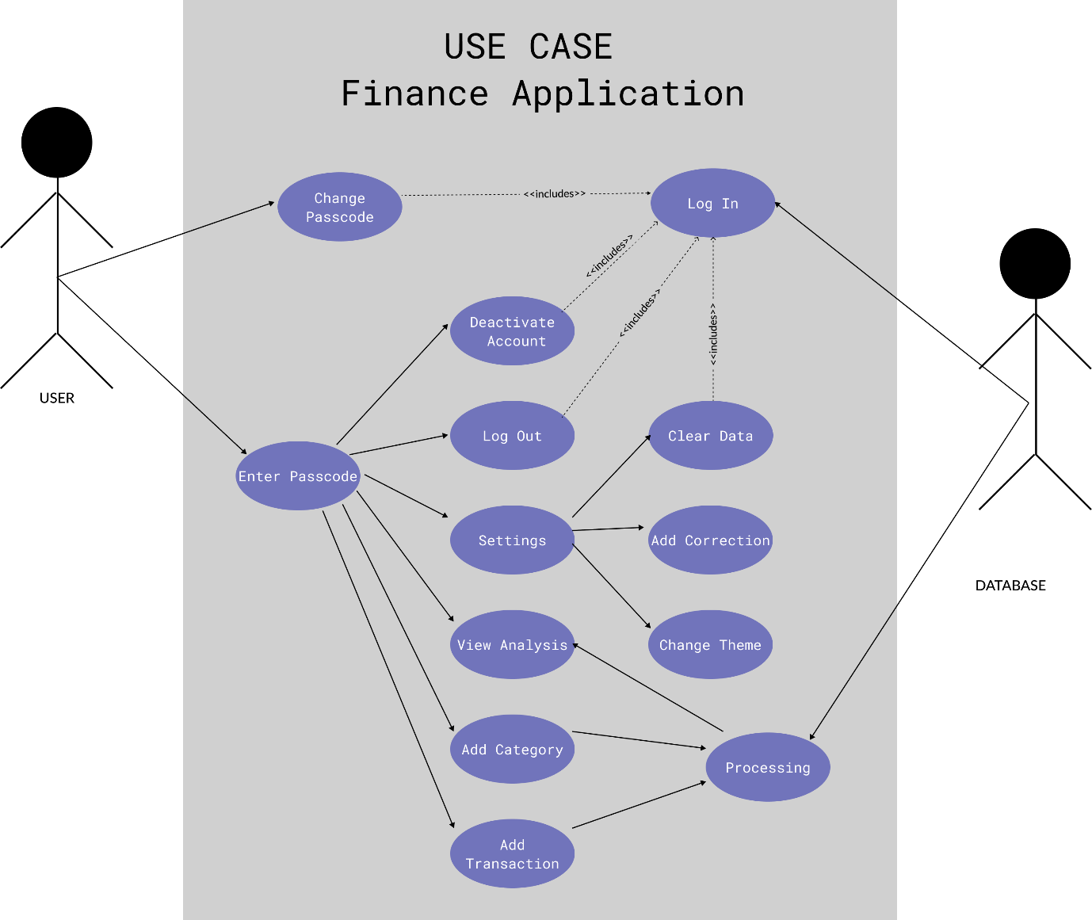

Figure 2: Functional Overview

# Wireframe

The wireframe below is made as the basic construction of how the application would look like at its core. It constitutes of most envisioned functionalities for the application as well as all of the non-functional requirements set for the application. It represents the UI portion of the application assuring certain usability principles provided the intended functionalities.

Green lines have been drawn in order to form a connection between the initialization of the screens and similarly yellow notes have been provided in order to clarify the purpose for definitive choices for a better understanding of the non-functional terms. A more in-depth description has been provided below for major screens.

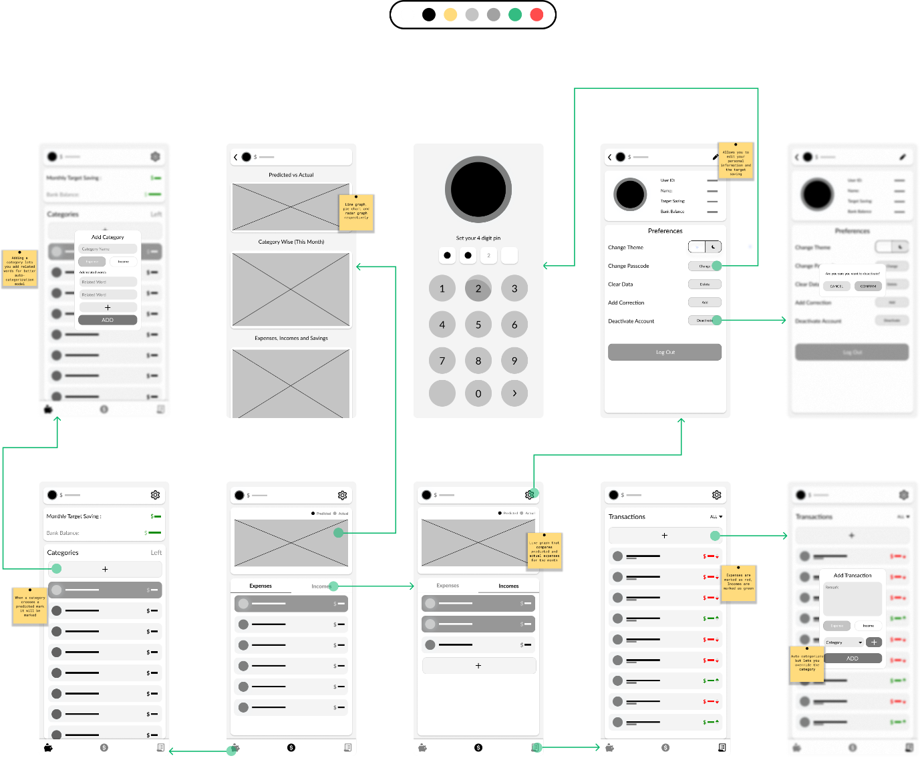

Figure 3: Connections in wireframe

## 3.1 Home Screen

Figure 4: Home Screen

The home screen of the finance application is the first screen seen by a user unless a passcode has not been set. This will constitute of a double line graph on the top card that will represent the predicted expense and the other graph will represent the actual expense for the user. The graphs will be drawn solely on basis of collective data of his personal past transactions occurred for last few months.

The bottom card will consist of tab view for expenses and incomes that will constitute of a categorized dataset of transactions performed by the user.

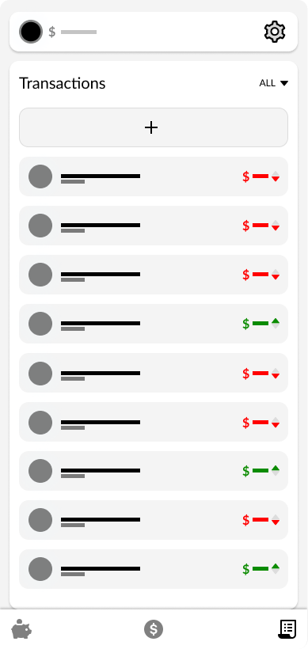

## 3.2 Transaction Screen

Transaction screen is the third screen on the bottom navigation bar and it provides list of all the transactions sorted descending by the most recently added ones. This will have a drop-down button in order to filter out the list. The transactions that are allocated as expenses are denoted in red and incomes are therefore denoted in green to represent the rise or fall in the overall balance of the user along with the amount by which it acted.

The header on the top most part of the screen represents the balance of the person along with his avatar and a button to navigate to the settings screen.

Figure 5: Transaction Screen

## Category Screen

Figure 6: Category Screen

The category screen lists out all of the categories that are present. The application will categorize the natural language text entered by the user as transactions. This will be highlighted red in case an expense category overhead the prediction or highlighted green in case an income category overhead the prediction. Similarly, the user is given freedom to add a category manually by clicking the add button. This list will be sorted in descending order by the amount of the transaction.

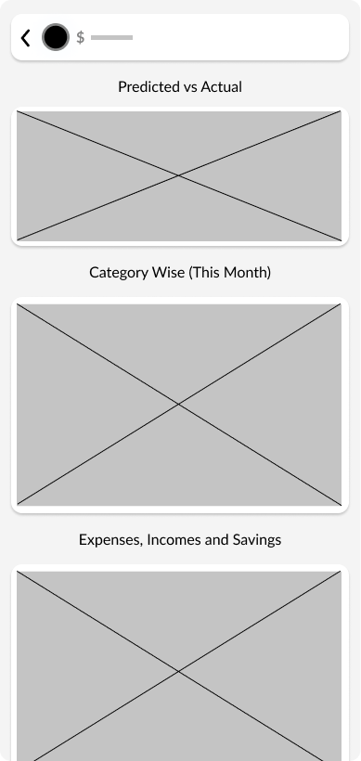

## 3.4 Analysis Screen

Analysis screen can be navigated by clicking on the graph on the home screen and it consists of three graphs that will help the user analyze the personal expenses. The first one will consist of the double line graph that helps the user compare his actual expenses with the predicted expense.

Similarly, the second card will have a pie chart that will represent the expenses category wise so that he can make a more informed decision to cut his expenses.

Lastly, the third card will represent a radar chart that will help compare the user’s expenses with income and savings for actual data compared with predicted data and data from last month.

Figure 7: Analysis Screen

## 3.5 Setting Screen

Figure 8: Setting Screen

The settings screen can be navigated through header and it will have personal preferences for the user like changing the theme of the app, changing the passcode, clearing the data, adding correction, deactivating the account and changing the avatar.

The user will also be able to change personal details like setting the target saving, bank balance or name. Lastly the user will also be given an option to log out from the account.

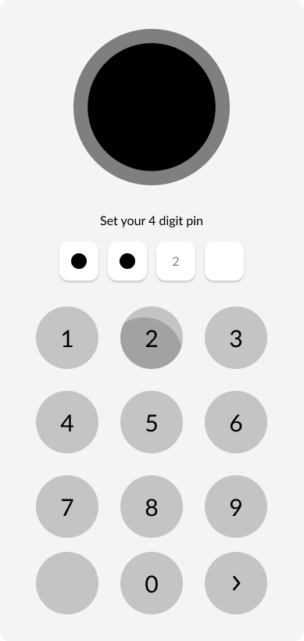

Figure 9: Lock Screen

## 

## 3.6 Lock Screen

Since the application is supposed to have delicate financial details, a lock screen is to be added for security purposes. Setting a lock screen can be navigated through the settings screen and it is protected by a 4-digit number pattern.

The user can set the application to delete it’s contains in case for a brute force attempt. If a passcode is set then the screen will be shown at every launch causing it to protect the application from data theft.

# Sequence Diagram

There are three objects in the system during a conventional interaction and they are the User, the database and the view that connects them which will be the application. For an example of the interaction in the application, the user sends the login credentials which is then verified by the O Auth API. If the entered credentials match the one in the database then the app lets the user enter to use the rest of the application else the user is not let in.

Similarly, when a transaction is entered in the application, it identifies the category with the data that has already been stored in the database with respect to the past entries and the user can see that the transaction is auto categorized.

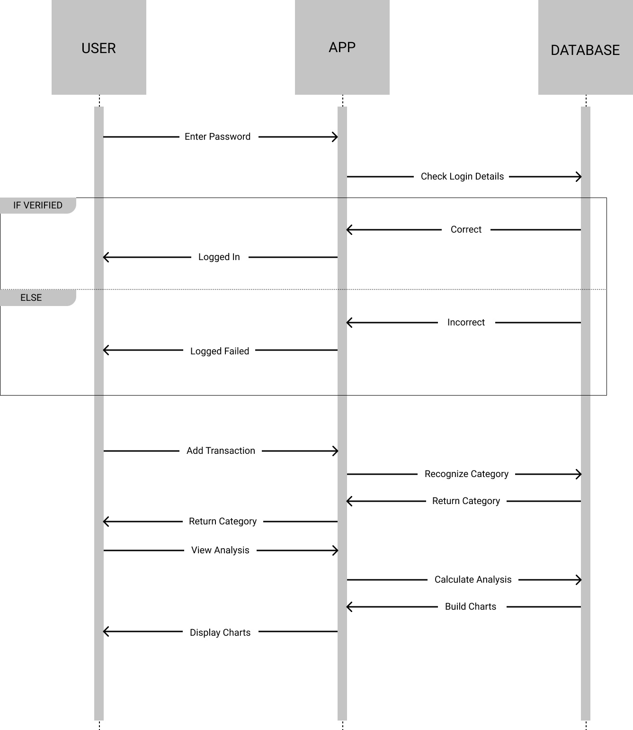

Figure 10: Interaction between objects

# Entity Relationship Diagram

The diagram shows the construction for the envisioned database for the application. The entity user covers the information like saving, bank balance, preferences and an avatar which will be a type of an emoji which will represent the age and gender of the user. Correction entity is used when the user wants to add a correction to his bank balance because of the miscellaneous transactions which were unable to be noted in the application.

Similarly, transactions have foreign keys like category ID which will be generated programmatically and related word entity will be words that is to be used for the preprocessing section of the natural language processing used to auto categorize the raw text written as remarks when the user adds a transaction. The reason to normalize with a separate entity for theme and gender was to support scalability.

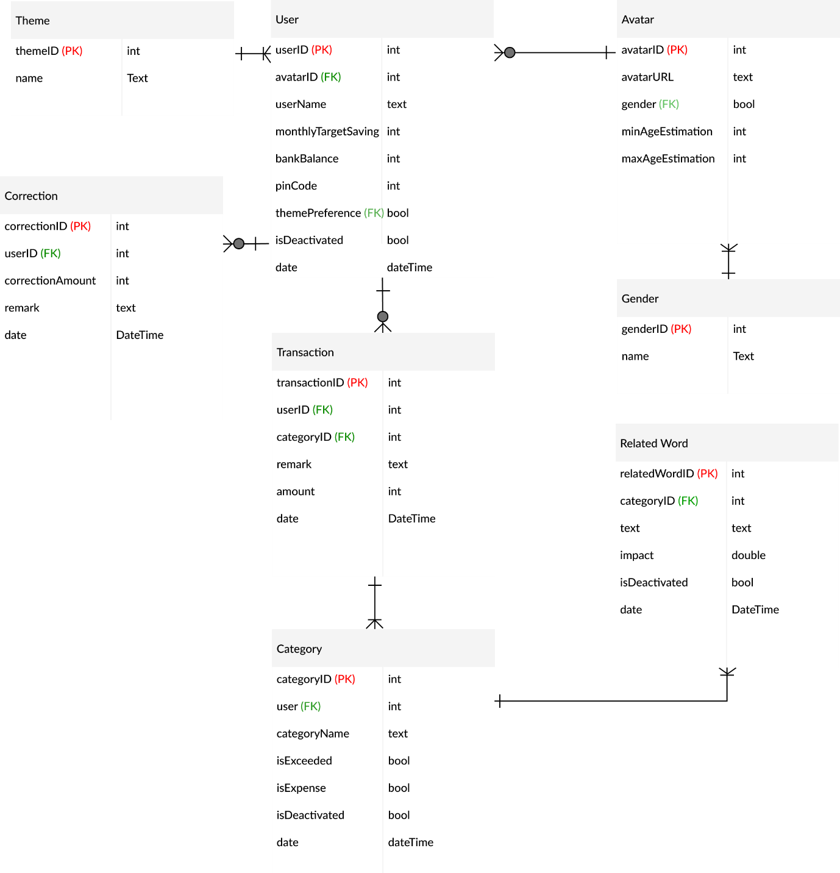

Figure 11: Entity Relationship Diagram