**Automatic extraction method of human body sizes**

**based on 3D point clouds**

张煜辉 group53 516030910561

Abstract: Considering that body size extraction based on point cloud data is a difficult problem for three­dimensional non­contact measurement of the human body, an automatic extraction method of human sizes was presented based on human point cloud data. The procedures were as follows. Firstly, the point cloud data were de­noisesed and a standard coordinate was built for measurement. Secondly, a method to segment the human body into six parts was proposed so that the landmarks could be recognized more efficiently and accurately. Thirdly, the recognition methods of human landmarks were introduced which were divided into three classes, i.e. the global extrema, the local extrema and the points that haven’t obvious characteristics. Finally, the human sizes were calculated based on the identified relative landmarks. The results show that the proposed method has characterization of shorter measure time and more flexible operation compared with the traditional size measurement method.

Key words:anthropometry;model segmentation;landmark recognition;bodysize

**Introduction**

Anthropometry is a very important research field in ergonomics. It measures the difference in body size between individuals and groups by measuring the size of various parts of the human body to study the morphological characteristics of human beings. Sports technology diagnosis and analysis, human-machine environment system engineering design, etc. provide anthropometric data, and are widely used in clothing, sports, national defense and other fields. In the development of anthropometric techniques in recent decades, it has undergone a process of contact-to-contact, two-dimensional to three-dimensional development. Traditional manual measurement mainly uses a tool such as a soft ruler, an altimeter, a distance meter and a sliding meter to make a contact measurement on the human body. Although it can obtain a human body size,

it cannot meet the needs of fast, accurate

and batch measurement. Non-contact automatic measurement is the development trend of modern anthropometric technology. Based on modern optics, it combines image processing and computer vision to obtain human parameter data accurately, efficiently and objectively.

The difficulty in extracting human body dimensions from a point cloud model is how to provide a human body measurement point with robustness and accuracy. Domestic and foreign scholars have proposed a variety of methods for extracting measuring points in point cloud models. At present, there are mainly three methods: template mesh deformation method, discriminant function fitting method and geometric shape analysis method. The template mesh deformation method is a general processing method in computer graphics. Blanz et al. carried out groundbreaking work based on template grid processing, mainly for face modeling. Inspired by Blanz et al., Allen et al. applied the template mesh model deformation registration method to the human point cloud model. The deformation process relied on human marker points, which were manually calibrated before human body data scanning. The deformation registration method uses an energy optimization method, which requires iterative solution and has a slow convergence rate. Anguelov proposed a method that does not need to specify the point in advance to perform deformation registration. The Markov network method is used to first obtain more than 200 points corresponding to the target point cloud model and the template grid model, and then use these points. The template model is deformed onto the target point cloud model. However, the corresponding point calculation algorithm proposed by Anguelov et al. still needs to initialize 4~10 points, which requires manual calibration, and it is difficult to guarantee the accuracy of the corresponding results. Azouz et al. improved the algorithm of Anguelov et al. based on a set of human models marked with measuring points, combined with machine learning methods and probability map models for point identification. Discriminant function fitting method identifies the measuring point by establishing a specific discriminant function for each measuring point. First proposed by Dekker et al., Leong et al. describe the human body features by logic mathematics, and use image processing and computational geometry techniques to identify the human body point cloud. The measuring point in the middle. The disadvantage of the discriminant function fitting method is that the process of function fitting is very complicated and time consuming, and it leads to loss of features in the function fitting process. Geometric shape analysis is also one of the main methods for extracting human point cloud features.

In view of the above problems, the author uses the sports technology diagnosis and analysis, the clothing set number as the background, based on the human body point cloud data output by the three-dimensional scanner, research and realize the automatic extraction method of human body size, and compare with the actual situation.

**Method**

**1 Data collection**

We use Kinect to get the 3D point clouds of body by structure from Motion (SFM).

1.1 SFM

This three-dimensional reconstruction method based on vision, calculates the change of the camera position and the spatial coordinates of the feature points by the image sequence captured during the movement of the camera.

The motion method has very low image requirements, and can be reconstructed in three dimensions using video or even random image sequences. At the same time, the image sequence can be used to realize the self-calibration of the camera during the reconstruction process, and the step of calibrating the camera in advance is omitted. Moreover, due to the advancement of various feature points extraction and matching techniques, the robustness of the motion method is also strong.

The shortcomings of the motion method are mainly due to the large amount of computation. At the same time, because the effect of revisiting depends on the density of the cheats of the feature points, the effect of revisiting the weak texture scene with fewer feature points is relatively poor.

1.2 Measurement Datum and Standard Measurement Coordinates In order to accurately locate the measurement points and accurately complete the measurement project, ergonomics specifies uniform standard postures and descriptive terms. The three datums used for anthropometry are determined by three mutually perpendicular axes (pig, vertical and horizontal). The plane passing through the vertical axis and the horizontal axis is called the coronal plane, which divides the human body into front and back parts; the plane passing through the horizontal axis and the vertical axis is called the horizontal plane, which divides the human body into upper and lower parts; All planes of the vertical and vertical axes are called sagittal planes, which divide the human body into left and right parts. In particular, the median sagittal plane divides the human body into two parts that are symmetrical left and right. The human body standard measurement coordinate system is defined as follows: the center point of the human body when standing naturally is the coordinate origin, the vertical upward direction is the Y-axis positive direction (the vertical axis), and the human body directly is the Z-axis positive direction (the vertical axis), the human body The positive left side is the X-axis positive direction (horizontal axis), and the XYZ coordinate system conforms to the right-hand rule.

**2 Data preprocessing**

2.1 Model stratification

Choose a thickness to store the point information layer by layer. Only store the x, z coordinates and ignore the difference in height between points in one layer.

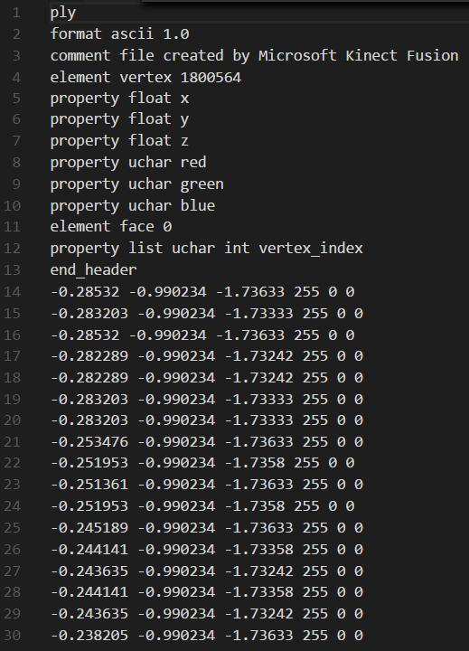

2.2 Point cloud noise reduction

I tried some methods to achieve point cloud model noise reduction but these methods that make the model surface smooth have changed the original shape of the model to some extent. It will have a big impact on the final result.

So I chose to find and remove the points out of the cluster to manually achieve the purpose of noise reduction.

1) Scanning model layer by layer.

2) Use K-means clustering algorithm to determine which part one point belongs to.

3) Calculate the average distance of adjacent points. Manually delete the point with an abnormally long distance.

**3 Model segmentation**

The key issue in human body size measurement is the correct identification of points on point cloud data. Since the measuring points are distributed in various parts of the body and the model is segmented before recognition, the problem of identifying points on the overall point cloud model can be converted into a local point identification problem. This not only makes the identification of the measuring points faster and more robust, but also can accurately find the proportion of the points on the part of the human body where the points are not clearly characterized, so that the proportional relationship can be obtained the exact initial point.

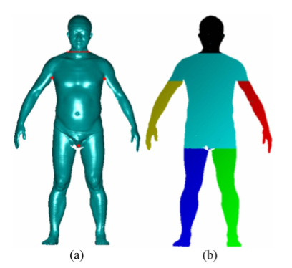

**4 Point identification**

The measuring points required for anthropometric measurements are distributed in various parts of the human body, and it is difficult to find a uniform recognition algorithm for all measuring points. According to the difference in the identification algorithm of the measuring points, the measuring points are divided into three categories: value points, local limit points and general measuring points. The value point is generally a measurement point with a large or small value on a certain coordinate axis; and the local limit point is usually a bump, a pit or a sudden point on a given contour line; the general measurement point is that the geometric feature is not obvious and Points that are not in the first two categories. The identification methods of these three types of measuring points are described below.

4.1 The most value point

The identification algorithm of the most value point is divided into two steps: firstly, according to the definition of the measurement point, the human body part where the point is located is determined, and then the corresponding point of the x (or y or z) coordinate when the coordinate reaches a large value or a small value can be searched for on the part. . For example, the head apex is the point on the human head with a large y coordinate, and the left middle finger cusp point is the point on the left arm of the human body with a small y coordinate.

4.2 Local limit points

The local limit points are further divided into two categories: the first type is the local limit point on the reference line; the second type is the local limit point on the section outline. The former is identified by positioning the baseline, while the latter is identified by the method of contour analysis.

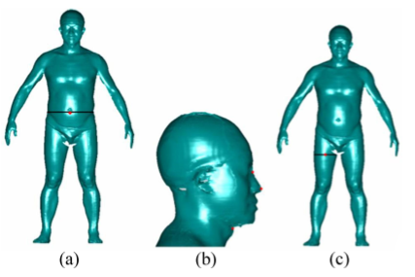

4.3 Ordinary measuring points

Ordinary measuring points usually have no obvious features. There are two methods for identifying such measuring points: one is to obtain the scanning line where the measuring point is located according to the proportional relationship of the measuring point on the height of the human body, and then according to the measuring point in the scanning line. The upper position is identified; the other is based on the positional relationship between the point to be identified and the measured point around it.

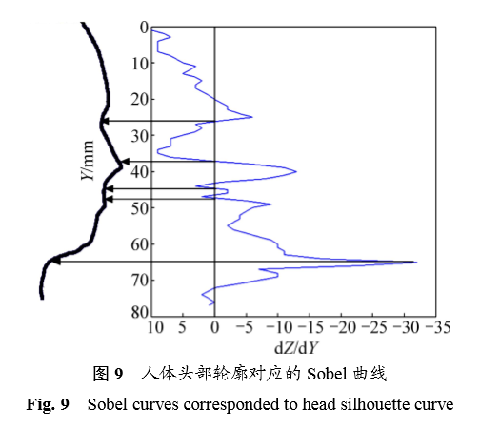

**5 Size calculation**

In this paper, the calculation method of the measurement project is divided into the following four categories.

5.1 Width, height, thickness.

The relevant measuring points of the known measurement items are P1(x1, y1, z1) and P2(x2, y2, z2), then the height $h=\left|y_{2}-y_{1}\right|$, width $w=\left|w_{2}-w_{1}\right|$, thickness $t=\left|z_{2}-z_{1}\right|$

5.2 Straight line distance.

The relevant measuring points of known measurement items are P1(x1, y1, z1) and P2(x2, y2, z2), then the distance between the defined point P1 and the point p2 is:

$$\left|\overline{p_{1}p_{2}}\right|=\sqrt{{(x_{2}-x_{1})}^{2}+{(y_{2}-y_{1})}^{2}+{(z_{2}-z_{1})}^{2}}$$

5.3The circumference

The calculation method of the girth is usually to cross the section of the relevant measuring point and the human body model to obtain a series of intersections between the section and the model, and the circumference of the small convex hull on the plane point set is used as the circumference. This paper uses Graham algorithm to solve convex hull

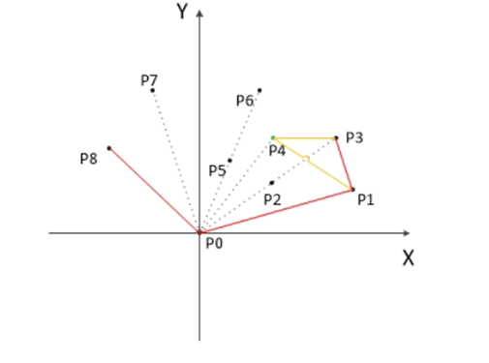

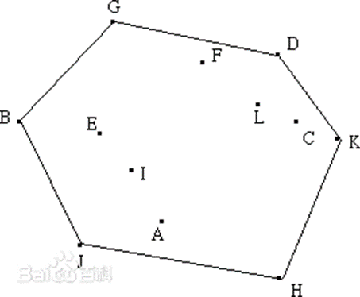

5.4 Arc length.

The calculation method of the arc length is as follows: the cross section of the relevant measuring point is intersected with the human body model to obtain a series of intersection points S of the section and the model; according to the definition of the arc length, the part of the point set S which is not related to the arc length is eliminated; The points in S are sorted by some criteria and fitted to a B-spline curve with its length as the arc length.

**Conclusion**

I successfully note the position of neck,chest, waistline, hipline, knee, ankle, wrist and so on by using different colors. And get the Length and circumference of various parts of the body.

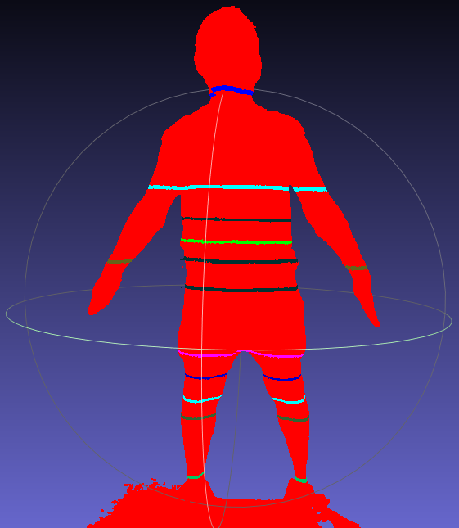

But it is still hard for me to use machine learning to achieve the goal.