3 Result of function F(x) calculation.

3.1 Matlab Result of different a,b,c,d.

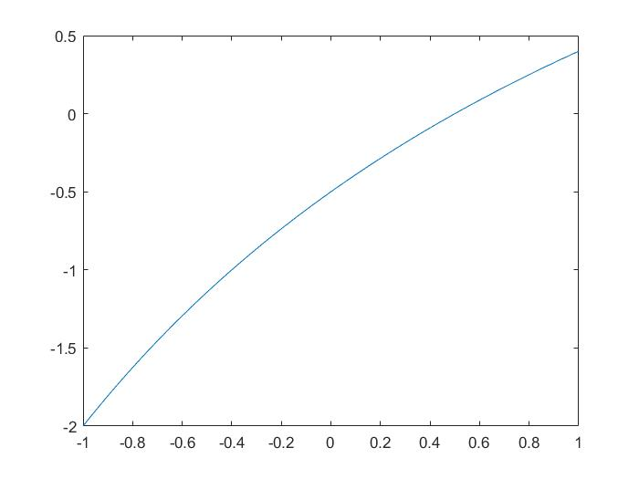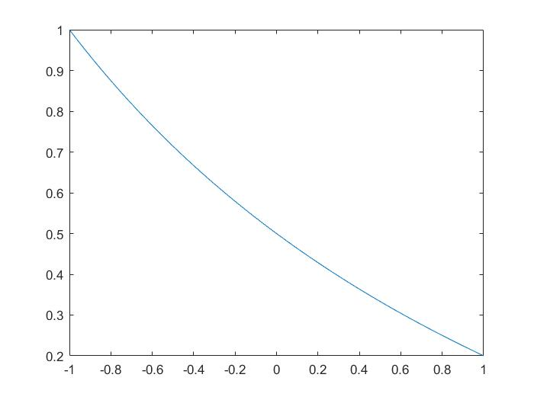

a=4, b=-2, c=1, d=4; a=4, b=-2, c=1, d=4;

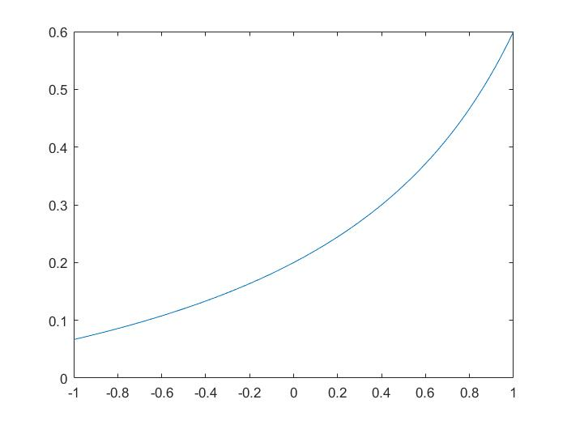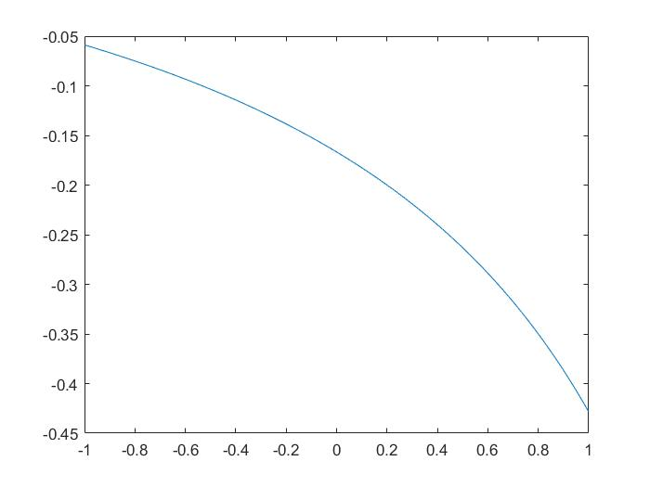

a=1, b=-2, c=-5, d=10; a=1, b=-2, c=5, d=-12;

Plot 1: Matlab result of different a,b,c,d.

3.2 Simulation result and its comparsion with theoreticcal values.

In this experiment, a=1, b=2, c=-5, d=12, and I_ref=1nA. Simplified calculation circuit (Fig:1) is implemented and simulated.

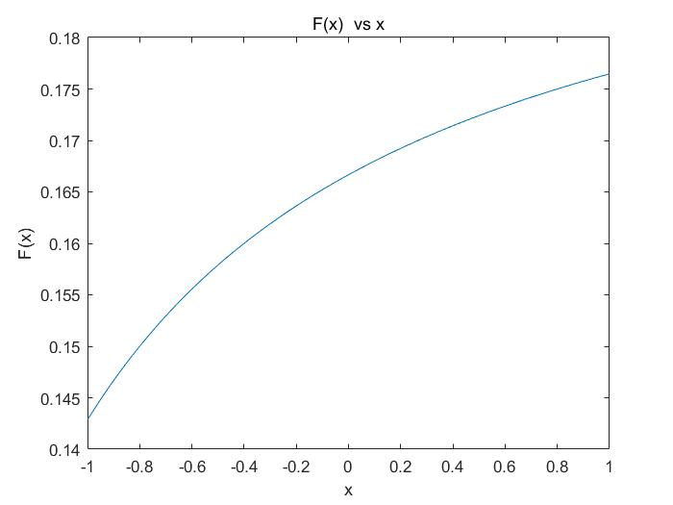

Plot 2: Matlab result of a=1, b=2, c=-5, d=12;

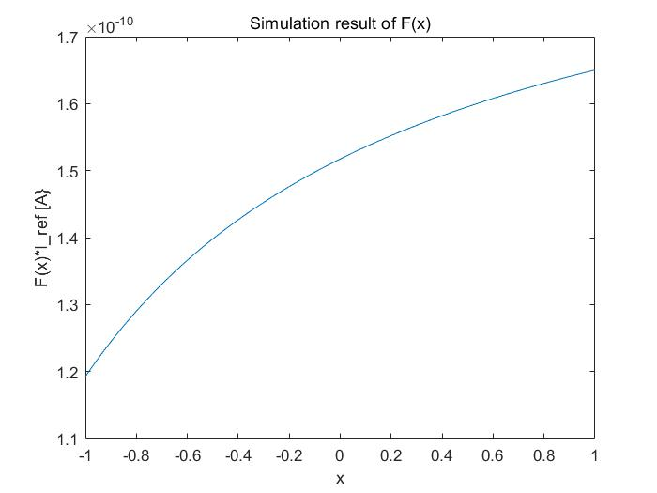

Plot 3: Simulation result of the circuit.

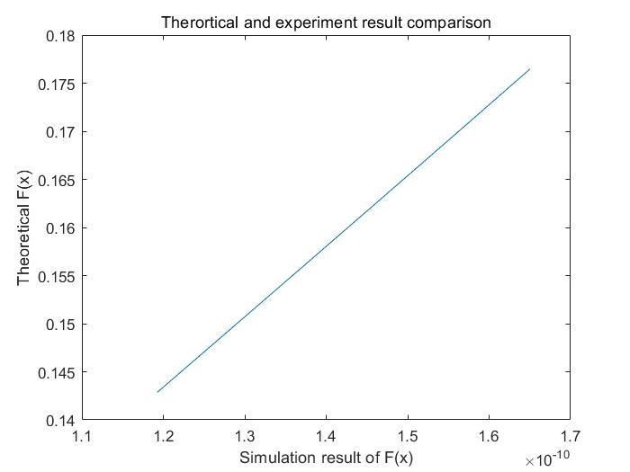

Plot 4: Comparison of two results.

We can see that simulaion results have strong correlation with matlab results.

4. Fixed-point simulation result

In this experiment, a=1, b=2, c=-5, d=12, and I_ref=1nA. Simplified fixed-point calculation circuit (Fig:2) is implemented and simulated.

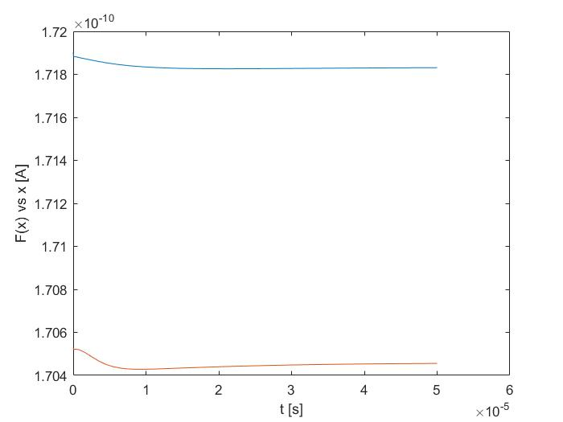

Plot 4: Fixed-point simulation result

The theoretical value of fixed point is x0=0.169, and the simulation result is 1.704. We can see that two result are close the the other.

The feedback circuit is stable, wich is guarantee by the simplicity of the circuits.

3.3 The performance of full circuits.

The values of currents sources can be implemented in similar way like shown in Fig3. Because a,b,c,d are parameters, the results of full circuit will have strong correlation with simplified circuit results. Further simulation is focused on complex number function calculation, thus the full version of calculation circuit was not implements in this project.

5.3 Complex calculation results

5.3.1 Matlab results

Set a=1+j, b=2+5j, c=5+j, d=8+12j, I_ref=1nA, We get matlab results by spanning x from -j to j with different real values.

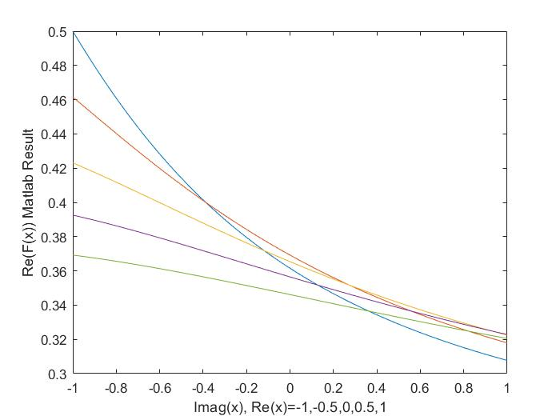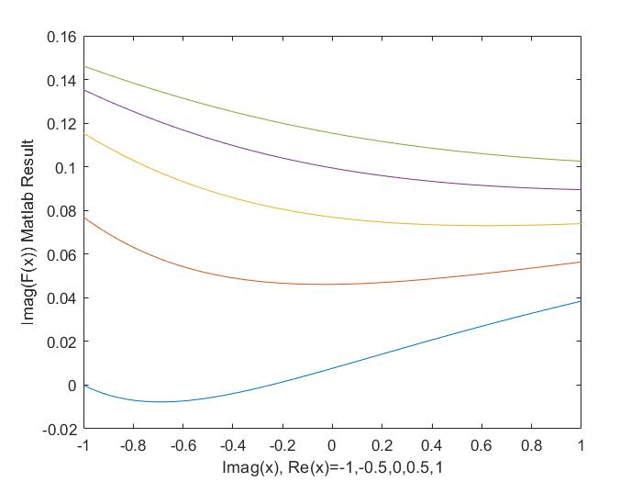

Plot 5: Matlab Results

5.3.2 Simulation Results

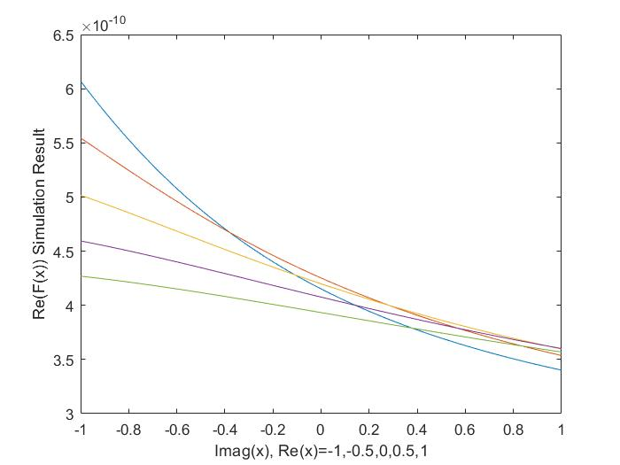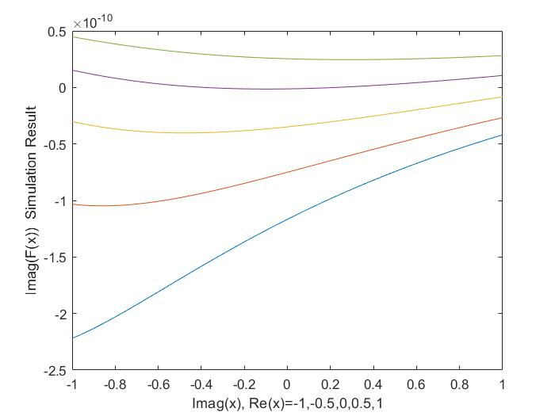

Plot 6: Simulation Results

5.3.3 Simulation and theoretical results comparison

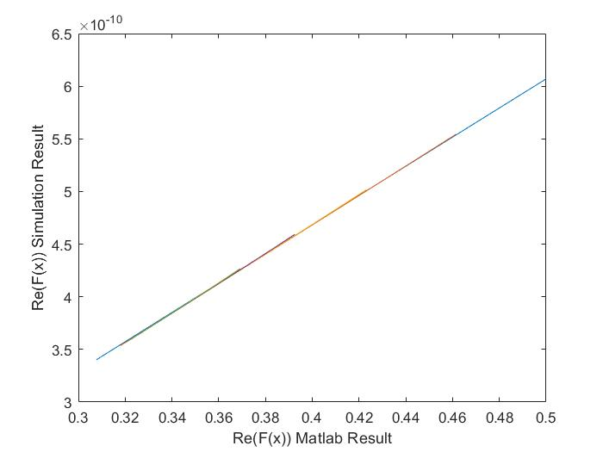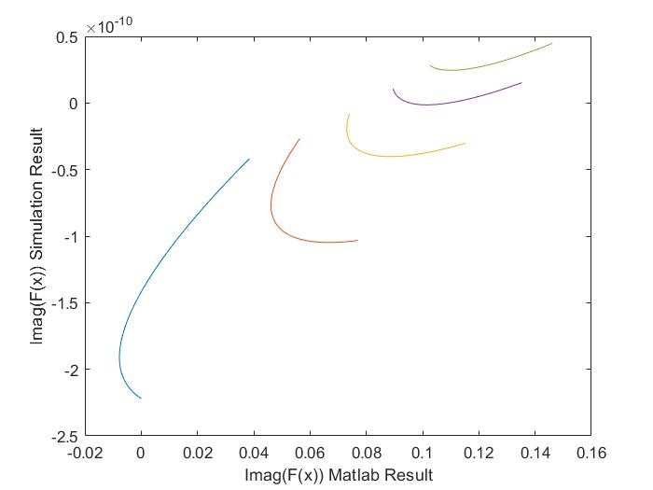

Plot 7: Comparison of two results

From comparison we see that the circuit performs well on calculation the real part of F(x), but have bad performance on imaginary part. The possible problem may be 1) There are some faults when I created the calculation schematics; 2) There are negative values transmitted when calculate the imaginary path.

5.4 Fixed-point calculation

The Fixed-point simulation was been done. The result is stable, however, the theoretical value of fixed-point is x=-0.471-0.188j, which is out of the operational range of current schematic. The result of simulation and theoretical is different. The reason may be same as mention in section 5.3.3.

No plot can be displayed because I lost the link to our server when I on this step. You can check github repo https://github.com/sjtucsw/ESE562ProjSubmit for details of this simulation, and the schematic is /FP/comp3.

6 Conclusion

Current project process is reported. There are problems remaining to be solved but I can’t link to the server now. As the result, I decided to report what I have done till now.

The main unstable work of the function is calculating the values depending on x. The main advantage of my solution is simplifying that calculating path as much as possible.