E1 versus E2: Which is better for me and you? The Thermodynamic Study of a Dehydration Reaction

*Dalia Hassan*, Yekaterina Fyodorova, Natalie Williams, Jonathan Yuan*

Department of Chemistry, St. John’s University. 8000 Utopia Parkway, Jamaica, NY 11439

Keywords: E1, E2, thermodynamics

Abstract

An experiment was conducted in order to thermodynamically compare two different mechanisms (E1 versus E2) in a dehydration reaction of a tri-substituted naphthalenone organic molecule. The E1 mechanism was believed to be the preferred reaction due to the lack of a strong base needed for the E2 mechanism. Several different simulations were run on Gaussian16, in which the reactant, products, and intermediates were optimized, and then several different energy calculations were run in increments in the basis sets 3-21G, 6-31G, 6-311G, 6-311G(2d), 6-311G(2d,2p). When comparing the changes in free energies of each step, the E2 mechanism is shown to be thermodynamically more favorable. This, however, contradicts what organic chemistry would suggest, since there is not a strong base present to help the E2 mechanism move forward. Further studies would have to be done in order to better understand why the theoretical data does not match that of the experimental data. One reason may be that the optimization and energy simulations run on Gaussian do not consider the solvent systems that the molecules are in; since the E2 mechanism is a one step mechanism, it may require less energy to run, but will not actually work experimentally without the proper solvent conditions.

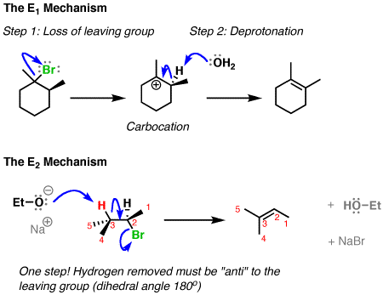

Introduction

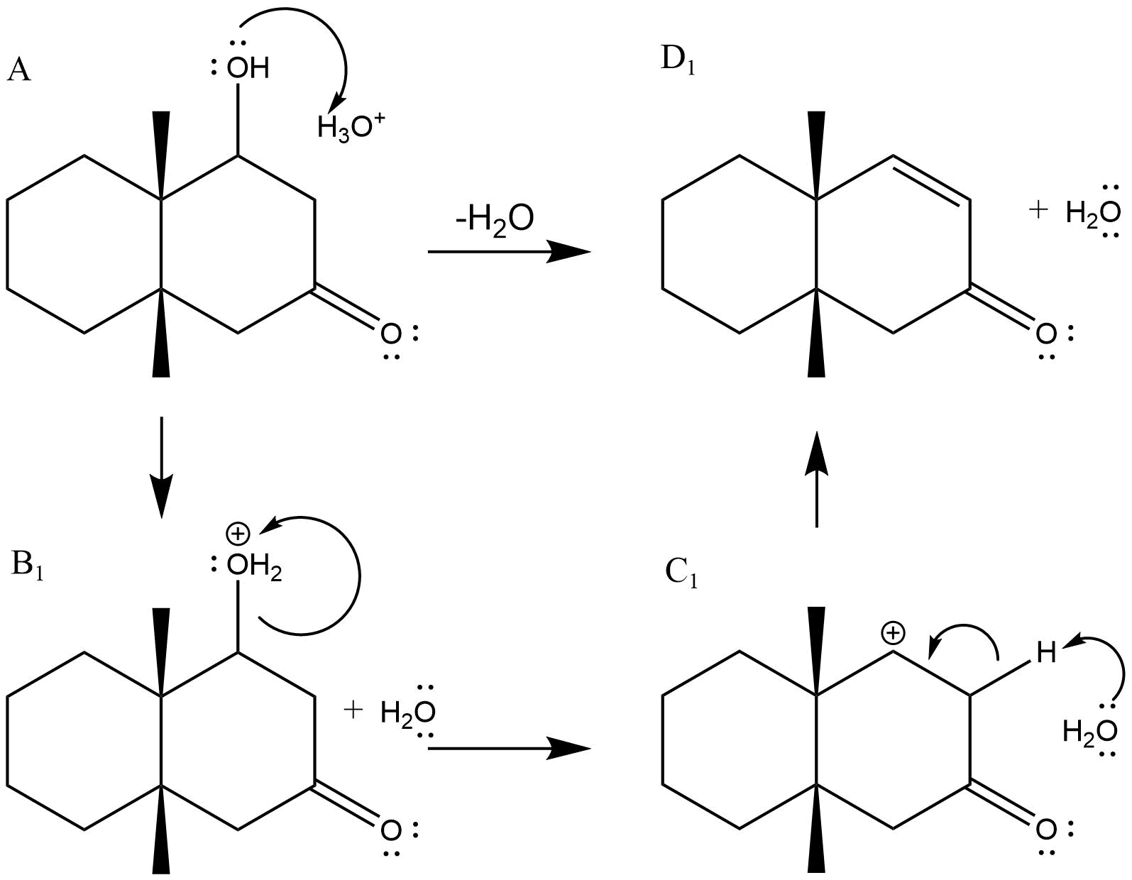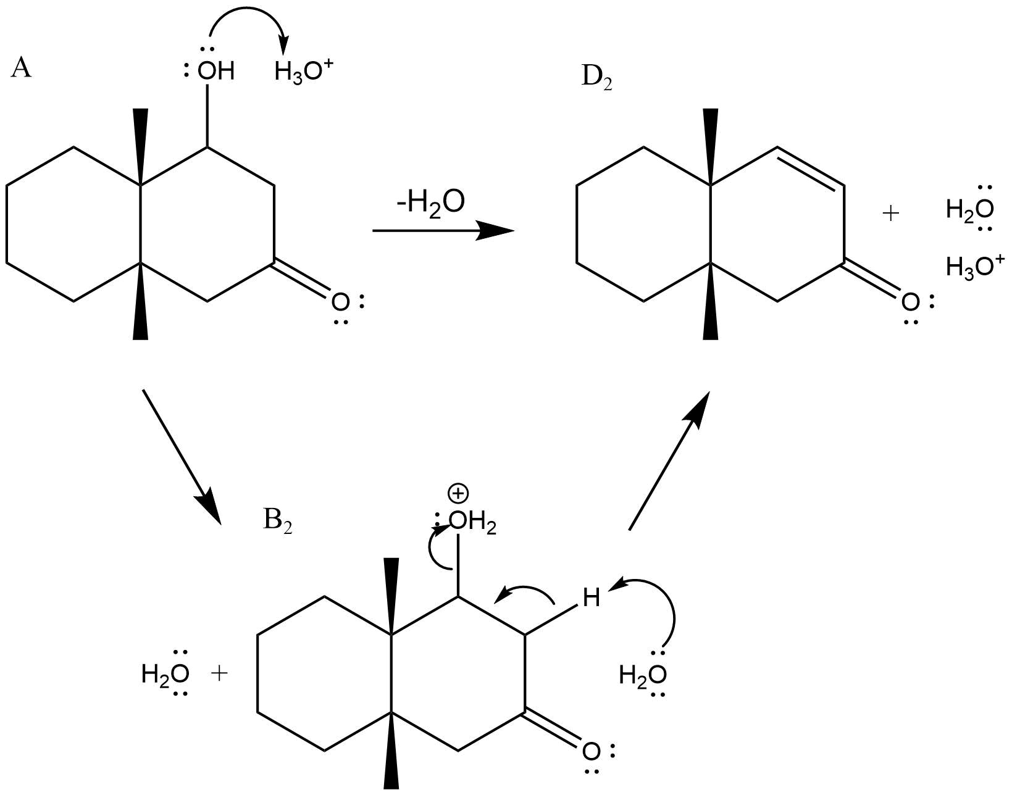In this experiment, two proposed methods for the dehydration of 2(1H)​-​Naphthalenone, octahydro-​3-​hydroxy-​4a,​8a-​dimethyl-​, (4aR,​3R,​8aS)​-​rel-, to become 2(1H)​-​Naphthalenone, 4a,​5,​6,​7,​8,​8a-​hexahydro-​4a,​8a-​dimethyl-​, (4aR,​8aS)​-, were observed theoretically in order to determine which mechanism would be the thermodynamically optimal choice.

***Scheme 1,2.*** *Mechanism 1, the E1 mechanism, and Mechanism 2, the E1 mechanism, shown respectively for the dehydration of our reactant. The labels A, B1/2, C1/2, and D1/2 are used to denote the reactant, different intermediates, and different products made from each mechanism (including the water molecule and hydronium ion). This labelling method will be used for future calculations.*

From an organic point of view, the first mechanism, which is an E1 mechanism, is the favored method because it does not require a strong base, is unimolecular, and there is no requirement for the stereochemistry of the reagent. The only barrier for an E1 mechanism would be that the formation of a carbocation is preferred for either a secondary or tertiary carbon; in this case, the reaction would be done on a secondary carbon. An E2 reaction, on the other hand, is bimolecular, which means that it depends on the concentration of both the substrate and the base, and it requires a strong base; also, the leaving group must be anti to the hydrogen removed, and so the stereochemistry is important for an E2 mechanism. Organically, the E1 mechanism is the preferred mechanism, since there is no strong base to help the E2 mechanism move forward1.

It was hypothesized that the E1 mechanism would be more thermodynamically favored as well, meaning that it would have a lower entropy, lower enthalpy, and lower free energy value in the intermediate steps of the reaction. Both mechanisms should, however, have the same overall change in entropy, enthalpy, and free energy.

Computational Details (Methods)

We studied the change in entropy and enthalpy of different organic molecules with DFT (density functional theory) energies. All calculations were carried out using the Gaussian162 program package. The initial HF (Hartree-Fock) calculation was an optimization performed with the basis set 3-21G. Afterwards, all DFT calculations were carried out using a series of the following basis sets; 3-21G, 6-31G, 6-311G, 6-311G(2d), 6-311G(2d,2p). The DFT energies were obtained with the following exchange and correlation functional: Becke’s three-parameter hybrid DFT/HF method with Lee-Yang-Parr’s correlation functional (B3LYP)3. Lastly, an optimization/frequency job was performed with the basis set 6-311G(2d,2p). The basis sets were used in the following order to ensure that the structures of the reactants/products were in their most stable form before being fully optimized.

Results and Discussion

|  |  |  |  |  |
| --- | --- | --- | --- | --- |
| ∆H (kcal/mol) |  |  |  |  |
| **E1** | **B1-A** | **C1-B1** | **D1-C1** | **Overall** |
| UUU | -32.70 | -2.41 | 38.17 | 3.06 |
| **E2** | **B2-A** | **D2-B2** |  | **Overall** |
| UUU | -32.70 | 35.76 |  | 3.06 |

**Table 1.** The change in enthalpy for each step of the E1 and E2 mechanisms. The “UUU” refers to the orientation of the hydroxide and two methyl groups, respectively (up-up-up).

|  |  |  |  |  |  |  |  |  |
| --- | --- | --- | --- | --- | --- | --- | --- | --- |
| ∆S (kcal/molK) |  |  |  |  |  |  |  |  |
| **E1** | **B1-A** | **T∆S** | **C1-B1** | **T∆S** | **D1-C1** | **T∆S** | **Overall** | **T∆S** |
| UUU | -0.0043 | -1.27 | 0.0481 | 14.36 | -0.0057 | -1.699 | 0.0382 | 11.39 |
| **E2** | **B2-A** | **T∆S** | **D2-B2** | **T∆S** |  |  | **Overall** | **T∆S** |
| UUU | -0.0043 | -1.27 | 0.0425 | 12.66 |  |  | 0.0382 | 11.39 |

**Table 2.** The change in entropy for each step of the E1 and E2 mechanisms.

|  |  |  |  |  |
| --- | --- | --- | --- | --- |
| ∆G (kcal/mol) |  |  |  |  |
| **E1** | **B1-A** | **C1-B1** | **D1-C1** | **Overall** |
| UUU | -31.40 | -16.77 | 39.87 | -8.30 |
| **E2** | **B2-A** | **D2-B2** |  | **Overall** |
| UUU | -31.40 | 23.10 |  | -8.30 |

**Table 3.** The change in free energy for each step of the E1 and E2 mechanisms.

|  |  |  |  |  |
| --- | --- | --- | --- | --- |
| ∆U (kcal/mol) |  |  |  |  |
| **E1** | **B1-A** | **C1-B1** | **D1-C1** | **Overall** |
| UUU | -32.44 | -15.86 | 37.91 | -10.38 |
| **E2** | **B2-A** | **D2-B2** |  | **Overall** |
| UUU | -31.40 | 23.10 |  | -8.30 |

**Table 4.** The change in internal energy for each step of the E1 and E2 mechanisms.

**Figure 1.** The Gibbs Free Energy Plot for each Intermediate Step of Each Mechanism.

As shown in the tables above, there is a general trend in each mechanism. The overall change in the entropy and enthalpy are positive, while the change in free energy and internal energy appear to be negative. Despite the mechanism, the reaction is overall endothermic and driven to greater disorder; however, since the change in free energy is negative, the reaction is still spontaneous, implying that T∆S>∆H. Since the change in internal energy is also negative, this just confirms that the reactant becomes a more stable structure after dehydration4. There is also a general trend which follows when observing the HOMO-LUMO gaps in Mechanism 1 (refer to SI). The overall gap decreases when looking at the gap of the reactant versus the product; excitations becomes easier as the HOMO-LUMO gap converges, such as for large aromatic systems. Although the product is not an aromatic system, it has a conjugated double bond (an aromatic property), and small HOMO-LUMO gaps lead to mobile π electrons, which leads to a greater distribution of energy throughout the molecule, making it more stable. Hence, a decrease in the HOMO-LUMO gap corresponds to a better stability of the product5.

Based on the results shown above, both mechanisms are shown to be overall entropically driven. The change in enthalpy, or ∆H, of the reaction is positive for both mechanisms, and the change in entropy, or ∆S, is also positive for both mechanisms. This shows that both mechanisms are endothermic and are driven to greater disorder. However, both mechanisms have an overall negative change in free energy, or ∆G, which can be due to the high temperature that the reaction was performed at, which was 298.15 K. In other words, T∆S>∆H. Since the change in free energy is so temperature dependent, it supports the fact that the dehydration of this organic compound is entropically driven, whether it is performed through an E1 or E2 mechanism.

When looking at the individual steps, some of the steps in each mechanism are shown to be entropically driven, and some are shown to be enthalpically driven. In both mechanisms, the first step consists of the alcohol abstracting a proton from a hydronium ion; this step appears to be entropically driven, since T∆S>∆H, or since the change in entropy is greater than the change in enthalpy, making the change in free energy negative. In mechanism 1, there is an extra step, in which the reagent forms a carbocation; this step appears to be enthalpically driven. In this case, ∆H>T∆S, and the change in free energy is positive, which implies that this step is not spontaneous; this is what leads the E1 mechanism to move to intermediate to its more stable product. The last steps in both the E1 and E2 mechanism are both entropically driven, similarly to the first step of the mechanism, since T∆S>∆H, making the change in free energy negative4.

Based on thermodynamics, the best mechanism is mechanism 2, or the E2 mechanism (refer to Figure 1). Although both mechanisms have the same overall change in entropy, enthalpy, and free energy, there is a higher jump in free energy, or a higher ∆G, from the first step of the mechanism to the second step of the mechanism. Although both reactions are exergonic, there is a bigger “dip” in the E1 mechanism, implying that this mechanism requires more energy to transition from the abstraction of the proton to the formation of the carbocation. There are several reasons why this may be the case. The optimization and energy simulations run on Gaussian do not consider the solvent systems that the molecules are in; since the E2 mechanism is a one-step mechanism, it may require less energy to run, but will not actually work experimentally without the proper solvent conditions. The Gaussian simulations are creating a reaction that would not actually be plausible when done experimentally.

Overall, the role of stereochemistry in the reaction is not as large as expected (refer to SI). Most of the reactions had a positive change in entropy (∆S>0), a positive change in enthalpy (∆H>0), and a negative change in free energy (∆G<0). Since the dehydration reactions had a ∆G<0 in each mechanism with all the different stereocenter combinations, it shows that the orientation of the methyl groups and hydroxide did not matter much, if there was not too much steric hindrance between the substituents. However, there were two orientations that produced a negative change in enthalpy (∆H<0), and a much more negative change in free energy; these orientations consist of the methyl groups pointing down rather than up. These orientations are likely more stable due to the electron density of the methyl groups being farther away from the ketone substituent, making the abstraction of the proton an overall easier process.

Conclusion

An experiment was conducted to observe whether a dehydration reaction would theoretically be more stable through an E1 mechanism versus an E2 mechanism, as suggested through organic theory. It was hypothesized that the first mechanism, or the E1 mechanism, would be more stable than the E2 mechanism and have a lower change in free energy because there is no strong base that can help move the E2 mechanism forward. Our data was shown to contradict our hypothesis, and the E2 mechanism was shown to theoretically be more favorable due to the higher gap between the Gibbs free energy, and higher activation energy, required between the intermediate steps of mechanism 1. Further experimentation would need to be done to try and simulate the reactions in a solvent system instead of in the gas phase to see if the results differ.

Bibliography

1. Ashenhurst, J. E1 vs E2: Comparing the E1 and E2 reactions. *Master Organic Chemistry.* [Online]. 2012.

<https://www.masterorganicchemistry.com/2012/10/10/comparing-the-e1-and-e2-reactions/> (accessed November 10, 2019).

1. Gaussian 16, Revision C.01, Frisch, M. J.; Trucks, G. W.; Schlegel, H. B.; Scuseria, G. E.; Robb, M. A.; Cheeseman, J. R.; Scalmani, G.; Barone, V.; Petersson, G. A.; Nakatsuji, H.; Li, X.; Caricato, M.; Marenich, A. V.; Bloino, J.; Janesko, B. G.; Gomperts, R.; Mennucci, B.; Hratchian, H. P.; Ortiz, J. V.; Izmaylov, A. F.; Sonnenberg, J. L.; Williams-Young, D.; Ding, F.; Lipparini, F.; Egidi, F.; Goings, J.; Peng, B.; Petrone, A.; Henderson, T.; Ranasinghe, D.; Zakrzewski, V. G.; Gao, J.; Rega, N.; Zheng, G.; Liang, W.; Hada, M.; Ehara, M.; Toyota, K.; Fukuda, R.; Hasegawa, J.; Ishida, M.; Nakajima, T.; Honda, Y.; Kitao, O.; Nakai, H.; Vreven, T.; Throssell, K.; Montgomery, J. A., Jr.; Peralta, J. E.; Ogliaro, F.; Bearpark, M. J.; Heyd, J. J.; Brothers, E. N.; Kudin, K. N.; Staroverov, V. N.; Keith, T. A.; Kobayashi, R.; Normand, J.; Raghavachari, K.; Rendell, A. P.; Burant, J. C.; Iyengar, S. S.; Tomasi, J.; Cossi, M.; Millam, J. M.; Klene, M.; Adamo, C.; Cammi, R.; Ochterski, J. W.; Martin, R. L.; Morokuma, K.; Farkas, O.; Foresman, J. B.; Fox, D. J. Gaussian, Inc., Wallingford CT, 2016.
2. Stephens, P. J.; Devlin, F. J.; Chabalowski, C. F.; Frisch, M. J. *J. Phys. Chem.***1994**, *98*, 11623−11627.
3. Free Energy and Temperature. *Chemistry Libretexts*. [Online]. <https://chem.libretexts.org/Bookshelves/General_Chemistry/Map%3A_Chemistry_-_The_Central_Science_(Brown_et_al.)/19%3A_Chemical_Thermodynamics/19.6%3A_Free_Energy_and_Temperature> (accessed November 11, 2019).
4. Truong-Son, N. What is the HOMO-LUMO gap and how does it change the properties of a substance? *Socratic Q&A.* [Online]. 2015. <https://socratic.org/questions/53d3c53702bf345ebe2a51f0> (accessed November 12, 2019).