**Graduate Research Plan Statement**

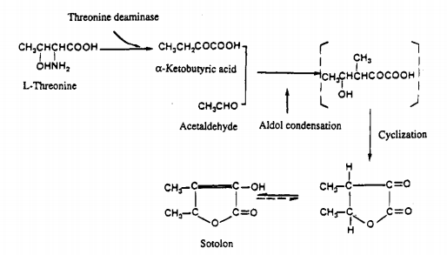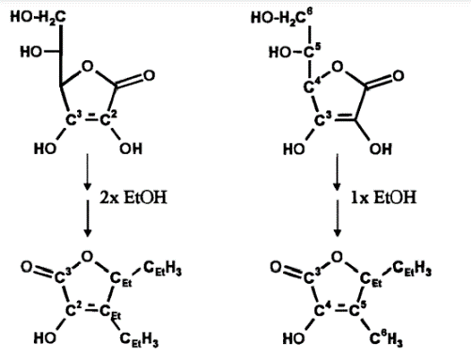Sotolon is a compound that produces an unsavory flavor in beverages that can cause them to taste degraded. There are several suggested pathways for how sotolon are produced1. Konig suggests two pathways involving ascorbic acid in which sotolon may be produced. The first incorporating two ethanol molecules, while the other implies the use of one ethanol molecule (Fig. 12). Pham’s mechanism suggests production of sotolon from a-ketobutyric acid and acetaldehyde (Fig. 23). Through computational analysis, we can investigate the thermodynamic properties of the suggested pathways.

Figure 2: Pham suggested reaction scheme.

Figure 1: Konig suggested reaction scheme.

This will allow us to learn more about the systems they occur in and gain a better understanding of the production of sotolon. By using Gaussian, we can simulate the molecules to obtain thermodynamic data such as the enthalpy, entropy and free energy of each step. The process will involve running an optimization with the Hartree-Fock method and 3-21G basis set. This basis set can be built up for each molecule from 3-21G to 6-31G and finally 6-311G. Once the 6-311G run is complete, an Opt-Freq can be ran using DFT method to obtain simulated thermodynamic values. With these values, we can directly compare the processes of sotolon production.

**Intellectual Merit**

This experiment will allow us to understand the production of sotolon in various systems more clearly which will expand knowledge in food chemistry. The results found from this experiment may be applicable to other systems that include similar materials. Along with these benefits, this may bring to light new ways to artificially produce furanone-based compounds more efficiently and economically.

**Broader Impacts**

The most prominent impact this study can produce is more effective ways of storing beverages to either slow down sotolon production or stop it completely. This would allow wines and soft drinks to retain their desired flavors for longer times without being sabotaged by the undesured sotolon tastes.

**References**

**(1)** Alexandre Pons, Valérie Lavigne, Yannick Landais, Philippe Darriet, and Denis Dubourdieu Journal of Agricultural and Food Chemistry 2010 58 (12), 7273-7279 DOI: 10.1021/jf100150q **(2)** T. König,B. Gutsche,M. Hartl,R. Hübscher,P. Schreier, and, and W. Schwab* Journal of Agricultural and Food Chemistry **1999** 47 (8), 3288-3291 DOI: 10.1021/jf981244u **(3)** Pham Thu Thuy, Guichard Elisabeth, Schlich Pascal, and Charpentier Claudine Journal of Agricultural and Food Chemistry 1995 43 (10), 2616-2619 DOI: 10.1021/jf00058a012