**Shayan Pournazari**

**Syed Khalid**

**Demitrius Smith**

**Project 3 Report**

**Group 8**

**Introduction:**

Our Zero Gravity software aims to provide simplicity and efficiency for our PRPG program. We worked within the specified criteria and created a program to accurately and quickly decode our PRPG instructions.

**Instruction Table:** The following is our instruction table complete with the format, opcodes, and examples:

|  |  |  |  |  |
| --- | --- | --- | --- | --- |
| **PC** | **Coding** | **Instruction** | **Functionality** | **Example** |
| - | 11111111 | exit | exit | ------- |
| PC++ | 0000 | STORE | MEM[Ry] = Rx | store R2,R3  00001011 |
| PC++ | 0001 Rx Ry | LOAD | Rx = MEM[Ry] | load R2,R3  00011011 |
| PC = R(i) | 0010 iiii | JUMP | PC = R(imm) | Jump 6  00100110 |
| PC++ | 0011 | MARK | Rx = PC + 4 | Mark 1   00110001 |
| PC++ | 0100 iiii | INIT | R0 = imm [imm = (-8,7)] | init 6  01000110 |
| PC++ | 0101 Rx Ry | ADD | Rx=Rx + Ry | add R2,R2  01011111 |
| PC++ | 0110 Rx Ry | SPLIT | Rx = R0 & 0xFF  Ry = R0 >> 8 | split R1,R2  01100110 |
| PC++ | 0111 Rx ii | ADDI | Rx = Rx +imm | addi R3, 2  01111101 |
| PC++ | 1000 Rx ii | SRL | Rx = Rx >>imm | Srl R2, 3 10001011 |
| PC++ | 1001 Rx Ry | SAND | Rx =( Ry&1)-1 | sand R3,R2  10011110 |
| PC++ | 1010 Rx Ry | SUB | Rx = Rx-Ry | sub R1,R3  10100111 |
| PC++ | 1011 Rx ii | BEQ | If Rx=0, Branch imm  else , PC +4 | Beq R1, 2 10110110 |
| PC++ | 1100 Rx Ry | SLT | If Rx<Ry than R0 = 1  Else               R0 = 0 | slt R1,R0  11000100 |
| PC++ | 1101 Rx Ry | XOR | Rx = Rx XOR Ry | xor R0,R3  11010011 |
| PC++ | 1110 Rx Ry | DC | Drop and Combine | dc R2,R3  11101011 |

As you see we’ve used every 4-bit combination for our Opcodes(except 1111, which is used for terminating the program).

**Registers:** We have support for Registers 1-7. R1-R3 are standard registers, both represented by two bits. We included support for register 4 in four different instructions, Store, SLT, ADDi, and Sub. We examined these instructions and determined that we were able to include a fourth register(for only these instructions) if were were to replace a register that we weren’t using in our code. R5 was a constant register, in which it would always equal 23(just as in Mips R0 is always 0). This served a purpose that we no longer needed, but was good to include. R6 and R7 are exclusive to Jump and Mark. These are used to jump to where we need to go.

**Branching:** Our program supports “Jump” and “Branch If Equal” instructions. Our beq instruction can only function for up to 3(4x3 PC) spaces. We were able to work around this limitation however. The combination of “Mark” and “Jump” allows us to go virtually anywhere we’re looking to go in our code though.

**Data Memory:** Load and Store are both fully supported. We can support range of addresses equal to the max amount a register could hold. We stop at 48 though.

Overall, our code works fairly well. If we were allowed an extra bit we’d be able to clean up the program quite a bit. We could support a lot more registers and our instructions that include immediates would increase, allowing us to cut down on our instructions. If we were down 1 bit we’d be in quite a bit of trouble. We would need to be very conservative with our use of registers, otherwise we would need to get rid of half of our opcodes. It would still be possible to perform though, it would just take a bit more planning.

The advantages of our ISA is the amount of opcodes we were able to extract. We use 15 opcodes, which allows us a plethora of operations. This allows us to efficiently calculate anything that we need to calculate. This puts us at a little disadvantage however, because compromising all of our opcodes into 4 bits means that some of our immediate values are condensed to a maximum of 2. However, for our code, it works well. If we were to restart fresh, we would definitely begin work on the design much earlier. We built our ISA but ended up changing just about everything not too long before the due date. We would have been able to foresee this if we were able to design much earlier than we did.

**Activity Log**

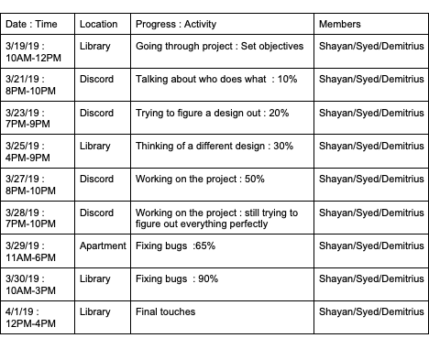

**NOTE BY: SYED KHALID**

**TO THE GRADER.**

**I HAD TO ALL THE ARCHITECTURE BY MYSELF, THEY DID NOT KNOW EXACTLY WHAT WAS GOING ON. THE FIRST ISA I MADE WAS NOT VERY ACCORDING TO THE GUIDELINES. I ASKED THEM TO HELP BUT THEY HARD CODED EVERYTHING I HAD A LOT OF HARD TIME WORKING ALONG WITH THEM.**

**THEY BOTH DID THE REPORT AND THE HARDWARE WHICH I DON’T KNOW HOW GOOD IS. AS FAR AS SOFTWARE AND WHOLE ARCHITECTURE CONCERN I DID THAT BY MESELF. THEY BOTH DID NOT EVEN KNOW HOW TO USE GITHUB.**

**THIS ACTIVITY LOG ALSO MADE BY THEM. WE ONLY MET THREE TIMES. IN WHICH WE ONLY DISCUSSED. I HAD TO SPENT HOURS WORKING ON THE SOFTWARE PART. PLEASE GRADE ME ON MY EFFORT.**

**Hardware Implementation**

Datapath Design:

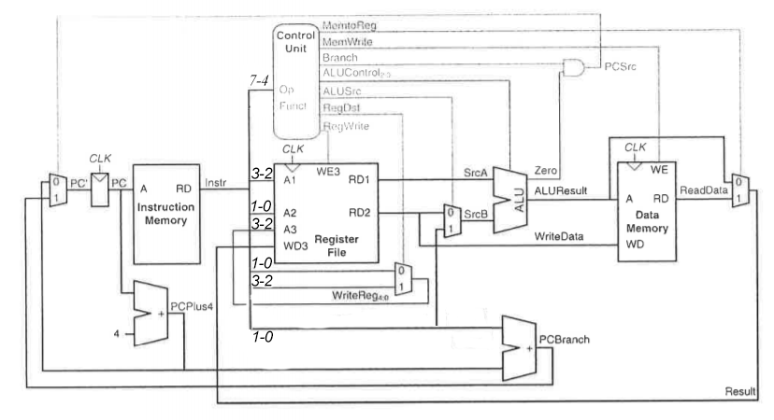

Control Logic Design:

|  |  |  |  |  |  |  |  |  |  |
| --- | --- | --- | --- | --- | --- | --- | --- | --- | --- |
| **Instructions** | **REgWrite** | **RegDst** | **ALUSrc** | **Branch** | **MmWrite** | **MemtoReg** | **ALUOp** | **jump** | **jalctrl** |
|  |  |  |  |  |  |  |  |  |  |
| STORE | **0** | **x** | **1** | **0** | **1** | **x** | **00** | **0** | **0** |
| LOAD | **1** | **0** | **1** | **0** | **0** | **1** | **00** | **0** | **0** |
| JUMP | **0** | **x** | **x** | **x** | **0** | **x** | **x** | **1** | **0** |
| MARK | **1** | **0** | **1** | **0** | **x** | **0** | **x** | **0** | **0** |
| INIT | **1** | **x** | **1** | **1** | **1** | **1** | **1** | **0** | **0** |
| ADD | **1** | **1** | **0** | **0** | **0** | **0** | **10** | **0** | **0** |
| SPLIT | **1** | **1** | **1** | **x** | **0** | **1** | **1** | **0** | **0** |
| ADDI | **1** | **0** | **1** | **0** | **x** | **0** | **x** | **x** | **x** |
| SRL | **1** | **1** | **0** | **0** | **0** | **0** | **11** | **x** | **0** |
| SAND | **1** | **1** | **0** | **0** | **0** | **0** | **10** | **0** | **0** |
| SUB | **1** | **1** | **0** | **0** | **0** | **0** | **10** | **0** | **0** |
| BEQ | **0** | **x** | **0** | **1** | **0** | **x** | **01** | **0** | **0** |
| SLT | **1** | **1** | **0** | **0** | **0** | **0** | **10** | **0** | **0** |
| XOR | **1** | **1** | **0** | **0** | **0** | **0** | **10** | **0** | **0** |
| DC | **1** | **1** | **0** | **0** | **0** | **0** | **10** | **0** | **0** |

SCREENSHOTS:

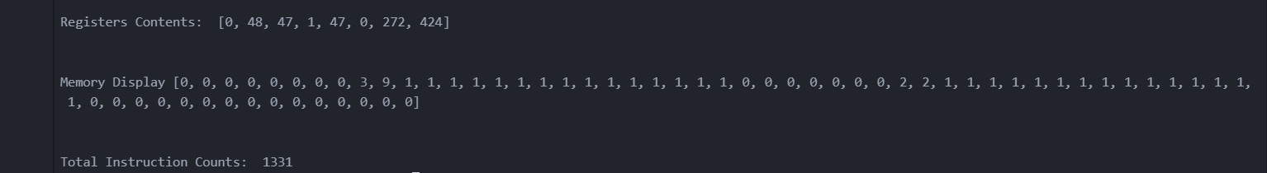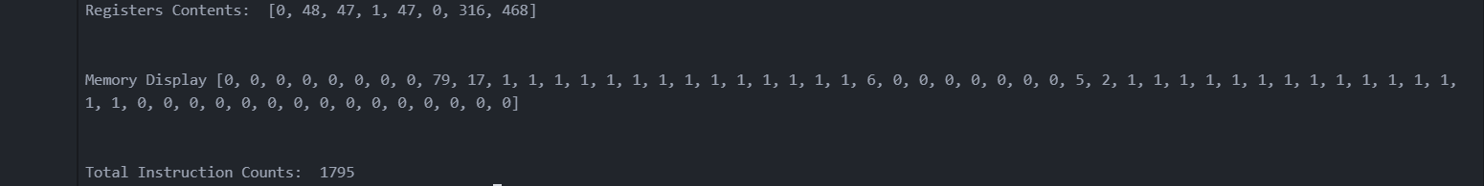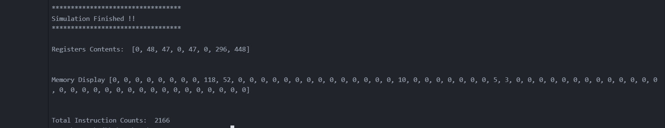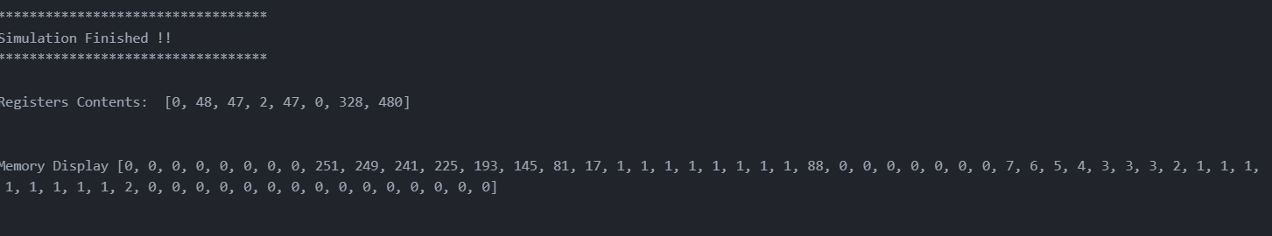

*ASSEMBLY FILE FOR ALL OF THE SEEDS:*

.asm for s3

Init 3

add R1,R0

add R3,R0

addi R4,3

addi R4,3

addi R4,2

store R1,R4

init 1

add R2,R0

mark R6

slt R2,R1

beq R0,3

add R3,R1

addi R2,1

Jump R6

add R0,R3

addi R4,1

Split R1,R3

dc R1,R3

xor R1,R1

add R1,R0

store R1,R4

init 7

xor R2,R2

add R2,R0

add R2,R2

add R2,R0

addi R2,2

slt R4,R2

beq R0,5

xor R2,R2

addi R2,1

xor R3,R3

add R3,R1

Jump R6

xor R1,R1

xor R2,R2

xor R3,R3

init 7

add R1,R0

Mark R7

addi R1,1

load R2,R1

add R3,R2

init 7

add R0,R0

xor R2,R2

add R2,R0

addi R2,3

addi R2,3

addi R2,3

slt R1,R2

beq R0,1

Jump R7

addi R1,1

srl R3,3

srl R3,1

store R3,R1

addi R4,3

addi R4,3

addi R4,2

xor R2,R2

addi R2,3

addi R2,3

addi R2,2

load R1,R2

xor R2,R2

Mark R6

PC 272 sand R0,R1

beq R0,3

srl R1,1

beq R1,3

Jump R6

addi R2,1

srl R1,1

beq R1,1

Jump R6

xor R3,R3

addi R4,1

store R2,R4

xor R1,R1

init 7

add R0,R0

add R1,R0

addi R1,3

addi R1,3

addi R1,3

addi R1,1

xor R0,R0

add R0,R1

Sub R1,R4

addi R1,1

Sub R0,R1

beq R0,3

load R1,R1

xor R2,R2

Jump R6

xor R1,R1

xor R2,R2

xor R3,R3

init 7

add R0,R0

add R0,R0

add R1,R0

addi R1,3

Mark R7

addi R1,1

load R2,R1

add R3,R2

init 7

add R0,R0

add R0,R0

xor R2,R2

add R2,R0

addi R2,3

addi R2,3

addi R2,3

addi R2,3

addi R2,3

addi R2,3

addi R2,1

slt R1,R2

beq R0,1

Jump R7

addi R1,1

srl R3,3

srl R3,1

store R3,R1

.ASM for 79

init 7

add R0,R0

add R0,R0

add R0,R0

add R1,R0

addi R1,3

addi R1,3

addi R1,3

addi R1,3

addi R1,3

addi R1,3

addi R1,3

addi R1,2

add R3,R1

addi R4,3

addi R4,3

addi R4,2

store R1,R4

init 1

add R2,R0

mark R6

slt R2,R1

beq R0,3

add R3,R1

addi R2,1

Jump R6

add R0,R3

addi R4,1

Split R1,R3

dc R1,R3

xor R1,R1

add R1,R0

store R1,R4

init 7

xor R2,R2

add R2,R0

add R2,R2

add R2,R0

addi R2,2

slt R4,R2

beq R0,5

xor R2,R2

addi R2,1

xor R3,R3

add R3,R1

Jump R6

xor R1,R1

xor R2,R2

xor R3,R3

init 7

add R1,R0

Mark R7

addi R1,1

load R2,R1

add R3,R2

init 7

add R0,R0

xor R2,R2

add R2,R0

addi R2,3

addi R2,3

addi R2,3

slt R1,R2

beq R0,1

Jump R7

addi R1,1

srl R3,3

srl R3,1

store R3,R1

addi R4,3

addi R4,3

addi R4,2

xor R2,R2

addi R2,3

addi R2,3

addi R2,2

load R1,R2

xor R2,R2

Mark R6

sand R0,R1

beq R0,3

srl R1,1

beq R1,3

Jump R6

addi R2,1

srl R1,1

beq R1,1

Jump R6

xor R3,R3

addi R4,1

store R2,R4

xor R1,R1

init 7

add R0,R0

add R1,R0

addi R1,3

addi R1,3

addi R1,3

addi R1,1

xor R0,R0

add R0,R1

Sub R1,R4

addi R1,1

Sub R0,R1

beq R0,3

load R1,R1

xor R2,R2

Jump R6

xor R1,R1

xor R2,R2

xor R3,R3

init 7

add R0,R0

add R0,R0

add R1,R0

addi R1,3

Mark R7

addi R1,1

load R2,R1

add R3,R2

init 7

add R0,R0

add R0,R0

xor R2,R2

add R2,R0

addi R2,3

addi R2,3

addi R2,3

addi R2,3

addi R2,3

addi R2,3

addi R2,1

slt R1,R2

beq R0,1

Jump R7

addi R1,1

srl R3,3

srl R3,1

store R3,R1

.ASM for 118

init 7

add R0,R0

add R0,R0

add R0,R0

add R0,R0

add R1,R0

addi R1,3

addi R1,3

add R3,R1

addi R4,3

addi R4,3

addi R4,2

store R1,R4

init 1

add R2,R0

mark R6

slt R2,R1

beq R0,3

add R3,R1

addi R2,1

Jump R6

add R0,R3

addi R4,1

Split R1,R3

dc R1,R3

xor R1,R1

add R1,R0

store R1,R4

init 7

xor R2,R2

add R2,R0

add R2,R2

add R2,R0

addi R2,2

slt R4,R2

beq R0,5

xor R2,R2

addi R2,1

xor R3,R3

add R3,R1

Jump R6

xor R1,R1

xor R2,R2

xor R3,R3

init 7

add R1,R0

Mark R7

addi R1,1

load R2,R1

add R3,R2

init 7

add R0,R0

xor R2,R2

add R2,R0

addi R2,3

addi R2,3

addi R2,3

slt R1,R2

beq R0,1

Jump R7

addi R1,1

srl R3,3

srl R3,1

store R3,R1

addi R4,3

addi R4,3

addi R4,2

xor R2,R2

addi R2,3

addi R2,3

addi R2,2

load R1,R2

xor R2,R2

Mark R6

sand R0,R1

beq R0,3

srl R1,1

beq R1,3

Jump R6

addi R2,1

srl R1,1

beq R1,1

Jump R6

xor R3,R3

addi R4,1

store R2,R4

xor R1,R1

init 7

add R0,R0

add R1,R0

addi R1,3

addi R1,3

addi R1,3

addi R1,1

xor R0,R0

add R0,R1

Sub R1,R4

addi R1,1

Sub R0,R1

beq R0,3

load R1,R1

xor R2,R2

Jump R6

xor R1,R1

xor R2,R2

xor R3,R3

init 7

add R0,R0

add R0,R0

add R1,R0

addi R1,3

Mark R7

addi R1,1

load R2,R1

add R3,R2

init 7

add R0,R0

add R0,R0

xor R2,R2

add R2,R0

addi R2,3

addi R2,3

addi R2,3

addi R2,3

addi R2,3

addi R2,3

addi R2,1

slt R1,R2

beq R0,1

Jump R7

addi R1,1

srl R3,3

srl R3,1

store R3,R1

.ASM for 251

init 7

add R0,R0

add R0,R0

add R0,R0

add R0,R0

add R0,R0

add R1,R0

addi R1,3

addi R1,3

addi R1,3

addi R1,3

addi R1,3

addi R1,3

addi R1,3

addi R1,3

addi R1,3

add R3,R1

addi R4,3

addi R4,3

addi R4,2

store R1,R4

init 1

add R2,R0

mark R6

slt R2,R1

beq R0,3

add R3,R1

addi R2,1

Jump R6

add R0,R3

addi R4,1

Split R1,R3

dc R1,R3

xor R1,R1

add R1,R0

store R1,R4

init 7

xor R2,R2

add R2,R0

add R2,R2

add R2,R0

addi R2,2

slt R4,R2

beq R0,5

xor R2,R2

addi R2,1

xor R3,R3

add R3,R1

Jump R6

xor R1,R1

xor R2,R2

xor R3,R3

init 7

add R1,R0

Mark R7

addi R1,1

load R2,R1

add R3,R2

init 7

add R0,R0

xor R2,R2

add R2,R0

addi R2,3

addi R2,3

addi R2,3

slt R1,R2

beq R0,1

Jump R7

addi R1,1

srl R3,3

srl R3,1

store R3,R1

addi R4,3

addi R4,3

addi R4,2

xor R2,R2

addi R2,3

addi R2,3

addi R2,2

load R1,R2

xor R2,R2

Mark R6

sand R0,R1

beq R0,3

srl R1,1

beq R1,3

Jump R6

addi R2,1

srl R1,1

beq R1,1

Jump R6

xor R3,R3

addi R4,1

store R2,R4

xor R1,R1

init 7

add R0,R0

add R1,R0

addi R1,3

addi R1,3

addi R1,3

addi R1,1

xor R0,R0

add R0,R1

Sub R1,R4

addi R1,1

Sub R0,R1

beq R0,3

load R1,R1

xor R2,R2

Jump R6

xor R1,R1

xor R2,R2

xor R3,R3

init 7

add R0,R0

add R0,R0

add R1,R0

addi R1,3

Mark R7

addi R1,1

load R2,R1

add R3,R2

init 7

add R0,R0

add R0,R0

xor R2,R2

add R2,R0

addi R2,3

addi R2,3

addi R2,3

addi R2,3

addi R2,3

addi R2,3

addi R2,1

slt R1,R2

beq R0,1

Jump R7

addi R1,1

srl R3,3

srl R3,1

store R3,R1