processingEMG

Sjur Ofsteng

31 januar 2018

# Change emg to emg object  
emg.x <- emg$VLL #   
length(emg.x)

## [1] 1415

emgraw <- as.emg(emg.x, samplingrate = 1500, units = "mV", date.name = "VLL") # sampling rate 1500Hz to avoid signal loss  
is.emg(emgraw) # EMG object check

## [1] TRUE

plot(emgraw, main = "Raw EMG signal")

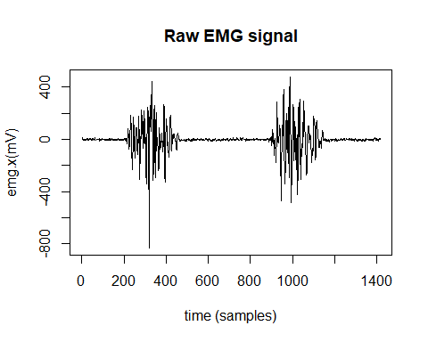

# High pass filter  
x <- highpass(emgraw, cutoff = 20) # 20 Hz recommended for sport activities (maybe as much as 30 Hz)  
emghpass <- rectification(x)  
  
plot(x, main = "High pass filter")

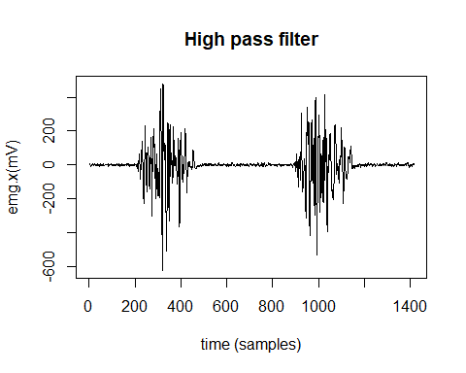

plot(emghpass, main = "High pass filter with rectification")

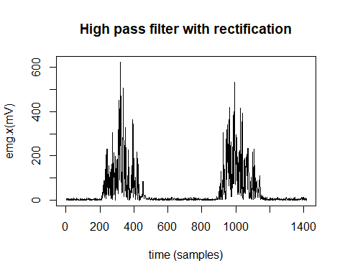

#EMG RMS (preferred recommendation for smoothing)  
emgrms <- envelope(emghpass, method = "RMS", wsize = 100) # wsize; 100 ms, most common for all conditions  
plot(emgrms, main = "RMS-envelope")

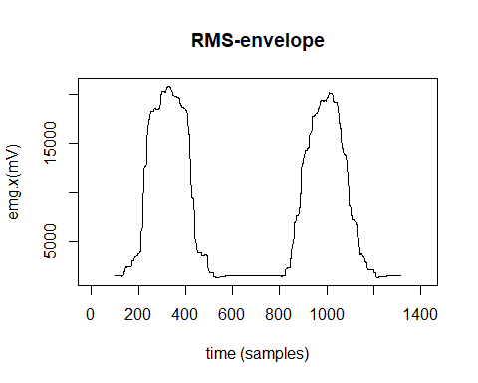

#EMG Moving average  
emgrms <- envelope(emghpass, method = "MA", wsize = 100) # wsize; 100 ms, most common for all conditions  
plot(emgrms, main = "MA-envelope")

