There’s Gold in Them Thar Stack Traces

Christopher Theisen and Laurie Williams

North Carolina State University

Researchers have begun mining data from stack traces of software crashes for a variety of fault localization purposes. Stack traces in the context of software crashes are a record of the active stack frames, or code, active during the time period of the crash. Liblit and Aiken [1] use stack traces from crashes to build “timelines” of the possible actions a piece of software took right before a crash took place. By stepping backwards through the call stack from crashes and building a map of possible paths, the researchers can then summarize the set of nodes common to a set of crashes to determine the possibly flawed path. Paths that appear frequently in multiple crashes are suspects for containing faults.

Wu et al. [2] developed a tool called CrashLocator, which can help practitioners locate a faulty function based on stack traces from crashes of the system under test. By combining the stack traces with information from the static call graph of the system, the tool determines which functions are appearing most frequently in the set of crashes and provides this information to the user. The more often a function appears in crashes, the more likely a fault exists in that function.

**Another use of stack traces?**

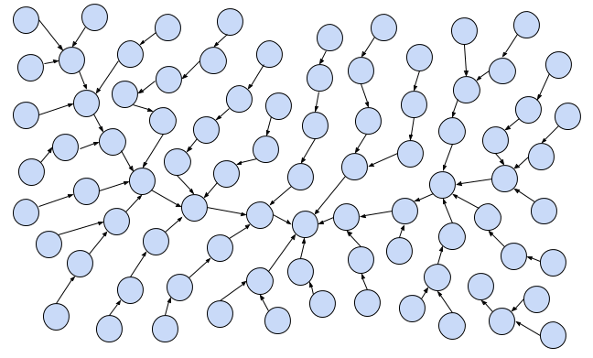

Figure 1: A tangled web of files

Take a look at Figure 1. This graph represents a software system, with individual nodes representing code elements (such as binaries, files, or functions). This graph is pretty dense and difficult to parse, right? If you look at a software system with no prior knowledge and attempt to dive in to find vulnerabilities, you’ll feel a similar level of confusion. To combat that effect, security professionals have developed the concept of an attack surface.

Ok, so what is the attack surface? OWASP defines it as the paths in and out of a system, the data that travels those paths, and the code that protects both. In short; if a someone or something outside the system can send some data through it, it’s on the attack surface. That’s a pretty useful definition to busy security engineers. By focusing on code considered to be on the attack surface, they can prioritize their security hardening efforts, like code review and refactoring, on the code exposed to the outside. That’s more important than hardening code in your internal test suites or unreachable areas of your code.

While that all sounds good, explicitly defining the attack surface of a software system is hard. Traditionally, defining the attack surface has meant a lot of manual effort on the part of the security teams. That’s obviously an issue because you want those resources tied up as little as possible. There have been efforts to automate this process, but those efforts were limited to API scanning techniques and the like; they don’t capture the depth areas of the attack surface beyond the API. What sort of new metrics could we use to determine what code in a system is relevant for security professionals? Stack traces, maybe?

Stack traces may have several useful properties for security professionals. They represent user activity that puts the system under stress, and they also allow the security professional to get inside the head of attackers. When attackers are looking for ways into a system, one common technique is to try to get the system to crash, creating a denial-of-service. Not only do crashes indicate where data handling may have flaws, it also gives the attacker more information on code flow within the system they’re attacking.

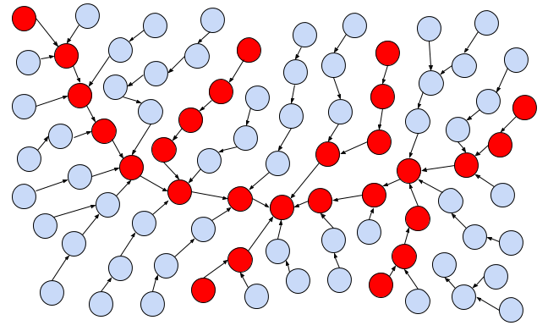

Figure 2: Making some sense of the tangled web, color files that appear in stack traces

**Attack Surface Approximation**

Researchers at North Carolina State University and Microsoft Research have developed a technique called *Attack Surface Approximation* [3]. In this approach, the attack surface of a system is determined by looking at stack traces from crash dumps from the target system. The crash dump stack traces are parsed out into the individual code elements that are seen on each stack trace. Depending on the stack trace in question, these elements could be binaries, files or functions. Any code element that is seen on at least one stack trace is considered to be on the attack surface of the system, as determined by this approach. Put another way, we color nodes from our original graph red if they are seen in at least one stack trace, as seen in the figure above. Researchers also explored other metrics, such as the frequency of appearance of code elements, how often code elements appear next to each other, and the shapes that form within the graph representation of the stack traces.

Early results from research into *Attack Surface Approximation* have yielded interesting results. In a study on Windows 8, 48.4% of shipped binaries were identified as appearing in at least one stack trace, while 94.8% of vulnerabilities fixed over the same time period appeared in that same 48.4% of binaries. Busy security professionals, can uses this information to focus their security testing and hardening efforts on half of the codebase while getting 95% of the vulnerabilities. Attack surface approximation has also been performed on Mozilla Firefox, with 8.4% of files appearing in at least one stack trace. 72.1% of vulnerabilities occurred in the files placed on the attack surface [4].

One of the advantages of this approach is its simplicity. If your software system outputs any sort of stack trace when it fails, this approach could apply to you! No additional metrics are necessary to see practical returns; parsing out individual code elements from your stack trace dataset is enough to build your list of code on the attack surface. For organizations without extensive resources, attack surface approximation is a useful first step for determining where to start security hardening efforts.

References:

[1]  B. Liblit and A. Aiken, "Building a Better Backtrace: Techniques for Postmortem Program Analysis," University of California, Berkeley, Berkeley, 2002.

[2]  R. Wu, H. Zhang, S.-C. Cheung and S. Kim, "CrashLocator: Locating Crashing Faults Based on Crash Stacks," in Proceedings of the 2014 International Symposium on Software Testing and Analysis, 2014.

[3] C. Theisen, K. Herzig, P. Morrison, B. Murphy, and L. Williams, “Approximating Attack Surfaces with Stack Traces”, in *Companion Proceedings of 37th International Conference on Software Engineering,* 2015.

[4] C. Theisen, R. Krishna, and L. Williams, “Strengthening the Evidence that Attack Surfaces can be Approximated with Stack Traces”, NCSU Technical Report