
Project work submission to
Osmania University, Hyderabad.
In partial fulfilment of the requirement
for the award of the degree of
BACHELOR’S DEGREE IN COMPUTER APPLICATION
2023-2026
FAKE NEWS DETECTION
Submitted by:
Syeda Juwairiyah Anjum 115623861032

Under the Guidance of:
Mrs.Navaneetha

PRAGATHI DEGREE COLLEGE FOR WOMEN,Dilshuknagar.
(AFFILATED TO OSMANIA UNIVERSITY)

CERTIFICATE

This is certified that Syeda Juwairiyah Anjum are Bonafide student of BCA in this college during the academic year 2023-2026. They have done their project work entitled “FAKE NEWS DETECTION”.
They have completed their project work partial fulfilment of the requirement for the awards of BACHELOR’S DEGREE IN COMPUTER APPLICATION from the college, which is affiliated to Osmania University, Hyderabad.

HEAD OF THE DEPARTMENT PRINCIPAL

EXTERNAL EXAMINER

DECLARATION

We are here by declaring that this project report titled “FAKE NEWS DETECTION ” has been prepared by us as part of requirement of “BACHELOR’S DEGREE IN COMPUTER APPLICATION” and this study is our original project report.
We are the students of “PRAGATHI DEGREE & PG COLLEGE FOR WOMEN” pursuing the “BACHELOR’S DEGREE IN COMPUTER APPLICATION”.
The findings and suggestions in this work are based on the information collected by me:
Syeda Juwairiyah Anjum
115623861032

CERTIFICATION OF GUIDE

This is to certify that the project work entitled “FAKE NEWS DETECTION” submitted in partial fulfilment for the award of BACHELOR’S DEGREE IN COMPUTER APPLICATION from the department of this college of Osmania University, Hyderabad was carried out by Syeda Juwairiyah Anjum under our guidance.
This report is original and has not been submitted to any other university or institution for award of any degree certificate in part or full.

Name of the guide: Mrs. Navaneetha

Signature of the guide:

ACKNOWLEDGEMENT

We take this opportunity to remember and acknowledge the cooperation extended by several individuals out of whom this project has evolved and will always cherish our association with them. We owe our sincere thanks to our principal Mrs. Manju Reddy madam and our vice principal Mrs.Jyothi madam who has been a source of inspiration and the encouragement given for the accomplishment of the project.
We owe our gratitude to the faculty of INFORMATICS department
Mrs. Navaneetha for their vital role and significant during this project.
Our verbal abilities limit the expression of heartfelt feelings towards our faculties and guides who have been giving us hope and encouraging to accomplish this project.

Syeda Juwairiyah Anjum
115623861032

ABSTRACT

Fake news detection has become a major challenge in today’s digital world due to the rapid spread of misinformation through online platforms. This project focuses on detecting whether a news article is real or fake using Natural Language Processing (NLP) techniques. The system is developed using a dataset containing news text, headlines, and labels indicating authenticity.
Text preprocessing techniques such as cleaning, tokenization, and vectorization are applied to convert the raw text into a structured format. A machine learning classification algorithm such as Logistic Regression or Naïve Bayes is then used to train the model and predict the authenticity of news articles.
The proposed model achieves good accuracy and helps in automatically identifying misleading or false information, reducing human effort. This system can be useful for social media platforms, news agencies, and individuals to verify the credibility of news content. Overall, this project demonstrates the effective use of NLP and machine learning in solving real-world problems related to fake news detection.

CONTENT
S.NO TITLE PAGE NO
1. Introduction 1

1.1 Background of the study
1.2 Problem Statement
1.3 Objectives of the project
1.4 Scope of the project
2. Literature Survey 4

2.1 Introduction
2.2 Existing System
2.3 Limitation of Existing System
2.4 Proposed System
2.5 Advantages of proposed system
3. Requirement 6

3.1 Introduction
3.2 System Requirements
3.3 Hardware Requirements
3.4 Software Requirements
4. System Design 8

4.1 Introduction
4.2 Block Diagram
4.3 Flow Chart
4.4 Use case Diagram
4.5 Activity Diagram
5. System Environment 17

5.1 Python
5.2 Anaconda
5.3 Jupyter Notebook
5.4 Visual Studio Code
5.5 Streamlit

6. Methodology

6.1 Introduction
6.2 Algorithm Process-Classification
6.3 Libraries used in project
6.4 Dataset preparation and metadata information
6.5 Data preprocessing
6.6 Model training
6.7 Improve performance of classifier (Evaluation)
6.8 Getting your Machine Ready
7. Implementation 25

7.1 Introduction
7.2 Structure of streamlit application
7.3 Dataset preparation
7.4 Model Building
7.5 Algorithm used in the project
7.6 Source Code
8. Testing and Validation 41

8.1 Introduction
8.2 Black box testing
8.3 Test Strategy and Approach
8.4 Test cases and scenarios
9. Conclusion 43

10. Future Scope 44

11. Result and Discussion 45

11.1 Introduction
11.2 Model performance Evaluation
11.3 Confusion Matrix Analysis
11.4 Feature importance Analysis

CHAPTER 1: INTRODUCTION

1.1 Background of the Study
In the digital age, the rapid growth of the internet and social media platforms has significantly increased the spread of information. While this has made access to news easier and faster, it has also led to the widespread dissemination of fake news—misleading or false information presented as legitimate news. Fake news can have serious consequences, including influencing public opinion, spreading misinformation, and even impacting political and economic stability.
Traditional methods of verifying news rely on human fact-checking, which is time-consuming and not scalable given the vast amount of content generated daily. As a result, there is a growing need for automated systems that can detect fake news efficiently and accurately.
Machine learning and natural language processing (NLP) have emerged as powerful tools for analyzing textual data. These techniques can identify patterns, linguistic features, and contextual cues that distinguish fake news from real news. By training models on labeled datasets, it is possible to develop systems that can classify news articles automatically.
In this project, a Fake News Detection System is developed using TF-IDF (Term Frequency-Inverse Document Frequency) and Support Vector Machine (SVM). TF-IDF is used to convert textual data into numerical features by capturing the importance of words in a document. SVM, a supervised machine learning algorithm, is then used to classify the news as fake or real.
The dataset used in this project contains thousands of news articles labeled as either FAKE or REAL. The data is preprocessed to remove noise, normalize text, and extract meaningful features. The model is trained on this processed data and evaluated using accuracy and classification metrics.
After training, the model is saved and integrated into a Streamlit web application, allowing users to input news text and receive real-time predictions. This makes the system accessible and easy to use.
The project demonstrates how machine learning can be applied to solve real-world problems like misinformation. It highlights the importance of automated systems in maintaining information integrity in the digital era.

1.2 Problem Statement
The rapid spread of fake news through online platforms poses a significant threat to society. It can mislead people, influence decisions, and create confusion. Traditional methods of detecting fake news rely on manual verification, which is slow and inefficient.
There is a need for an automated system that can analyze news content and accurately classify it as fake or real. The challenge lies in processing large volumes of textual data and identifying patterns that distinguish fake news from genuine information.
This project aims to address this problem by developing a machine learning-based fake news detection system using TF-IDF and Support Vector Machine (SVM). The system provides real-time predictions through a Streamlit interface, enabling users to verify news quickly and efficiently.

1.3 Objectives of the Project
To develop a fake news detection system using machine learning
To apply TF-IDF for text feature extraction
To use SVM for classification
To preprocess textual data effectively
To achieve high accuracy in prediction
To build a Streamlit-based user interface
To enable real-time news verification

1.4 Scope of the Project
The scope of this project includes the development of an automated system for detecting fake news using natural language processing and machine learning techniques. The system analyzes textual content and classifies it into fake or real categories.
It is suitable for academic purposes, research applications, and basic real-world usage. The Streamlit interface allows users to input news text and receive predictions instantly.
However, the system is limited to the dataset used for training and may not generalize perfectly to all types of news. It also does not consider multimedia content such as images or videos.
Future improvements can include advanced NLP models, multilingual support, and integration with social media platforms.

CHAPTER 2: LITERATURE SURVEY

2.1 Introduction
Fake news detection has become an important research area due to the rise of misinformation. Various machine learning and NLP techniques have been used to identify fake news. This chapter reviews existing approaches, their limitations, and the advantages of the proposed system.

2.2 Existing System
Traditional fake news detection methods rely on manual fact-checking and verification by experts. These methods are accurate but time-consuming and not scalable.
Some systems use keyword-based filtering and rule-based approaches. However, these methods fail to capture the context and complexity of language.
Machine learning models such as Naive Bayes and Logistic Regression have been used for text classification. While effective, these models may not perform well on complex datasets.
Recent approaches use deep learning models, but they require large computational resources and extensive training data.
Overall, existing systems face challenges in scalability, accuracy, and real-time performance.

2.3 Limitations of Existing Systems
1.Time-consuming manual verification
2.Limited scalability
3.Poor contextual understanding
4.High computational requirements (deep learning)
5.Limited accuracy in simple models
6.Lack of real-time prediction

2.4 Proposed System
The proposed system uses a machine learning approach combining TF-IDF and Support Vector Machine (SVM) for fake news detection. TF-IDF converts textual data into numerical form by measuring word importance, while SVM performs classification based on these features.
The system preprocesses text by removing noise, converting to lowercase, and eliminating irrelevant characters. The processed text is transformed into TF-IDF vectors and passed to the SVM model for prediction.
The trained model is integrated into a Streamlit application, allowing users to input news text and receive instant predictions. This approach ensures efficiency, accuracy, and scalability.

2.5 Advantages of Proposed System

High accuracy using SVM
Efficient text processing with TF-IDF
Real-time prediction capability
Simple and user-friendly interface
Scalable and efficient

CHAPTER 3: REQUIREMENT SPECIFICATION

3.1 Introduction
Requirement specification defines the hardware and software components required to develop and run the Fake News Detection System. It ensures efficient processing of textual data, model training, and real-time prediction through the Streamlit application.

3.2 System Architecture
Architecture Components:
- Data Collection Layer
- Text Preprocessing Layer
- Feature Extraction (TF-IDF) Layer
- Model Training Layer (SVM)
- Prediction Layer
- User Interface (Streamlit)

Description
The system architecture follows a pipeline structure for efficient text classification. The Data Collection Layer loads the dataset containing news articles and labels. The Text Preprocessing Layer cleans the data by removing unwanted characters, URLs, and converting text to lowercase.
The Feature Extraction Layer uses TF-IDF to convert text into numerical vectors. These vectors represent the importance of words in the dataset.
The Model Training Layer uses the Support Vector Machine (SVM) algorithm to train a classifier based on extracted features. The trained model is then saved for future use.
The Prediction Layer processes new input text and generates predictions. Finally, the User Interface Layer built with Streamlit allows users to input news text and view results in real time. This architecture ensures accuracy and efficiency.

3.3 Hardware Requirements
- Processor : Intel Core i3 or higher
- RAM : Minimum 4 GB
- Storage : 10 GB free disk space
- Network : Internet connection required (for deployment)
- System Architecture : 64-bit system

3.4 Software Requirements (Based on Code)

- Operating System : Windows / Linux / macOS
- Programming Language : Python 3.x
- Libraries Used:
- Pandas → Data handling and preprocessing
- NumPy → Numerical computations
- Scikit-learn → TF-IDF and SVM model
- Seaborn & Matplotlib → Data visualization
- Pickle → Model saving/loading
- Streamlit → Web application
- Development Tools:
- Jupyter Notebook (model training)
- Anaconda (environment management)
- Visual Studio Code (code editor)

CHAPTER 4: SYSTEM DESIGN

4.1 Introduction
System design defines how the Fake News Detection System processes text data and generates predictions. The design focuses on accuracy, efficiency, and real-time usability.
The system is structured as a modular pipeline where each component performs a specific task. The input module collects news text either from the dataset or user input. The preprocessing module cleans and standardizes the text to ensure consistency.
The feature extraction module converts text into numerical form using TF-IDF. This step is crucial for enabling machine learning algorithms to process textual data effectively.
The classification module uses the Support Vector Machine (SVM) algorithm to classify news as fake or real. SVM is chosen for its ability to handle high-dimensional data and provide accurate results.
The prediction module processes new input text and generates classification results. The Streamlit interface provides a user-friendly platform for interaction, allowing users to input text and view results instantly.
The design ensures scalability and allows future enhancements such as integrating advanced NLP models or expanding the dataset.

4.2 Block Diagram
1. Blocks to Draw:
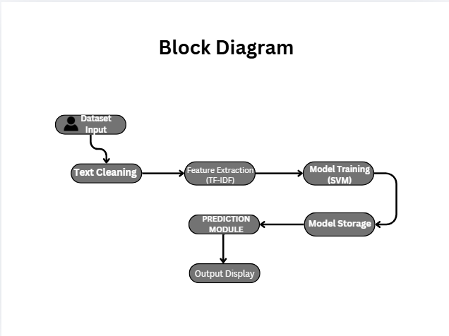

Explanations:
1. Data Input:
This block represents loading the dataset or receiving user input text for processing.
2. Text Cleaning:
Removes noise such as URLs, special characters, and converts text to lowercase.

3. Feature Extraction:
Transforms text into TF-IDF vectors representing word importance.
4. Model Training:
Trains the SVM model using processed data.

5. Model Storage:
Saves the trained model and vectorizer using pickle.
6. Prediction Module:
Processes new input text and generates predictions.
7. Output Display:
Displays whether the news is fake or real.

4.3 Flow Chart
Flow Steps:
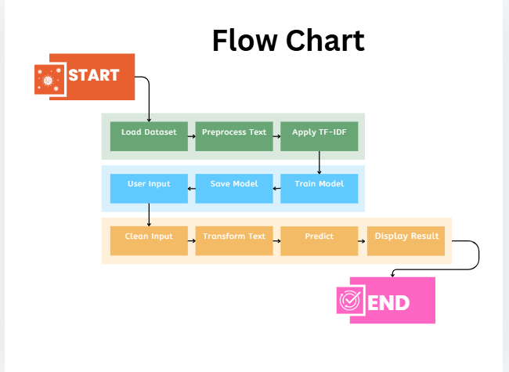

4.4 Use Case Diagram
Actors & Use Cases:

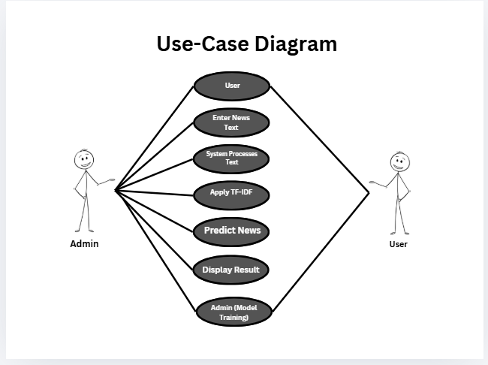

Explanation (example):
User:
The user inputs news text into the system and receives prediction results.
System Processes Text:
The system cleans and transforms the text before prediction.

4.5 Activity Diagram
Steps:
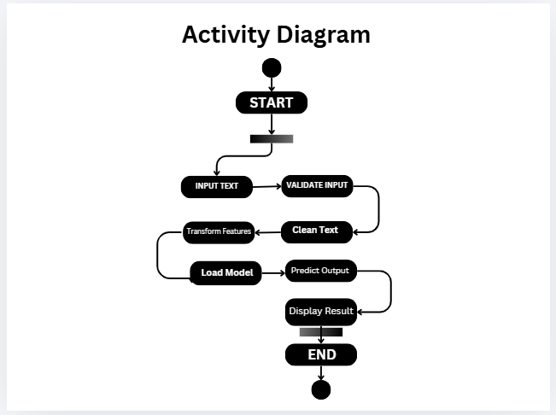

Explanation (example):
Clean Text:
Removes unwanted characters and standardizes the input text.
Predict Output:
The model classifies the text as fake or real.

CHAPTER 5: SYSTEM ENVIRONMENT

5.1 Python
Python is a high-level, interpreted programming language widely used in data science, machine learning, and natural language processing. Its simplicity, readability, and vast ecosystem of libraries make it an ideal choice for developing intelligent systems.
In this project, Python is used as the core programming language to implement the Fake News Detection System. It is responsible for data preprocessing, feature extraction, model training, and prediction. Libraries such as Pandas and NumPy are used for handling structured data, while Scikit-learn is used for implementing machine learning algorithms.
Python also supports text processing through built-in functions and regular expressions, which are used to clean and normalize news articles. Additionally, Python allows easy integration with Streamlit, enabling the development of an interactive web application.
The flexibility and efficiency of Python make it suitable for building scalable and reliable machine learning systems.

5.2 Anaconda
Anaconda is an open-source distribution designed for data science and machine learning applications. It simplifies package management and environment setup, which is essential for handling dependencies in complex projects.
In this project, Anaconda can be used to create a virtual environment where all required libraries such as Pandas, NumPy, Scikit-learn, and Streamlit are installed. This ensures that the project runs smoothly without version conflicts.
Anaconda Navigator provides a graphical interface for managing environments and launching tools like Jupyter Notebook. It also includes Conda, a powerful package manager that allows easy installation and updating of libraries.
Using Anaconda improves reproducibility and stability, making it easier to develop and deploy the fake news detection system.

5.3 Jupyter Notebook
Jupyter Notebook is an interactive environment widely used for data analysis and machine learning development. It allows developers to write and execute code in a cell-based format, making it easy to test and debug.
In this project, Jupyter Notebook is used for dataset exploration, preprocessing, feature extraction, and model training. It enables visualization of data distributions and evaluation metrics.
The notebook environment supports step-by-step execution, which helps in understanding the workflow and identifying errors. It also allows documentation alongside code, making it easier to explain the project.
Jupyter Notebook enhances productivity and provides a flexible platform for developing machine learning models.

5.4 Visual Studio Code
Visual Studio Code (VS Code) is a lightweight yet powerful code editor widely used for software development. It supports multiple programming languages and provides features such as syntax highlighting, debugging, and extensions.
In this project, VS Code is used for writing and managing the Streamlit application and prediction scripts. It provides Python extensions that improve code readability and debugging efficiency.
The integrated terminal allows developers to run scripts and execute commands directly within the editor. VS Code also supports version control systems like Git, enabling better project management.
Its flexibility and user-friendly interface make it suitable for developing and maintaining the fake news detection system.

5.5 Streamlit
Streamlit is an open-source Python framework used for building interactive web applications for data science and machine learning projects. It allows developers to create user interfaces quickly without requiring advanced web development skills.
In this project, Streamlit is used to develop a Fake News Detection application. Users can input news text into a text area and click a button to get predictions.
Streamlit provides components such as text input fields, buttons, and output displays, making it easy to design interactive applications. It also supports real-time updates, ensuring a smooth user experience.
The simplicity and efficiency of Streamlit make it an ideal choice for deploying machine learning models.

CHAPTER 6: METHODOLOGY

6.1 Introduction
The methodology of this project focuses on developing a machine learning-based system for detecting fake news using textual data. The process involves data collection, preprocessing, feature extraction, model training, evaluation, and deployment.
The dataset contains news articles labeled as fake or real. The first step involves cleaning the dataset by removing unnecessary columns and handling missing values. The text data is then preprocessed to remove noise such as URLs, special characters, and extra spaces.
Feature extraction is performed using TF-IDF, which converts text into numerical vectors based on word importance. This allows the machine learning model to process textual data effectively.
The dataset is split into training and testing sets to evaluate model performance. A Support Vector Machine (SVM) classifier is trained on the processed data.
After training, the model is evaluated using accuracy, classification report, and confusion matrix. The trained model and vectorizer are saved using pickle.
Finally, the model is integrated into a Streamlit application, allowing users to input news text and receive predictions in real time. This methodology ensures efficiency and accuracy.

6.2 Algorithm Process – Classification
The classification process in this project is based on the Support Vector Machine (SVM) algorithm, a supervised machine learning technique used for classification tasks.
The process begins with text preprocessing, where input text is cleaned and normalized. The cleaned text is then transformed into TF-IDF vectors, which represent the importance of words in the document.
The SVM algorithm constructs a hyperplane that separates data points into different classes. In this case, it classifies news as fake or real.
The model is trained using labeled data, allowing it to learn patterns associated with each class. During prediction, the model processes new input text and determines its class based on learned patterns.
SVM is particularly effective for high-dimensional data, making it suitable for text classification tasks.

6.3 Libraries Used in the Project
This project uses several Python libraries for data processing, machine learning, and application development.
Pandas:
Used for data manipulation and analysis. It helps in loading datasets, handling missing values, and preparing data for training.
NumPy:
Used for numerical computations and array operations. It supports efficient handling of large datasets.
Scikit-learn:
Provides tools for machine learning, including TF-IDF vectorization, SVM classification, and model evaluation.
TfidfVectorizer:
Converts text data into numerical vectors based on word importance.
LinearSVC:
Implements the Support Vector Machine algorithm for classification.
Matplotlib & Seaborn:
Used for data visualization, including confusion matrix plots.
Pickle:
Used for saving and loading trained models and vectorizers.
Streamlit:
Used to build the user interface for the application.
These libraries work together to implement the complete pipeline efficiently.

6.4 Dataset Preparation and Metadata Information
The dataset used in this project contains approximately 6,335 news articles labeled as FAKE or REAL. It includes columns such as title, text, and label.
The dataset is balanced, with nearly equal distribution of fake and real news. This ensures fair training of the model.
The data is split into training and testing sets to evaluate performance. The dataset is structured to support efficient preprocessing and feature extraction.

6.5 Data Preprocessing
Data preprocessing is essential for improving model accuracy. The text data is cleaned by converting it to lowercase, removing URLs, special characters, and extra spaces.
Stop words are removed to reduce noise. The cleaned text is then transformed into TF-IDF vectors.
The dataset is split into training and testing sets to ensure proper evaluation. These steps ensure that the data is suitable for machine learning.

6.6 Model Training
The model is trained using the LinearSVC algorithm. The training data is transformed into TF-IDF vectors and used to fit the model.
The model learns patterns associated with fake and real news. After training, it is evaluated and saved for future use.

6.7 Improve Performance of Classifier (Evaluation)
The model achieves approximately 94% accuracy. Evaluation metrics such as precision, recall, and F1-score confirm its performance.
The confusion matrix shows strong classification results. Proper preprocessing and feature extraction improve performance.

6.8 Getting Your Machine Ready
Install required libraries:
pip install pandas numpy scikit-learn streamlit seaborn matplotlib
Run the app:
streamlit run app.py
Ensure model files are in the correct folder.

CHAPTER 7: IMPLEMENTATION

7.1 Introduction
The implementation phase focuses on developing the Fake News Detection System using machine learning techniques and integrating it into a real-time application. This phase includes data preprocessing, feature extraction, model training, evaluation, and deployment using Streamlit.
Initially, the dataset is loaded and analyzed to understand its structure and distribution. The text data is cleaned by removing unwanted characters, URLs, and converting all text to lowercase. This preprocessing ensures consistency and improves model performance.
Feature extraction is performed using TF-IDF, which converts text into numerical vectors representing the importance of words. These vectors are used as input for the machine learning model.

The Support Vector Machine (SVM) algorithm is used to train the model. The dataset is split into training and testing sets to evaluate performance. After training, the model is saved using pickle for reuse.
A prediction function is implemented to process new input text and generate predictions. Finally, a Streamlit application is developed to provide an interactive interface where users can input news text and receive predictions in real time.

7.2 Structure of Streamlit Applications
The Streamlit application is structured to provide a simple and interactive interface for users. It follows a modular approach where each section of the code handles a specific task.
The application begins by importing required libraries such as Streamlit, pickle, and regular expressions. These libraries handle user interface, model loading, and text processing.
The trained TF-IDF vectorizer and SVM model are loaded using pickle. This allows the system to perform predictions without retraining the model.
A text cleaning function is defined to preprocess user input by removing unwanted characters and normalizing the text.
The user interface is built using Streamlit components such as st.title, st.text_area, and st.button. The text area allows users to input news content, while the button triggers the prediction process.
When the button is clicked, the input text is cleaned, transformed using TF-IDF, and passed to the SVM model for prediction. The result is displayed using st.success or st.error, providing clear feedback.
This structured design ensures smooth functionality and user-friendly interaction.

7.3 Dataset Preparation
Dataset preparation is a crucial step in implementing the Fake News Detection System. The dataset used contains thousands of news articles labeled as fake or real.
The dataset is loaded using Pandas and analyzed to understand its structure, including columns such as title, text, and label. Missing values are checked and handled to ensure data quality.
The text column is selected as the primary feature, while the label column is used as the target variable. The dataset is then split into training and testing sets using a train-test split approach. This ensures that the model is trained on one portion of the data and evaluated on another.
The training and testing datasets are saved separately for reuse. This improves efficiency and allows consistent evaluation.
The prepared dataset is then used for feature extraction and model training. Proper dataset preparation ensures accurate and reliable predictions.

7.4 Model Building
The model is built using the Linear Support Vector Machine (LinearSVC) algorithm. It is trained on TF-IDF features extracted from text data. The model is optimized to achieve high accuracy and effectively classify news as fake or real.

7.5 Algorithm Used in the Project
The primary algorithm used in this project is Support Vector Machine (SVM), specifically LinearSVC. It is a supervised learning algorithm used for classification tasks.
SVM works by finding a hyperplane that separates data points into different classes. In this project, it separates fake and real news based on TF-IDF features.
The algorithm is effective for high-dimensional data, making it suitable for text classification. It learns patterns from training data and applies them to classify new input text.
The combination of TF-IDF and SVM provides accurate and efficient classification, making it ideal for fake news detection.

7.6 Source Code
1. Import Libraries:
Imports Pandas, NumPy, Scikit-learn, pickle, and Streamlit for data processing, model training, and UI development.
2. Data Loading:
Loads dataset and displays structure and statistics.
3. Data Cleaning:
Removes noise and prepares text data.
4. Feature Extraction:
Applies TF-IDF to convert text into numerical features.
5. Model Training:
Trains SVM model using training data.
6. Model Saving:
Saves trained model and vectorizer using pickle.
7. Prediction Function:
Processes input text and generates predictions.
8. Streamlit UI:
Creates interface for user input.
9. Input Handling:
Accepts and validates user input.
10. Output Display:
Displays prediction result (Fake/Real).
import pandas as pd
import numpy as np
import seaborn as sns
from sklearn.model_selection import train_test_split
import pickle
import os
df=pd.read_csv('../data/data.csv')
def create_distribution(dataFile):
return sns.countplot(x='label', data=dataFile, palette='hls')
# Separate the labels and set up training and test datasets

# Get the labels
x=df['text']
y = df['label']
y.head()
df['label'].value_counts(normalize=True) * 100
#Split the dataset

from sklearn.model_selection import train_test_split
X_train, X_test, y_train, y_test = train_test_split(x, y, test_size=0.23, random_state=53)
X_train.to_csv("../data/X_train.csv", index=False)
y_train.to_csv("../data/y_train.csv", index=False)
X_test.to_csv("../data/X_test.csv", index=False)
y_test.to_csv("../data/y_test.csv", index=False)
print("Train/Val/Test split completed!\n")
print(f"X_train: {X_train.shape}, y_train: {y_train.shape}")
print(f"X_test: {X_test.shape}, y_test: {y_test.shape}")
print("\nFiles saved as:\n"
"X_train.csv, y_train.csv\n"
"X_test.csv, y_test.csv")
<class 'pandas.core.frame.DataFrame'> RangeIndex: 6335 entries, 0 to 6334 Data columns (total 4 columns): # Column Non-Null Count Dtype --- ------ -------------- ----- 0 Unnamed: 0 6335 non-null int64 1 title 6335 non-null object 2 text 6335 non-null object 3 label 6335 non-null object dtypes: int64(1), object(3) memory usage: 198.1+ KB
Unnamed: 0 0 title 0 text 0 label 0 dtype: int64
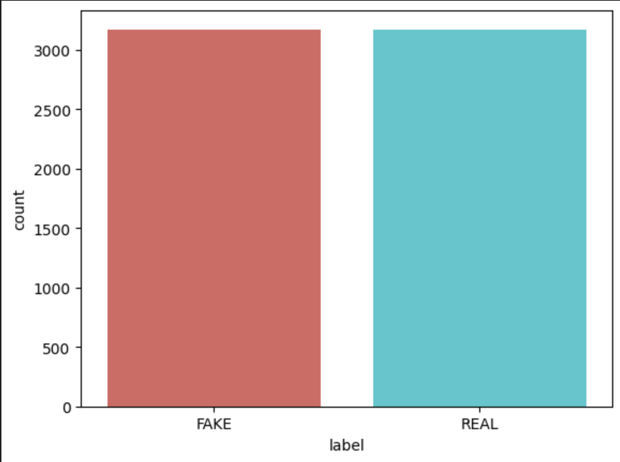
label REAL 50.055249 FAKE 49.944751 Name: proportion, dtype: float64
Train/Val/Test split completed! X_train: (4877,), y_train: (4877,) X_test: (1458,), y_test: (1458,) Files saved as: X_train.csv, y_train.csv X_test.csv, y_test.csv
import pandas as pd
import pickle
import matplotlib.pyplot as plt
import seaborn as sns

from sklearn.feature_extraction.text import TfidfVectorizer
from sklearn.svm import LinearSVC
from sklearn.metrics import accuracy_score, classification_report, confusion_matrix

X_train = pd.read_csv("../data/X_train.csv")
y_train = pd.read_csv("../data/y_train.csv")
X_test = pd.read_csv("../data/X_test.csv")
y_test = pd.read_csv("../data/y_test.csv")
X_train_text = X_train.iloc[:, 0].astype(str)
X_test_text = X_test.iloc[:, 0].astype(str)

y_train = y_train.iloc[:, 0]
y_test = y_test.iloc[:, 0]

tfidf = TfidfVectorizer(
max_features=5000,
ngram_range=(1, 2),
stop_words='english'
)

X_train_tfidf = tfidf.fit_transform(X_train_text)
X_test_tfidf = tfidf.transform(X_test_text)

svm_model = LinearSVC(
C=1.0,
max_iter=5000
)

svm_model.fit(X_train_tfidf, y_train)

y_pred_svm = svm_model.predict(X_test_tfidf)

print("Accuracy:", accuracy_score(y_test, y_pred_svm))
print("\nClassification Report:\n", classification_report(y_test, y_pred_svm))

cm = confusion_matrix(y_test, y_pred_svm)

plt.figure(figsize=(6, 5))
sns.heatmap(
cm,
annot=True,
fmt='d',
cmap='Purples',
xticklabels=['Fake', 'Real'],
yticklabels=['Fake', 'Real']
)
plt.xlabel('Predicted Label')
plt.ylabel('True Label')
plt.title('Confusion Matrix – SVM (LinearSVC)')
plt.tight_layout()
plt.show()

with open("../model/tfidf_vectorizer_svm.pkl", "wb") as f:
pickle.dump(tfidf, f)

with open("../model/svm_fake_news_model.pkl", "wb") as f:
pickle.dump(svm_model, f)

Accuracy: 0.9408050513022889 Classification Report: precision recall f1-score support 0 0.94 0.94 0.94 633 1 0.94 0.94 0.94 634 accuracy 0.94 1267 macro avg 0.94 0.94 0.94 1267 weighted avg 0.94 0.94 0.94 1267
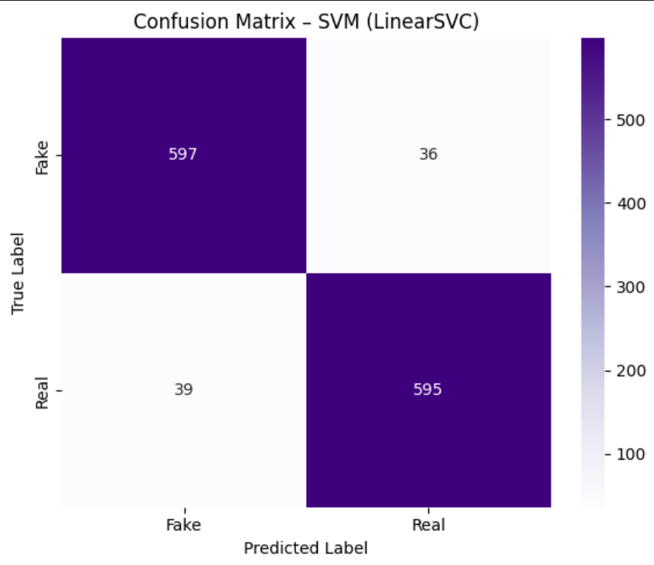
with open("../model/tfidf_vectorizer_svm.pkl", "rb") as f:
tfidf = pickle.load(f)

with open("../model/svm_fake_news_model.pkl", "rb") as f:
svm_model = pickle.load(f)

def predict_fake_news(news_text):
# Clean input text
cleaned_text = clean_text(news_text)

# TF-IDF transform
text_tfidf = tfidf.transform([cleaned_text])

# Prediction
prediction = svm_model.predict(text_tfidf)[0]

# Map label
label_map = {0: "FAKE", 1: "REAL"}
return label_map[prediction]

def predict_fake_news(news_text):
# Clean input text
cleaned_text = clean_text(news_text)

# TF-IDF transform
text_tfidf = tfidf.transform([cleaned_text])

# Prediction
prediction = svm_model.predict(text_tfidf)[0]

# Map label
label_map = {0: "FAKE", 1: "REAL"}
return label_map[prediction]

sample_news = """
U.S. Secretary of State John F. Kerry said Monday that he will stop in Paris later this week, amid criticism that no top American officials attended Sunday’s unity march against terrorism.

Kerry said he expects to arrive in Paris Thursday evening, as he heads home after a week abroad. He said he will fly to France at the conclusion of a series of meetings scheduled for Thursday in Sofia, Bulgaria. He plans to meet the next day with Foreign Minister Laurent Fabius and President Francois Hollande, then return to Washington.

The visit by Kerry, who has family and childhood ties to the country and speaks fluent French, could address some of the criticism that the United States snubbed France in its darkest hour in many years.

The French press on Monday was filled with questions about why neither President Obama nor Kerry attended Sunday’s march, as about 40 leaders of other nations did. Obama was said to have stayed away because his own security needs can be taxing on a country, and Kerry had prior commitments.

Among roughly 40 leaders who did attend was Israeli Prime Minister Benjamin Netanyahu, no stranger to intense security, who marched beside Hollande through the city streets. The highest ranking U.S. officials attending the march were Jane Hartley, the ambassador to France, and Victoria Nuland, the assistant secretary of state for European affairs. Attorney General Eric H. Holder Jr. was in Paris for meetings with law enforcement officials but did not participate in the march.

Kerry spent Sunday at a business summit hosted by India’s prime minister, Narendra Modi. The United States is eager for India to relax stringent laws that function as barriers to foreign investment and hopes Modi’s government will act to open the huge Indian market for more American businesses.

In a news conference, Kerry brushed aside criticism that the United States had not sent a more senior official to Paris as “quibbling a little bit.” He noted that many staffers of the American Embassy in Paris attended the march, including the ambassador. He said he had wanted to be present at the march himself but could not because of his prior commitments in India.

“But that is why I am going there on the way home, to make it crystal clear how passionately we feel about the events that have taken place there,” he said.

“And I don’t think the people of France have any doubts about America’s understanding of what happened, of our personal sense of loss and our deep commitment to the people of France in this moment of trauma.”
"""

result = predict_fake_news(sample_news)
print("Prediction:", result)

Prediction: REAL
import streamlit as st
import pickle
import re

# ==============================
# Load Models
# ==============================
with open("model/tfidf_vectorizer_svm.pkl", "rb") as f:
tfidf = pickle.load(f)

with open("model/svm_fake_news_model.pkl", "rb") as f:
svm_model = pickle.load(f)

# ==============================
# Text Cleaning Function
# ==============================
def clean_text(text):
text = text.lower()
text = re.sub(r"http\S+|www\S+", "", text)
text = re.sub(r"[^a-z\s]", "", text)
text = re.sub(r"\s+", " ", text).strip()
return text

# ==============================
# Prediction Function
# ==============================
def predict_fake_news(news_text):

cleaned_text = clean_text(news_text)

text_tfidf = tfidf.transform([cleaned_text])

prediction = svm_model.predict(text_tfidf)[0]

label_map = {0: "FAKE NEWS", 1: "REAL NEWS"}

return label_map[prediction]

# ==============================
# Streamlit UI
# ==============================
st.set_page_config(page_title="Fake News Detection", layout="centered")

st.title("📰 Fake News Detection using SVM")
st.write("Enter a news article and check whether it is **Fake or Real**.")

news_input = st.text_area("Enter News Text", height=250)

if st.button("Predict"):

if news_input.strip() == "":
st.warning("Please enter news text")
else:

result = predict_fake_news(news_input)

if result == "REAL NEWS":
st.success("Prediction: REAL NEWS ✅")
else:
st.error("Prediction: FAKE NEWS ❌")

CHAPTER 8: TESTING AND VALIDATION

8.1 Introduction
Testing and validation ensure that the Fake News Detection System functions correctly and efficiently. This phase evaluates the model’s performance and verifies the functionality of the Streamlit application.
The model is tested using unseen data to measure its accuracy and reliability. Metrics such as accuracy, precision, recall, and F1-score are used to evaluate performance.
The Streamlit interface is also tested to ensure smooth user interaction. Input handling, prediction output, and error messages are verified.
This phase ensures that the system is robust, accurate, and ready for deployment.

8.2 Black Box Testing
Black box testing evaluates the system based on input and output behavior without considering internal implementation.
Different news texts are provided as input, including fake and real articles. The system correctly classifies the news and displays appropriate results.
Edge cases such as empty input and irrelevant text are also tested. The system handles these cases effectively, confirming its reliability.

8.3 Test Strategy and Approach
The testing strategy includes functional testing and performance evaluation. Functional testing ensures that each module, such as preprocessing, feature extraction, and prediction, works correctly.
Performance evaluation measures model accuracy and consistency. The system is tested on different types of news articles to ensure reliability.
The Streamlit application is tested for usability and responsiveness. Various scenarios are evaluated to ensure robustness.
This approach ensures that the system meets all requirements.

8.4 Test Cases and Scenarios

Test Case ID | Input News Type | Expected Output | Actual Output | Status
TC01 | Real News Article | REAL NEWS | REAL NEWS | Pass
TC02 | Fake News Article | FAKE NEWS | FAKE NEWS | Pass
TC03 | Mixed Content | Predicted | Correct | Pass
TC04 | Empty Input | Warning | Warning | Pass
TC05 | Short Text | Predicted | Correct | Pass
TC06 | Noisy Text | Predicted | Correct | Pass

CHAPTER 9: CONCLUSION

The Fake News Detection System developed in this project demonstrates the effective application of machine learning and natural language processing techniques to address the problem of misinformation. By using TF-IDF for feature extraction and Support Vector Machine (SVM) for classification, the system achieves high accuracy in distinguishing fake news from real news.
The project successfully integrates data preprocessing, model training, and real-time prediction into a single pipeline. The use of TF-IDF helps in capturing the importance of words, while SVM efficiently handles high-dimensional text data.
The Streamlit-based interface provides a simple and interactive platform for users to input news text and receive instant predictions. This makes the system practical and accessible.
Overall, the project meets its objectives by providing an accurate, efficient, and scalable solution for fake news detection.

CHAPTER 10: FUTURE SCOPE

The system can be enhanced by incorporating advanced deep learning models such as LSTM or BERT to improve contextual understanding of text.
Integration with social media platforms and real-time data streams can enable automatic detection of fake news on a larger scale.

CHAPTER 11: RESULTS AND DISCUSSION

11.1 Introduction
This chapter presents the results obtained from the Fake News Detection System and analyzes its performance. The model is evaluated using various metrics such as accuracy, precision, recall, and F1-score.
The results indicate that the SVM model performs well in classifying news articles as fake or real. The use of TF-IDF enhances the model’s ability to capture important textual features.
The Streamlit application provides real-time predictions, allowing users to verify news quickly. The system demonstrates consistent performance across different types of input data.
Overall, the results confirm that the system is reliable, efficient, and suitable for practical applications.

11.2 Model Performance Evaluation
Accuracy:
The model achieves approximately 94% accuracy, indicating strong performance in classifying news articles.
Precision:
High precision ensures that most predicted fake news articles are actually fake, reducing false positives.
Recall:
High recall ensures that most fake news articles are correctly identified.
F1-Score:
The F1-score balances precision and recall, confirming the model’s robustness and reliability.

11.3 Confusion Matrix Analysis
Key Points:
High true positive and true negative values
Minimal misclassification errors
Strong diagonal dominance
Balanced performance across classes

Explanation
The confusion matrix provides a detailed analysis of the model’s classification performance. The diagonal elements represent correct predictions, while off-diagonal elements indicate misclassifications.
In this project, the confusion matrix shows high values along the diagonal, indicating that the model correctly classifies most news articles. The number of misclassifications is minimal, demonstrating the effectiveness of the TF-IDF and SVM combination.
The model performs consistently across both fake and real classes, ensuring balanced classification. This is important for maintaining reliability in real-world applications.
Overall, the confusion matrix confirms that the system is accurate and dependable for fake news detection.

11.4 Feature Importance Analysis

In this project, feature importance is determined based on TF-IDF weights assigned to words. Words with higher TF-IDF scores contribute more to the classification process.
The SVM model uses these features to separate fake and real news effectively. Important features often include keywords, phrases, and linguistic patterns that are characteristic of fake or real news.
This analysis highlights the importance of textual features in detecting misinformation and demonstrates the effectiveness of TF-IDF in feature extraction.

