Main Page(top line) – Office for International Affairs
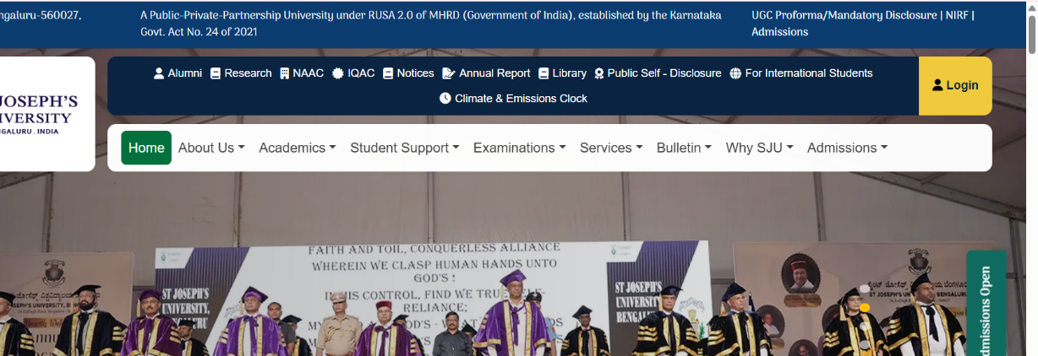
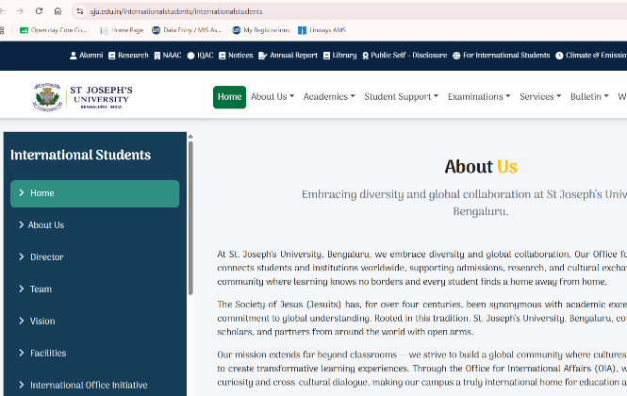
(Need to change the key sections as mentioned below in numbers)

Key sections as follows:-
- Home page
- About us – OiA
- Vision and Mission
- Vice-Chancellor's Message
- Honorary Chairman's Message
- Director's message
- Team
- International Students’ Services Committee
- Facilities
- Admission guidelines and regulations
- FRRO support
- Support services
- Collaborations
- Exchange
- Academic Events
- Student Life
- Partnerships
- International office initiative
- IAJU Global Citizenship Program
- Jesuit University Worldwide
- UNAI (United Nations Academic Impact)
- J40
- International Collaborations
- Greet and meet international students
- OIA notice
- Invitations to the programs
- Student/faculty achievements
- Gallery
- Contact
Detailed information
 Office for International Affairs

- Home page – (Sju photo of main gate)
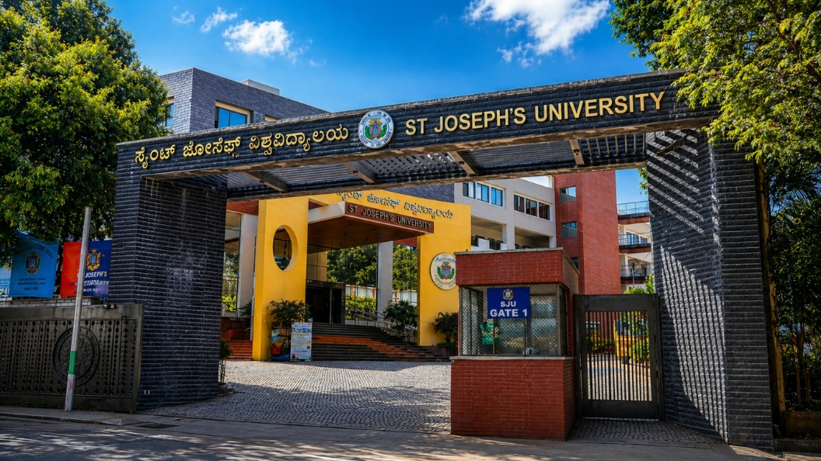

- About us – OiA
At St Joseph’s University Bengaluru, we celebrate diversity and promote meaningful global engagement. The Office for International Affairs (OIA) serves as the university’s gateway to the world, connecting students, scholars, and partner institutions across different countries. Through international admissions support, academic collaborations, research partnerships, and cultural exchange initiatives, the OIA works to strengthen the university’s global presence while creating a welcoming environment for international students.
Guided by the rich educational tradition of the Society of Jesus (Jesuits), which for more than four centuries has stood for academic excellence, ethical leadership, and global understanding, the university continues to uphold these values in its academic and community life. This heritage inspires a learning environment that encourages intellectual curiosity, critical thinking, and respect for diverse cultures.
Through the Office for International Affairs, St Joseph’s University Bengaluru fosters cross-cultural dialogue, international mobility, and collaborative learning. Our campus welcomes students from around the world, creating a vibrant global community where education extends beyond borders and every student finds a place to learn, grow, and belong.

- Vision and Mission {purpose- delete}
Vision
At St Joseph’s University, our Office for International Affairs (OIA) envisions a world where education transcends borders, cultures, and ideologies. We aspire to foster global connectivity by building bridges between nations and people — nurturing an academic community that values collaboration, empathy, and shared growth.
Our vision is to create an inclusive international network that drives meaningful partnerships and sustainable progress. Through transformative global engagement, we aim to empower individuals and institutions alike to become changemakers — contributing to a brighter, more peaceful, and more interconnected future for all.
Mission
Our mission at the Office for International Affairs is to nurture understanding across cultures, facilitate enriching exchange programs, and advance international research collaborations that shape the leaders of tomorrow. We are committed to internationalising education at every level — supporting mobility for students, faculty, and researchers while fostering shared learning and innovation. By promoting diversity, inclusivity, and academic excellence, we strive to prepare our students for a truly global future. Through these collective efforts, OIA serves as a gateway to the world — inspiring a spirit of unity, discovery, and positive change that extends far beyond our campus.

- Vice-Chancellor's Message
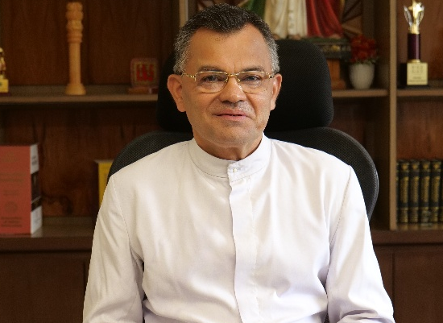
Dear International Student,
We invite you to join St Joseph’s University, Bengaluru, and embark on a transformative higher education journey that will enrich your academic and professional future at one of India’s oldest and most distinguished educational institutions, established in 1882.
The University is administered by the Society of Jesus (SJ), also known as the Jesuits, founded by St Ignatius of Loyola in 1540. Headquartered in Rome, the Jesuits are globally renowned for their commitment to quality education and character formation across nearly fifty countries. The Jesuits arrived in India in 1542 under the leadership of St Francis Xavier and established St Paul’s College, the first higher education institution in India. Over the centuries, they founded numerous schools, colleges, and seminaries throughout the country. Many of India’s premier century-old, not-for-profit institutions continue to be administered by the Jesuits, including St Joseph’s College, Trichy, St. Xavier’s College, Kolkatta, St Xavier’s College, Mumbai, Loyola College, Chennai and St. Aloysius, Mangalore.
Founded as St Joseph’s College in 1882, our institution has built an illustrious legacy of academic excellence spanning more than 143 years. On 2 July 2022, the Government of Karnataka elevated the college to the status of a university under the Rashtriya Uchchatar Shiksha Abhiyan (RUSA) initiative of the Ministry of Education, Government of India. St Joseph’s University has the unique distinction of being the first Public-Private-Partnership (PPP) university of its kind in India.
On 27 September 2022, Her Excellency, Smt. Droupadi Murmu, President of India, formally inaugurated the University. The Bangalore Jesuit Educational Society has since undertaken a visionary mission to develop the University into a centre of world-class education that remains affordable and accessible to deserving students from all backgrounds, irrespective of caste, creed, economic status, or nationality. This mission is guided by the enduring values of academic excellence, character formation, and social responsibility.
The University is also committed to significant expansion and modernisation of its infrastructure. Plans are underway to enhance facilities at the Lalbagh Road Campus, including libraries, laboratories, computer and network systems, hostels, cafeterias, sports facilities, auditoriums, seminar halls, observatories, student wellness and counselling centres, placement and skill development cells, and more. Simultaneously, a state-of-the-art new campus is being envisioned on the 30-acre site at Mount Saint Joseph, Bannerghatta, to support the University’s future growth and aspirations over the coming years.

Rev. Fr Dr Victor Lobo SJ
Vice-Chancellor

- Honorary Chairman's Message

Dear International Student,
We warmly invite you to join the vibrant campus of St Joseph’s University, Bengaluru, to have an enriching higher education experience along with nearly ten thousand students aspiring to make a success of their lives through academic excellence and enriched professional skills. Being a Jesuit institution of higher learning, you will have a chance to study under the highly qualified, hardworking and dedicated teachers ably led by the competent and experienced leaders of the Jesuit religious community in a world-class environment characterised by ethnic diversity and social concerns. The University has world-class infrastructural facilities and global competence to offer quality education at affordable costs to all aspiring young people, irrespective of caste, creed or ethnic considerations!
During the last nearly 145 years of history, the institution has educated thousands of Indian leaders in all walks of life and has played a useful role in the development of the nation. Among our past students, we can also count many from the Afro-Asian nations who have made a success of their lives at international levels. I am sure you will also have a chance to develop your full potential at our University.
Dr J.W. Lobo
Honorary Chairman,
Office for International Affairs

- Director's message
(Add the same photo that is there on the website)
Welcome and greetings to all.
In an increasingly interconnected world, higher education must transcend geographical boundaries and equip students with the knowledge, skills, and global perspectives necessary to thrive in diverse cultural and professional environments. At St Joseph's University, we believe that internationalisation is not merely an aspiration but an integral part of our mission to nurture responsible global citizens.
The Office for International Affairs serves as the University's gateway to the world. Through strategic partnerships with universities, institutions, industries, and international organizations across the globe, we create opportunities that enrich learning, research, innovation, and cultural understanding. Our commitment is to foster meaningful international engagement that benefits students, faculty members, researchers, and the wider academic community.
Over the years, St Joseph's University has actively expanded its global footprint through student and faculty exchange programmes, semester-abroad opportunities, international internships, collaborative research initiatives, joint academic events, global immersion programmes, and cross-cultural learning experiences. These initiatives enable our students to develop intercultural competencies, broaden their perspectives, and prepare themselves for leadership in a rapidly changing world.
We are equally committed to providing a welcoming and supportive environment for international students who choose St Joseph's University as their academic home. Through comprehensive support services, orientation programmes, cultural integration activities, visa and regulatory assistance, and student engagement initiatives, we strive to ensure that every international student experiences a sense of belonging and success during their journey with us.
As a Jesuit institution with a rich heritage of academic excellence and social responsibility, we seek to build bridges between nations, cultures, and communities. We encourage collaboration that promotes innovation, sustainability, peace, social justice, and human development. Through our international partnerships, we aspire to create transformative opportunities that contribute to the advancement of knowledge and the betterment of society.
I invite students, scholars, researchers, institutions, and global partners to connect with us and explore the many opportunities available through the Office for International Affairs. Together, let us create a vibrant global learning ecosystem where ideas flourish, cultures connect, and futures are transformed.
We look forward to welcoming you to St Joseph's University and partnering with you in shaping a globally connected future.
Warm regards,
Dr V Christo Selvan
Pro Vice-Chancellor – Block B
Director, Office for International Affairs

- Team (Add these photos and names to the team)
- 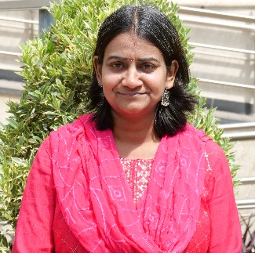
Dr Sunita Rajamani,
Assistant Professor, Department of Chemistry
Convenor - International Students’ Services

- 
Ms Anisha Mariyal Rodrigues
Secretary - Office for International Affairs

- International Students’ Services Committee
- Dr J.W. LOBO, HONORARY CHAIRMAN
- DR SUNITA RAJMANI, CONVENOR
- MR P. VENUGOPAL, CO-CONVENOR
- DR NEETA PEREIRA, MEMBER
- DR SUSAN MARY PHILIP, MEMBER
- DR TANNEN NEIL LINCOLN, MEMBER
- DR RAJU M, MEMBER
- DR SANTHOSH JAGADEESHAN, MEMBER
- DR NIKHIL JHA, MEMBER
- DR PADMAJA PANCHARATNAM, MEMBER
- DR PRAMOD K.M, MEMBER
- DR PARINITH SHINDE, MEMBER

- Facilities

Admission guidelines and regulations
https://drive.google.com/file/d/1Ot-lYCoL1BRW8HlYU7kKALzJJ70K0wOF/view?usp=drive_link

FRRO support
https://drive.google.com/file/d/1FsflkfdgQgYUpjfQDbqLY4QehMYDQtXR/view?usp=sharing

Support services
https://drive.google.com/file/d/13JVL8LcpgjT6TY0v2EJxTX4XO5PwgKgr/view?usp=sharing

Collaborations

Exchange

Academic Events

Student Life

Partnerships
- International office initiative
- IAJU Global Citizenship Program
https://docs.google.com/document/d/1CCfKkUVT51Dt3eKSzesBrtzwjtWoAPXA/edit?usp=drive_link&ouid=103887283505193700080&rtpof=true&sd=true
- Jesuit Worldwide Learning
- UNAI (United Nations Academic Impact)
- J40
https://docs.google.com/spreadsheets/d/1Vu-HoUuBAFWZ-_6_pmp8sXRAfK5d1_2s/edit?usp=drive_link&ouid=103887283505193700080&rtpof=true&sd=true
- International Collaborations
- {special Workshops delete}
- Greet and meet international students
https://docs.google.com/document/d/1jWS-p_ZQ-hyuygMan2iT7OXGtRysGXx4/edit?usp=drive_link&ouid=103887283505193700080&rtpof=true&sd=true

- OIA notice:
- Invitations to the programs
- Student/faculty achievements
- Gallery:
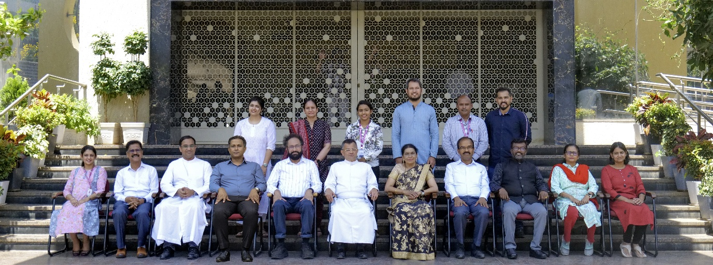
https://drive.google.com/drive/folders/1ldtVUV7n8PxJyGjuviBcW9XdLw2B52nk?usp=drive_link

- Contact
- Director
Dr Christo Selvan
Pro Vice-Chancellor, Block B
Director, Office for International Affairs
+918022274079 EXT 602
director.internationalaffairs@office.sju.edu.in
Arrupe Block Ground floor
St Joseph’s University
36 Langford Road Bengaluru – 560027
Karnataka, India.

- Associate Director
Mr Venugopal Padavu
Associate Director, PRO
+918022211429 Ext 209
+919480811926
- officeinternationalaffairs@sju.edu.in
Ground Floor, Science Block
Associate Director, Office of International Affairs
St Joseph's University 36, Lalbagh Road
Bengaluru-560027

- Secretary
Ms Anisha M Rodrigues
Secretary, Office for International Affairs
EXT 602
secretary.internationaloffice@office.sju.edu.in
Arrupe Block Ground floor
St Joseph’s University
36 Langford Road Bengaluru – 560027
Karnataka, India.

