Figure 2. Representative pictures of BLD symptoms and hemispherical canopy photos. Severity of symptoms increases when moving from left to right in the images. Canopy photos display changes in canopy openness, percent estimated by ImageJ, over time (2015-2019) under the same beech tree in one of the BLD observation plots at Holden Arboretum. Photo credits: 0 – emileewaldrop, iNaturalist; 1 –bkmert, iNaturalist; 2 – Grace Bianchi, iNaturalist; 3 – Brianna Shepherd, Holden Forests and Gardens; 4 – jlayman, iNaturalist.
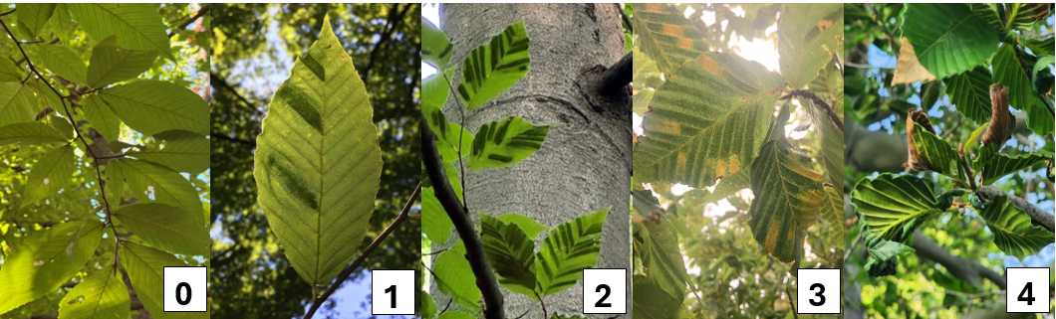
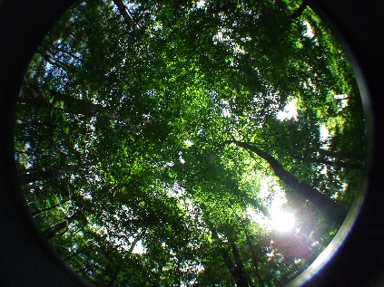
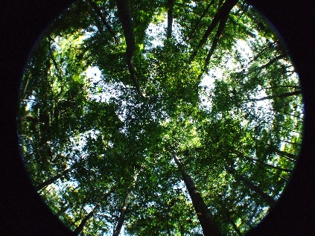
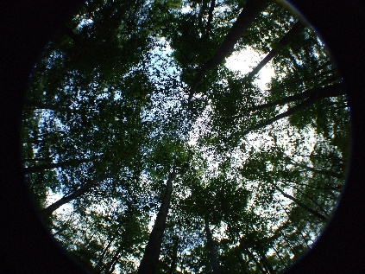
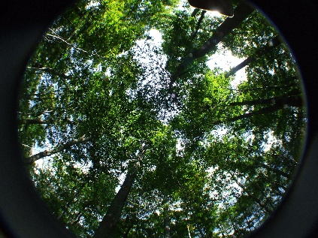
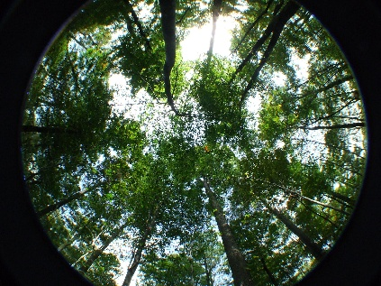
2019: 14.2%
2015: 4.8%
2016: 9.4%
2018: 9.2%
2017: 12.9%
0
1
2
3
4

