CodeIgniter Application Flow Chart

The following architecture illustrates how data flows of CodeIgniter application:

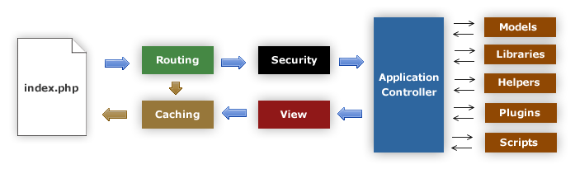

1. Shown in figure when request comes first it will hit index.php
2. **Routing** will decide whether to pass http request
3. If request a cache file exists, it will send directly to the browser, and bypassing the normal process.
4. If the request page not exist in **Caching**, then **Routing** pass the request **Security**
5. After the check of security, the application controller loads the model, libraries, helpers, plugins, css, scripts, and any other resources needed to process the specific request and pass on to view.
6. **View** will deliver the response with available data and pass it on for **Caching**. If the requested response was not cached so this time it will be cached in **Caching**, to process this response quickly for future requests.