DETECTION OF EMOTION OF A PERSON BASED ON SOCIAL INTERACTIONS ON DIFFERENT SOCIAL MEDIA

K Tejasvi(157132)
G Vineetha Reddy(157218)
J S N Sushma(157226)
K Divya(157230)
S Deeksha(157255)

Under the esteemed guidance of
Dr.T.Ramakrishnudu

Department of Computer Science and Engineering
National Institute of Technology Warangal
2015-2019

DECLARATION
We declare that this written submission represents our ideas in our own words and where others’
ideas or words have been included we have adequately cited and referenced the original sources. We also declare that we have adhered to all principles of academic honesty and integrity and have not misrepresented or fabricated or falsified any idea/ data / fact / source in our submission. We understand that any violation of the above will be a cause for disciplinary action by the Institute and can also evoke penal action from the sources which have thus not been properly cited or from whom proper permission has not been taken when needed.

ABSTRACT
It is very important these days to manage emotion levels. With the busy lives of people now-a-days, a lot are experiencing mood changes and various kinds of emotions frequently. Health problems caused by negative emotions include depression and anxiety, sleep problems, weight problems, digestive issues and heart diseases. Hence it becomes a matter of significant importance to detect the emotional status of a person before it might turn into some chronic problems. However, the usually existing methods for emotional state detection depend on physiological devices and image processing, making the detection of emotion complicated and costly. Now a days popularity of social media has increased rapidly. People are interested to share their everyday activities, express their views, opinions, thoughts on various social media platforms like Twitter, Facebook, Snapchat etc making it feasible for the usage of these platforms for detecting emotional status of people. In our work, we ﬁnd that emotional state of users is related in many instances to that of his/her friends in social media platforms, and we use a large-scale datasets collected from real-world social media platform like Twitter to study the relationship between the users’ emotional states and social interactions.
Usage of real online social media data, we first investigate the relationship between users’ emotional states and their tweeting content, public engagement and behavioral patterns. We define a type of emotional-related attributes: tweet level attributes from a single tweet including text, images and social interactions

INTRODUCTION
Negative emotional state detection remains a serious problem at the present stage. Detection and managing the emotional state before it turns into severe problems is of great importance. In recent years, several efforts have been done for emotion detection by researchers from different areas. They have developed several strategies to measure emotions, including psychological questionnaire based interviews and physiological signal based measures. However, these methods have their limitations in several aspects. Psychological questionnaires typically contain a varied range of queries designed by psychologists. People are usually unwilling to try these questionnaires unless they need to. Physiological strategies usually require professional devices to measure users’ physiological and biochemical properties and need specialists to analyze the acquired data.
With the quick development of social networks, individuals are widely using social media platforms to share their thoughts and feelings. Individuals post tweets containing text and pictures on micro-blog platforms to share opinions, express emotions, record daily routines and communicate with friends. We can acquire linguistic and visual content which will indicate negative emotion related symptoms. This makes the detection of users’ emotional state detection through their tweets and posting patterns from social networking platforms possible.
Various micro blogging sites provide a common platform for its users to discuss and share their everyday activities, views & information regarding various topics/subjects in an informal and casual manner. In recent years, Facebook, Twitter etc. have become some of the booming social networking sites all over the world. Among these various sites Twitter is one of the most feasible platforms for users to express their emotion.
1.1 Twitter
Twitter is an online news and social networking service where users post and interact with messages, "tweets," restricted to 140 characters. Registered users can post/put up tweets; however individuals who are unregistered can only read them. Twitter has been compared to a web-based Internet Relay Chat (IRC) client. Users access Twitter through its website interface, SMS (Short Message Service) or a mobile device app.
1.1.1 Tweets
Tweets are publicly visible by default, but senders can restrict message delivery to just the people following them. Users may subscribe to other users’ tweets – this may be known as “following” and subscribers are known as “followers” or “tweeps”, a portmanteau of Twitter and peeps. When you decide to follow another Twitter user, that user's tweets appear in reverse chronological order on your main Twitter page. Individual tweets can be forwarded by other users to their own feed, a technique known as a "retweet". Users can also “like”/”favorite” individual’s tweets.
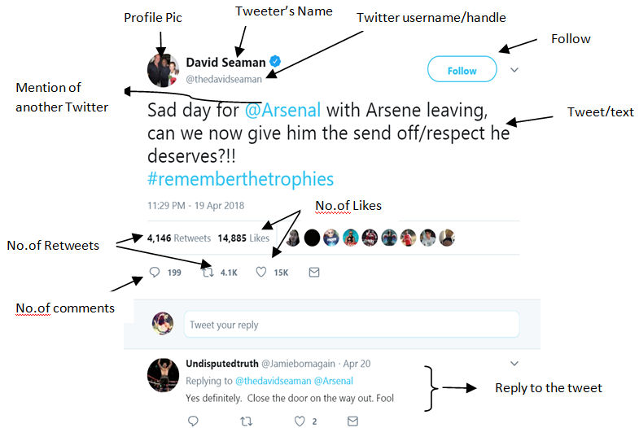
Fig 1.1 : Structure of a tweet

1.2 Emotions
Emotions can be classified as negative and positive emotions.
1.2.1 Positive Emotions
Positive emotions can be considered as a feeling that has the lack of negativity, such that there is no discomfort or pain. The most common positive emotions that can be identified are joy, gratitude, pride, peaceful/serenity, interest, hope, etc. There are also other positive emotions that can be considered such as the emotion felt when helping others. So, satisfaction and relief can also be considered as positive emotion
1.2.2 Negative Emotions
Negative emotions can be described as any feeling which makes you to be miserable and sad. These emotions make you dislike yourself and others, and takes away your confidence levels. The five main categories of negative emotions include
1) sadness (stress ,depression, despair etc)
2) anger ( irritation, frustration, rage etc)
3) anxiety (fear, worry, nervous, panic,etc)
4) guilt
5) shame/embarrassment.
Whenever a person is feeling negatively emotional it may be determined as one of the five emotions mentioned above (and also more than one of these types could be experienced at the same time).
In this project, the main focus is on stress detection.
1.3 Effects of Social Media on Health
Negative emotions are impossible to avoid and everyone feels them at anytime. They may be difficult, but they don’t have to be stressful and once they become stressful it can lead to serious health problems such as sleep problems, digestive problems, depression and anxiety, heart disease, weight problems, thinking and memory problems, etc. Each person reacts differently to different situations. What is stressful to one person may not be stressful to another. Some of the common major events that can cause for negative emotion or trigger stress include major life changes, work or school, relationship difficulties, financial problems, negative self-talk, unrealistic expectations etc.
1.4 Social Media’s Role in Emotion Detection
Now a days more people are interested to share their daily events and interact with friends through social network. This social media information can be used for representing and finding out the individuals behavior patterns through large-scale social networks. It can be observed that people who are negative emotioned are more likely to be less active in social media. Similarly, during a social interaction one person’s negative mood can be transferred to the other person.
PROBLEM STATEMENT

ATTRIBUTES CATEGORIZATION AND DEFINITION
The social media data is a typical type of cross-media data. It contains text, emoticons, pictures and social interactions. Besides these various attributes, the usage behavior of social media in the sampling period also contain useful information regarding the emotion detection.
Therefore, in order to take advantage of both content information present in single cross-media social network tweet and the behavior of social media usage in sampling period tweets ,we defined two sets of attributes to measure the differences of the negative and positive emotioned users.
1). Tweet level attributes:
Tweet level attributes explains about the contents of a single tweet. We defined textual attributes from each part of a tweet.
- Textual attributes:
The measure of these attributes is done through NLTK(Natural Language Processing Tool Kit)

- Positive and negative emotion words : The count of positive and negative words in a single tweet is maintained in a count variable.

- Most commonly used punctuation marks: These are removed in preprocessing of tweets.

- Polarity of each word: Polarity of each word in the tweet is calculated using nltk.

- Parts of Speech Tagging: Through nltk,parts of speech of each word is marked.

MODEL FRAMEWORK
In this section, we describe about the challenges involved and the model frame work for our proposed model.
Challenges
There are several challenges involved in this work. Some of the challenges faced and their corresponding solutions are given below as:
1）Challenge 1: Social media platforms contain huge data. It is very difficult manually to label the data . So, efficient methods are required to automatically label the acquired data.
Our solution: we have constructed a emotion based-twitter-posting database using some sentence patterns like “I feel stressed/sad/happy/joy” etc. as the ground truth label for emotional state detection from social media data.
2）Challenge 2: Tweets may contain images and videos. Since our project is based on texual format,it is mandatory that these images and videos must be deleted. On extraction of tweets through API, images and videos will be in URL format. These links are to be deleted.
3 ) Challenge 3: Since LIWC (Linguistic Inquiry Word Count) is proprietary, count of positive and negative polarity words is obtained by processing each word.

EXPERIMENTAL RESULTS
6.1 Data Preprocessing
We considered Twitter as a source for data. For data processing, first we need to get raw tweets data from twitter. Secondly we need to pre-process and extract features from the raw tweets for observation and analysis.
Data collection:
Twitter has Official Twitter APIs for developers to collect publicly available tweets. There are many tools that use the official APIs to collect data. We used tweepy , a python library that use Twitter APIs.
We used the following to collect raw tweets. 1) Python , 2) Tweepy and 3) Access Tokens given by Twitter APIs.
Twitter REST APIs:
There are two types of APIs given by twitter. They are REST APIs and Streaming APIs. REST APIs are standard APIs to get publicly available tweets while Streaming APIs are the advanced APIs that give real-time tweets based on search terms. We used REST APIs which are sufficient enough to collect required tweets data.
Data extraction using python and tweepy
Steps involved in collecting raw tweets data
1) Get access Tokens from Twitter APIs:
In order to access twitter REST APIs, We need to get access tokens from Twitter APIs. There are four tokens to be taken from Twitter APIs to collect required tweets data. They are 1) Consumer Key, 2) Consumer Secret, 3) Access Token and 4) Access Token Secret. Following are the steps to get the four tokens.
- Go to https://apps.twitter.com/ and log in with your twitter credentials.
- Click on “Create New App” button.
- Complete the form, check the “agree to the terms” check box and click on “Create your Twitter application” Button
- In the next page, click on “API keys” tab, and copy the application’s “API key” and “API secret”.
- Scroll down and click “Create my access token”

2) Collect tweets data:
In order to collect data, we need to select the twitter users whose tweets are being collected. We selected two set of users who are active in twitter. Then we collected their tweets for a period of four months. Total number of tweets collected is around 40,000. Following is the code snippet to collect data for a specific user.
All the tweets collected are stored in organized structured format.
Data Preprocessing involves following steps
1) Removal of URLs in tweet text
2) Removal of emoticons.
3) Removal of punctuations
4) Tokenizing the sentences
5) Removal of stop words as they do not contribute to polarity
6) Parts of speech tagging of the sentences
7) Count of positive and negative polarity words
8) Grouping these modified tweets by user screen name or id

Data labeling:
We labeled the tweets as positive tweet (1), negative tweet(-1) and neutral tweets(0) based on the common sentence patterns that expresses the emotion of a person such as , “I feel happy”, “ I feel stressed” etc., This method of labeling is proved to be effective in emotional analysis .
Now data is available for feature extraction, analysis, further processing.
Datasets Summary
We collected 51 users tweet data from 01.2018 to 04.2018 as dataset1 and 62 users tweet data from 11.2017 to 02.2018 as dataset2. Details of the datasets are summarized in tables
Dataset 1: We have collected 51 users tweet data from 01.2018 to 04.2018 as dataset1
Table 6.1 Dataset-1
Label | Positive | Negative | Neutral
No of tweets | 36507 | 14423 | 44719
Average Number of Tweets per user | 715.8235 | 282.8039 | 876.8431
Average Number of Tweets per day | 165.19 | 65.2624 | 202.3484
Average Number of Tweets per week | 1106.273 | 437.0606 | 1355.121
Average Number of Tweets per user per day | 7.5993 | 3.0023 | 9.3087
Average Number of Tweets per user per week | 42.0104 | 16.5972 | 51.4603

CONCLUSION
.Throughout this project, we focus on a challenging problem of detecting emotional state of a person based on his/her interactions on social media platforms ,here twitter.The main contributions of our work are as follows:

- Data labeling has been done using the ground-level truth sentence patterns like “I feel sad, happy etc” . This method of data labeling has reduced the human effort to manually label the data sets.
- A variety of statistical attributes like behavioral attributes, social engagement and linguistic style attributes from users’ sampling period tweet postings have been proposed.

The results obtained showed us that proposed model is effective and efficient on detecting emotional state of user from micro-blog data.

