巡检脚本os层操作系统磁盘空间数据整理

修改步骤：

编辑脚本

|  |
| --- |
| Swap_Method=$(cat $file | grep Swap_Method | awk -F ":" '{print $2}') && echo "\"Swap_Method\"":"\"$Swap_Method\"""," >>$new_document    Totalsum=$(cat $file | grep Totalsum | awk -F ":" '{print $2}') && echo "\"Totalsum\"":"\"$Totalsum\"""," >>$new_document  Usesum=$(cat $file | grep Usesum | awk -F ":" '{print $2}') && echo "\"Usesum\"":"\"$Usesum\"""," >>$new_document  Freesum=$(cat $file | grep Freesum | awk -F ":" '{print $2}') && echo "\"Freesum\"":"\"$Freesum\"""," >>$new_document  Diskutil=$(cat $file | grep Diskutil | awk -F ":" '{print $2}') && echo "\"Diskutil\"":"\"$Diskutil\"""," >>$new_document  Freeutil=$(cat $file | grep Freeutil | awk -F ":" '{print $2}') && echo "\"Freeutil\"":"\"$Freeutil\"""," >>$new_document      IO_User=$(cat $file | grep IO_User | awk -F ":" '{print $2}') && echo "\"IO_User\"":"\"$IO_User\"""," >>$new_document |

将swap_method和io_user中磁盘数据修改为

|  |
| --- |
| Swap_Method=$(cat $file | grep Swap_Method | awk -F ":" '{print $2}') && echo "\"Swap_Method\"":"\"$Swap_Method\"""," >>$new_document  diskinfo=$(df -h |grep -v 'tmpfs'|grep -v 'boot' |grep -v 'overlay' |grep -v 'iso'|grep -v 'shm') && echo "\"diskinfo\"":"\"$diskinfo\"""," >>$new_document ###新修改数据      IO_User=$(cat $file | grep IO_User | awk -F ":" '{print $2}') && echo "\"IO_User\"":"\"$IO_User\"""," >>$new_document |

修改word模板，将如下信息

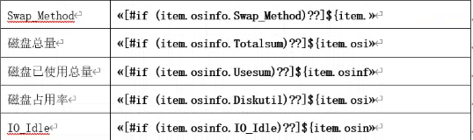

修改为：

