CoverMap
Technical Methods Guide
Inputs · Equations · Outputs · Definitions · Limitations
Stephen Zimmerman, CCA MS | Ankeny, Iowa | Spring 2026 | v1.8 | Pending ISU Extension Review
Purpose CoverMap combines Sentinel-2 satellite NDVI with the Iowa 3-meter DEM to produce field-scale cover crop stand assessments and simplified erosion risk estimates for Iowa CCAs and NRCS advisors. This document describes every method, input, equation, and output in the CoverMap pipeline so that any agronomist, NRCS conservationist, or ISU Extension reviewer can evaluate the scientific basis of each output. Known limitations and planned improvements are explicitly documented throughout.

1. Complete Data Pipeline Overview
CoverMap processes five input streams through three computational layers to produce seven distinct outputs. The pipeline below shows the complete data flow from satellite image acquisition through final PDF report generation.
Figure 1. CoverMap complete data pipeline — inputs, processing layers, and outputs.

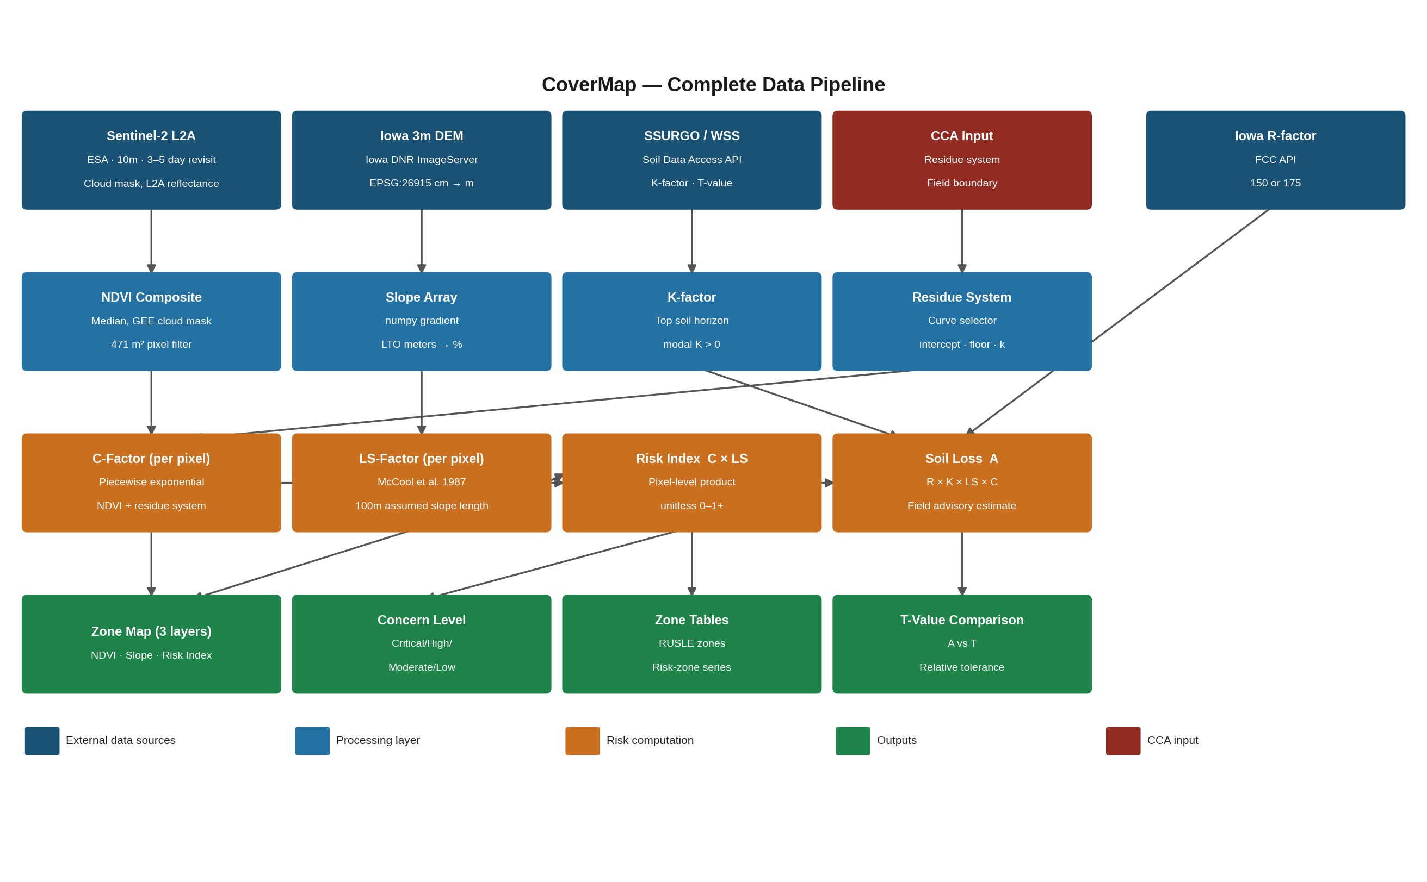

Layer | Input | Process | Output
Input | Sentinel-2 L2A (GEE) | NDVI computation, cloud filter, temporal median | NDVI raster 10m
Input | Iowa DNR 3m DEM (WCS) | Slope percent computation per pixel | Slope raster 3m
Input | SSURGO WSS API | Dominant soil K-factor lookup | K-factor, soil series
Input | FCC Census Block API | County R-factor zone lookup | R-factor (175 or 150)
Input | CCA / Operator | Field boundary upload, residue system selection | GeoJSON polygon
Compute | NDVI + Residue system | NDVI + residue system → piecewise exponential C-factor model | C-factor (integrated residue + NDVI)
Compute | DEM + Slope | LS-factor lookup (simplified, no slope length) | LS-factor per pixel
Compute | C-factor + LS-factor | Risk Index = C × LS per pixel; field concern level | Risk Index map
Compute | R, K, LS, C, P=1.0 | RUSLE A = R × K × LS × C; compare to T-value | Soil loss (t/ac/yr)
Output | All above | Zone summaries, EQIP checklist, PDF/CSV/SHP export | 2-page PDF report + SHP

1.1 Plain-Language Risk Zone Summary
The diagram below shows how CoverMap combines the two primary inputs—cover crop thickness and slope steepness—to assign each 10m × 10m pixel on a field its erosion risk zone. This figure is intended for producer-facing presentations and field consultations.

Figure 1.1. How the erosion risk zone is determined. Each pixel’s risk color is computed by multiplying the satellite-derived C-factor (from NDVI) by the CCA-selected residue multiplier and the terrain LS-factor (from slope). Risk Index = C × Residue × LS.

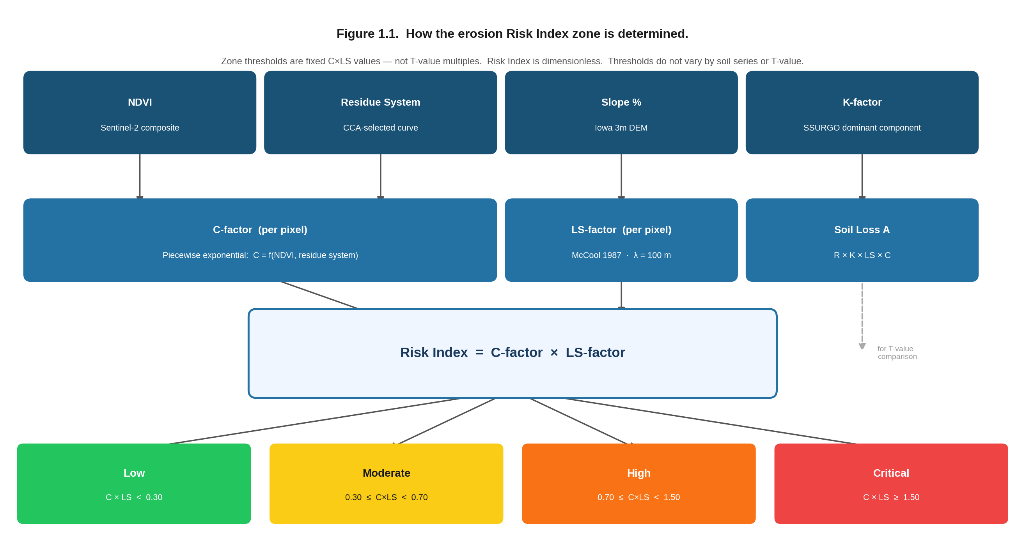

[Risk Zone Diagram - Figure 1.1]

2. Normalized Difference Vegetation Index (NDVI)

2.1 Data Source and Collection
Parameter | Value / Method | Notes
Satellite | Sentinel-2A and Sentinel-2B (ESA / Copernicus) | Two-satellite constellation
GEE Collection | COPERNICUS/S2_SR_HARMONIZED — Level-2A Surface Reflectance | Atmospherically corrected
Native resolution | 10 meters per pixel (bands B04 and B08)
Revisit frequency | 3–5 days over Iowa | Two-satellite constellation
Date window | Default: Custom spring window (user-specified year, start date MM-DD, and end date MM-DD). Rolling window options: Last 7 days, Last 14 days, Last 30 days. Minimum 7 days recommended. | Default targets Iowa spring greenup period. Custom spring window recommended for accurate spring cover crop scoring.
Cloud filter — Stage 1 | Scene-level: CLOUDY_PIXEL_PERCENTAGE < 80% | Scenes above threshold excluded
Cloud filter — Stage 2 | Field-level SCL classes 3, 8, 9, 10, 11 within boundary. Scenes with >30% cloud/shadow excluded
Compositing method | Pixel-wise temporal median across all scenes passing both cloud filters | Consistent with USDA CDL, NASA MODIS, ESA seasonal products

2.2 NDVI Equation
NDVI = (B08 − B04) / (B08 + B04)
B08 = Near-infrared band (842nm) │ B04 = Red band (665nm)
Term | Definition | Typical Iowa range (spring)
B08 | Near-infrared reflectance. Healthy vegetation reflects strongly in NIR due to cell structure | 0.3–0.6 for actively growing cereal rye
B04 | Red reflectance. Chlorophyll absorbs red light — low values indicate healthy vegetation | 0.05–0.15 for cereal rye in active growth
NDVI | Dimensionless index -1.0 to 1.0. Higher = more living vegetation | 0.10–0.45 for Iowa spring cereal rye (March–May)

2.3 Valid Pixel Definition and Quality Rules
The NDVI > 0.05 threshold defines the valid pixel display metric used for coverage warnings and data quality flags. It is not applied to the scoring population. The C-factor lookup uses the mean of all non-NaN, in-polygon pixels regardless of NDVI magnitude — including low-NDVI pixels representing bare soil patches or weak establishment. This is intentional: suppressing those pixels would overstate cover performance on partially established fields. A separate data quality guard blocks report generation if field-mean NDVI falls below −0.05, a threshold physically inconsistent with agricultural land surfaces and indicative of cloud shadow contamination surviving the median composite."

Figure 2. NDVI zone thresholds (left) and multi-scene cloud shadow rejection (right).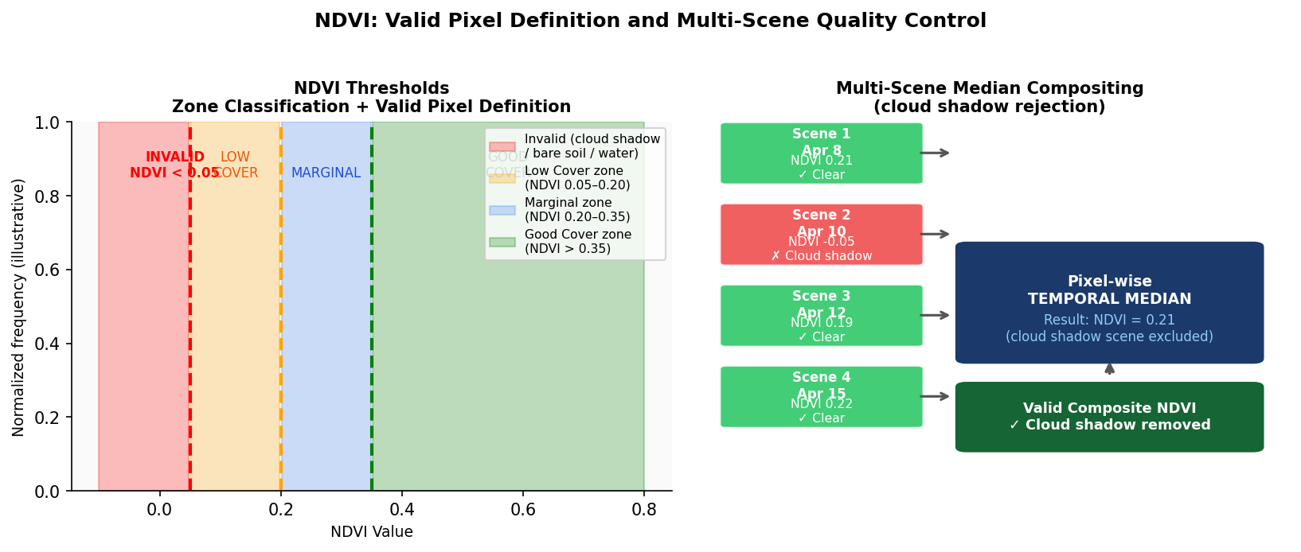
Rule | Threshold | Action if failed
Valid pixel | NDVI > 0.05 | Pixels ≤ 0.05 are water, cloud shadow, or saturated bare soil — excluded from all statistics
Minimum valid fraction | ≥ 75% of field pixels | Yellow warning displayed. Results may be cloud-contaminated
Critical valid fraction | ≥ 50% of field pixels | Red warning — results flagged unreliable. Widen date range
Single-scene warning | Scene count = 1 | Warning: cloud contamination risk elevated. Median compositing cannot filter cloud shadows from single scene
Negative NDVI mean | Mean NDVI < -0.05 | Error raised — physically impossible for vegetation. Indicates complete cloud shadow contamination
Saturation warning | Mean NDVI > 0.75 | Warning: likely mature cash crop not cover crop. Verify image date

2.4 NDVI Zone Classification
NDVI values are classified into three cover quality zones. The threshold is user-adjustable via sidebar slider (default 0.20). Zone labels update dynamically based on the selected threshold.
Zone | NDVI Range | Estimated biomass (national rye database) | Map color | Agronomic meaning
Low Cover | < 0.20 | < 900 lb/acre | Orange #F97316 | Below erosion protection threshold
Marginal | 0.20 – 0.35 | 900–2,200 lb/acre | Steel blue #38BDF8 | Partial protection, variable coverage
Good Cover | > 0.35 | > 2,200 lb/acre | Yellow #FACC15 | Adequate for Iowa spring conditions
Known limitation: NDVI saturates above approximately 3,500 kg/ha (~3,100 lb/acre — national cereal rye database mean). CoverMap cannot differentiate between good and excellent stands above this threshold. The same NDVI value in March (dormant rye) means something different than in May (active growth). No growing degree day adjustment is currently applied.

3. Digital Elevation Model and Slope Computation
CoverMap auto-fetches the Iowa 3m Digital Elevation Model from the Iowa Geospatial Data Clearinghouse via WCS API. The DEM is buffered 50m beyond the field boundary to ensure accurate edge slope computation.

3.1 Data Source
Parameter | Value / Method
Source | Iowa 3-meter Digital Elevation Model — Iowa Department of Natural Resources
Access method | ArcGIS ImageServer REST API: programs.iowadnr.gov/geospatial/rest/services/Elevation/DEM_3M_I/ImageServer/exportImage
Native resolution | 3 meters per pixel — highest resolution publicly available statewide DEM in Iowa
Native units | UInt16 integer — elevation stored in centimeters. CoverMap auto-detects (mean elevation > 10,000 = centimeters) and converts to float32 meters before slope computation
CRS | EPSG:26915 — NAD83 / UTM Zone 15N (meters). Slope is computed in this CRS before reprojection to EPSG:4326 to prevent degree-unit artifacts
Coverage | Statewide Iowa. Fields outside Iowa require manual DEM upload

3.2 Slope Computation Equation
Slope is computed per pixel using numpy gradient in percent (rise/run × 100). The DEM is delivered in meters (native Iowa DNR format). Slope percent is computed as: slope_pct = sqrt(dz/dx² + dz/dy²) × 100, where dz/dx and dz/dy are the horizontal and vertical gradient components at 3m resolution.
slope_pct = sqrt((dz/dx)² + (dz/dy)²) × 100
Computed using numpy.gradient in UTM meters (EPSG:26915) before CRS reprojection
Known limitation: CoverMap resamples the 3m slope grid to match the 10m NDVI grid for per-pixel Risk Index computation. Slope values represent the mean slope within each 10m pixel. Micro-topographic variation at sub-10m scale is not captured.

4. Soil Data — USDA SSURGO Web Soil Survey

4.1 Data Source and Query Method
Parameter | Value / Method
Source | SSURGO — Soil Survey Geographic Database, USDA-NRCS. Contains century-scale field-validated soil mapping
API endpoint | Soil Data Access REST: SDMDataAccess.nrcs.usda.gov/Tabular/post.rest — free, no authentication
Spatial query function | SDA_Get_Mukey_from_intersection_with_WktWgs84(polygon_wkt) — returns all map unit keys intersecting field boundary polygon in WGS84
Data returned | Dominant component (majcompflag = Yes, highest comppct_r): map unit name, soil series name, K-factor (kwfact from top horizon hzdept_r = 0)
K-factor field | kwfact — whole-soil K-factor, dimensionless (0.10–0.64). Represents soil erodibility under standard unit plot conditions
T-value lookup | Hardcoded by soil series name in IOWA_T_VALUES dictionary. Monona = 5, Ida = 4, all others default = 5 tons/acre/year

Known limitation: The WSS query returns only the dominant component by percentage — it does not return all soil series within the field boundary. A 105-acre Shelby County field with Monona (65%), Judson (20%), and Ida (7%) returns only Monona. This K-factor is applied uniformly across all pixels for the soil loss estimate, which understates risk on steeper Ida slope units.

4.2 Iowa R-Factor — Two-Zone Lookup
Iowa NRCS recognizes two R-factor zones per Iowa FOTG Section I Figure 2 (Updated September 2002). CoverMap automatically determines the zone from the field centroid using the FCC Area API (geo.fcc.gov/api/census/block/find). R=175 is the default for the majority of Iowa. R=150 applies only to approximately 34 northwest Iowa counties. Shelby County is R=175.

Zone | R-Factor | Iowa counties
Northwest Iowa only | 150 | Lyon, Osceola, Dickinson, Emmet, Kossuth, Winnebago, Worth, Mitchell, Howard, Winneshiek, Sioux, O’Brien, Clay, Palo Alto, Hancock, Cerro Gordo, Floyd, Chickasaw, Plymouth, Cherokee, Buena Vista, Pocahontas, Humboldt, Wright, Franklin, Butler, Woodbury, Ida, Sac, Calhoun, Webster, Hamilton, Monona, Crawford (~34 counties)
Remainder of Iowa (DEFAULT) | 175 | All other Iowa counties — includes Shelby, Pottawattamie, Harrison, Audubon, Carroll, and all central, east, and south Iowa counties. Majority of Iowa row crop acreage. Shelby County = R=175.

Source: Iowa NRCS FOTG Section I — USLE Erosion Prediction, Figure 2 (Rainfall Factors), Updated Electronically September 2002. R=175 reflects greater storm intensity from Gulf of Mexico moisture in central and eastern Iowa. CoverMap defaults to R=175 if county lookup fails — conservative for most Iowa fields. For formal conservation planning use the NRCS RUSLE2 Iowa State File which has location-specific values.

5. C-Factor — Cover-Management Factor

5.1 Piecewise Exponential C-Factor Model
CoverMap uses a piecewise exponential C-factor model. Each residue management system selects its own exponential decay curve parameterized by three values: intercept (C-factor at baseline NDVI, representing residue-only protection with no living cover), floor (minimum achievable C-factor under a dense stand), and k (decay rate controlling how rapidly C-factor drops as NDVI rises above baseline).

NDVI baseline = 0.185. Derived from n=15 Iowa no-cover-crop fields across Dallas, Shelby, Cass, Adair, and Madison counties (Zimmerman 2026). Sentinel-2 L2A imagery, March–April 2026. Mean field NDVI = 0.179, SD = 0.013. Baseline set at mean + 0.5 SD. No significant difference in bare-field NDVI by tillage system was detected. Pixels at or below 0.185 are treated as residue-only; C-factor equals the intercept for the selected residue system.

if NDVI ≤ 0.185: C = intercept
if NDVI > 0.185: C = floor + (intercept − floor) × exp(−k × (NDVI − 0.185))

Table A. Piecewise exponential C-factor parameters by residue management system. Values are pre-calibration estimates based on RUSLE literature C-factor ranges and the Shelby County Monona silt loam validation dataset. Uncertainty: approximately ±0.02 on intercept and floor; ±10 percentage points on erosion reduction estimates.

Residue System | Intercept | Floor | k
No-till corn (~80% residue) | 0.050 | 0.005 | 8
No-till soybeans (~60% residue) | 0.100 | 0.015 | 7
Conservation tillage (>30% residue) | 0.250 | 0.050 | 6
Conventional tillage (<30% residue) | 0.450 | 0.100 | 5
Unknown (conservative default) | 0.450 | 0.100 | 5

⚠️ PRE-CALIBRATION PARAMETERS: Intercept, floor, and k values are field-calibrated estimates, not RUSLE2-validated. Planned validation: compare CoverMap C-factor outputs against RUSLE2 Iowa State File runs for Shelby County Monona silt loam map units 100D2, 100E2, and 100F2 (Weston Dittmer, Shelby Co. NRCS, in progress). Until validation is complete, present CoverMap erosion reduction estimates as credible field advisory outputs, not formal soil loss determinations. Do not substitute for NRCS RUSLE2 conservation planning.

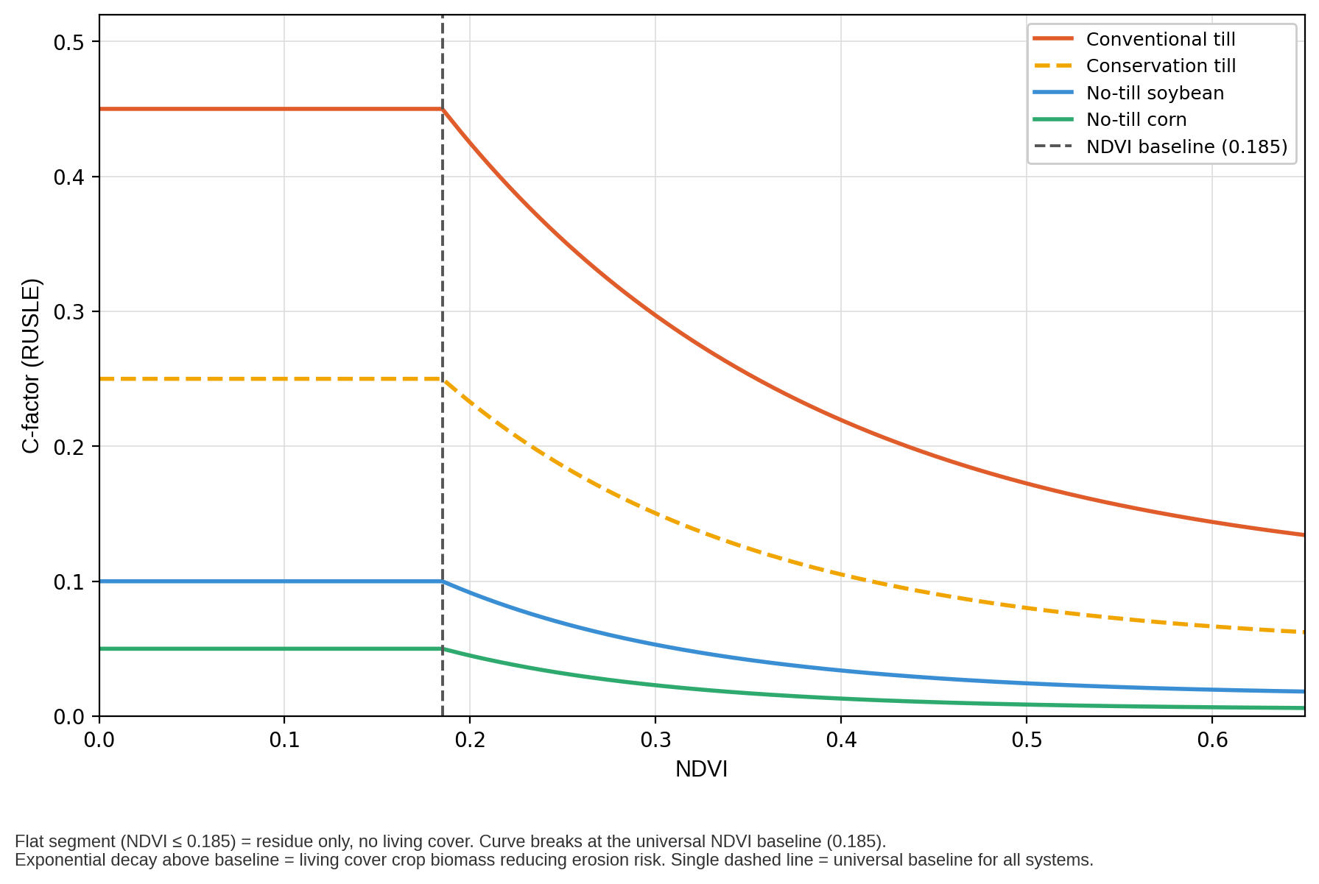
Figure 3. Piecewise exponential C-factor curves by residue management system. Each curve shows C-factor vs. NDVI for one residue system. C equals the intercept at or below NDVI 0.185 (residue-only zone). Above 0.185, C decays exponentially toward the floor as living biomass accumulates. Steeper backslope positions with higher LS-factor amplify the risk difference between systems.

5.2 Residue System — Curve Selector
CoverMap v1.8 does not apply a residue multiplier. The CCA-selected residue system controls which exponential decay curve is applied to each pixel’s NDVI. Residue protection is embedded in the intercept parameter — the C-factor for that management system when no living cover is present (NDVI = baseline). This replaces the v1.7 approach of multiplying a lookup-table C-factor by a separate residue factor, which treated residue and living vegetation as independent rather than integrated effects.

C_baseline is the intercept for the selected residue system. It represents the erosion risk from that tillage system with no cover crop planted. Because R, K, and LS remain constant between scenarios, erosion reduction simplifies to a pure C-factor ratio. C_baseline is used in all erosion reduction outputs in Section 5.3 and the CCA report.

C_baseline = intercept (C-factor at NDVI ≤ 0.185 — residue-only, no living cover)
C_adjusted = piecewise exponential model applied per-pixel
Pct_reduction = (C_baseline − C_adjusted) / C_baseline × 100

5.3 — Erosion Reduction by Risk Zone
CoverMap disaggregates RUSLE erosion reduction estimates by Risk Index zone. Each zone receives its own C-factor computation, LS-factor, and soil loss estimate derived independently from the pixel population assigned to that zone. This approach identifies which landscape positions carry the highest erosion load and quantifies the cover crop benefit at each position separately.

The zone-level table is the primary erosion reduction output in the CCA report and Streamlit app. Producer reports receive a single area-weighted summary (Section 7.6). All inputs (R, K, LS) and the piecewise exponential C-factor parameters are identical to the field-level RUSLE computation described in Section 7.

Step 1 — C-Factor Derivation Per Zone
Each zone’s C-factor is derived from zone-mean NDVI using the same piecewise exponential model (Section 5.1) and residue system parameters (Section 5.2) applied at field level.
C_adj = piecewise exponential ( zone-mean NDVI, residue system )
C_baseline = intercept for selected residue system ( NDVI ≤ 0.185 )
Pct_reduction = ( C_baseline − C_adj ) / C_baseline × 100
Pct_reduction = ( C_baseline − C_adj ) / C_baseline × 100

Note: Zone-mean NDVI is a single value per zone. Within-zone NDVI variance is suppressed. A Critical zone with bimodal NDVI distribution (eroded knob + vegetated waterway) is assigned a single C_adj. Absolute soil loss (t/ac/yr) still differs between zones because LS varies independently.

Table A — C-Factor Derivation: Shelby County Example (No-Till Corn, R=175, K=0.37)
Zone-mean NDVI is computed across all pixels assigned to each Risk Index zone and evaluated continuously in the piecewise exponential formula — no NDVI binning is applied. Zones with different mean NDVI values produce distinct C_adj outputs even when those values are close together.
Risk Zone | Zone Area | Mean NDVI | C_adj (piecewise) | C_baseline | Est. Reduction
Low | 35% | 0.52 | 0.077 | 0.250 | 69%
Moderate | 28% | 0.38 | 0.112 | 0.250 | 55%
High | 24% | 0.27 | 0.170 | 0.250 | 32%
Critical | 13% | 0.24 | 0.194 | 0.250 | 22%

Step 2 — Zone-Level RUSLE Soil Loss
Zone-mean LS is computed as the arithmetic mean of per-pixel McCool et al. (1987) LS values (see Section 6.1) across all pixels assigned to that zone. Zone-mean slope percent is the arithmetic mean of the Iowa 3m DEM pixel slopes within the zone, resampled to the 10m NDVI grid.
A_current = R × K × LS_zone × C_adj
A_baseline = R × K × LS_zone × C_baseline
A_saved = A_baseline − A_current

Table B — RUSLE Output by Zone (matches app and CCA report display):
Risk Zone | Zone Area | Mean Slope | C-factor | Mean LS | Est. Soil Loss (t/ac/yr) | Est. Reduction (%) | Est. Soil Saved (t/ac/yr)
Low | 35% | 4% | 0.024 | 0.8 | 1.2 | 91% | 12.8
Moderate | 28% | 9% | 0.060 | 2.1 | 8.2 | 78% | 28.5
High | 24% | 15% | 0.135 | 4.3 | 37.6 | 50% | 37.6
Critical | 13% | 22% | 0.135 | 6.6 | 57.7 | 50% | 57.7
Field (area-weighted) | 100% | — | — | — | 19.23 | 60% | 29.0

Field (area-weighted) footer row computations:
a_saved_weighted = Σ( A_saved_zone × area_fraction )
= (0.35×12.8) + (0.28×28.5) + (0.24×37.6) + (0.13×57.7) = 29.0 t/ac/yr
a_baseline_weighted = Σ( A_baseline_zone × area_fraction )
= (0.35×14.0) + (0.28×36.7) + (0.24×75.2) + (0.13×115.4) = 48.2 t/ac/yr
pct_reduction_weighted = a_saved_weighted / a_baseline_weighted × 100 = 29.0 / 48.2 × 100 = 60%

Known limitations: Zone-mean NDVI suppresses within-zone variability. A Critical zone with bimodal NDVI distribution (eroded knob + low-lying waterway) is assigned a single C_adj. The residue system C-factor parameters (intercept, floor, k) do not vary by landscape position — an assumption that may understate cover crop benefit on backslopes where residue retention differs from summit positions. Piecewise exponential C-factor parameters are pre-calibration estimates (±10 pt uncertainty). Validation priority: Weston Dittmer RUSLE2 comparison runs, Shelby County Monona map units.

6. LS-Factor and Risk Index (C×LS)

6.1 LS-Factor — Simplified Lookup from Slope
The LS-factor combines slope length (L) and slope steepness (S) effects on erosion. True RUSLE2 LS-factor requires flow accumulation analysis to determine slope length. CoverMap uses a simplified per-pixel lookup from slope percent only — slope length is not computed.
Figure 4 (existing). Slope% → LS-factor lookup (left) and Risk Index zone classification (right).
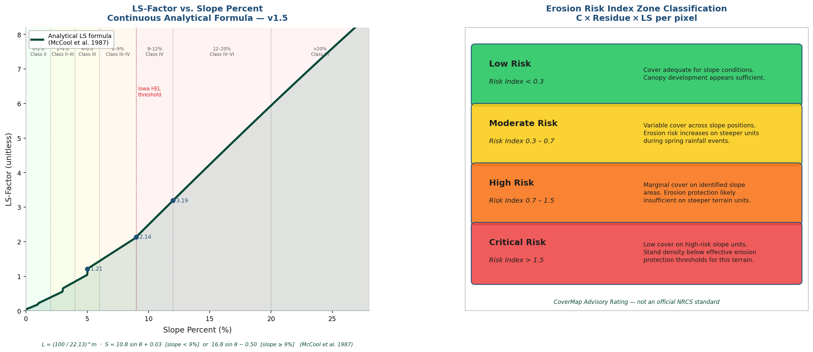
θ = arctan(slope_pct / 100)
S = 10.8 × sin(θ) + 0.03 [slope < 9%]
S = 16.8 × sin(θ) − 0.50 [slope ≥ 9%]
L = (100.0 / 22.13) ^ m
LS = L × S [per pixel, numpy vectorized]
Term | Value / Source | Definition
θ | arctan(slope_pct / 100) | Slope angle in radians. Derived from per-pixel slope% computed from Iowa 3m DEM.
S | Continuous function of θ | Slope steepness factor. McCool et al. (1987) piecewise formula: lower equation for slopes < 9%, upper equation for slopes ≥ 9%. Floor = 0.03 to prevent zero values on flat ground.
L | (100.0 / 22.13) ^ m | Slope length factor. Assumed slope length λ = 100m — consistent with Iowa Loess Hills summit-to-backslope field geometry. True slope length requires flow accumulation analysis (planned Phase 2 improvement). Unit plot reference length = 22.13m.
m | 0.5 (slope ≥5%), 0.4 (3–5%), 0.3 (1–3%), 0.2 (<1%) | Slope-length exponent. Varies with slope class per RUSLE convention. Applied per pixel.
LS | Unitless | Combined length-steepness factor. Continuous and spatially explicit — every pixel receives its own LS value from its exact slope%.

Known limitation — slope length not computed: CoverMap uses simplified per-pixel slope lookup for the Risk Index map. For the RUSLE soil loss estimate, a single field-mean slope drives a single LS value. In both cases, slope length is not computed — true RUSLE2 LS requires the horizontal distance from flow origin to concentration point. This is appropriate for field advisory use but not for formal NRCS conservation planning.

6.2 Risk Index — Pixel-Level C×LS Computation
Risk Index (per pixel) = C_adjusted × LS
Unitless composite erosion vulnerability score. Computed at 10m resolution across entire field.

Both C-factor and LS-factor are computed at every pixel. The Risk Index array is then classified into four zones. This is the key improvement over field-mean approaches — steep backslopes get high Risk Index values even when the field-wide average is moderate.

Risk Index | Zone | Map color | Agronomic meaning | Recommendation text
< 0.3 | Low Risk | #22C55E green | Cover adequate for slope conditions | Cover crop establishment adequate for slope conditions. Canopy development appears sufficient to reduce erosion risk based on NDVI analysis.
0.3–0.7 | Moderate Risk | #FACC15 yellow | Variable cover on slope positions | Cover crop stand is variable across slope positions based on NDVI analysis. Erosion risk increases on steeper units during spring rainfall events.
0.7–1.5 | High Risk | #F97316 orange | Marginal cover on steeper terrain | Cover crop establishment is marginal on identified slope areas. Erosion protection is likely insufficient on steeper terrain units based on NDVI analysis.
> 1.5 | Critical Risk | #EF4444 red | Low cover on high-risk slope units | Satellite imagery indicates low cover crop establishment on high-risk slope units. Stand density appears below effective erosion protection thresholds for this terrain based on NDVI analysis.

6.3 Field-Level Concern Level — From Zone Distribution
The field-level concern level (used in the CoverMap Advisory and report header) is determined from the pixel distribution of Risk Index zones. This approach is more meaningful than a field-mean Risk Index because it captures the area of the field that is truly at highest risk. Logic is applied in priority order — the first condition met determines the level.

Concern Level | Pixel distribution trigger | Working definition
Critical | ≥20% of valid field pixels in Critical zone (C×LS > 1.5) | Critical erosion risk dominant across significant field area. Inadequate cover on high-risk slope units.
High | ≥5% of pixels Critical, OR >40% of pixels in combined High/Critical zones | Substantial erosion risk. More than 40% of field has marginal or failed cover on moderate-to-steep slopes.
Moderate | 20–40% of pixels in combined High/Critical zones AND Critical pixels <5% | Variable cover across slope positions. Erosion risk elevated on steeper units but not dominant field condition.
Low | ≥80% of valid pixels in Low/Moderate zones AND Critical pixels <5% | Cover adequate for slope conditions. Canopy development appears sufficient across the majority of field pixels.

Priority order: (1) Critical fires if ≥20% Critical pixels. (2) High fires if ≥5% Critical OR >40% combined High/Critical. (3) Moderate fires if 20–40% combined High/Critical AND Critical <5%. (4) Low applies to all remaining fields.

7. Simplified RUSLE — Estimated Soil Loss

7.1 RUSLE Equation and Factor Sources
Figure 5. RUSLE factors (top), T-value comparison zones (middle), and Iowa example (bottom).
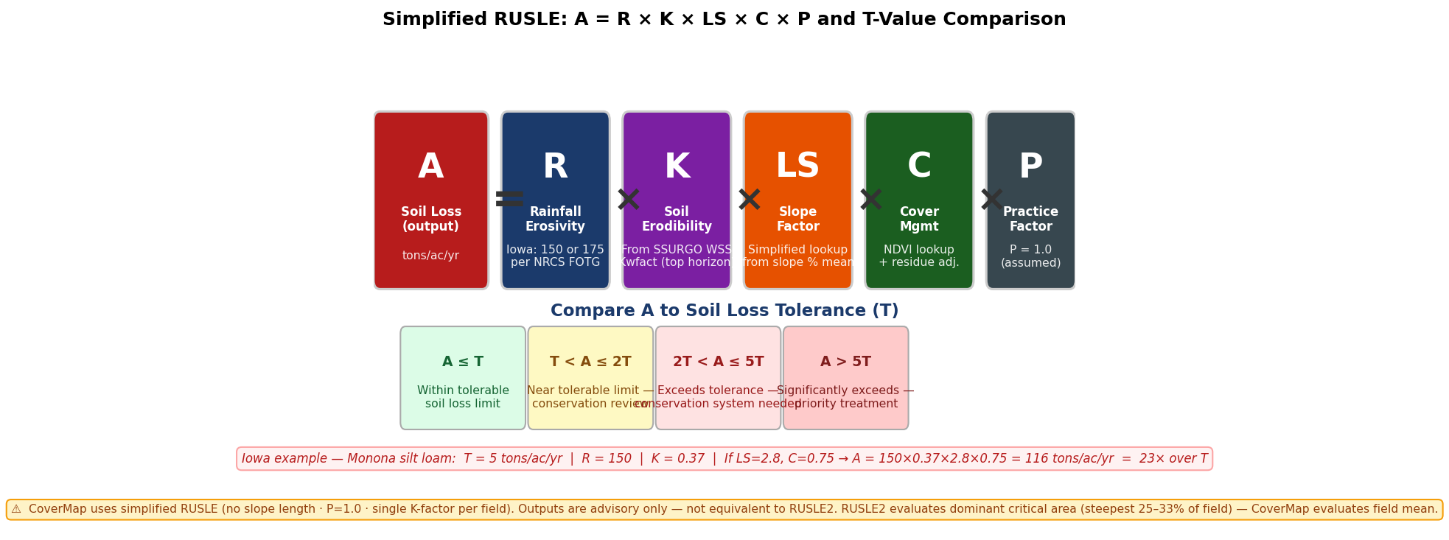

A = R × K × LS × C × P
A = estimated annual soil loss (tons/acre/year) │ P = 1.0 assumed (no practice factor)

Factor | Name | CoverMap source | Value / range | Limitation
A | Annual soil loss (t/ac/yr) | Computed output | Varies by field | Field-average — see Section 7.3
R | Rainfall erosivity | FCC API → Iowa FOTG 2-zone lookup | 175 (standard Iowa default); 150 (NW Iowa — 34 counties) | County-level precision only. Fallback = 175 (conservative)
K | Soil erodibility | SSURGO WSS API — kwfact, top horizon | 0.28–0.37 (Shelby Co. typical) | Dominant component only — single value per field
LS | Slope length-steepness | Analytical S-factor formula (McCool et al. 1987), 100m assumed slope length | Continuous — varies with exact pixel slope% | No flow-accumulation slope length — see Section 6.1
C | Cover-management | Piecewise exponential C-factor model (NDVI + residue system parameters) | 0.03–0.90 | Model parameters pre-calibration; RUSLE2 comparison in progress (W. Dittmer, Shelby County NRCS, 2026)
P | Support practices | Assumed P = 1.0 (none) | 1.0 (fixed) | Terraced fields require P < 1.0

7.2 T-Value Comparison
Estimated soil loss A is compared to the tolerable soil loss T for the dominant soil series. T is the maximum average annual erosion rate a soil can sustain indefinitely without long-term productivity loss. T is retrieved from SSURGO or looked up in the IOWA_T_VALUES dictionary by soil series name.

Ratio A/T | Conservation status | Meaning
A ≤ T | Within tolerable limit | Current management is maintaining soil within long-term sustainable loss rate
T < A ≤ 2T | Near tolerable limit | Conservation system review recommended — approaching threshold
2T < A ≤ 5T | Exceeds tolerable limit | Conservation system needed per NRCS planning criteria. Soil loss is 2–5× the sustainable rate
A > 5T | Significantly exceeds limit | Priority conservation treatment indicated. Soil loss is more than 5× the sustainable rate

7.3 How CoverMap Differs from RUSLE2 — Critical Distinction
This is the most important limitation for NRCS and ISU audiences to understand.
Zone-level outputs in Section 5.3 reduce the dilution effect by separating backslope pixels, but CoverMap zone estimates still reflect field-average conditions within each zone and remain lower than RUSLE2 dominant critical area values

Dimension | RUSLE2 | CoverMap
Computational unit | Single hillslope profile — a line from water origin to concentration point | Field average across all pixels including flat bottomland
Area selected | Dominant critical area — the steepest 25–33% of field (per Iowa Agronomy Technical Note 29) | Mean of entire field — flat areas dilute the risk estimate
Slope length (L) | Measured or estimated from topographic survey or DEM flow accumulation | Assumed 100m — continuous S-factor applied per pixel (v1.5)
C-factor | Computed daily through crop stage periods with detailed residue sub-factors | Single NDVI observation with piecewise exponential model with per-residue-system parameters (intercept, floor, k). NDVI baseline 0.185 separates residue-only from living-cover signal.
Deposition | Explicitly computed on concave toeslopes — sediment that deposits before leaving field is credited | Not computed — all detached sediment assumed to leave field
Expected relationship | RUSLE2 evaluates worst-case — highest values | CoverMap field average almost always LOWER than RUSLE2 for same field

Practical implication: If a CCA presents a CoverMap report showing A = 47 tons/ac/yr and an NRCS conservationist runs RUSLE2 on the same field and gets 180 tons/ac/yr, this is expected — not a bug. CoverMap averages the whole field including flat toeslopes. RUSLE2 focuses on the steepest slope segment. Both are correct for what they measure. The CoverMap report disclaimer explicitly states: “CoverMap estimates field-average soil loss. RUSLE2 evaluates the dominant critical area. RUSLE2 outputs will be higher than CoverMap estimates for the same field.”
7.6 Producer Report Output — Erosion Reduction Summary
The producer report displays erosion reduction as three labeled rows rather than the full zone table. This format is intentional — producers receive the field-level weighted summary without zone-level RUSLE detail that requires CCA interpretation.

Output Row | Value | Description
Est. Cover Crop Erosion Reduction | pct_reduction_weighted (%) | Loss-weighted % reduction across all Risk Index zones. Computed as a_saved_weighted / a_baseline_weighted × 100. More precise than a simple field average because high-LS backslope zones are weighted by their disproportionate baseline soil loss contribution.
Baseline Soil Loss (no cover) | a_baseline_weighted (t/ac/yr) | Area-weighted baseline soil loss across zones under the same tillage system with no cover crop planted. C_baseline = intercept for selected residue system (piecewise exponential model).
Est. Soil Saved (area-weighted) | a_saved_weighted (t/ac/yr) | Area-weighted soil saved: Σ(A_saved_zone × area_fraction). Accounts for disproportionate erosion contribution of high-LS backslope positions.

Disclaimer shown in producer report: Estimates based on RUSLE C-factor methodology. Piecewise exponential C-factor parameters are pre-calibration estimates. ±10 pt uncertainty on reduction percentage. For official soil loss determination contact your local NRCS field office.

7.5 Cover Crop Erosion Reduction
CoverMap provides per-zone and field-level erosion reduction estimates in a dedicated Erosion Reduction by Risk Zone section, displayed separately from the Estimated Soil Loss vs. Soil Loss Tolerance section in all output formats (Streamlit app, CCA report, and producer summary). This section quantifies the erosion protection benefit of the observed cover crop stand compared to a baseline scenario with no cover crop planted, using the same RUSLE factors (R, K, LS) applied across both scenarios so that the percentage reduction isolates the C-factor contribution of living cover.

% Erosion Reduction = (C_baseline - C_factor_adjusted) / C_baseline × 100
Where C_baseline = the C-factor intercept for the selected residue system (C at NDVI=0 from the piecewise exponential model) represents the same tillage system with no cover crop planted. Because R, K, and LS factors remain constant between scenarios, the percentage reduction simplifies to a pure C-factor ratio comparison.

REMOVE_THIS_SECTION_76
Parameter | Formula | Example (No-till corn, NDVI=0.25)
C_baseline | intercept (residue system) | intercept = 0.250 (conservation tillage)
C_factor_adjusted | piecewise exponential ( NDVI, residue system ) | 0.050 + (0.250−0.050) × exp(−6 × (0.251−0.185)) = 0.185
A_baseline | Current soil loss × (C_baseline / C_factor_adjusted) | 12 t/ac/yr × (0.27 / 0.135) = 24 t/ac/yr
% Reduction | (C_baseline - C_factor_adjusted) / C_baseline × 100 | (0.27 - 0.135) / 0.27 × 100 = 50%

7.6 Display Format — CCA Report and App
The erosion reduction metric appears as a 3-column table row in the 'Estimated Soil Loss vs. Soil Loss Tolerance' section:

Metric | Baseline (no cover) | Current / Saved
Est. Cover Crop Erosion Reduction | 24.0 tons/ac/yr | 12.0 tons/ac/yr (50% reduction)

Validation Status: Piecewise exponential C-factor parameters (intercept, floor, k) are pre-calibration estimates — not yet validated against RUSLE2 Iowa State File runs. The erosion reduction estimate inherits ±10 percentage point uncertainty directly. Baseline assumption: same tillage system, no cover crop planted. For official conservation planning use NRCS RUSLE2 Iowa State File.

This metric provides CCAs and producers with a concrete, quantified estimate of the erosion protection benefit achieved by establishing cover crops. The baseline comparison enables economic justification for cover crop investments and supports EQIP conservation practice documentation.

8. Zone Summary Tables — Outputs

8.1 NDVI Zone Summary Table
The NDVI zone table is computed from the clipped NDVI array using boundary-masked pixels only. Acreage is computed from pixel count × pixel area (10m × 10m = 100m² = 0.0247 acres per pixel).
Column | Computation | Units | Notes
Zone label | Dynamic from ndvi_threshold slider: Low Cover (NDVI < threshold), Marginal, Good Cover | Text
Acres | pixel_count × (10m × 10m) / 4046.86 — boundary-masked pixels only | Acres (US survey)
% of Field | zone_acres / total_valid_acres × 100 | Percent

8.2 Risk Index Zone Summary Table
The Risk Index zone table is computed from the pixel-level C×LS array after applying the boundary mask. Only pixels with valid NDVI (non-NaN) are counted. Acreage confirmed accurate against WSS AOI measurements (Spring 2026 pilot fields).
Column | Computation | Units
Zone | Critical (4), High (3), Moderate (2), Low (1) — from classify_risk_zones() | Text
C×LS Range | Fixed thresholds: >1.5, 0.7–1.5, 0.3–0.7, <0.3 | Unitless
Acres | np.sum((zone_array == val) & ~np.isnan(ndvi_array)) × 0.0247 | Acres
% of Field | zone_pixel_count / total_valid_pixels × 100 | Percent
Mean Slope (%) | Arithmetic mean of per-pixel slope values within zone, derived from Iowa 3m DEM resampled to 10m NDVI grid. Converted from degrees: tan(slope_radians) × 100. | Percent

8.3 Cover Crop Stand Assessment — EQIP Documentation Checklist
This table documents what satellite remote sensing can and cannot verify for NRCS EQIP Practice Standard 340 (Cover Crop). It is supplemental documentation — it is not a payment determination.
Checklist Item | Method | What it verifies | What it does NOT verify
Cover crop present | NDVI > 0.20 | Spatial presence of living vegetation in field boundary | Species identity — NDVI cannot distinguish cereal rye from weeds or volunteer crop
Image date | GEE metadata + scene count | Date-stamped record before termination with scene quality indicator | That conditions are unchanged from date of image to date of field visit
Estimated biomass | NDVI proxy ±40% | Rough biomass range — order of magnitude estimate only | Actual weight. ±40% uncertainty. Not a scale measurement.
30% ground cover | % pixels above NDVI threshold | Spatial estimate of adequate cover zones | Actual ground cover percentage — requires line transect field measurement per NRCS protocol
Seeding rate | Field records required | Nothing — satellite cannot verify seeding rate | Seeding rate, depth, method — require seed receipt and field records
Termination date | Field records required | Nothing — must be documented at time of termination | Termination date and method — NRCS Cover Crop Termination Guidelines compliance
Field boundary | Operator provided | That a boundary polygon was submitted | Boundary accuracy — operator-drawn boundaries are not survey-grade
Valid pixels | NDVI > 0.05 threshold | Percentage of in-polygon pixels with detectable vegetation signal | That the remaining pixels are cloud-free — see data quality guard
Species confirmation | Field records required | Nothing — satellite cannot verify species | Cover crop species, mix ratios, or variety — require seeding records
Cooperator signature | Physical form required | Nothing — app generates no legal document | Producer attestation — requires wet signature on NRCS AD-1026 or equivalent

9. Known Limitations and Planned Improvements
Limitation | Current approach | Impact | Planned improvement
Piecewise exponential C-factor parameters pre-calibration | Initial parameter estimates based on published RUSLE2 value ranges for Iowa cropland (Renard et al. 1997). NDVI baseline 0.185 derived from 15 Iowa field observations (mean=0.179, SD=0.013). | HIGH — affects every soil loss estimate and C-factor when residue system is selected | RUSLE2 Iowa State File comparison runs for 6–8 Iowa field scenarios. Prioritize before NRCS formal review.
No slope length in LS-factor | Simplified slope% lookup — same LS for 50ft and 300ft slope at same gradient | MODERATE — LS underestimated on long slopes, overestimated on short slopes | Flow accumulation analysis using pysheds or richdem on Iowa 3m DEM. Phase 2 feature.
Single K-factor per field | Dominant soil component only from WSS — applied uniformly | MODERATE — understates risk on Ida/Burchard slope units in mixed Shelby County fields | Pixel-level K-factor from SSURGO polygon intersection. WSS API supports this query.
No GDD / phenology adjustment | Same NDVI thresholds applied regardless of image date or growing degree days | MODERATE — March dormant rye at NDVI 0.18 is very different from May rye at same NDVI | NOAA GDD API lookup at field centroid. Adjust biomass estimate and threshold interpretation by GDD.
NDVI-biomass saturation | Cannot differentiate stands above ~3,500 kg/ha | LOW for erosion planning — above saturation means excellent stand | NDRE (red-edge) band from Sentinel-2 saturates higher — add as optional layer.
P=1.0 assumed | No support practice factor applied | LOW for most Iowa fields — few have terraces or contour strips | Add P-factor dropdown (terraced/contoured/none). Iowa FOTG has county-specific P values.
Single-season validation | One field, one season, one WSS comparison (Shelby County, Spring 2026) | HIGH — insufficient for peer review or NRCS formal acceptance | Five additional pilot fields across Iowa landscapes and soil types. ISU Extension co-validation. CIG grant funding target.
Conservation tillage C-factor not split by crop residue | Single curve applied to all conservation tillage systems regardless of previous crop (corn vs. soybean residue differ meaningfully in mass and decomposition rate) | LOW — directionally correct; underestimates difference between corn-residue and soybean-residue scenarios in conservation tillage | Split conservation tillage into separate corn-residue and soybean-residue curves with distinct intercept and k parameters. Pending RUSLE2 validation for each scenario.

11. References and Data Sources
1. Huddell, A.M., Thapa, R., Marcillo, G.S. et al. (2024). U.S. cereal rye winter cover crop growth database. Scientific Data, 11, 200. doi:10.1038/s41597-024-02996-9
2. Laflen, J.M. & Roose, E.J. (1998). Methodologies for assessment of soil degradation due to water erosion. Advances in Soil Science.
3. Iowa State University Extension and Outreach. Cover Crops. Integrated Crop Management, Iowa State University, Ames IA. crops.extension.iastate.edu/crops/cover-crops
4. ISU Extension PM-1901. Tillage, Manure Management and Water Quality. Iowa State University Extension.
5. USDA-NRCS (2002). Iowa FOTG Section I — USLE Erosion Prediction, Figure 2: Iowa Rainfall Factors. Updated Electronically September 2002. Iowa NRCS State Office, Des Moines IA.
6. Iowa Agronomy Technical Note 29. Dominant Critical Area. USDA-NRCS Iowa State Office, April 2024.
7. USDA-NRCS (2024). Conservation Practice Standard 340 — Cover Crop. Iowa Supplement.
8. USDA-NRCS National Soil Survey Handbook, Part 622. Land Capability Classification.
9. Prabhakara, K. et al. (2015). Evaluating the relationship between biomass, percent groundcover and remote sensing indices across six winter cover crop fields in Maryland. Remote Sensing of Environment, 163, 220–233.
10. Iowa Department of Natural Resources (2024). Three-Meter Digital Elevation Model of Iowa. Iowa Geospatial Data Clearinghouse.
11. European Space Agency (2023). Sentinel-2 User Handbook. ESA Standard Document.
12. USDA-ARS (2013). Revised Universal Soil Loss Equation Version 2 (RUSLE2) User’s Reference Guide.
13. Federal Communications Commission. Area API (geo.fcc.gov/api/census/block/find). Used for Iowa county R-factor zone lookup.
14. Zimmerman, S. (2026). Sentinel-2 NDVI baseline observations for Iowa no-cover-crop fields. Unpublished field validation dataset. n=15 fields, five counties (Dallas, Shelby, Cass, Adair, Madison), three tillage systems, corn and soybean residue, March–April 2026 Sentinel-2 L2A imagery. Mean NDVI = 0.179, SD = 0.013. Used to derive UNIVERSAL_NDVI_BASELINE = 0.185 for CoverMap piecewise exponential C-factor model.
15. McCool, D.K., Brown, L.C., Foster, G.R., Mutchler, C.K., and Meyer, L.D. (1987). Revised slope steepness factor for the Universal Soil Loss Equation. Transactions of the ASAE, 30(5), 1387–1396.

CoverMap Technical Methods Guide — v1.8, Spring 2026. Stephen Zimmerman CCA MS, Ankeny Iowa. Pending ISU Extension Agronomy review. This document does not constitute an official NRCS technical standard or USDA publication. For official soil loss determinations contact your local NRCS field office.

Appendix A — Example Field Outputs and Graphics
This appendix documents representative CoverMap outputs from Shelby County pilot fields (Spring 2026). Figures illustrate the spatial outputs described in Sections 1–8. All field data are from the CCA-operated validation program. Graphics will be inserted as finalized.
A.1— CoverMap Risk Index Analysis: Sample Field Report Output
The Risk Index Analysis page is the primary field-facing output of a CoverMap CCA report. It displays the Erosion Risk Zone map, NDVI classification map, field-level concern level, zone summary tables, and the Erosion Reduction by Risk Zone table. The sample below is from a Shelby County pilot field (Spring 2026) and illustrates how spatial outputs from Sections 5 and 6 are presented to the CCA.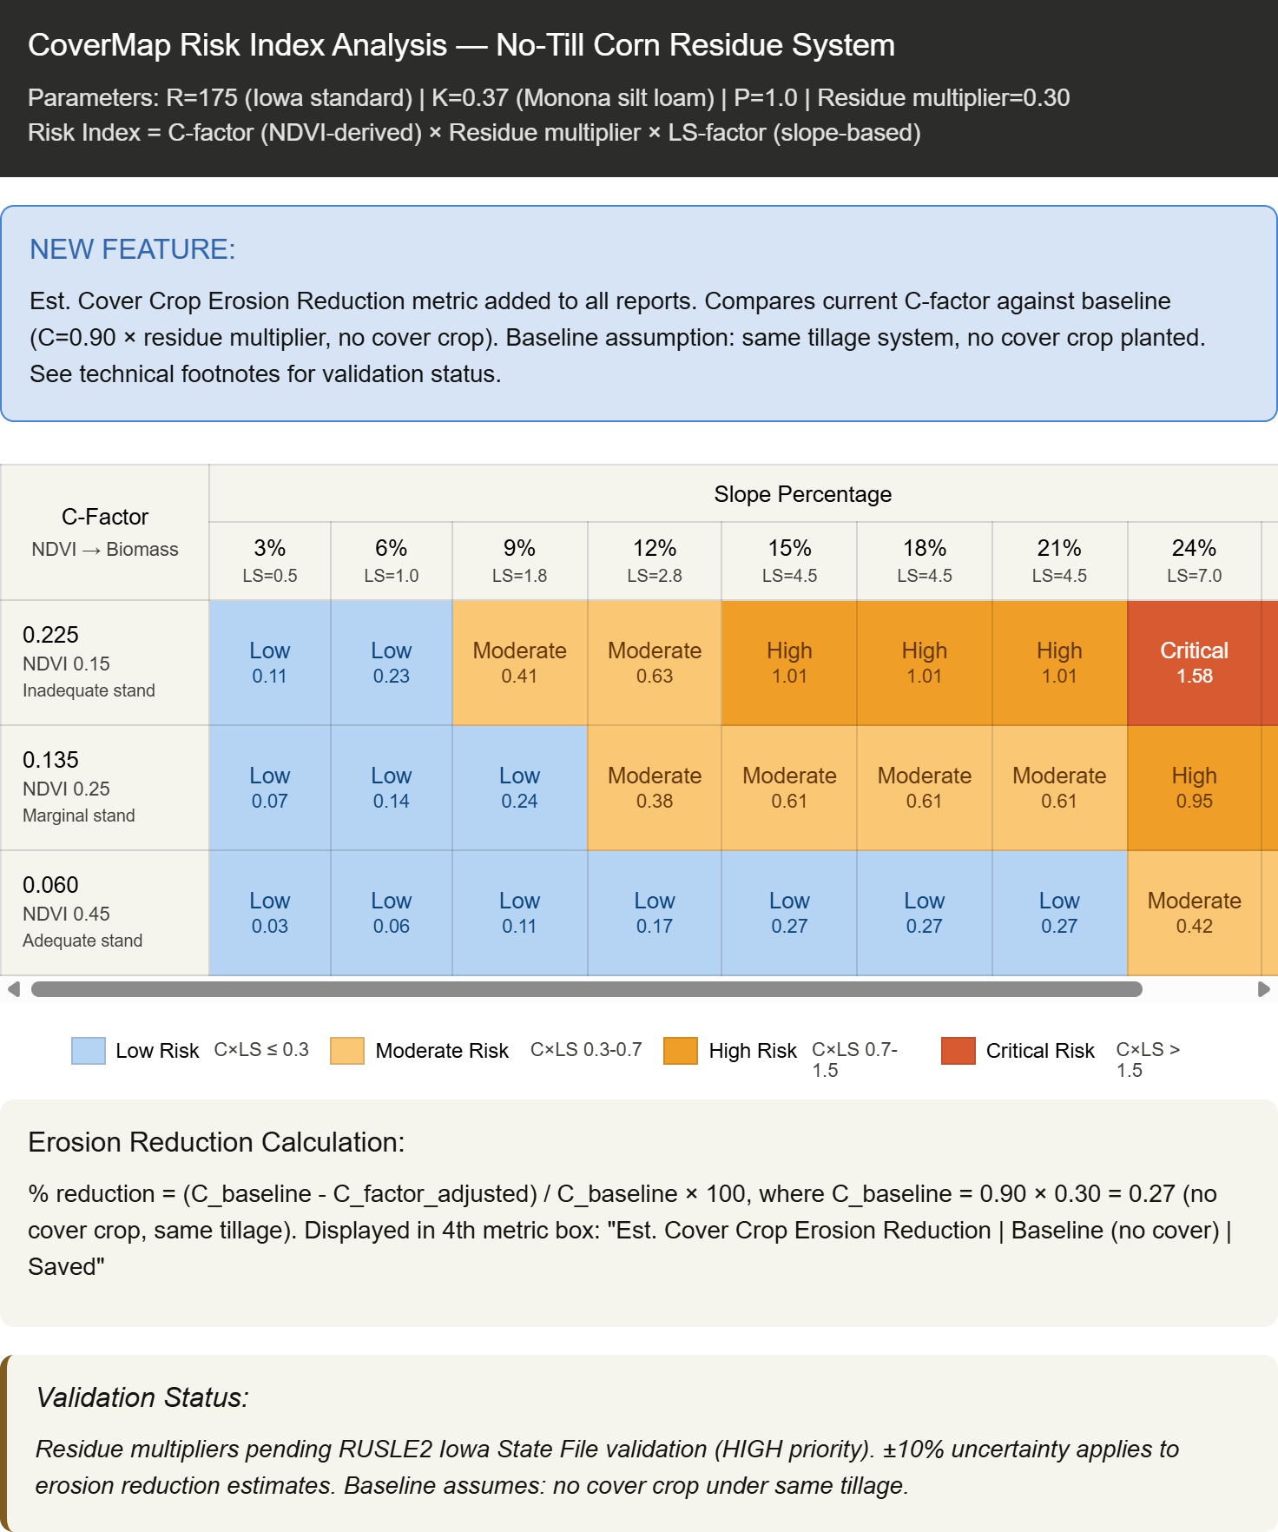

A.2 Erosion Risk Zone Map Example
The risk zone map shows per-pixel C×LS classification across the field boundary. Low (green), Moderate (yellow), High (orange), Critical (red). Backslope concentration of High and Critical pixels is the primary spatial output differentiating CoverMap from field-average NDVI tools.
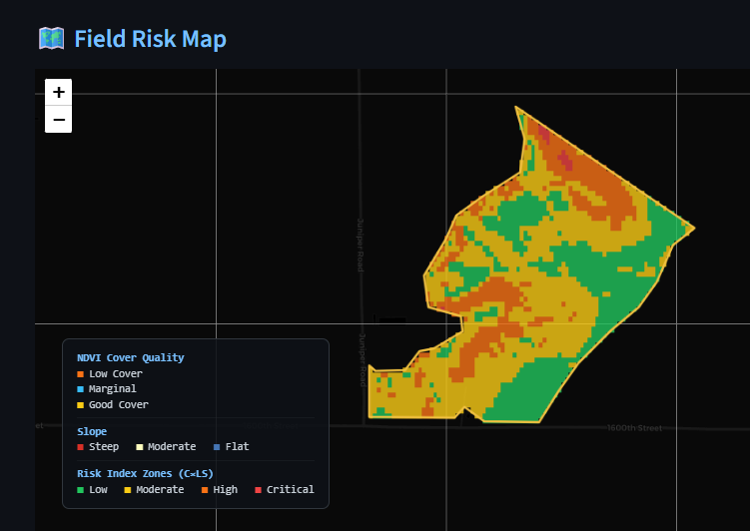

A.3 NDVI Classification Map Example
The NDVI classification map shows per-pixel cover quality zones (Low Cover, Marginal, Good Cover) derived from the Sentinel-2 median composite. Overlay with the risk zone map identifies where low-NDVI pixels coincide with high-LS backslope positions — the highest-priority management zones.

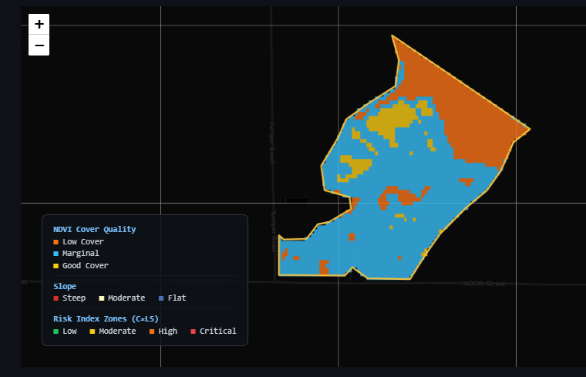

A.4 Erosion Reduction by Risk Zone — Example Report Table
The zone table as it appears in the CCA report PDF output. Columns match Section 5.3 Table B. The Field (area-weighted) footer row provides the headline figures for producer report and app display.

