# **GitHub**

**Q1. Git bash: (command: git bash)**

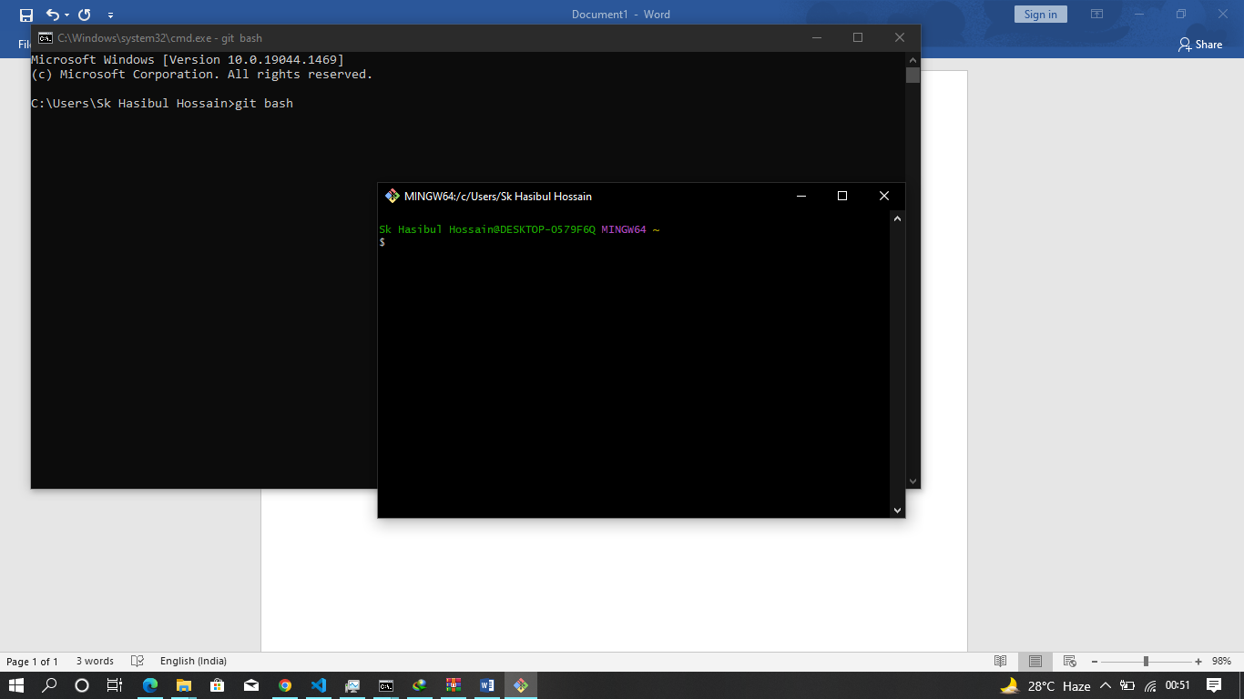

**Q2. Git shell modify: steps->**

1. **Goto the path-> C:\Program Files\Git\etc\profile.d**
2. **Find the file and open:- git-prompt.sh**

**TITLE bar name change: remove ($TITLEPREFIX) [Before]**

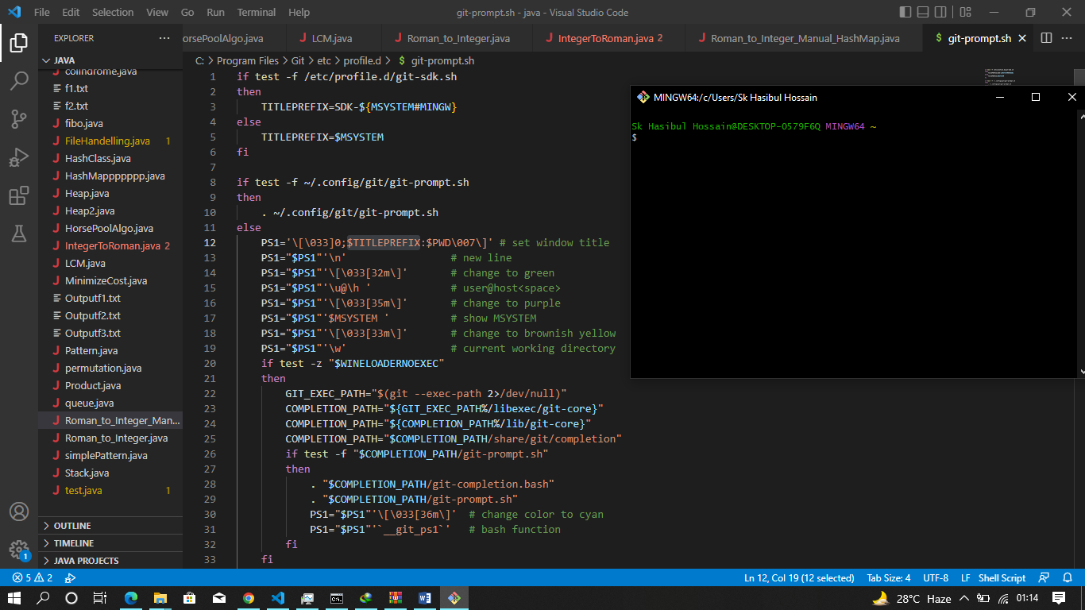

**After:**

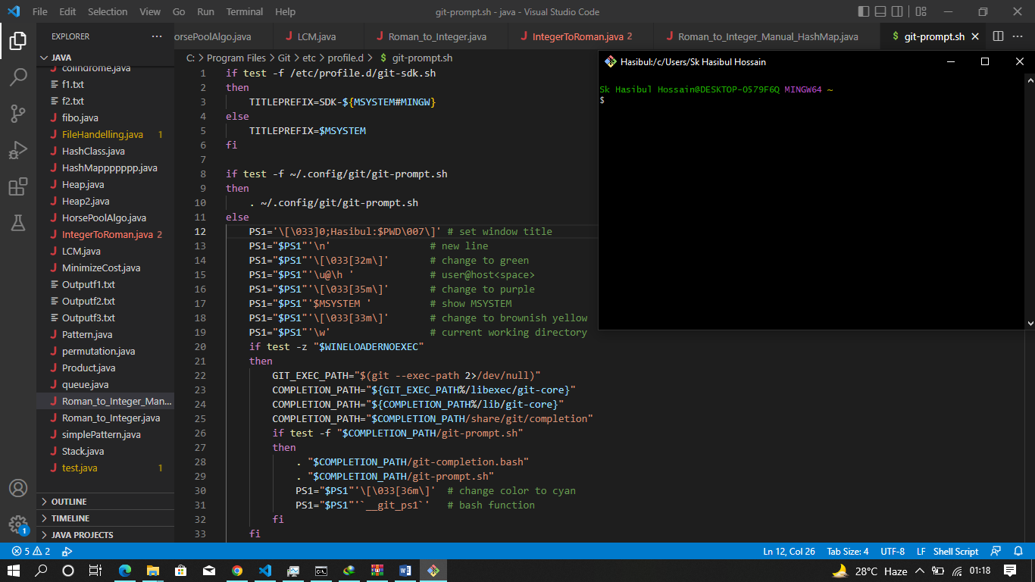

**Remove: PS1=”$PS1”’$MSYSTEM ’ # show MSYSTEM**

**Remove : PS1=”$PS1”’$\u@\h ’ # user@host<space>**

**Change:** **PS1=”$PS1”’\w ’ # current working directory**

**TO**

**PS1=”$PS1”’[ \w ]’ # current working directory**

**Change: PS1=”$PS1”’$ ’ # prompt: always $**

**TO**

**PS1=”$PS1”’> ’ # prompt: always >**

**Output:**

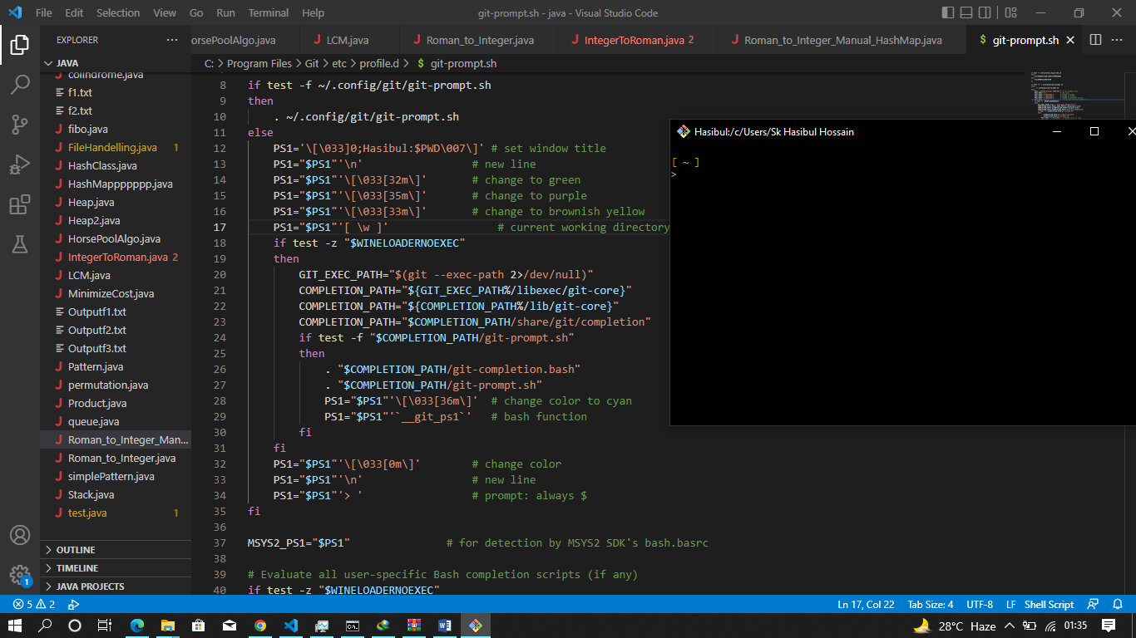

**Q3. Create git repository: git init**

**Q4. Check status file/folder : git status**

**Q5. Git has three stages: untrack state, staging state, commit state**

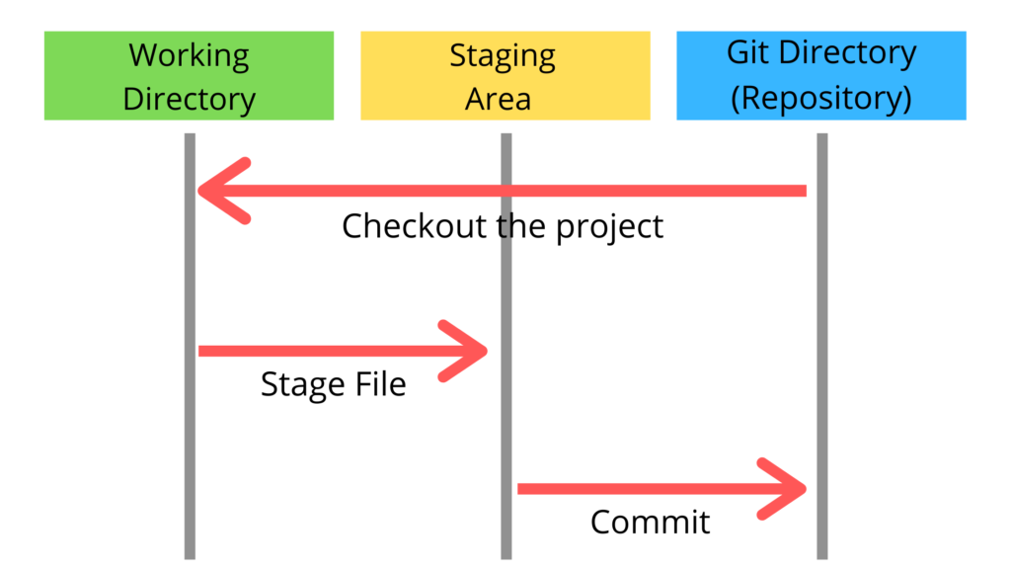

**Q6. Add file: git add file.extension (staging state)**

**Q7. Add all file: git add . (dot represent all files staging state)**

**Q8. Commit file: git commit**

**Q9. log files(show all history on changes): git commit**

**Q10. Push: git push origin master**

# **Node Js**

**Nodejs $ NPM part 2: cowsay**

**Install: npm install -g cowsay**

**EsLint:- install-** npm init @eslint/config

**Create a file: .eslintrc (dot)eslintrc**

**Code:-**

**{**

**“rules”{**

**“no-unused-vars”: “warn” //warn/error/off**

**}**

**}**