PA4 Report

Problem statement : Performing any program analysis, use its result to transform Java class files and then measure the improvement within the Java Virtual Machine.

Approach to this problem: To solve this problem we decided to apply live variable analysis and based on the liveness analysis a deadcode eliminiation is supposed be performed.

Problems encountered:
1. While folowing the instruction for installation, many errors were encountered, missing libraries outdated instruction, and there were also some instructions that were missing, which were important for instatllation.

2. we couldn’t disable default intraprocedural optmization done by soot (live variable, constant forwarding, copy propagation, dead code elimination etc.) due to which it became hard for us to check whether our changes in the AnalysisTransformer were really changing the Jimple or not.

3. later, we thought of performing reaching defination analysis,
Implementation:

Result and Discussion:

one of the testcase we used to check our program.
Program: Test2.java

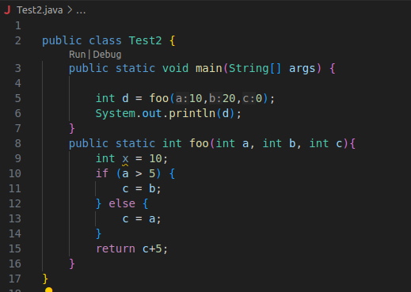

To check the removal of dead code, we used FernFLower Decompiler embedded in VSCode.

Decompiled code without soot
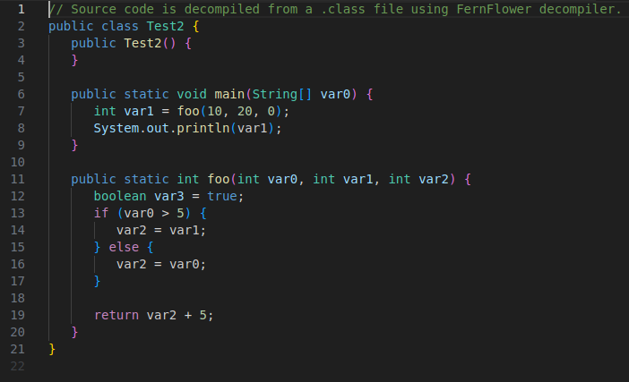

Decompiled Code with soot (sootOutput)
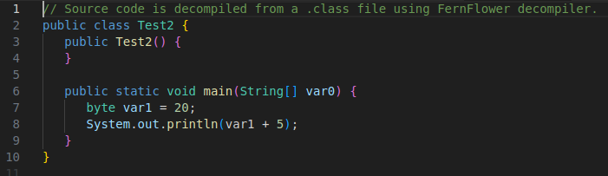
It is evident that dead has been eliminated after doing some static analysis and optimization like constant forwarding, live variable and reaching defination.

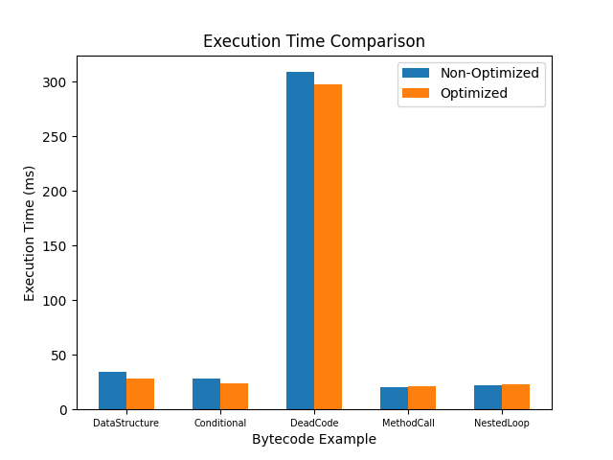

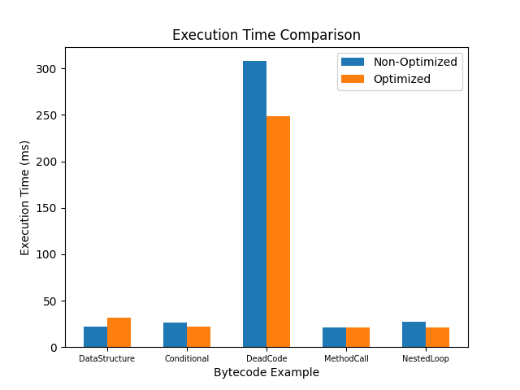
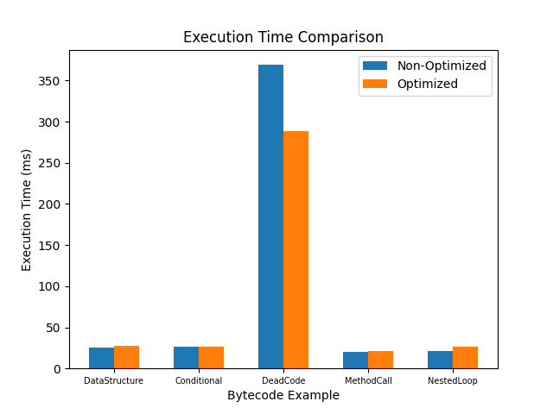
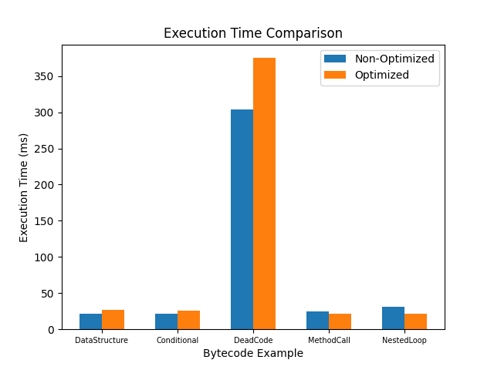

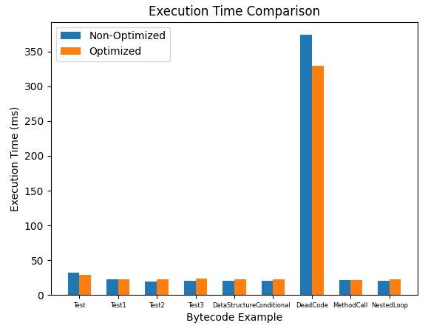
Adding more test cases:

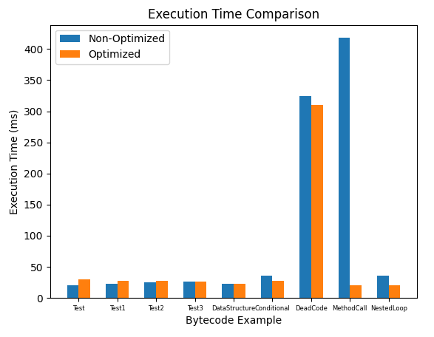
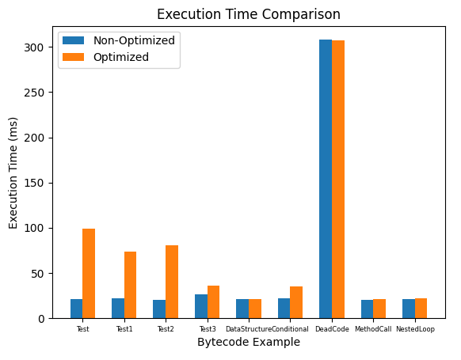

Now, there were instances where we could see optimized code is taking longer time than the former.
Reasons we could think of for this to happen are:
If the optimized version of the bytecode is taking more time than the non-optimized version, there could be several reasons for this:
- Optimization Overhead: The optimization process itself may introduce additional overhead, such as analysis time or additional computations, which could outweigh the performance benefits gained from the optimizations.
- Suboptimal Optimization: The optimizations performed by Soot may not be effective for certain bytecode examples. Some optimizations may have limited effectiveness or may even degrade performance in specific scenarios.
- Incorrect Optimization: There could be cases where the optimizations performed by Soot are not correct or do not produce the expected results, leading to suboptimal or even worse performance.
- Compiler Bugs or Limitations: There might be bugs or limitations in the Soot compiler that cause it to incorrectly optimize certain bytecode examples or fail to apply optimizations effectively.
- Hardware or Environment Differences: Differences in the hardware, runtime environment, or JVM settings between the optimized and non-optimized executions could also contribute to variations in performance.

Shubham Kumar Maurya (23M0836)
Nikhil Kumar Parida (23D0380)

