**I-LINK: INTERNATIONALIZATION, LINKAGE AND COLLABORATION**

**INFORMATION SYSTEM FOR CAVITE STATE UNIVERSITY –**

**TRECE MARTIRES CITY**

Undergraduate Capstone Project

Submitted to the Faculty of the

Department of Information Technology

Cavite State University – Trece Martires City Campus

Trece Martires City, Campus

In partial fulfillment

of the requirements for the degree

Bachelor of Science in Information Technology

**MEDELEN T. CAMANZO**

**ROBIN V. CLIMACOSA**

**JOSHUA P. CLUTARIO**

**CATHERINE N. DICHOSO**

May 2024

Republic of the Philippines

**CAVITE STATE UNIVERSITY**

**Trece Martires City Campus**

🕾 410-5247

[www.cvsu.edu.ph](http://www.cvsu.edu.ph)

**COLLEGE OF ENGINEERING AND INFORMATION TECHNOLOGY**

**Department of Information Technology**

Authors: **MEDELEN T. CAMANZO**

**ROBIN V. CLIMACOSA**

**JOSHUA P. CLUTARIO**

**CATHERINE N. DICHOSO**

Title:  **I-LINK: INTERNATIONALIZATION, LINKAGE AND COLLABORATION INFORMATION SYSTEM FOR CAVITE STATE UNIVERSITY – TRECE MARTIRES CITY CAMPUS**

**A P P R O V E D:**

|  |  |  |  |
| --- | --- | --- | --- |
| **PAMELA DAPHNE R. BUSOG MIT** | **______** | **KHENILYN P. LEWIS, DIT** | **______** |
| Adviser | Date | Technical Critic | Date |
|  |  |  |  |
|  |  |  |  |
|  |  |  |  |
| **KHENILYN P. LEWIS, DIT** | **______** | **VIENNA MI A. FERANIL, MED** | **______** |
| Department Chairperson | Date | Campus Research Coordinator | Date |
|  |  |  |  |
|  |  |  |  |
|  |  |  |  |
| **JESSIE ANNE T. DEMETILLO, PhD** **______** | | | |
| Campus Administrator Date | | | |
|  | | | |

**BIOGRAPHICAL DATA**

**Mr. Joshua P. Clutario** was born on October 6, 1999 at Makati City. He is the youngest among the five children of Mr. Roberto P. Clutario and Mrs. Maria Gina P. Clutario. He is currently residing at Brgy. San Aguistin III, City of Dasmariñas, Cavite.

In 2014, he obtained his primary education in Lancaan Learning Center located at City of Dasmariñas, Cavite. He finished his secondary education with honors in Langkaan II National High School from the academic year 2017 – 2018. Furthermore, he studies multimedia (arts and design) track in his senior high school at Francisco E. Barzaga Integrated High School.

In August 2020, he was accepted and he enrolled in Cavite State University - Trece Martires City Campus taking up a Bachelor of Science in Information Technology. He is also an active member of League of Information Technology Leaders (LITL) organization. In addition, he had participated some activities such as Fire Safety and Evacuation Drill and the Gender Sensitivity Training.

**I-LINK: INTERNATIONALIZATION, LINKAGE AND COLLABORATION**

**INFORMATION SYSTEM FOR CAVITE STATE UNIVERSITY –**

**TRECE MARTIRES CITY**

**Medelen T. Camanzo**

**Robin V. Climacosa**

**Joshua P. Clutario**

**Catherine N. Dichoso**

A capstone project manuscript submitted to the faculty of the Department of Information Technology, Cavite State University **–** Trece Martires City Campus, Trece Martires City, Cavite in partial fulfillment of the requirements for graduation with the degree Bachelor of Science in Information Technology with Contribution No. ____. Prepared under the supervision of Ms. Pamela Daphne R. Busog.

**INTRODUCTION**

To provide graduates with deep knowledge and relevant work experience in their respective areas of the study, the Cavite State University – Trece Martires City Campus have the Campus Linkage and Collaboration Unit to initiates, consolidates and sustains efforts to establish linkages to further academic and non-academic activities of the campus in support the plan towards internationalization. The unit has partnered with different institutions, organizations, and companies, local and international, to give its students the best training ground before they set out to the real world.

Collaboration and linkages will help each collaborating institution, agency and industry to fulfill its own mission. Apart from this, the university also engaged in the initiation, planning, implementation and monitoring of linkage activities. It promotes academic partnership with local and foreign universities by providing opportunities to faculty and students to participate in collaborative seminars, research and paper presentations, academic visits, person-to-person interactions and other academic activities between and among academic partners.

**Project Context**

The main reason why the study is being conducted is to lessen the burden and the works of the campus linkage and management information system officers. There is just one linkage and one management information system officer at the Cavite State University – Trece Martires City Campus, and they both manage all the records by themselves. But there are circumstances where files and data are pending due to loaded jobs. All processes are manual, so it requires a lot of time and effort. The documents submitted by the students and guest are manually encoded and recorded to their files. There is a possibility that the manual process may result in a slow process or the transaction will cause of delay that can lead to lack of engagement and / or for lack of progress in the partnership. The current process of the campus linkage and collaboration unit, the guest or private government must go to the campuses to conduct a meeting and draft the memorandum of understanding (MOU) to achieve a mutual understanding between two or more companies, government agencies or other parties. Each project to be undertaken shall be covered by memorandum of agreement wherein the specific duties and responsibilities of each party are fully defined. Once approved and stamped to legal form, the document is then forwarded to the dean or campus administrator to review and sign off. Afterwards, the documents will be sent to the Academic Council as well as, Admin Council to add their signatures to the sign off sheet. Finally, the signatures and dates are collected on an approval form and scanned to Office of the President for approval of Board of Regents.

The researchers aims to develop a web-based I-link: Internationalization and Linkage Information System for Cavite State University – Trece Martires City Campus to provide better access to information that can easily access to the system which reassure and build guest satisfaction by providing them an efficient and hassle-free transaction.

**Objectives of the Study**

The general objectives of the study was to develop a web-based information system for Internationalization and Linkage Collaboration in Cavite State University – Trece Martires City Campus.

Specifically, this study is aims to:

1. design a system that is capable of:
2. signing up or logging in as a guest, admin or as students;
3. communicate from admin to guests or students and vice versa using a chat box;
4. allows files transfer feature for distributing files and submit other documents online;
5. announce different important events, news, and programs in school;
6. can select a specific date for appointment or meetings; and
7. allows guest to monitor the status of their process for real-time status updates;
8. develop the system using the following hardware and software materials;
9. HTML and CSS for Front-end Programming;
10. PHP as Back-end Programming;
11. Visual Studio Code for Editor;
12. MySQL for database;
13. XAMPP for the localhost of the test system; and
14. phpMyAdmin for the Administration tool;
15. test the functionality of the system through unit testing, integration testing and system testing;
16. evaluate the system using ISO 25010 standards; and
17. prepare an implementation plan for the deployment of the system.

**Purpose and Description**

The main purpose of this capstone project is to develop a web-based Information System that is fast, accurate, reliable and easy to use. The proposed capstone project entitled “I-Link: Internationalization, Linkage and Collaboration Information System for Cavite State University – Trece Martires City Campus” will be designed and developed by the researchers for the school administrators, guest, and students of school. The proposed project will replace the university’s current manual process of the campus linkage and collaboration unit and will use web-based information system that enables authorized users to speed up the process, provide an updated, secured and easy to access to the system. This study will be beneficial to the students, admin, and with the university’s partners with different institutions, organizations, and companies, local and international. It provides information about the linkage’s services, scholarships, sponsorships, and manage all communication and documents in relation to students and admin exchanges programs. The list of pool of expert’s, linkages and partners, institutional memberships and OJT partners will be stored in the system. In addition, it provides the contact information and schedule of department heads, faculty members together with designated position. This means the users can easily find, identify, select and access the information they need.

**Time and Place of the Study**

The study will be conducted from May 2023 to December 2023 at Cavite State University – Trece Martires City Campus, Trece Martires City, Cavite.

**Scope and Limitation of the Study**

The study is primarily focused in designing, developing, testing, and evaluating a web-based of internationalization and linkage information system for Cavite State University – Trece Martires City Campus.

The system is designed using PHP and MySQL to address the issues and challenges that existed in the manual system’s transactions. The researchers design the system having three types of users; (1) admin that can access all the system’s features such as announcement, news, programs in school, and appointments. Also, admin can perform database and system maintenance; (2) guest can request appointments/meetings, submit other documents online and to monitor the status of their process; and (3) students (internship finder) can submit other documents online, inquire to the school admin (internship provider) using a chat box so that they could browse for available internship employer.

The system will limit the access in the system by providing a secure account for the student and only the admin has full access on the system and only be running through its domain. The guest creates their accounts so that they could have a transaction for linkages programs. The said project is an online platform, which implies that transactions can be accessed via the internet or local area network.

**Conceptual Framework**

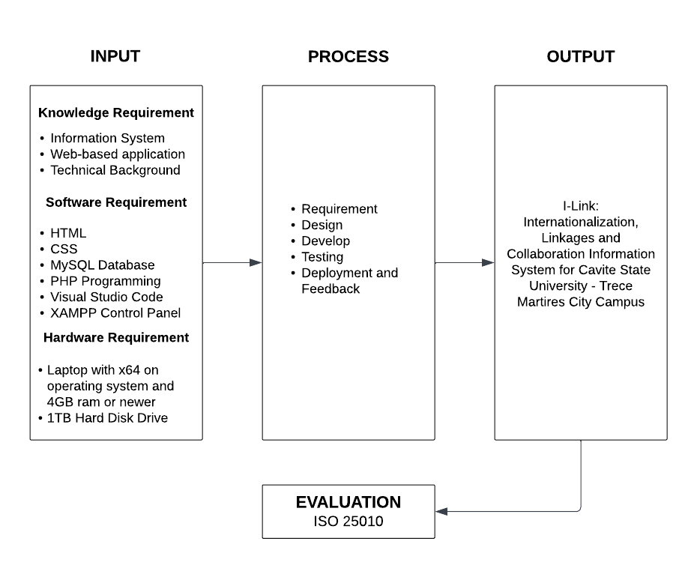 The conceptual framework includes the knowledge, hardware and software requirements for input; while in the process plan, design development, testing, release and feedback of the project and evaluation for the output of the system.

Figure 1. Conceptual Framework of the development of i-link: internationalization, linkage and collaboration information system for Cavite State University – Trece Martires City Campus

Figure 1. shows the conceptual framework of the I-Link: Internationalization, Linkages and Collaboration Information System in Cavite State University-Trece Martires City Campus. It consists of input, process and output. The input block indicates the knowledge, software and hardware requirements. The knowledge requirements consist of information system, web-based application and technical background. The software requirement consists of HTML, CSS, MySQL Database, PHP Programming, Visual Studio Code, XAMMP Control Panel. The hardware requirements that the researchers needed are laptop with x64 operating system and 4GB RAM or newer. The process block composed of requirement, design, develop, testing, and deployment and review the output is the I-link: Internationalization, Linkages and Collaboration Information System in Cavite State University Trece Campus application was evaluated using the ISO 25010 evaluation

instrument.

**Definition of Terms**

To make the study to be more understandable, the following terms used in this study are defined:

**Client.** A client of a professional person or organization is a person or company that receives a service from them in return for payment.

**Collaboration.** Is an act of working together with other people or organizations to create or achieve something

**Externals.** Is used to indicate that something connected with or located on the outside of something/somebody.

**Hypertext Markup Language (HTML).** is amarkup language that is used to structure a web page.

**Information System.** Can be defined technically as a set of interrelated components that collect, process, store, and distribute information to support decision making and control in an organization.

**Internationalization.** Is an action or process of making something become international.

**Link.** Is an identifier attached to an element in a system in order to indicate or permit connection with other similarly identified elements.

**Linkage.** "connection" the act of linking or the fact of being linked specifically the kind of connection where one thing follows the other, as if in a chain.

**MOA.** Is a legal document describing a business partnership between two parties that have agreed to cooperate to meet an agreed objecting or complete a project.

**MOU.** Is a formal agreement that outlines plans for a common line of action between two or more parties.

**MySQL.** Is an open-source database management system that is used for accessing, storing and managing of data.

**PHP.** Acronym of Hypertext Preprocessor. It is a server-side programming language that is used to develop a dynamic website or website applications.

**phpMyAdmin.** Is an open-source administration tool that gives user the ability to interact with MySQL.

**Pool of Experts.** Is a group of expert is somebody who has a broad and deep [understanding](https://en.wikipedia.org/wiki/Understanding) and [competence](https://en.wikipedia.org/wiki/Competence_(human_resources)) in terms of [knowledge](https://en.wikipedia.org/wiki/Knowledge), [skill](https://en.wikipedia.org/wiki/Skill) and [experience](https://en.wikipedia.org/wiki/Experience).

**Visual Studio Code.** is an open-source code editor primarily used to correct and repair cloud and web applications coding errors.

000

**REVIEW OF RELATED LITERATURE**

This chapter is about the related literature of I-Link: Internationalization, Linkage and Collaboration Information System for Cavite State University - Trece Martires Campus. This written information is related and relevant to a specific study. The studies in question were reliable and came from credible sources.

**Internationalization**

Internationalization in universities is the process of bringing global perspectives into the curriculum and campus culture. It is the integration of international, intercultural, and global dimensions into teaching, research, and service at universities. This includes activities such as faculty and student exchanges, international collaborative research, foreign language instruction, and the study of global issues. Internationalization is important for universities to remain competitive in the global market, as well as to offer students the opportunity to gain knowledge and skills that are increasingly necessary in the globalized world (Munilla, 2016).

According to CHED (2020). Internationalization has become an important part of higher education in the Philippines. Universities in the Philippines are increasingly engaging in international activities such as student exchange and study abroad programs, international partnerships, international research collaborations, and international faculty and staff recruitment. These activities provide students with the opportunity to expand their knowledge and experience of different cultures, as well as to gain a global perspective on the world. Internationalization has become an integral part of the Philippine higher education landscape and is seen as an effective way of improving the quality of education and preparing students for the global workforce.

**Benefits of Internationalization in Universities**

Internationalization of universities provides numerous benefits to students, faculty, and institutions. Internationalization can help universities to become more diverse and inclusive in their approach to teaching and learning, providing an opportunity for students to gain intercultural competency, develop a global mindset, and broaden their perspectives (Bourdeau & Murray, 2017).

Internationalization can help universities to gain access to a larger pool of talent and recruit students, faculty, and staff from around the world. Furthermore, internationalizing universities can help to increase collaboration and academic partnerships, enabling universities to build bridges between countries and foster mutual understanding between cultures (Harrison and Thomas, 2017).

**Linkage**

As mentioned by Adams (2009). Linkage is the process of connecting different educational institutions to create and share resources, programs, and services that benefit students. This can be done through collaborations, partnerships, or other forms of relationships. Linkage strengthens the higher education system by enabling universities to share resources and create new and innovative programs. This helps to better meet the needs of students, while also increasing the quality of education overall. Linkage also encourages diversity, since students from different institutions are able to learn from each other and create a more diverse learning environment. Finally, linkage helps to create a more efficient higher education system, since universities can more easily share resources and benefit from each other’s expertise.

As defined by Garcia & Huang (2014), Linkage in universities refers to the collaboration between two or more educational institutions in order to facilitate the exchange of students, faculty, and other resources. Linkage agreements can involve a variety of activities, such as sharing classes and courses, joint research projects, student exchange programs, and other collaborations. These agreements are beneficial for both institutions involved, as they provide students with the opportunity to gain valuable experience in different educational settings, to learn from different resources, and to broaden their knowledge base. Linkage agreements also provide universities with a valuable networking opportunity, allowing them to form partnerships with other institutions to share resources and ideas.

**Benefits of Linkage in Universities**

Linkage in universities has been proven to be a powerful tool for knowledge transfer and collaboration. It is a form of partnership between universities and other organizations, such as businesses, government agencies, and other universities, which allows them to share resources and develop joint initiatives. This type of collaboration allows universities to access a larger pool of resources, engage in research projects, and transfer knowledge and skills among institutions. Linkage also enables universities to bridge the gap between their research and the real world, allowing students to gain practical experience and skills. In addition, universities can benefit from an increase in funding for research and development projects, as well as access to the latest technology and resources. Thus, linkage in universities provides numerous benefits to students and faculty, as well as the wider community (Simmons et al., 2020).

**Collaboration**

According to Harper (2014). Collaboration is the process of two or more people or organizations working together to complete a task or achieve a goal. This involves sharing knowledge and resources, working together to analyze a problem and develop a solution, and making joint decisions. Working together has become increasingly important in today's globalized economy, where organizations must work together to be successful. Collaboration is not only beneficial for businesses, but also for individuals, as it can lead to improved communication, problem solving, and decision-making skills. Furthermore, collaboration can help to build trust and understanding between individuals, which can lead to better relationships and improved performance.

Collaboration between universities has been successful in the areas of student exchange, joint research and development, and the sharing of resources and information. Furthermore, the universities involved in collaboration reported increased visibility, improved resources, and increased academic performance. The university collaboration can benefit both universities and the society at large (Alim, 2015).

**Benefits of Collaboration in Universities**

Collaboration in universities can be highly beneficial for both students and faculty. Studies have shown that collaboration helps students learn more effectively, build relationships, and develop critical thinking skills. It also encourages students to be more involved in the learning process, which can lead to improved learning outcomes. Collaboration among faculty can also lead to increased productivity and creativity. By working together, faculty can share research findings, discuss teaching strategies, and develop innovative ideas. Collaboration in universities can lead to a more productive and successful learning environment (Horn & Staker, 2013).

**Information System**

According to Little (2013), an information system is a combination of hardware, software, and telecommunications networks that people build and use to collect, create, and distribute, store, and manage information. Information systems are used to process data into useful information which can then be used to support decision making, coordination, and control in an organization. An information system is most effective when it is designed to fit the needs of the organization it is intended to support. The information system must be able to effectively collect, store, analyze, and disseminate information in order to meet the specific goals of the organization.

The technology components of an information system can range from a simple handheld calculator to a complex network of computers, databases, and software applications. Information systems are used to support a variety of business functions, including finance and accounting, marketing, operations, and human resources. The use of information systems provides organizations with the ability to analyze data and make informed decisions, improve efficiency and productivity, reduce costs, and improve customer service (Bhattacharya and Ghosh, 2017).

**Importance of using Information system in universities**

According to Fahy (2018), Information systems are essential for the effective management of university operations and for the delivery of services to students, faculty, and staff. They provide the necessary infrastructure and software to store, retrieve, manage, and distribute information. With information systems, universities can streamline processes, improve access to information, and better manage resources. The use of information systems can facilitate communication, increase collaboration, and enable data-driven decision making. In addition, information systems can also be used to track student progress, create timetables, and manage student enrollment. As such, they are an essential component of any university's operations, and their continued use can help universities achieve their educational goals.

**Advantage of using information system**

The utilization of information systems in Philippine universities is advantageous in a variety of ways. Information systems provide a platform for universities to store and manage data and documents, track student progress, streamline processes, and improve communication. Furthermore, information systems enable universities to increase their efficiency and effectiveness when managing courses, students, and staff. Additionally, information systems provide universities with improved access to data and analytics, which can be used to make informed decisions and improve the quality of education. With the help of these systems, universities can also offer more personalized learning experiences and better services to their students. All in all, the utilization of information systems in Philippine universities provides a number of benefits that can help them to achieve their mission and goals (Ledo and Mariano, 2017).

**Universities-Industry Linkage**

Universities-Industry Linkage is a term used to describe the collaboration between universities and industry. It is a two-way process which seeks to leverage the strengths of both parties to create mutual benefit. Universities are typically able to provide research and development support to industry while industry can provide funding, access to experts, and resources to universities. Through this process, universities and industry can work together to create innovative solutions to industry problems, accelerate the commercialization of research, and develop new technologies and products. This type of collaboration has become increasingly important in today’s economy and is seen as a major factor in driving economic growth (Chen, 2016).

**Advantage of University-Industry Linkage**

University-industry Linkage have been found to be beneficial for both the university and industry. These partnerships have resulted in increased knowledge and technology transfer to industry, increased research and development in universities, and increased human resource development. They have also been found to increase industry-university collaboration and networking, and have been found to lead to new products and services, new markets, and new jobs. The study concluded that university-industry linkage has the potential to improve the competitiveness of the country’s economy (Reyes, 2018).

University-industry linkage can help bridge the gap between universities and industry, thus allowing the country to benefit from an increased flow of knowledge, ideas, and resources. Furthermore, this linkage can also help create an environment that encourages innovation and entrepreneurship, create jobs, and provide economic development opportunities. In addition, the linkage can also help to facilitate the development of new products, services, and technologies, which can help drive the growth of the country’s economy (Domingo et al., 2019).

**University-Industry Collaboration**

University-industry collaboration is a type of partnership between universities and businesses that involves the joint development of research and technology, as well as the sharing of resources and knowledge. Such collaborations are beneficial to both parties, as universities gain access to industry expertise, resources and technology, while businesses can benefit from the research and knowledge base of the university. Examples of university-industry collaboration include joint research projects, technology transfer, and knowledge exchange. Additionally, universities and businesses collaborate on the development of new technologies, the exchange of personnel and the design of educational programs (García-Peñalvo, et al., 2016).

**Advantage of University-Industry Collaboration**

University-industry collaboration has become an increasingly important part of the country's economic development. The collaboration enables partners to share knowledge and resources, as well as to create new and innovative products and services. This type of collaboration has numerous advantages, including the ability to quickly bring new products to market, access to capital, access to new markets and new customers, the opportunity to develop strategic partnerships, and the ability to leverage existing resources. Additionally, university-industry collaborations can help to build a culture of entrepreneurship, encourage innovation, and promote economic growth. By partnering with industry, universities can also benefit from the resources, knowledge, and expertise of the companies they are working with (Gonzales, 2019).

**Link**

A link, sometimes referred to as a hyperlink, is a reference to a page or material on the web which can be activated by clicking or pressing to get access to that material. Links are usually shown as text or images that are underlined or highlighted, making them stand out from the other words. They are a way for the content maker to offer extra context, information, or resources to their readers, as well as a way to move through the huge network of webpages on the internet (Gustin, 2019).

**Benefits of links in website**

According to Farooq et al. (2020), Link is a great way to increase website traffic and increase brand awareness. Links are valuable because they act as a vote of confidence from one website to another. When a website links to another website, it can help to boost the credibility of that website. Additionally, links to a website can help search engines to crawl and index a website more quickly and accurately. Thus, link building can help a website to gain greater visibility in search engine results pages.

**External**

According to Feinberg and Keegan (2017), External is refer to something that is outside or separate from a particular system, organization, or entity. In the context of the internet, external refers to resources, information, or links that are located outside of the website or webpage being viewed. For example, an external link on a webpage would take the user to a different website or webpage, rather than remaining within the same site. External resources can be useful for providing additional information, context, or perspectives on a particular topic, but it is important to verify the reliability and credibility of external sources before citing or using them.

**External Link**

According to the World Wide Web Consortium (2017), External links are links to websites that are not part of the current website. They are typically used to provide additional information or resources to the user. External links are often used to link to official documents or other authoritative sources. External links are links to other websites, including other websites from the same organization.

**Difference between link and external link**

A link is a hyperlink, or a reference from one web page to another web page on the same website. An external link, also known as an outbound link, is a reference from one web page to another web page on a different website. External links allow for the website to connect with other websites and provide relevant information to their users (SEO Gear, 2019).

**Difference between University-Industry Linkage and University-Industry Collaboration** According to Chen (2018). University-industry linkage and university-industry collaboration are two distinct concepts related to the relationship between universities and industries. University-industry linkage focuses on the transfer of knowledge, resources, and/or technologies between the two entities. University-industry collaboration, on the other hand, is a more holistic approach of combining the strengths of both entities, such as research, development, and education, to create a mutually beneficial relationship. Although the two concepts are related, university-industry linkage tends to have a more one-sided focus, while university-industry collaboration is more focused on the long-term partnership between both entities.

**Related Studies**

**Internationalization, Linkages and Collaborations: Information System Needs in the Philippines**

The study entitled “Internationalization, Linkages and Collaborations: Information System Needs in the Philippines” was conducted by the National Academy of Science and Technology (NAST) in the Philippines (2018). The study revealed that the use of information systems facilitates the sharing of knowledge and resources and the development of new collaborative projects between local and foreign institutions. By using information systems, organizations can access and exchange information with other stakeholders in a faster, more efficient and cost-effective way. The study concluded that the use of information systems is essential for organizations to take advantage of the opportunities offered by internationalization, linkages and collaborations. This could help to foster innovation, create jobs and spur economic growth in the region.

**Internationalization, Linkage and Collaboration Information Systems in the Philippines: Philippine Institute of Development Studies**

The study entitled “Internationalization, Linkage and Collaboration Information Systems in the Philippines: Philippine Institute of Development Studies” was introduced by Que, A. (2013). This study explored the role of internationalization, linkage and collaboration information systems in the Philippine context. The study aimed to determine how information systems can facilitate the sharing of knowledge across borders, between public and private institutions and between organizations. The study found that information systems can play an important role in the internationalization of Philippine organizations by providing access to global networks and enabling collaboration between organizations. Furthermore, the study concluded that information systems can be used to strengthen the economic and social ties between different countries and to provide access to needed resources and expertise. The study also found that information systems can also facilitate the identification of potential partners and the establishment of joint research, production and distribution networks. All in all, the study concluded that information systems have the potential to improve the overall performance of the Philippine economy by providing access to global resources and opportunities.

**A web-based platform to facilitate internationalization, linkage and collaboration efforts. International Journal of Online and Distance Learning**

The project entitled “A web-based platform to facilitate internationalization, linkage and collaboration efforts. International Journal of Online and Distance Learning” was established by Gutierrez, L (2017). It is a web-based platform designed to facilitate internationalization, linkage, and collaboration efforts between Philippine universities, industries, and other stakeholders. The Internationalization, Linkage and Collaboration Information System (ILCIS) is a one-stop shop that provides a comprehensive listing of the Philippine universities, their respective internationalization activities, and other collaboration opportunities. It also serves as a platform for the universities and industries to share information and collaborate on projects. Through the ILCIS, universities, industries and other stakeholders can access comprehensive and up-to-date information on Philippine universities, their respective internationalization activities, and collaboration opportunities. The ILCIS also serves as a virtual meeting place for universities, industries and other stakeholders to collaborate in the development of new projects and initiatives. This platform is an important tool to foster internationalization and collaboration in the Philippines.

**International Linkages for Education and Cooperation (ILEC)**

The project entitled “International Linkages for Education and Cooperation (ILEC)” was initiative of the International Council for Open and Distance Education (2020), this project aims to improve education and collaboration opportunities for global citizens. Through the ILEC project, International Council for Open and Distance Education (ICDE) has developed a platform that supports the sharing of knowledge and resources between universities, organizations, and individuals from different countries. The platform includes an online database of global education and collaboration opportunities, as well as a network of international institutions and organizations that are working together to promote internationalization, linkage and collaboration. The ILEC project also provides resources such as research and development, training, and support for those interested in pursuing internationalization and collaboration.

**Developing an Integrated Internationalization, Linkage and Collaboration Information System**

The project entitled “Developing an Integrated Internationalization, Linkage and Collaboration Information System” was established by Tan et.al, (2016). Is a highly useful tool for developing international ties between countries and organizations. It provides important information about trade agreements, cultural and economic agreements, diplomatic and political dealings, and professional and academic collaborations. In addition to helping individuals, businesses, and governments to find and establish new partnerships, it also encourages and facilitates global interactions. By providing access to a range of data, this system assists countries and organizations in finding and maintaining the sought-after links in interdependent international relationships. Furthermore, through this information system, users can easily and efficiently access and manage related information that is relevant for their activities. The development of this system is a vital step towards fostering global collaboration and integration.

|  |  |  |  |  |  |
| --- | --- | --- | --- | --- | --- |
| **FEATURE** | **ILINK: INTERNATIONALIZATION, LINKAGE, AND COLLABORATION INFORMATION SYSTEM FOR CVSU TRECE MARTIRES CAMPUS** | **INTERNATIONALIZATION, LINKAGES AND COLLABORATION INFORMATION SYSTEM NEEDS IN THE PHILIPPINES** | **INTERNATIONALIZATION, LINKAGE AND COLLABORATION INFORMATION SYSTEMS IN THE PHILLIPINES: PHILIPPINE INSTITUTE OF DEVELOPMENT STUDIES** | **INTERNATIONAL LINKAGES FOR EDUCATION AND COOPERATION (ILEC)** | **A WEB-BASED PLATFORM TO FACILITATE INTERNATIONALIZATION, LINKAGE AND COLLABORATION EFFORTS. INTERNATIONAL JOURNAL OF ONLINE AND DISTANCE LEARNING** |
| Login and Registration | ✓ | ✓ | ✓ | ✓ | ✓ |
| Account management | ✓ | ✓ | ✓ | ✓ | ✓ |
| Scheduling module | ✓ | ✓ | ✓ | ✓ | ✓ |
| Information  Module | ✓ | ✓ | ✓ | ✓ | ✓ |
| Communication Module | ✓ | ✓ | ✓ | ✓ | ✓ |
| Security Management | ✓ | ✓ | ✓ | ✓ | ✓ |

Table 1. Comparison of different studies in different aspects.

Table 1 shows the features of related studies of the proposed study. I-Link: internationalization, linkage, and collaboration information system are similar to cited work and related studies. I-Link and the cited work and related studies have features such as Login and Registration, Account management, scheduling module, information module, communication module, and security modules.

**Technical background**

The proposed project will be available in website in any technology such as computer and mobile phone, by accessing it through any browser. The technology that will be used in this project is VS Code, MySQL, XAMPP, and phpMyAdmin. The code editor that will be used in this project is called Visual Studio Code (VS Code) which is often used for web development. It was created by Microsoft and widely used by developers for tasks such as writing and debugging code, building and deploying applications, and working with version control systems.

**Visual Studio Code**

According to Redmonk (2021), Visual Studio Code is a lightweight source code editor for web and cloud development, supporting the most popular programming languages. It offers a wide range of features, including intelligent code completion, syntax highlighting, debugging tools, version control integration, and support for various programming languages. Its user-friendly interface and extensive plugin ecosystem make it a favored choice among developers for a diverse range of projects and development workflows.

VS Code has the most active open-source community of developers by a wide margin, with thousands of extensions available for various programming languages, frameworks, and development tools. These extensions provide additional features, such as code linting, debugging capabilities, language support, Git integration, and much more. The ability to tailor VS Code to specific programming needs through these extensions allows developers to boost productivity and streamline their workflow, making it a preferred choice for many programmers and organizations.

**MySQL for the database**

According to Ahmad and Ullah (2017), MySQL is an open-source relational database management system. It is fast, reliable, and flexible. One of the main advantages of MySQL is its ease of use. It can be used for a wide range of applications, from small websites to large enterprise applications. MySQL also offers a wide range of features such as replication, triggers, stored procedures, and views. Furthermore, MySQL is highly scalable, meaning that it can easily handle large amounts of data and transactions. It is also easy to maintain, as its database structure is well-defined and structured. MySQL is also compatible with a wide range of programming languages, including PHP, Python, and Java. This makes it an ideal solution for many web development projects.

As specified by Thomas (2020), MySQL is a popular and powerful open-source relational database management system and is widely used for managing and storing data. It is a multi-threaded, multi-user database management system and provides secure and fast data transaction capabilities, helping to improve the reliability of data-driven systems. The researchers choose to utilize MySQL as it is well-known for its speed, dependability, and usability and is frequently used in web development.

**XAMPP**

Based on Uribe (2021), XAMPP is a freely available project developed by Apache, designed to facilitate the creation and experimentation of programs on a local server. It encompasses a comprehensive set of components, including the Apache HTTP Server, MariaDB, and interpreters for multiple programming languages like Perl and PHP. The name XAMPP itself represents its core components: Cross-platform, Apache, MySQL, PHP, and Perl. This software package empowers users to construct websites on their personal computer's local server and subsequently publish them online.

XAMPP is an easy to install Apache distribution containing MariaDB, PHP, and Perl. It is an open-source software package that provides developers and administrators with an easy way to configure a web server. One of the major benefits of using XAMPP is the quick and simple setup, allowing users to be up and running in a matter of minutes. Additionally, the software is freely available and regularly updated with the latest versions of Apache, MariaDB, PHP and Perl. This gives users access to the latest development and security features.

**phpMyAdmin**

phpMyAdmin is a free, open-source software platform that is preferred by many for managing MySQL and MariaDB data on the web. Mostly written in PHP, it is a graphical user interface tool which can handle various data-related functions such as creation, editing, and elimination, as well as the modification of tables in databases. It is efficient enough for managing multiple databases concurrently. It is additionally capable of conducting activities like exploring data, executing SQL commands, and managing index, users, and privileges. Furthermore, it can provide backup, carry out search operations, and bring in and export data in numerous file formats such as SQL, CSV, XML, and spreadsheets (geeksforgeeks, 2019).

**Figma for web design**

Figma is a popular web design software that has gained immense popularity in recent years. It is a collaborative interface design tool that allows teams to create and share designs in real-time. With Figma, users can create complex user interfaces, animate them, and share them with fellow designers. It is user-friendly and easy to learn, making it suitable for both novice and professional. Figma also offers a variety of design assets, from UI kits to vector libraries, to help designers create beautiful websites (Nguyen, 2020).

**Synthesis**

The Capstone project of the researchers aims to help the campus by providing a platform for international collaboration, allowing the campus to connect with and leverage the expertise of academics and industry professionals from around the world. It also helps the campus to explore and develop international linkages, which can help to open up new opportunities for students and faculty. Furthermore, it serves as a powerful communication tool, helping to build relationships and foster collaboration among different organization. Finally, it can support the campus in its efforts to reach out to potential partners, providing access to valuable resources and information.

Ilink is an online portal designed to support internationalization, linkage and collaboration of CvSU Trece Martires Campus. It provides a platform for the exchange of information, resources, and collaboration between the University and organizations. ilink: internationalization, linkage and collaboration information system is comparable to cited work and related studies. All of these systems share the goal of facilitating international linkages for education, cooperation and collaboration. Specifically, they share same of features such as a web-based platform to establish and manage relationships between organizations and individuals, a account management to manage all their account activities such as creating, editing, and deleting personal information, a information management to store, organize, and maintain data in order to make it more accessible and useful, a communication module to allow users to communicate with admin using email message or system chat box, and a security management to protect the system from security breaches, unauthorized access, and other malicious activities. In addition, they all have the capacity to aggregate data and to provide access to a range of resources. Ultimately, the common goal of all these systems is to create an environment that enables organizations and individuals to collaborate, share knowledge and work together in a globalized context.

**METHODOLOGY**

000

# This chapter includes the requirement analysis, requirement documentation, design of software, systems, products and/or processes, project testing and evaluation, data analysis and implementation plan of the proposed study.

**Design of Software, Systems, Products and/or Processes**

**Requirement Analysis**

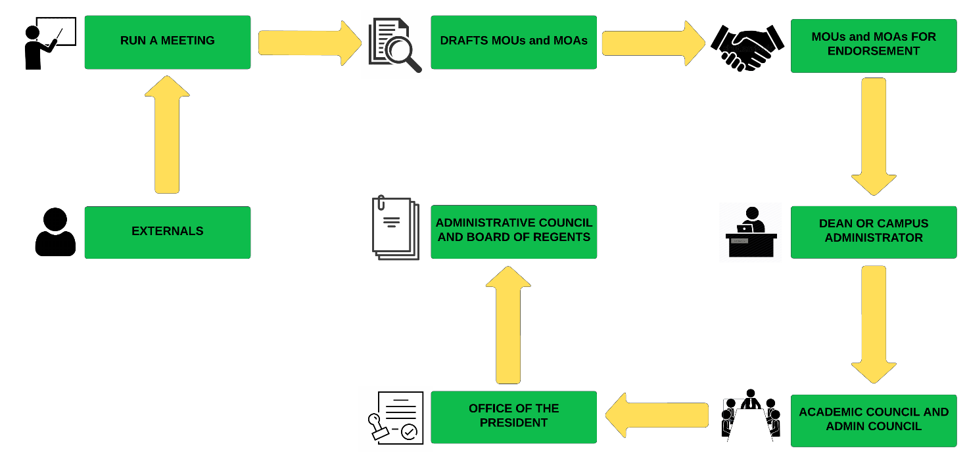 The requirement analysis introduced the current process flow of the campus linkage and management information system. It was the basis of the developed system to help the users; admin, student and guest in identifying unit in CvSU – Trece Martires City Campus.

Figure 1. Conceptual diagram of the current process flow of the campus linkage and collaboration unit

The process flow of the campus linkage and collaboration unit is depicted in figure 2. Beginning with the guest or private government assist by the campus linkage and management information system officer to conduct a meeting for both parties to cooperatively work together on an agreed upon project or meet an agreed upon objective. Once you get a draft agreement shall endorse the MOU/MOA to the dean or campus administrator. Once he/she has approved it, it will go to the academic council and admin council to identify and discuss issues that may impact on university’s internationalization strategy. The academic council and admin council will sign the agreement once they have reviewed it. Afterwards, the documents will be sent to the Office of the President for approval of Board of Regents.

**Requirement Documentation**

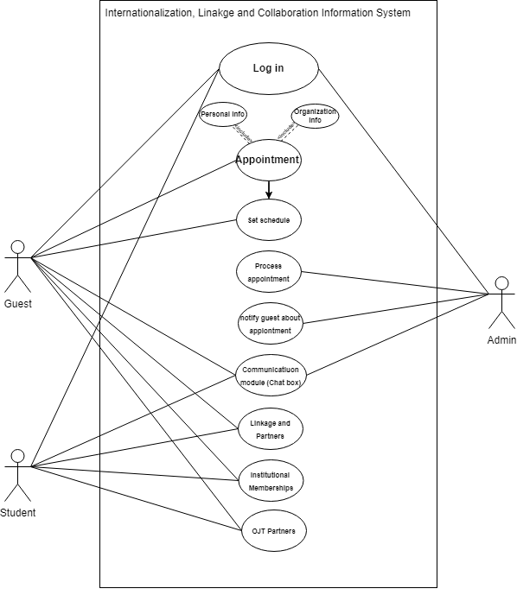

Figure 2. Use case diagram of web-based of internationalization, linkage and collaboration system for Cavite State University-Trece Martires City Campus

A use case design of the system is depicted in Figure 2. It depicts the various components of the system. A login element that allows the end-user to log in as a user, guest, admin or student. Every user has their own set of attributes. Request appointments, submit other documents online, communicate from admin to guests vice versa using chat box and monitor the status of their process are available to guest. To set appointments, announce different important events, news and programs, add user account, edit account, add student record, edit student record, add organizational record, edit organizational record, access all the system’s features, make any necessary changes, and perform database system maintenance are available to school administrator are available to admin. Submit other documents online, inquire to the school admin using a chat box are available to student or internship finder. These aspects are critical for both types of end-users. The element will make the process faster and more efficient.

**Account Management Module.** This module is for individuals to keep track of all their account activities, which includes the ability to create, edit, or delete personal information. it should provide an easy-to-use interface, enabling users to quickly access their accounts and manage their personal information as needed.

**Scheduling Module.** This module is for organizing appointment, tasks, events, and other activities. It allows users to quickly and easily coordinate activities and assign tasks. It also helps track project milestones, provide reminders of appointment, and can integrate with other system features like calendars.

**Information Module.** This module can be used to store and manage in order to make it more accessible and valuable. This system helps to organize data in a way that is easy to navigate, making it simple to access and utilize information. Additionally, this system can be used to maintain data, ensuring accuracy and accuracy to the most current data.

**Communication module.** This moduleprovides an efficient and convenient way to allow for continuous communication between active users and those in charge of the system. The email option allows for a simple text-based exchange of vital information, while the chat box provides real-time conversations and support. This communication module makes it simple and user friendly for inquiries, comments, and feedback to be exchanged in a timely and secure manner.

**Security management Module.** This module ensures the protection of the system from any security breaches, unauthorized access, and other malicious activities. This system should contain a series of security policies and procedures that should be in place to prevent and detect security threats. This system should also include strong authentication methods to ensure that only approved users have access to the system.

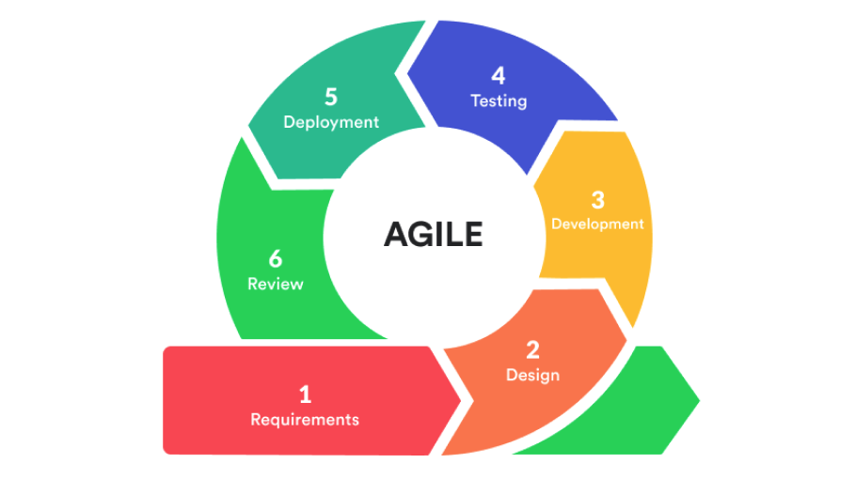**System Development**

Figure 3: Agile Model

Figure 3. illustrates the Agile Model that will be used by the researchers in developing the i-link: internationalization, linkage and collaboration information system which is made up of several phases. These are the following:

**Requirements**

The necessary software requirements for developing the I-Link: Internationalization, Linkage and Collaboration Information system includes HTML and CSS for front-end programming, PHP for back-end programming, MySQL for the database management, Visual Studio Code as the code editor, XAMPP to set up a localhost for testing the system, and Microsoft Edge for navigating phpMyAdmin. The hardware requirements for the project involve a laptop with or x64 operating system and a minimum of 4GB RAM, or a newer version.

**Design**

The researchers created an initial system prototype using Figma. Once the initial design was completed, they submitted it to their capstone advisor and technical advisor for feedback and necessary modifications. After receiving the initial reviews, the researchers implemented the requested changes from both advisors, iterating until they achieved the final prototype.

**Development**

After gathering all the software and hardware requirements and finishing the design, the researchers started to code the back-end of the application using PHP. The researchers used the phpMyAdmin administration tool to temporarily store the information needed, which acted as the connection database and served as the navigation for the localhost domain. After finishing the back-end coding, the researchers started to code the front-end of the application using an integration of HTML, CSS, and JavaScript.

**Testing**

Once all the previous stages were implemented, the researchers tested the system for potential bugs and errors. They checked that all functionalities were working on both the front-end and back-end of the system and made sure all the buttons and navigation were functional.

**Deployment**

This process involves installing the system on the production servers and making it accessible to its intended users. A comprehensive deployment plan is followed to ensure a smooth transition from development to production environments, minimizing disruption to the users. Once deployed, the system undergoes continuous monitoring to identify any potential issues. Regular maintenance tasks are carried out to keep the system up-to-date, secure, and optimized.

**Review**

The review phase plays an important part in the software development and implementation process. During this phase, the software is evaluated thoroughly, which includes analyzing the present requirements, evaluating the software's functionality and performance, and proposing changes and additions to the requirements as needed (Sitesbay.com, n.d.).

It involves researchers, admissions personnel, and students working together to evaluate the program against the set requirements. The primary goal is to ensure that the software functions appropriately for its purpose and meets the needs of the users. This phase is an iterative process, meaning numerous rounds of review, testing, and requirement refinement may be required. Each iteration's feedback feeds the successive review cycles, allowing for continual improvement and optimization of the system.

**Data analysis**

Data analysis is the summarization of collected data. It details interpreting data gathered through analytical and logical reasoning in order to determine patterns, relationships, or trends. Mean will be used to analyze and interpret evaluation results gathered using Cavite State University – Trece Martires City Campus software evaluation instrument.

Table 2. Data analysis of I-Link: Internationalization, Linkage and Collaboration Information System for Cavite State University Trece Martires City Campus

|  |  |
| --- | --- |
| **NUMERIC SCALE** | **INTERPRETATION** |
| 4.21 – 5.00 | Outstanding |
| 3.41 – 4.20 | Very Satisfactory |
| 2.61 – 3.40 | Satisfactory |
| 1.81 – 2.60 | Fair |
| 1.00 – 1.80 | Poor |

Table 2 shows the data analysis and interpretation the researchers use. The numerical scale that ranges from 1.00 to 1.80 corresponds to poor, numerical scale that range from 1.81 to 2.60 corresponds to fair, numerical scale of 2.61 to 3.40 corresponds to satisfactory, numerical scale range from 3.41 to 4.20 corresponds to very satisfactory and numerical scale that range from 4.21 to 5.00 corresponds to outstanding.

**System Testing**

The system would be tested by researcher, IT Professionals, admin of linkage and collaboration unit.

**Unit Testing**

Testers examined the system's performance, accuracy, and retrieval accessibility. Through conducting comprehensive unit tests, the researcher can identify any problems or errors that may limit the system's usability. Testers also facilitate the testing of linkage and collaboration features, ensuring seamless integration and smooth communication between different system components.

**Integration Testing**

For the internationalization aspect, integration testing ensures that cultural adaptations and character encodings work harmoniously together. It also revealed all modules and functionality required by the system. Account management enables users to create and manage their accounts, providing them with authentication credentials and personalized settings for a customized experience within the system. The Scheduling module allows users to efficiently manage and organize tasks, events, and appointments within a specified timeframe. The information module serves as a centralized repository, storing and providing access to various data, documents, and knowledge resources for users to retrieve and utilize. The Security module ensures the protection of sensitive data and resources by implementing authentication, authorization, and encryption mechanisms to prevent unauthorized access and maintain the confidentiality and integrity of the system.

**System Testing**

The system testing should cover functionality such as the integration of different systems, data migrations between systems, user interface performance, synchronization with external databases, error handling, system scalability, security, and user experience. All system components should be thoroughly tested for performance, scalability, security, and usability standards. Finally, several stability and performance tests should be conducted to ensure the system behaves and performs as expected.

**System Evaluation**

The application will be evaluated by students, IT Professionals, admin and guest using ISO 25010 evaluation instrument.

**Functional Suitability.**It is a degree of the system providing functions to meet the expectations and requirements that the users need. To determine if a system was suitable for a specific user, it was needed to assess if it fulfilled the necessary needs. If the application featured too many extra functionalities, it could be overwhelming to the user, alternatively, if the features weren't sufficient to meet the user's requirements, then their needs would not be met. Therefore, it was essential for the application to provide satisfactory responses to these three main questions.

**Performance Efficiency.** In specific conditions, the performance efficiency characteristic refers to the system's performance regarding the quantity of resources utilized. This characteristic evaluates how effectively the system operates and delivers its intended outcomes concerning the resources it consumes. It assesses how well the system optimizes resource utilization to achieve its objectives, ensuring that it performs efficiently even under varying conditions or workloads.

**Compatibility.** It means that the application is capable of intercommunication with other applications, as well as being able to use the same software and hardware components to carry out its tasks. This allows for greater efficiency, as the application can easily exchange data with other applications while also utilizing the same resources to execute its operations.

**Usability.** It means that the system is designed to allow specific users to achieve their desired outcomes within a set context in effectiveness, efficiency, and satisfaction. This will enable the specific users to reach their goals quickly and sufficiently, which will make them content with the results obtained in the specific context of use.

**Reliability**. It means that the system is completely operational and functioning properly without interruption or flaw. There are no irregularities or inconsistencies in the service, and it can be accessed and utilized as needed without any system malfunctions. In other words, the system is always available and consistently operating as intended.

**Security.** It is the degree to which the system is specifically designed to guard against any unauthorized entry to vital data and other assets. It functions to monitor and authenticate user access to guarantee the security and protection of assets. By allowing only approved users to gain access to restricted resources, it ensures that any of your sensitive data remains secure from outside infiltration and compromises.

**Maintainability**. It is a degree where the system can be edit or modified in order to correct it or to make it more effective. After such modifications have been made, the system should be able to accommodate the changes and still function efficiently and effectively. This system should also be able to adjust to subsequent changes in order to continually remain effective and efficient in its operations.

**Portability**. It is a degree to how well a system is relocated or its components are transferred from one environment to another that is an essential factor in determining how effective it is. Moving a system from one place to another can be a complex process, but one that is necessary in ensuring its overall compatibility and flexibility in various contexts. Different components of a system might be necessary for better functioning in a new environment, so it is important to understand how smoothly the system can be migrated between different settings.

**Description of System**

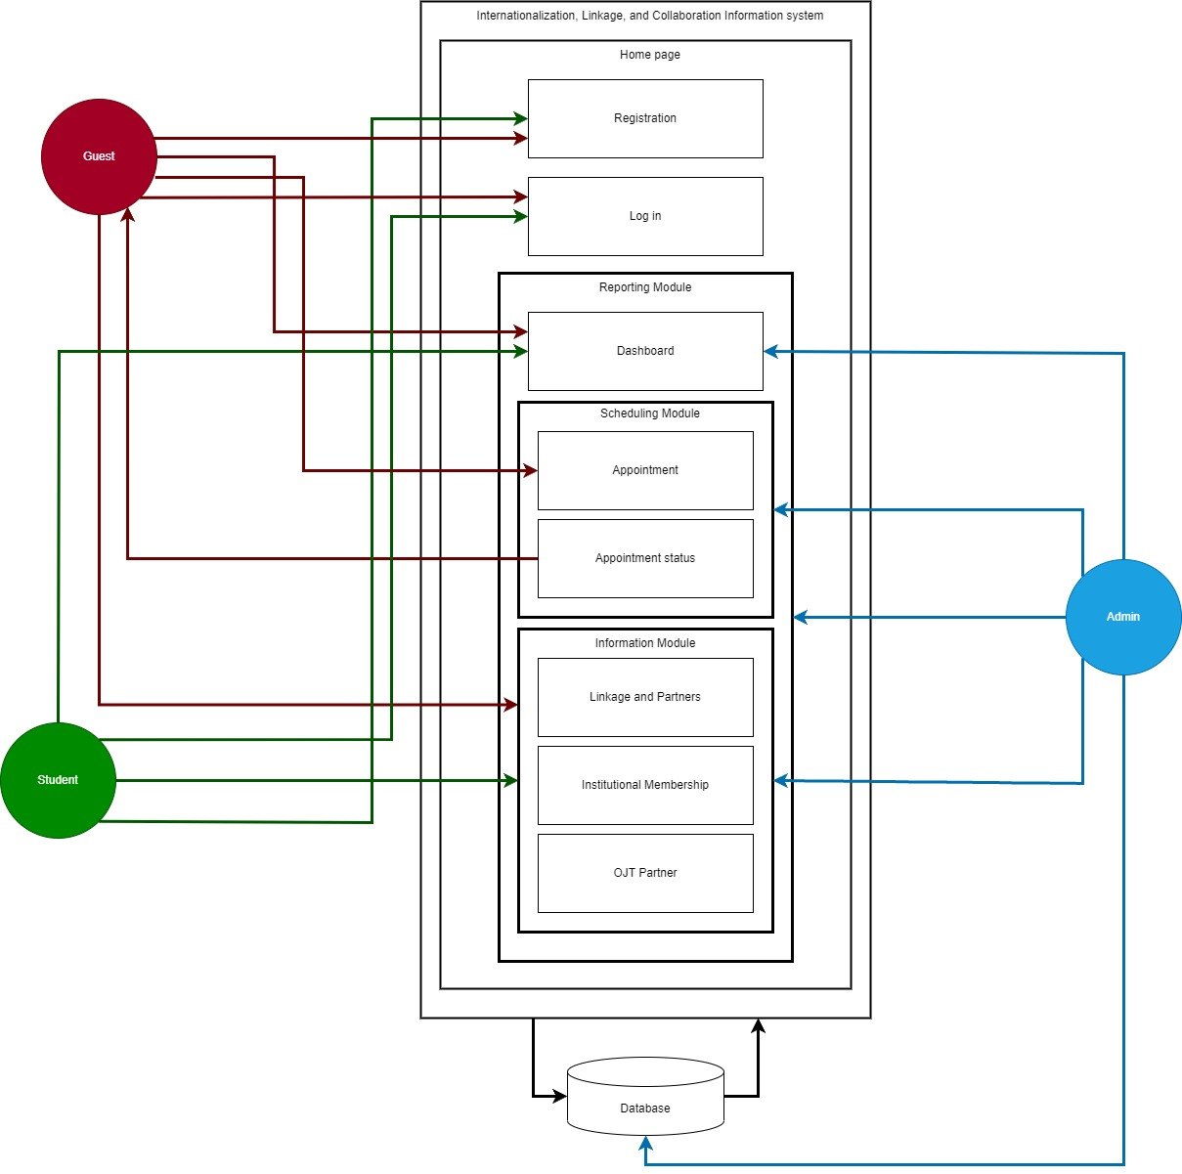The system architecture showed the process and the capabilities of guest, student and admin side.

Figure 4. System Architecture of the i-link: internationalization, linkage and collaboration information system for Cavite State University – Trece Martires City Campus

The system architecture, depicted in figure 4, is composed of different modules: account module, reporting module, scheduling module, and information module. To gain access to the system, guest, student and admin must enter their account credentials for logging in and setting up their accounts in the account module. After authenticating their accounts, guest can now access reporting module where they can cite the other system feature such as dashboard, scheduling/appointment module and information module request appointments and submit other documents online, can receive important updates on the status of their application. Admin have the ability to oversee and administer all application information, and they even have the ability to set appointments date and may control the specifics of the information being notified. Students can inquire to the school admin using a chat box, have the ability to oversee the information about the linkage’s services, scholarships, sponsorships, and the list of pool of expert’s, institutional memberships and OJT partners.

**Implementation Plan**

The implementation plan, they showed the strategy, activities, people involved, and duration of the project or initiative.

|  |  |  |  |
| --- | --- | --- | --- |
| **STRATEGY** | **ACTIVITIES** | **PERSONS INVOLVED** | **DURATION** |
| Uploading the system on a web server | Turn over the system into the administration | Researcher, IT Professionals, Admin | 1 day |
| System testing | Testing the functions of the system | Researcher, IT Professionals, Admin | 1 day |
| Evaluation of the system | Evaluation with the tested system | Researcher, Student, IT Professionals, Admin | 3 days |
| 1 day system tutorial | Hands on training | Researcher, IT Professionals, Admin | 1 day |

Table 3: Implementation plan of the project

Table 3 is the Implementation plan of the project which combines strategy, activities, persons involved, and duration of implementing the project. The activity was the way that ensured the strategy was carried out. The individuals who participated were the people who were included in the execution of the strategy, and the duration was the time limit for completing the strategy. In the first row, the researcher needed to upload the system on a web server within one day. The persons involved are the researcher, IT Professionals, and admin. After that, the researcher needed to test the system's functions within one day. The persons involved are the researcher, IT Professionals, and the admin. Then the researcher will evaluate the tested system, the person involved are the researcher, students, IT Professionals, and admin within three days. The last procedure was the one-day system tutorial through hands-on training. This involved the researcher, IT Professionals, and admin.

**REFERENCE**

Adams, J. (2009). Linking higher education institutions: Achieving the right balance. Higher Education Management and Policy, 21(1), 95-117.https://www.oecd.org/education/highereducationpolicy/

Alim, P. A. (2015). The role of university collaboration in the Philippines. International Journal of Social Science and Humanities Research, 3(5). https://www.researchgate.net/publication/279066875_The_Role_of_University_Collaboration_in_the_Philippines ‘

Bhattacharya, D., & Ghosh, R. (2017). Business information systems. New Delhi: PHI Learning Pvt. Ltd. https://www.amazon.com/Business-Information-Systems-Debabrata-Bhattacharya/dp/8131745862

Bourdeau, P., & Murray, B. (2017). Internationalization of higher education: Benefits for students, faculty, and institutions. International Higher Education, 91, 9-13. https://ejournals.bc.edu/index.php/ihe/index

Chen, H. (2018). University-Industry Linkage vs. University-Industry Collaboration. University World News, 365. Retrieved from https://www.universityworldnews.com/post.php?story=20180921113324462.

Domingo, J. (2019). The Role of Universities in Boosting the Philippine Economy. Retrieved from https://www.rappler.com/views/imho/225629-universities-philippines-economy

D’Souza, S. A., Negi, S. S., & Shukla, R. (2016). Linkage and collaboration among higher education institutions: A study. International Journal of Educational Management, 30(7), 994-1009. https://www.sciencedirect.com/science/article/pii/S0951832016000845

Eddy, Pamela L., "Partnerships and collaborations in higher education" (2010). School of Education Book Chapters. 38.https://scholarworks.wm.edu/educationbookchapters/38

Fahy, A. (2018). The importance of information systems in universities. Irish Times. Retrieved from https://www.irishtimes.com/news/education/the-importance-of-information-systems-in-universities-1.2820626

Garcia, S. & Huang, X. (2014). Linkage: A Key Tool for Strengthening International Education. International Education, 39(1), 26-41. https://www.tandfonline.com/toc/riie20/current

García-Peñalvo, F. J., Pardo, A., & López, J. M. (2016). University-industry collaboration: Definition, current state, and perspectives. Education and Information Technologies, 21(4), 857-873. https://www.researchgate.net/publication/294518072_University-Industry_Collaboration_Definition_Current_State_and_Perspectives

Gibop, S. S., Osman, S. H., & Ghazali, S. (2017). Promoting collaboration and reducing competition in higher education: The role of linkage. International Journal of Educational Management, 31(5), 1000-1011. https://www.emerald.com/insight/content/doi/10.1108/IJEM-11-2016-0372/full/html

Golhar, D., & Sharma, M. (2018). Information systems for business. New Delhi: Pearson Education India. https://link.springer.com/chapter/10.1007/978-3-319-94536-0_2

Gonzales, J. (2019). The Advantages of University-Industry Collaboration in the Philippines. Retrieved December 28, 2020, from https://www.nus.edu.sg/cri/industry-collaboration/advantages-of-university-industry-collaboration-in-the-philippines.

Gutierrez, L. (2017). Internationalization, Linkage and Collaboration Information System (ILCIS) in the Philippines: A web-based platform to facilitate internationalization, linkage and collaboration efforts. International Journal of Online and Distance Learning, 10(2), 16-27. https://www.academia.edu/35144590/Internationalization_Linkage_and_Collaboration_Information_System_ILCIS_in_the_Philippines_A_web-based_platform_to_facilitate_internationalization_linkage_and_collaboration_efforts

Harper, P (2014). Collaboration what is it and why is it important. https://www.teambonding.com/blog/collaboration-what-is-it-and-why-is-it-important/

Harrison, D., & Thomas, A. (2017). Internationalization of higher education: Benefits and challenges. Education and Training, 59(3/4), 254-266.https://www.emerald.com/insight/content/doi/10.1108/ET-10-2016-0122/full/html

Horn, M. B., & Staker, H. (2013). Blended: Using disruptive innovation to improve schools. John Wiley & Sons. https://www.worldcat.org/title/blended-using-disruptive-innovation-to-improve-schools/oclc/814455020

International Council for Open and Distance Education (ICDE). (2020). International Linkages for Education and Cooperation (ILEC). Retrieved from https://www.icde.org/projects/international-linkages-for-education-and-cooperation-ilec

KPMG LLP. (2016). Data and analytics: Achieving the full potential. Retrieved from https://assets.kpmg/content/dam/kpmg/xx/pdf/2016/02/data-analytics-achieving-the-full-potential-report.pdf

Little, B. (2013). Information Systems: Definition and Components. Retrieved from https://smallbusiness.chron.com/information-systems-definition-components-75457.html

Ledo, M. J. and Mariano, M. A. (2017). The Advantages of Using Information Systems in Philippine Universities. International Journal of Engineering and Technology, 5(4), pp.8-11.http://www.enggjournals.com/ijet/

National Academy of Science and Technology (NAST). (2018). Internationalization, Linkages and Collaborations: Information System Needs in the Philippines. Retrieved from https://www.nast.ph/publications/nast-

Que, A. (2013). Internationalization, Linkage and Collaboration Information Systems in the Philippines. Philippine Institute of Development Studies. Retrieved from http://dirp3.pids.gov.ph/ris/dps/pidsdps1322.pdf

Reyes, M. A. (2018). Philippine Institute for Development Studies. University-Industry Linkage in the Philippines: Challenges and Opportunities, 4, 1-11. https://www.pids.gov.ph/

monographs/internationalization-linkages-and-collaborations-information-system-needs-in-the-philippines

Simmons, C., Toohey, S., & Reid, A. (2020). The ACER Linkage Survey 2020. Australian Council for Educational Research. https://www.acer.org/

Vogl, G. (2016). Internationalization of universities: Benefits and challenges. International Higher Education, 88, 8-11. https://www.researchgate.net/publication/304518072_Internationalization_of_Universities_Benefits_and_Challenges