**INSTRUCTIONS TO RUN THE BEST MODEL:**

1. The training binary files and the test binary file should be inside a folder called ‘dataset’.
2. batches.meta.txt should also be inside ‘dataset’ folder.
3. The training binary files should be named as follows:
4. data_batch_1.bin
5. data_batch_2.bin
6. data_batch_3.bin
7. data_batch_4.bin
8. data_batch_5.bin
9. The test binary file should be names as follows:
   1. test_batch.bin
10. The .py files should be in the same level as the ‘dataset’ folder.

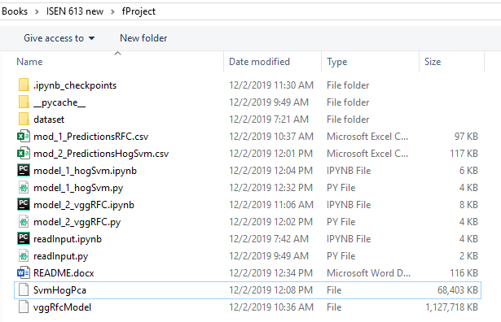

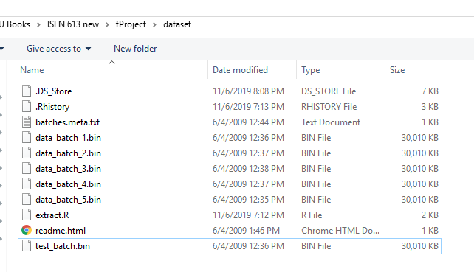

**RUNNING THE PYTHON FILE:**

Python version 3.6 or 3.7

BEST MODEL: MODEL 1 HOG + SVM CLASSIFIER

Filename : model_1_hogSvm.py

It should be run from Anaconda Prompt with an argument (‘preTrain’ or ‘forceTrain’).

Example:



ForceTrain – Starts Training from scratch

PreTrain – Loads previously trained classifier from folder if found and uses it to predict the test data.

**These packages are required to be installed:**

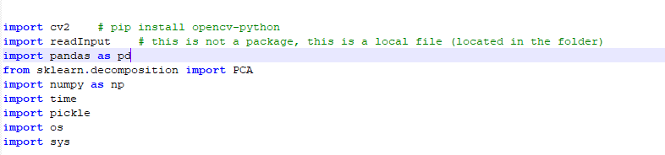

2nd BEST MODEL : MODEL 2 VGG + RFC CLASSIFIER

Filename : model_2_vggRFC.py

Similar instructions as model 1

**Package requirements:**

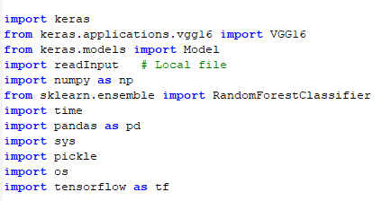

**OUTPUT:**

The testing Accuracy is displayed on the console.

The predictions are saved as a .csv file in the folder in respective model names.

**NOTE:**

If the pre-trained files are deleted from the folder, ‘ForceTrain’ is enforced automatically.