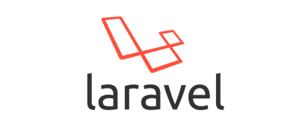

**Programming Language: -**

* Programming Language provides raw material for software development.
* Programming Language provides syntaxes and semantics for software development.
* C, C++, Java, C#, Python, PHP are some popular programming languages.

**Software Technology: -**

* Software Technology are non-installable software’s, but the software developed by using software technology are installable.

E.g. JDBC is non-installable, but the drivers developed by using JDBC are installable.

**Software Technology are two types: -**

1. **Open source technology**
2. **Closed source technology**

* **Open source technology: -** The source code of open source technology is available for users, user can modify source code of open source technology. E.g. Android, PHP, Java, Python, are open source technology.
* **Closed source technology: -** The source code of closed source technology is not available for users, User can’t modify source code of closed source technology. E.g. Microsoft .Net, IOS... are closed source technology.

**Framework: -**

* Framework are installable software’s, they provide us pre-designed architectures. By using framework’s you can develop software application more easily in less effort and in less time.

**Advantage of Framework: -**

* If you develop software application by using software technology, then you need to write common code and application specific code both.

And if you develop software application by using framework then you need to write only application specific logics and framework take care of common logics.

**Framework in different technologies: -**

**PHP: -** Laravel, CodeIgniter (CI), Cakephp…

**Java: -** Spring, Hibernate, Struts, JSF, Spring Boot…

**Python: -** Django, Flask...

**Python for ML: -** Scikit-learn, Tensor Flow, Theano, Keras…

**.Net: -** MVC, Xamarin…

**Laravel**

Laravel is a free and open source PHP web framework.

* Laravel is a powerful MVC PHP framework, which is designed for developer to create full-features web applications.
* **Develop by**- Taylor Otwell
* **Year:** - 2011

**Prerequisites to learn Laravel: -**

To learn Laravel you must have knowledge of HTML, CSS, Core Php, Advance Php.

**Command to create project in Laravel: -**

composer create-project laravel/laravel myproject

**Run** **Project** **Command: -**

php artisan serve

URL <http://localhost:8000/>

**Command for creating controller: --**

php artisan make:controller <controller-name>

**What is MVC?**

MVC stands for Model View Controller. It is an architecture of frameworks.

**Model: -** Model is container of database part of your web applications.

**View:** - View decides that which operation should be perform on a particular request.

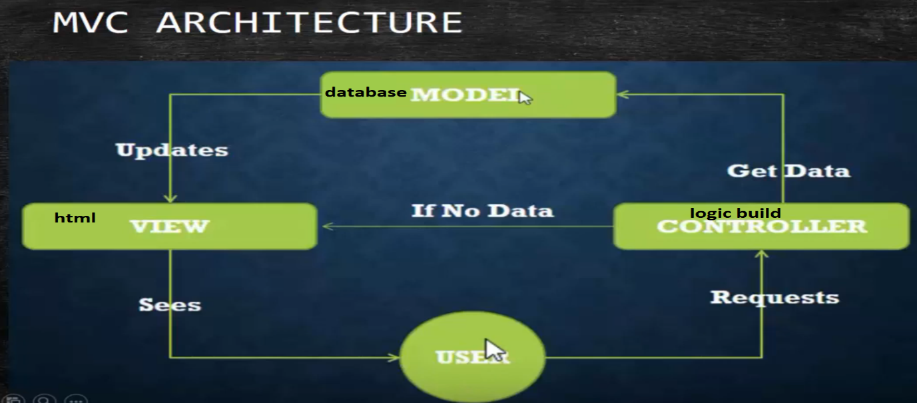**Controller:** - Controller is responsible to control entire web application.

Model

View Controller

**Web Browser: -** Web Browser is a type of application which is used to view web pages. E.g. Chrome, Firefox, Edge, etc...

.com -> Commercial Website.

.org -> Organizational Website.

.edu -> Educational Website.

.in -> India

.ac.in -> Academia India

**What is domain name?**

A domain name is a unique, easy-to-remember address used to access websites such as ‘’google.com’’ and ‘’facebook.com”.