Table of Contents

Project Scope 2

Purpose 2

Goal 2

Features 2

Page content Details 2

Home 2

Purpose of the Home Page 2

Cinema page 2

Purpose of the page 2

Movies 3

Purpose of the page 3

Kids Collection 3

Purpose of the page 3

Shows 3

Purpose of the page 3

Tasks Detail 3

# Project Scope

## Purpose

The main purpose of the website is to provide the knowledge to the customers about movie and cinemas which is available on the website.

## Goal

The main goal of the website to Give the more entertainment to people and gain more customers with this website.

## Features

User friendly

* This is the secure website which can be easily accessible on mobile phones and pc as well.

Attractive layout

* Using attractive colours like greenyellow and red these are normally unique colours attract the individuals easily.

## Target audience

* Girls 17 to 25
* Women 26 to 60

# Page content Details

## Home

### Purpose of the Home Page

As the home page is known as main page, I have provided the main information about the website and also add one image.

Also, some information is providing about the website on homepage.

### 

## Cinema page

### Purpose of the Cinema page

This page contains all the information about Cinemas which is available on website.

Registered users can also edit, create and delete cinemas details on this page.

### 

## Movies

### Purpose of Movie page

On this page people can see all the movies which is available.

Authorise users only create, edit and delete movies on this page.

### 

## Kids Collection

# Purpose of the kid’s collection page

The purpose of this page contains information about movies only for kids.

Authorise user can create, delete and edit information on this page.

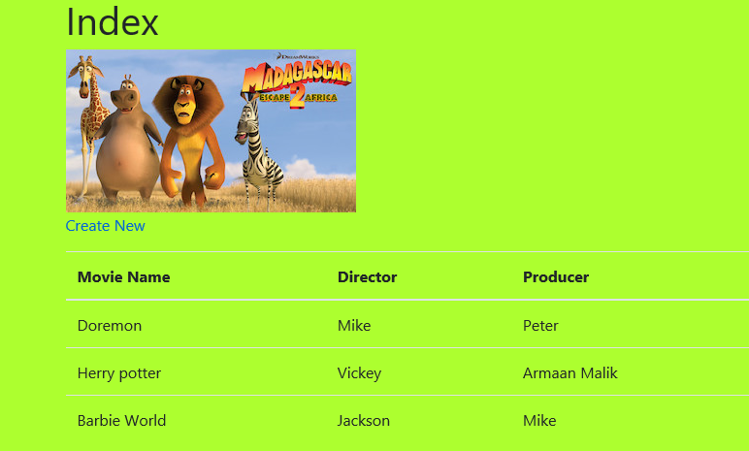

### Shows

# Purpose of the shows page

The purpose of this page to provide details that which movie is available in which cinema and how many shows are available for the day.

Authorize user can edit, create and delete the show details from this page.

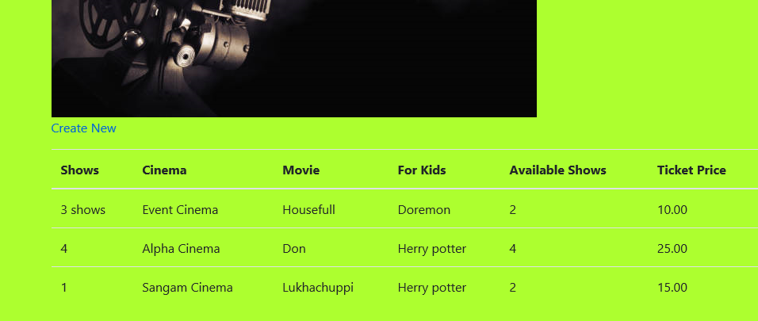

# Register login page.

# Purpose of Register login page

This page Helps to create registration for this website. People who register to this website can do all the operation on website.

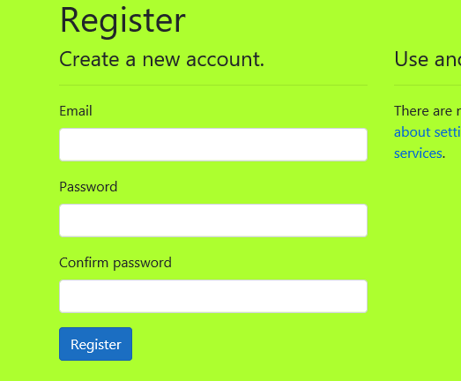

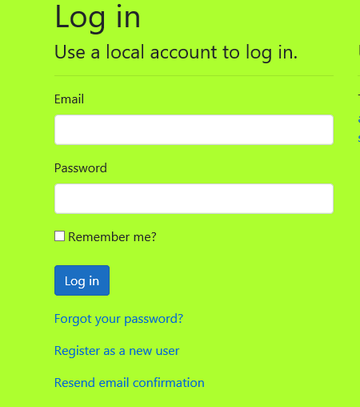

# Tasks Detail

|  |  |  |
| --- | --- | --- |
| Task | Task Description | Duration |
|  |  |  |
| 1 | Project scope | 60 minutes |
| 2 | Page content details | 150 minutes |
| 3 | Task details | 50 minutes |
| 4 | Images | 90 minutes |
| 5 | Browser support | 50 minutes |
| 6 | Final design | 200 minutes |
| 7 | screenshots | 5 minutes |
| 8 | Documentation | 1 hour |
| 9 | Testing | 30 minutes |
|  | Total time in hours | 636\60=10.6 Hours |
|  | Per hour pay | 35 Per hour  35x10.6=371N$D |
|  |  |  |

# Footer Area

Footer does not have so much content.

