# Phase 3 Project

Implement Frameworks the DevOps way

**SPORTY SHOES - E.COMM. STORE**

**Document Version 1.0**

**Author: Shubham Kumar**

**Git hub link: https://github.com/sk112-cmd/ProjectPhase3.git**

**Content**

**1. About this Document ………………………….............. 1**

**2. Flow chart …………………………............................... 2  
3. Sprint Planning ….…….……………………………… 3**

**5. GitHub Link ….…….……………………………… 3**

**6. Solution Overview ……………………………………. 4**

1. **About this Document**

Sporty Shoes is a company that manufactures and sells sports shoes. They have a walk-in store, and now, they wish to launch their e-commerce portal sportyshoes.com.

Sportyshoes.com is an e-commerce store focused on selling sports shoes. Users can signup/login to the portal, create a profile and select from a wide variety of shoes available and purchase them. There is also an admin backend with additional privileges. An extensive Database is developed and organized for storing user details, product details and purchase details.

**Objectives**

The expected goals and task to be achieved on a high level are as follows:

1. Create a front-end website through which users can interact and purchase shoes.

2. Create an admin backend with additional privileges to manage the website.

3. Develop and manage a database for storing user details, product details and purchase information.

4. Stable and optimized code.

5. To deliver a high-end quality product as early as possible.

**SPECIFICATIONS**

* **Product Capability**

The product development can be divided into 3 major parts:

* User Front End
* Admin Backend
* Database creation and management.

Let’s investigate more detailed specifications of each of the components.

* **USER FRONT END**

1. Users interact with the service using this front-end website. The demanded specifications are as follows:
2. Users should be able to login or register to the portal.
3. Users should be displayed with all the available products and make a purchase.
4. Order details should be accessible to the user.

* **ADMIN BACKEND**

1. At admin login page where the admin can change the password after login if he wishes.
2. Manage the products in the store including categorizing them.
3. Browse the list of users who have signed up and be able to search users.
4. See purchase reports filtered by date and category.

* **DATABASE**

For storing, managing, and retrieving the website data. Following data are handled:

1. User Details
2. Product details
3. Purchase Details

The goal of the company is to deliver a high-end quality product as early as possible.

1. **Flow Chart**

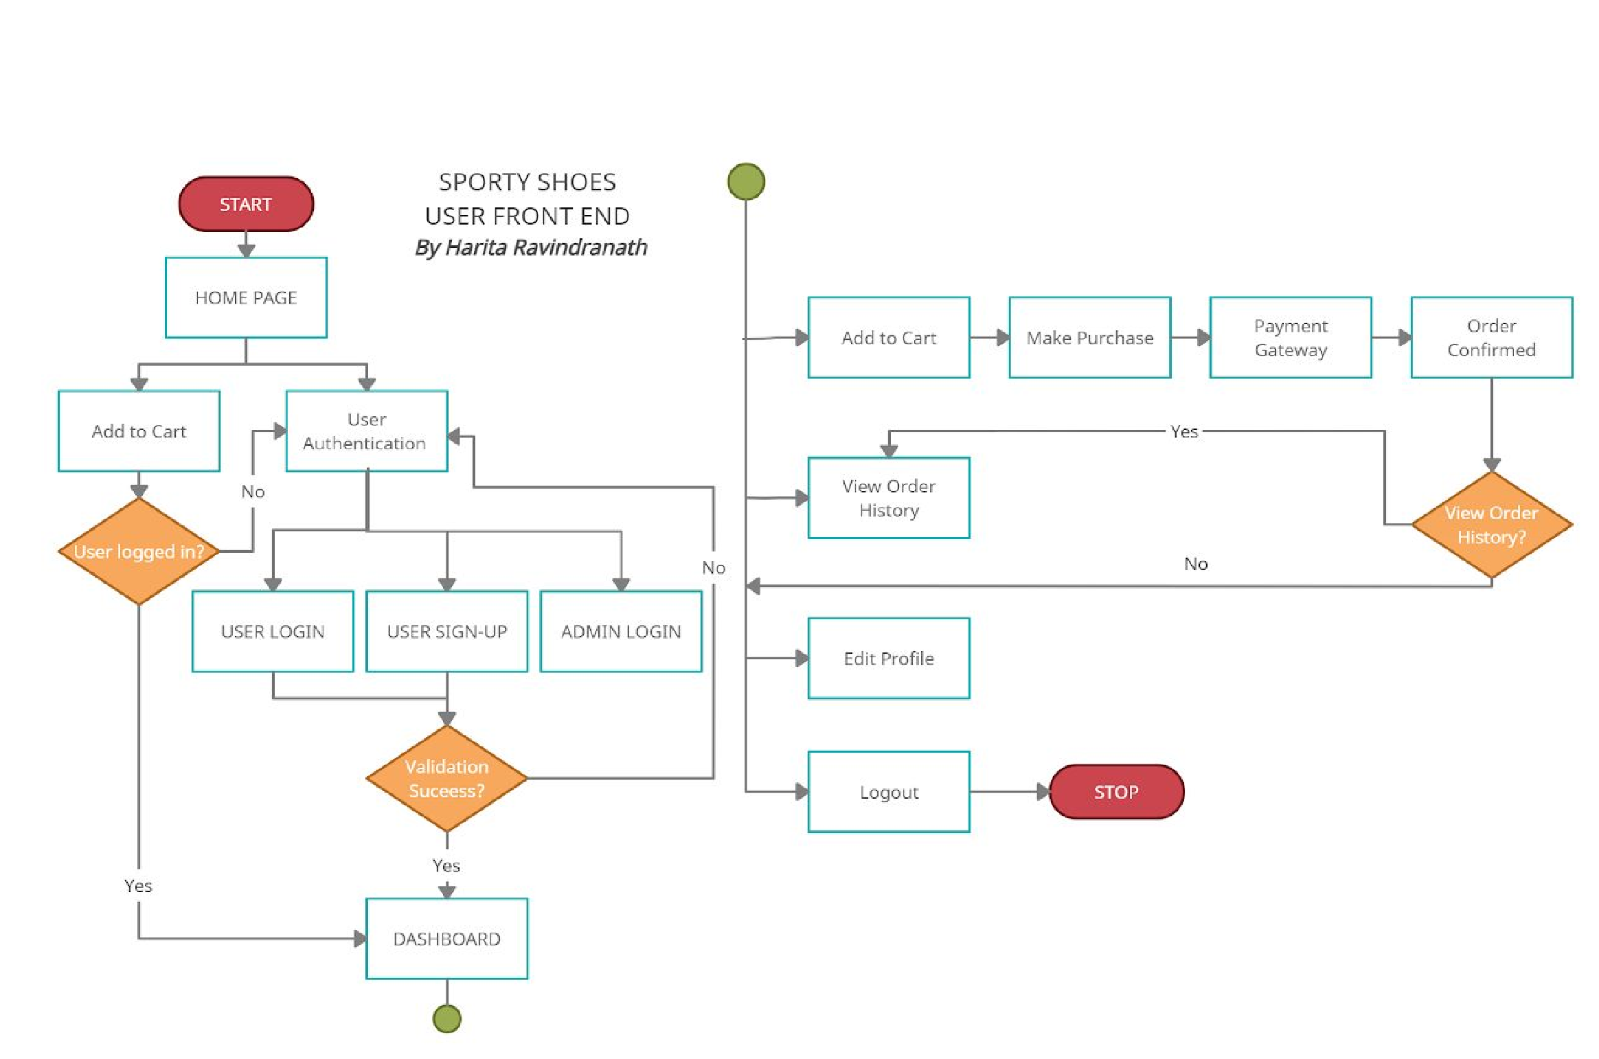

1. **Sprint planning**

**Sprint 🡪 Start Date: 10th Feb,2021, End Date: 3th Mar,2021**

1. Project needs to be completed in 3 sprints: Approx. 21 working days.
2. We are using Git Project Dashboard for tracking. Required Work Items are created in Git Projects.

Work Distribution

**Sprint 1: First week completed the basic functionality of the application.**

**Planned Goals:**

1. Create Login page
2. Create Sign Up page
3. Implement Logout Functionality
4. Implement Home Page
5. Implement Purchase E2E functionality

**Sprint 2: Second week completed the Admin panel of the application.**

**Planned Goals:**

1. Admin Home Page
2. Manage Product & Category Details
3. Browse User Details
4. Purchase History
5. Change Password

**Sprint 3: Last week tested for Product Functioning, Change Request and Bug fixing on priority.**

**4. Github link**

Source code of this applications has been pushed to GitHub. One can access that repository by accessing the below link:

<https://github.com/sk112-cmd/ProjectPhase3.git>

**Steps to be followed to pull my remote repository to your system:**

1. Open git and create directory by using command mkdir name (where name indicates directory name)

2. Check its location and navigate to directory and open git bash at that location.

3. Create the empty git repository using command git init.

Now create pull request by using command

**git pull https://github.com/sk112-cmd/ProjectPhase3.git**

4. Check the contents in directory

5. Use command “git add .“ to add files and command git commit –m “Type your message” to commit changes.

You can push to remote repositories using following commands

1. git init

2. git remote add origin “your repository URL”

3. git add .

4. git commit –m “Type your message”

5. git push origin master

**5. Solution Overview**

**Platform requirement**

The platform used for this project is eclipse IDE, Tomcat, XAMPP- PHPMyAdmin: MySQL database, Firefox/IE/Chrome Browser, Notepad++ or Sublime Text.

**Backend Programming Language**

Core Java. The software backend is completely developed in Spring Boot. Key concepts and Technologies implemented are:

* JSP
* Servlets
* Hibernate

Along with this, following critical Java concepts are also used:

* Collections
* Exception Handling
* Sorting

**Database:** MySQL is used for creating DB

**ORM:** Hibernate is used as an ORM tool.

**Front End:** HTML5 and CSS3 along with JavaScript is used in developing front-end.

**Build:** Maven with Spring MVC archetype is used in developing the application.

**Version Control:** Git and GitHub