There are mainly two type of methods in Instance segmentation.

1.Proposal based – (Mask RCNN),

2. Segmentation based (

Problem with Bounding Box Proposals Method:

* Number of proposals are limited by the number of proposals processed by the network.
* A pixel can be shared between two classes ( no constraint on pixel sharing b/w classes)
* 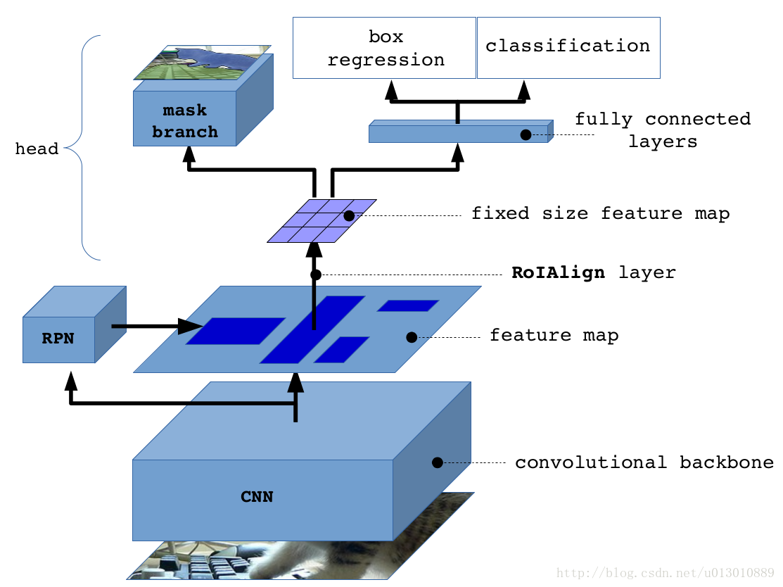

Our Network:

Fully convolution Network

No Fully connected layer, less parameters, fast

Others:

PAN (Path Aggregation Network)