**OSLC SETUP DOCUMENT** 

Contents

Basic Installation 2

Clone the Lyo Core git repository 3

Clone the Lyo Client git repository 6

Run sample application 9

Clone the CUSTOM git repository 11

# Basic Installation

**Please get the following softwares :**

* + - * **eclipse EE(latest version)**
      * **maven (latest version->for building projects from command prompt)**
      * **tomcat 1.7**
      * **jdk 1.7**

1. **install java,set JAVA_HOME AND PATH variable.**
2. **install maven and set M2_HOME & path variable.**
3. **In,eclipse go to windows->preferences->General->Network Connections**

**-choose active provider as Manual from the drop down**

**-set up proxy brbc1.persistent.co.in ,port as 8080,and put your persistent uid/pwd.**

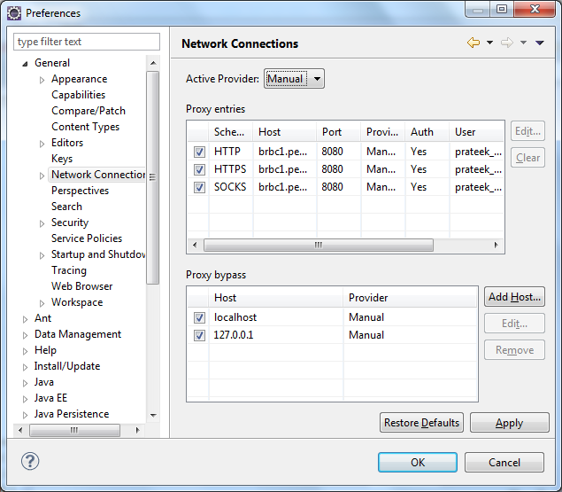

# Clone the Lyo Core git repository

1. **Open the Git Repositories view(windows->show view->other->Git->Git Repo) in Eclipse and click the Clone Git Repository icon**
2. **Use** <http://git.eclipse.org/gitroot/lyo/org.eclipse.lyo.core.git> **as the URI (browse it also** [**on line**](http://git.eclipse.org/c/lyo/org.eclipse.lyo.core.git/)**). User/Password are not required.**

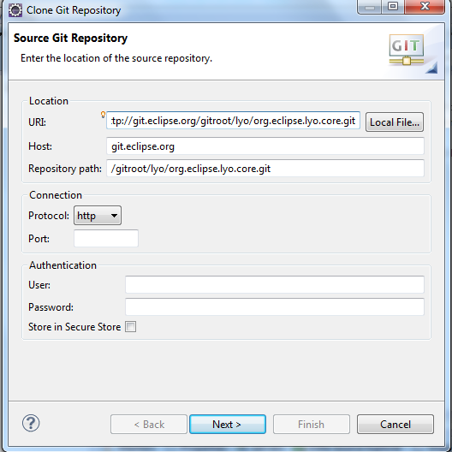

1. **On the Branch Selection page, select the master branch**
2. **On the Local Destination page, specify a location or accept the default and click Finish**
3. **The repository should now show up in your Git Repositories view.**
4. **Import Eclipse projects from the git repository**
5. **In the Git Repositories view, right click org.eclipse.lyo.core and select Import Projects**
6. **Select the Import Existing Projects wizard and click Next**



1. **Import the following projects:** 
   1. **org.eclipse.lyo.oslc4j.core**
   2. **org.eclipse.lyo.oslc4j.provider.jena**
   3. **org.eclipse.lyo.oslc4j.provider.json4j**
2. **You may import the other projects if you like, but they are not required for building the client.**
3. **[Optional] Add the projects to a new working set.**
4. **Build all projects**
5. **Expand org.eclipse.lyo.oslc4j.core**
6. **Right click pom.xml -> Run As -> Maven clean**
7. **Right click pom.xml -> Run As -> Maven install**

**Repeat these steps for the org.eclipse.lyo.oslc4j.provider.jena and org.ec**

**e.lyo.oslc4j.provider.json4j project**

# Clone the Lyo Client git repository

1. **Open the Git Repositories view in Eclipse and click the Clone Git Repository icon**
2. **Use** <http://git.eclipse.org/gitroot/lyo/org.eclipse.lyo.client.git> **as the URI (browse it also** [**on line**](http://git.eclipse.org/c/lyo/org.eclipse.lyo.client.git/)**). User/Password are not required.**

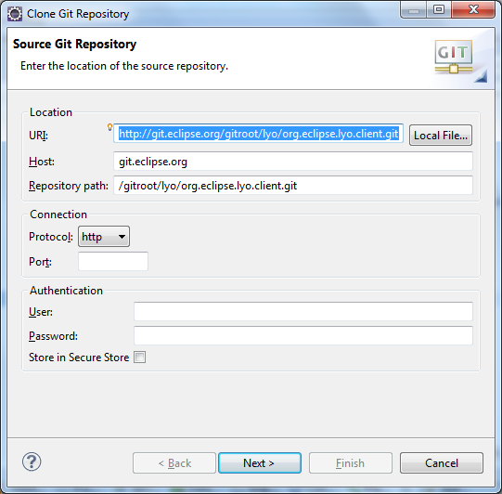

1. **On the Branch Selection page, select the master branch**
2. **On the Local Destination page, specify a location or accept the default and click Finish**
3. **The repository should now show up in your Git Repositories view.**
4. **Import Eclipse projects from the git repository**
5. **In the Git Repositories view, right click org.eclipse.lyo.client and select Import Projects**
6. **Select the Import Existing Projects wizard and click Next**
7. **Import the following projects:**
8. **org.eclipse.lyo.client.java**
9. **org.eclipse.lyo.java.sample**
10. **[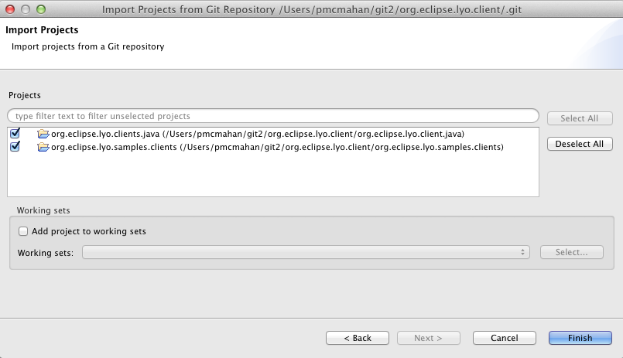](http://wiki.eclipse.org/File:Lyo_client_import_projects.png)**
11. **[Optional] Add the projects to a new working set.**
12. **Build all projects**
13. **Expand the org.eclipse.lyo.client.java project**
14. **Right click pom.xml -> Run As -> Maven clean**
15. **Right click pom.xml -> Run As -> Maven install**
16. **Repeat these steps for the org.eclipse.lyo.client.java.sample project**

# Run sample application

**This sample demonstrates how to use the Lyo client to interact with a Change Management (CM) Service Provider in the following ways:**

**run an OLSC ChangeRequest query and retrieve OSLC ChangeRequests and de-serialize them as Java objects**

**retrieve an OSLC ChangeRequest and print it as XML**

**create a new ChangeRequest**

**update an existing ChangeRequest**

**To run this sample you can install and configure a Change Management V2 service provider such as Rational Team Concert. Then create a launch configuration in eclipse to run RTCFormSample as a java application, passing in values for the command line arguments as shown below:**

**[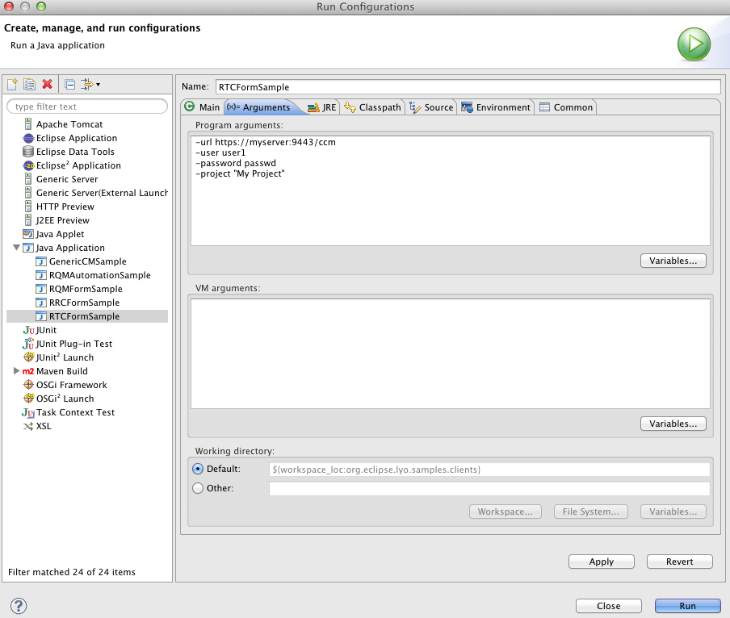](http://wiki.eclipse.org/File:RunRTCFormSample.png)**

Troubleshooting

**1.Cannot find the file tools.jar**

**Solution: In eclipse go to windows->Preferences->Java->Installed Jre and add the jdk path.**

**2.Failed to parse plugin descriptor for org.apache.maven.plugins:maven-resources-plugin:2.4.1**

**Solution: Delete the folder \.m2\repository\org\apache\maven\plugins\maven-clean-plugin\2.4.1**

**3.Failed to parse plugin descriptor for org.apache.maven.plugins:maven-resources-plugin:2.5**

**Solution: Delete the jar file .m2\repository\org\apache\maven\plugins\maven-resources-plugin\2.5\maven-resources-plugin-2.5**

**ALTERNATE WAY TO SET UP**

# Clone the CUSTOM git repository

1. **Open the Git Repositories view in Eclipse and click the Clone Git Repository icon**
2. **Use** <https://github.com/sk180283/OSLC_CODE_YASUR.git> **as the URI (browse it also** [**on line**](http://git.eclipse.org/c/lyo/org.eclipse.lyo.client.git/)**). User/Password are not required.**

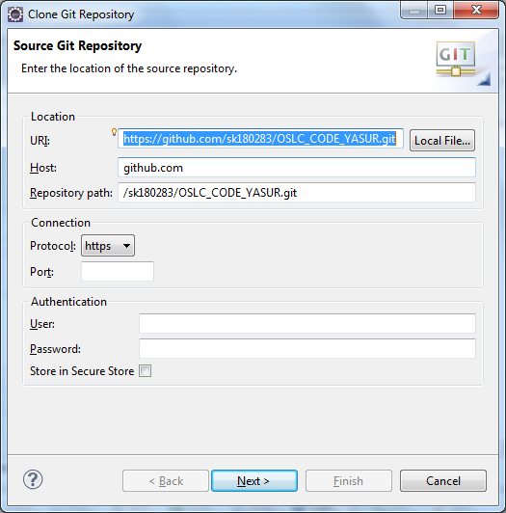

1. **On the Branch Selection page, select the master branch**
2. **On the Local Destination page, specify a location or accept the default and click Finish**
3. **The repository should now show up in your Git Repositories view.**
4. **Import Eclipse projects from the git repository**
5. **In the Git Repositories view, right click LOCAL REPO CREATED and select Import Projects**
6. **Select the Import Existing Projects wizard and click Next**
7. **Import all the projects.**
8. **Build all projects**
9. **Right click pom.xml -> Run As -> Maven clean**

**44) Right click pom.xml -> Run As -> Maven install**