设置大页内存
vi /etc/default/grub
cat /proc/meminfo |grep -i HugePages
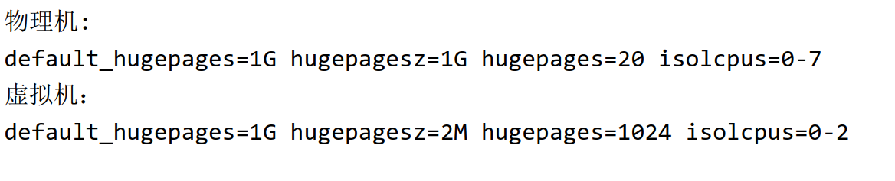

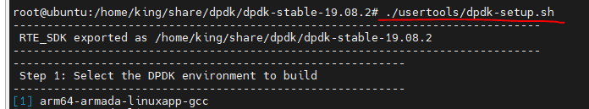

编译
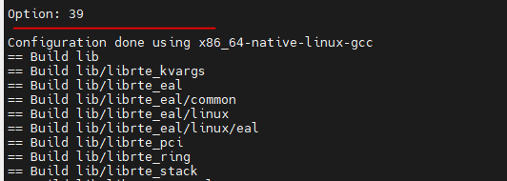

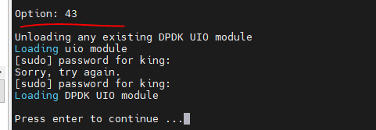
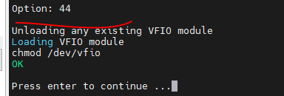
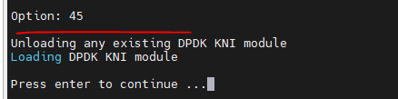
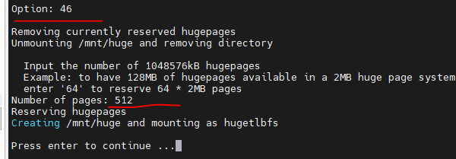
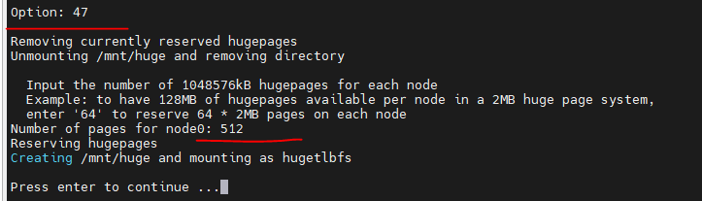

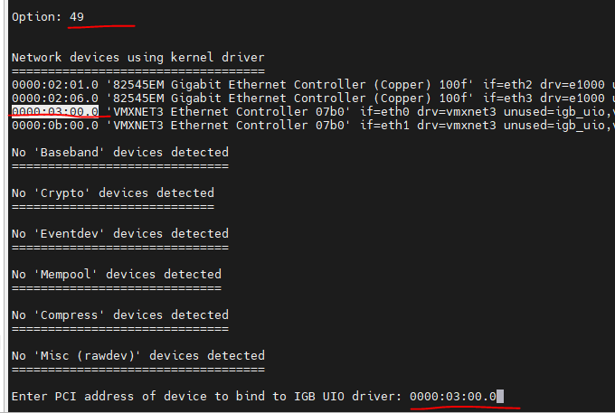

export RTE_SDK=/home/king/share/dpdk/dpdk-stable-19.08.2/
export RTE_TARGET=x86_64-native-linux-gcc/
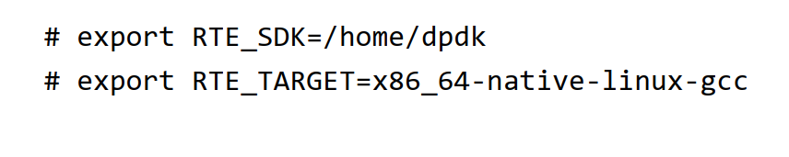

环境搭建也可以参考：https://blog.csdn.net/weixin_46263147/article/details/128553361

我把原始虚机的内存改成4G, 就会发生错误，改成原来的8G就没事了，不知道为啥？

EAL: Detected 8 lcore(s)
EAL: Detected 1 NUMA nodes
EAL: Multi-process socket /var/run/dpdk/rte/mp_socket
EAL: Selected IOVA mode 'PA'
EAL: No free hugepages reported in hugepages-1048576kB
EAL: No available hugepages reported in hugepages-1048576kB
EAL: FATAL: Cannot get hugepage information.
EAL: Cannot get hugepage information.
EAL: Error - exiting with code: 1
Cause: Not Supported eth found
root@ubuntu:/home/king/share/dpdk/dpd

