**Math exercise system**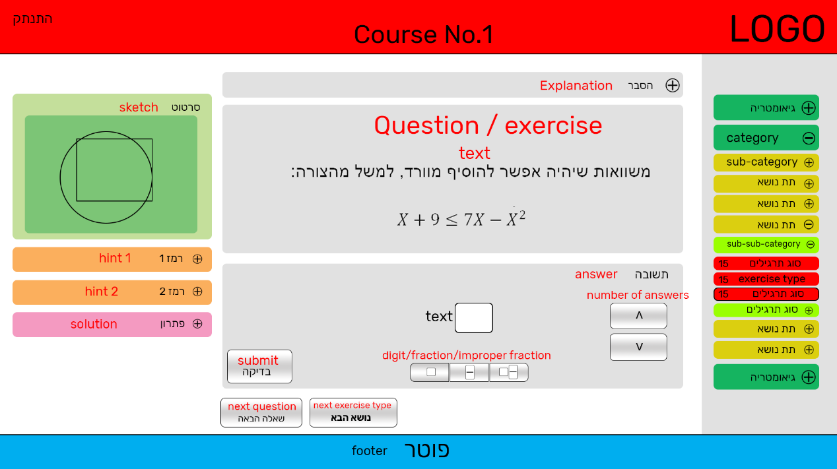

1. **Sidebar menu**
   1. On the right, folding (collapsing) menu of **categories**, **sub-categories**, **sub-sub-categories** and **exercise-types**.
   2. only one **exercise-type** is chosen ('active') at a time, and only the matching **category**, **sub-category** and **sub-sub-category** is open, all the other are folded.
   3. The chosen **exercise-type** will have unique design (like border or something else)
   4. Beside each **exercise-type** there will be a number (counter of solved questions)
2. **Question / exercise**
   1. Contains text
   2. Has a min height
3. **Sketch**
   1. Contains PNG picture that fit to max width
   2. Hidden if no picture available (from DB)
4. **Explanation + hints + solution**
   1. Contains text
   2. Folded / unfolded by clicking (hide / show the content)
5. **Answer**
   1. There will be 3 type of answers (depends on the question)
   2. 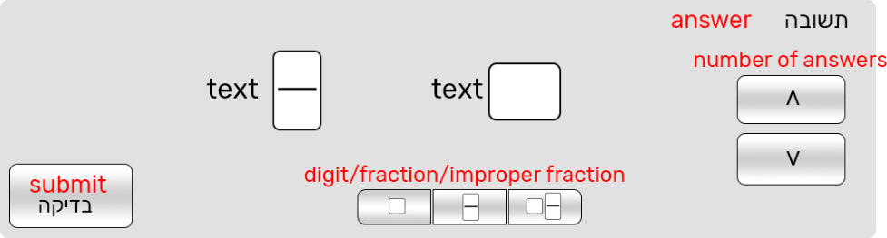One:
      1. The user can change the number of answers (from 1 up to 4) by clicking on the arrows. The answers will be displayed centered and spread evenly
      2. The user can change any input field to one of three types of input (digit / fraction / improper fraction) by clicking on a field (focused) and then clicking on one of the three choices.
   3. 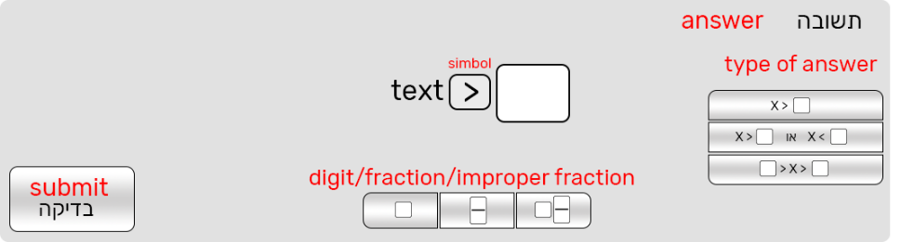Two (Inequation):
      1. Every click on the symbol will change it. The symbols are <,>,≥,≤,=,≠
   4. 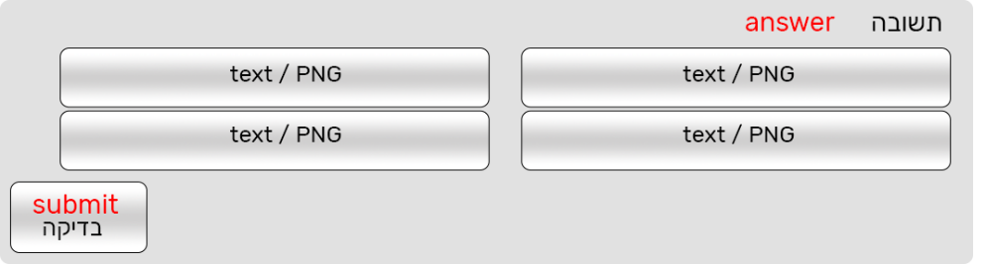Three (multiple choice questions):
      1. 4 choices (always 4) text / PNG answers. Only one can be chosen.
      2. The buttons (of the choices) will change there size so they will fit the text/PNG they supposed to contain.
      3. By pressing on one of the choices, it's design will change.
   5. For all the types of answers, pressing on the 'submit' button will show the user if he is correct or not by changing the design of the background of the 'answer' area.
6. **Notes**
   1. All the red text in the pictures are notes for you and not part of the design / system
   2. The pictures added to this document are to show functionality and not final design, you can change the colors and redesign all the elements on this page, as long as the functionality stay as described in this document.
   3. The page will be **responsive.**
   4. When folding / unfolding element, the user will see the expansion / shrinking
   5. The development will be in **Bootstrap, JavaScript, HTML, CSS**.
   6. The code will be clean and organized with guiding notes for the back-end developer (for example, where to insert the sidebar titles), please use "lorem ipsum" when needed.
   7. The language displayed to the user is Hebrew (right to left)
7. **Examples**
   1. 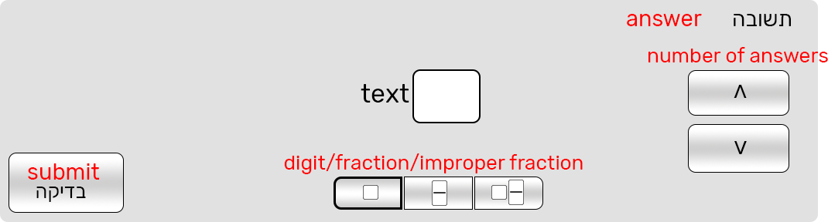One answer, digit type
   2. By clicking the up arrow button, the user add an answer to: Two answers, digit type

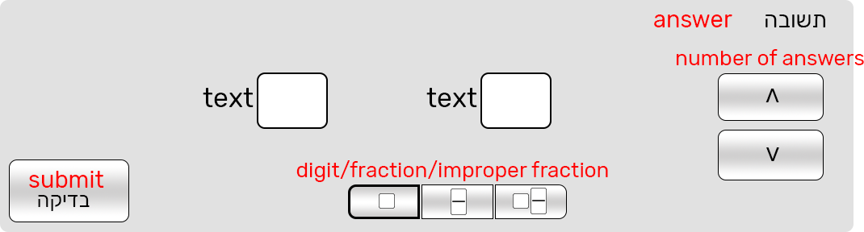

* 1. 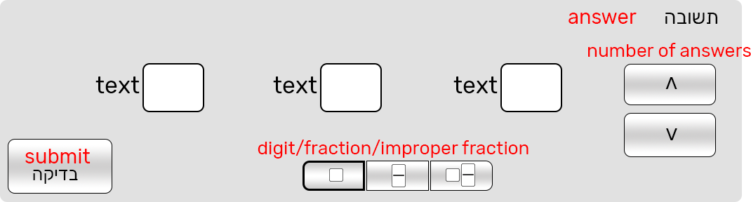: Three answers, digit type. The user can add up to 4 answers.
  2. by clicking on a field (left field, as you can see) and then clicking on one of the type buttons (circled), the field type will change its type (to fraction)
  3. by clicking on a field (left field, as you can see) and then clicking on one of the type buttons (circled), the field type will change its type (to improper fraction)

