Auszug aus Linq-Büchern:

Book: LINQ in Action MANNING

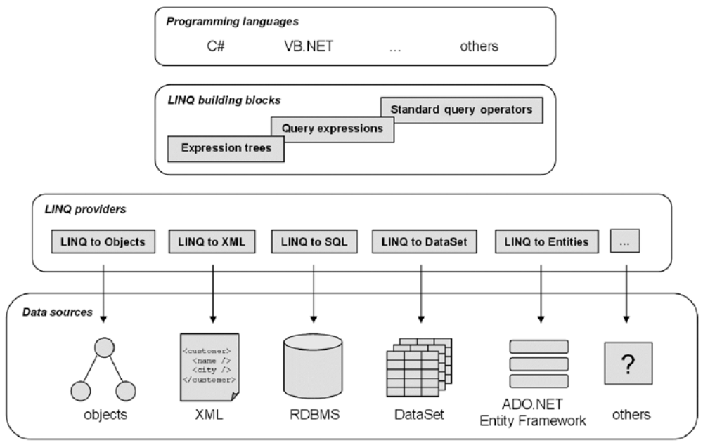

Hello LINQ to Objects

using System;
using System.Linq;
static class HelloWorld
{
static void Main()
{
string[] words =
{"hello", "wonderful", "linq", "beautiful", "world"};

var shortWords =
from word in words
where word.Length <= 5
select word;

foreach (var word in shortWords)
Console.WriteLine(word);
}
}

Ausgabe:
hello
linq
world

Hello LINQ in C# improved with grouping and sorting

using System;
using System.Linq;
static class HelloWorld
{
static void Main()
{
string[] words =
{"hello", "wonderful", "linq", "beautiful", "world"};
var groups =
from word in words
orderby word ascending
group word by word.Length into lengthGroups
orderby lengthGroups.Key descending
select new {Length=lengthGroups.Key,
Words=lengthGroups};
foreach (var group in groups)
{
Console.WriteLine("Words of length " + group.Length);
foreach (string word in group.Words)
Console.WriteLine(" " + word);
}
}
}

Ausgabe:
Words of length 9
beautiful
wonderful
Words of length 5
hello
world
Words of length 4
linq

Code, that uses Linq to query a database and create an XML Document

var contacts =
from customer in db.Customers
where customer.Name.StartsWith("A") && customer.Orders.Count > 0
orderby customer.Name
select new { customer.Name, customer.Phone };

var xml =
new XElement("contacts",
from contact in contacts
select new XElement("contact",
new XAttribute("name", contact.Name),
new XAttribute("phone", contact.Phone)
)
);

The goals of the LINQ project

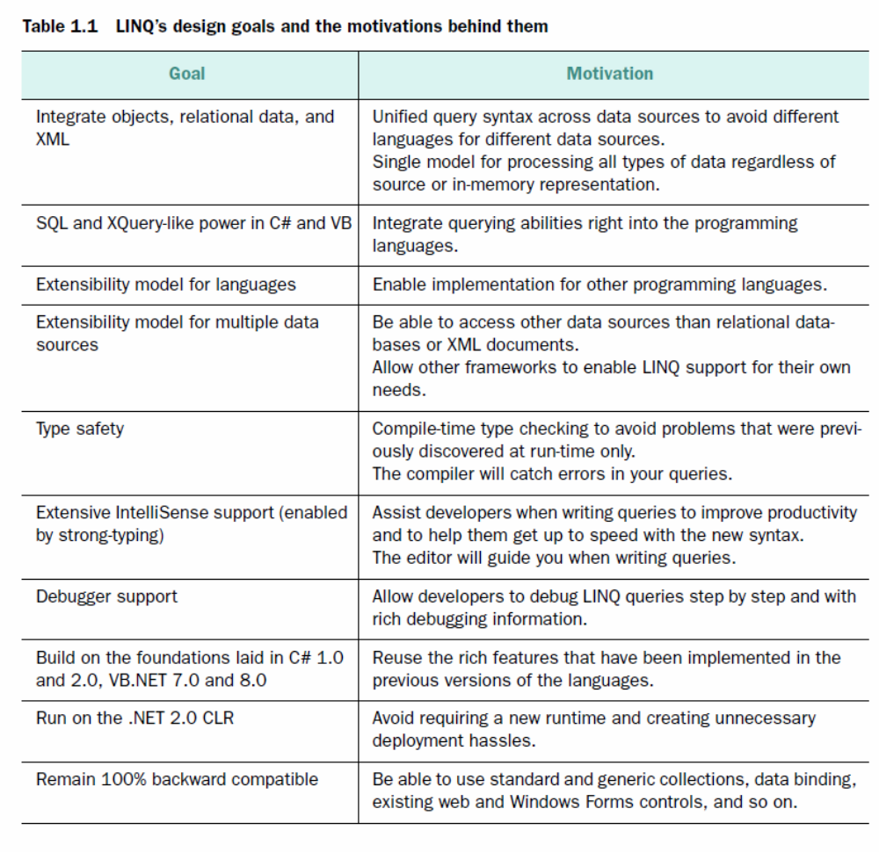

Hello LINQ to XML
The running example application we’ll use in this book deals, appropriately enough, with books. We’ll detail this example in chapter 4. For the moment, we’ll stick to a simple Book class because it is enough for your first contact with LINQ to XML. In our first example, we want to filter and save a set of Book objects as XML.
Let’s say we have the following collection of books:
Book[] books = new Book[] {
new Book("Ajax in Action", "Manning", 2005),
new Book("Windows Forms in Action", "Manning", 2006),
new Book("RSS and Atom in Action", "Manning", 2006)
};
Here is the result we would like to get if we ask for the books published in 2006:
<books>
<book title="Windows Forms in Action">
<publisher>Manning</publisher>
</book>
<book title="RSS and Atom in Action">
<publisher>Manning</publisher>
</book>
</books>

using System;
using System.Linq;
using System.Xml;
using System.Xml.Linq;
class Book
{
public string Publisher;
public string Title;
public int Year;
public Book(string title, string publisher, int year)
{
Title = title;
Publisher = publisher;
Year = year;
}
}
static class HelloLinqToXml
{
static void Main()
{
Book[] books = new Book[] {
new Book("Ajax in Action", "Manning", 2005),
new Book("Windows Forms in Action", "Manning", 2006),
new Book("RSS and Atom in Action", "Manning", 2006)
};

XElement xml = new XElement("books",
from book in books
where book.Year == 2006
select new XElement("book",
new XAttribute("title", book.Title),
new XElement("publisher", book.Publisher)
)
);
Console.WriteLine(xml);
}
}

