E-Commerce Customer Segmentation & Sales Analysis
E-Commerce Customer Segmentation & Sales Dashboard
Customer Behavior | RFM Segmentation | Customer Value Insights| 2025-26
Tools: Python • Pandas • MySQL • Power BI • DAX

Table of Contents
- Project Overview
- Project Objectives
- Dataset Overview
- Tools & Technologies
- Python Data Preparation & Analysis
- SQL Analysis
- Monthly Revenue & Growth
- RFM Analysis
- RFM Segmentation Logic
- RFM Customer Distribution
- RFM Revenue by Segment
- Power BI Dashboard
- 12.1 Sales & Product Analysis
- 12.2 Customer & RFM Analysis
- Key Business Insights
- Business Recommendations
- Conclusion
- Project Deliverables

1. Business Problem

The main business problem is to understand sales performance and customer behavior from transactional e-commerce data. The business needs to identify valuable, loyal, at-risk, and lost customers, understand revenue trends, and determine the key products and countries contributing to sales. RFM segmentation and an interactive Power BI dashboard are used to convert raw data into actionable business insights.

2. Project Objectives
- Measure overall sales, orders, customers, quantity sold, and average order value.
- Analyze monthly revenue and month-over-month growth.
- Identify top-performing products, countries, and customers.
- Analyze customer repeat behavior.
- Segment customers using Recency, Frequency, and Monetary (RFM) analysis.
- Build an interactive two-page Power BI dashboard.

3. Dataset Overview
The working dataset contained 48,294 rows and 12 columns.
Final dataset fields:
- InvoiceNo
- StockCode
- Description
- Category
- Quantity
- InvoiceDate
- UnitPrice
- CustomerID
- Country
- Revenue
- IsCancelled
- YearMonth

4. Tools & Technologies
- Python (Pandas, Matplotlib) — data preparation, aggregation, visualization, and RFM analysis.
- MySQL Workbench — KPI and business analysis using SQL.
- Power BI — KPI cards, charts, slicers, and interactive dashboard.

5. Python Analysis
- Product Performance — revenue by product description.
- Customer Revenue — Top 10 customers by revenue.
- Customer Repeat Behavior.
- Country Analysis.
- Monthly Revenue and MoM Growth.
- RFM scoring, segmentation, and segment revenue.

6. SQL Analysis
The cleaned dataset was loaded into MySQL using LOAD DATA LOCAL INFILE. SQL analysis was used for business KPIs and monthly growth.
- Total Revenue
- Total Orders
- Total Customers
- Total Quantity Sold
- Average Order Value

7. Monthly Revenue & Growth
Monthly revenue and MoM growth were calculated using YearMonth. The supplied output shows the following key observations:
- March 2025 recorded +16.62% MoM growth, the largest positive change in the supplied output.
- August 2026 recorded -50.02% MoM growth, the largest decline in the supplied output.
- April 2026 revenue was 526,583.93, the highest monthly revenue in the supplied output.

8. RFM Analysis
Reference Date: 2026-08-16 21:59:00.
RFM scoring was performed in Python using quintile-based pd.qcut logic:
- R_Score = pd.qcut(Recency, 5, labels=[5,4,3,2,1], duplicates='drop')
- F_Score = pd.qcut(Frequency.rank(method='first'), 5, labels=[1,2,3,4,5])
- M_Score = pd.qcut(Monetary, 5, labels=[1,2,3,4,5], duplicates='drop')

9. RFM Segmentation Logic
- Champions: R >= 4 and F >= 4 and M >= 4
- Loyal Customers: R >= 3 and F >= 4
- Big Spenders: R >= 4 and M >= 4
- At Risk: R <= 2 and F >= 3
- Lost Customers: R <= 2 and F <= 2 and M <= 2
- Potential Loyalists: remaining customers

10. RFM Customer Distribution
Segment | Customers
Potential Loyalists | 685
Lost Customers | 609
Champions | 581
At Risk | 318
Loyal Customers | 252
Big Spenders | 43

11. RFM Revenue by Segment
Segment | Revenue
Champions | 4,798,458.66
Potential Loyalists | 1,471,930.76
Loyal Customers | 1,287,287.53
At Risk | 1,207,936.91
Lost Customers | 691,145.95
Big Spenders | 167,877.67
Total RFM revenue from the supplied segment output: 9,624,637.48.

12. Power BI Dashboard

Page 1 — Sales & Product Analysis
- Five KPI cards.
- Monthly revenue/growth visualization.
- Product performance chart.
- Country analysis.
- Customer revenue/repeat behavior analysis.
- Synchronized slicers.
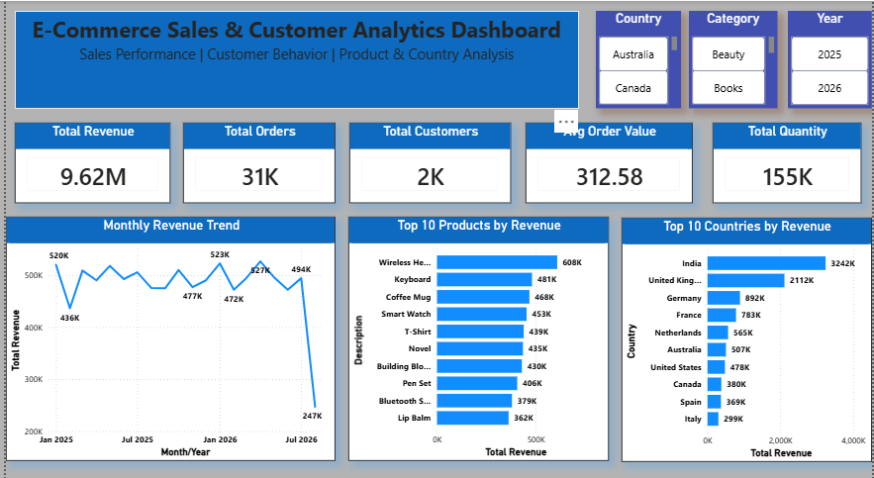

Page 2 — Customer & RFM Analysis
- Customer KPIs.
- Top 10 Customers by Revenue.
- Donut chart: Customer Distribution by RFM Segment.
- Bar chart: Revenue by RFM Segment.
- Synchronized slicers with Page 1.
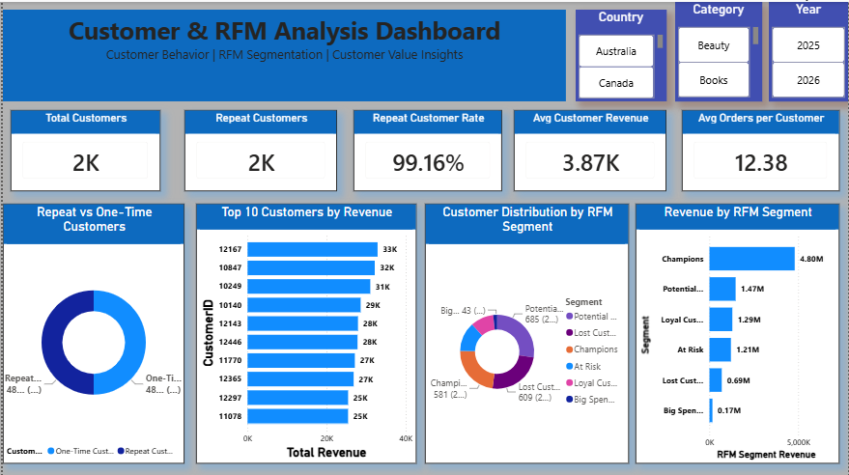

13. Key Insights
- Champions generated 4,798,458.66 in the supplied RFM analysis and are the highest-revenue segment.
- Potential Loyalists are the largest customer segment with 685 customers.
- Big Spenders contain only 43 customers but represent a distinct high-value segment.
- At Risk customers are a meaningful re-engagement opportunity.
- The supplied monthly output shows a sharp -50.02% revenue decline in August 2026.

14. Business Recommendations
- Prioritize retention and personalized offers for Champions.
- Convert Potential Loyalists into Loyal Customers through repeat-purchase campaigns.
- Run targeted reactivation campaigns for At Risk and Lost Customers.
- Protect and upsell Big Spenders with relevant high-value offers.
- Investigate the August 2026 decline using order volume, customer activity, and product mix.

15. Conclusion
The project delivers an end-to-end e-commerce analytics workflow using Python, MySQL, and Power BI. It combines sales performance, customer behavior, and RFM segmentation into an interactive two-page dashboard for business decision-making.

16. Deliverables
- Cleaned e-commerce dataset
- Python analysis notebook
- MySQL analytical queries/database
- RFM_Analysis.csv containing exact Python RFM results
- Two-page Power BI dashboard
- Project documentation

