**CSE 489/589**

**Programming Assignment 2**

**Reliable Transport Protocols**

1 - Academic Integrity Policy Statement

**[Your submission will NOT be graded without this statement.]**

**We have read and understood the course’s academic integrity policy.**

2 - Group and Contributions

* Name of member 1:
  + UBITName: mohamma09
  + Contributions: ABT, GBN
* Name of member 2:
  + UBITName: sagarkhu
  + Contributions: SR

3 - SANITY Tests

**[2.0]** ABT

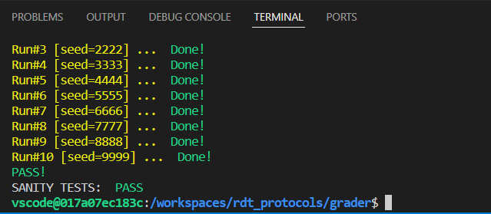

**[5.0]** GBN

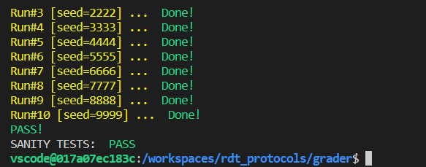

**[8.0]** SR

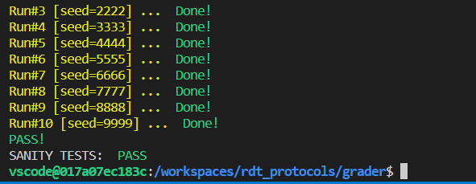

4 - BASIC Tests

**[5.0]** ABT

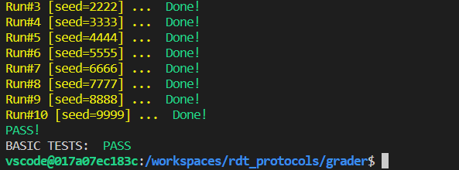

**[12.0]** GBN

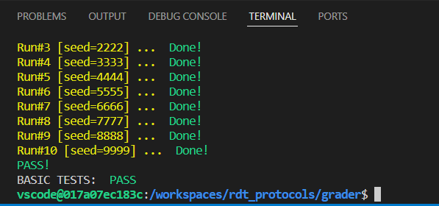

**[18.0]** SR

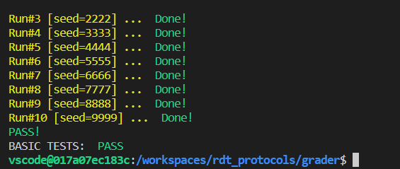

5 - ADVANCED Tests

**[5.0]** ABT

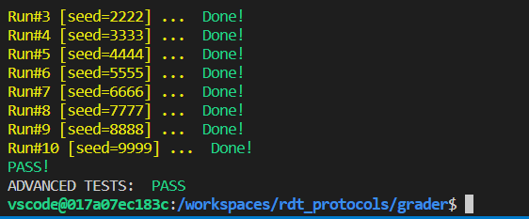

**[10.0]** GBN

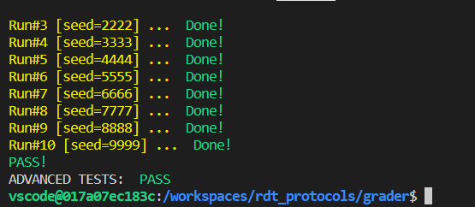

**[20.0]** SR

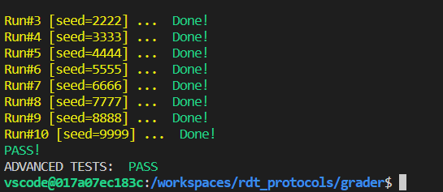

6 - ANALYSIS & REPORT **[15.0]**

(We expect you to use graphs to show your results for each of the experiments in 6.1 and then write down your observations. Further, your report, at the very least, should answer questions like: What variations did you expect for throughput by changing those parameters and why? Do you agree with your measurements; if not then why?)

6.1 a) Window Size – 10

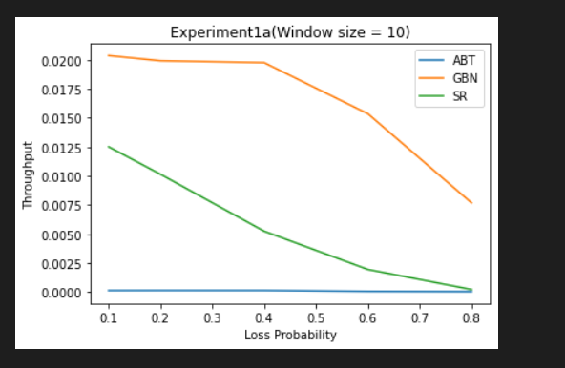

In experiment 1a with window size 10 we see that throughput for GBN is highest among the three. Even if the packet fails, the number of transmitted packets will be higher in GBN as compared to SR. Thus, the throughput is higher in the case of SR as the number of packets received(B_application in simulation.c) is higher in case of GBN. The result that Alternating bit protocol has the lowest throughput matches with our observation as it only sends and receives 1 packet at a time.

b) Window Size – 50

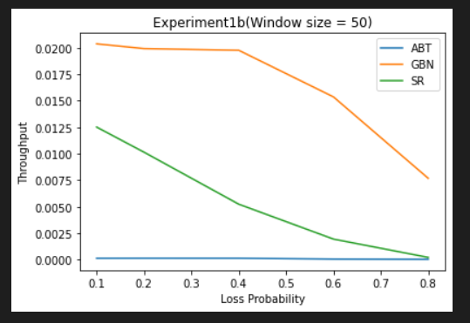

In the graph above, we see that the window size of 50 does not cause much change in any of the protocols and the behavior is very similar to the one we saw in window size of 10. This is probably because for thousand messages window size of both 10 and 50 are small.

6.2 a)

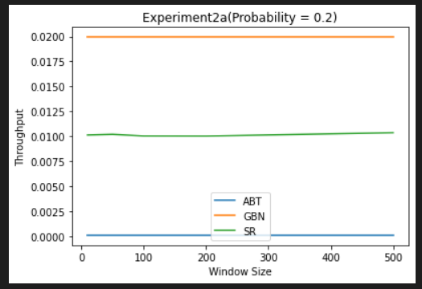

The graph we observe in experiment 2 for loss probability= 0.2 is that the throughput for all the three protocols are almost constant with GBN having the highest throughput. This is because the number of packets lost are low and hence the window size does not make much impact in the throughput. The ABT will have the lowest throughput as the number of packets transmitted in the given period is the lowest in abt.

b)

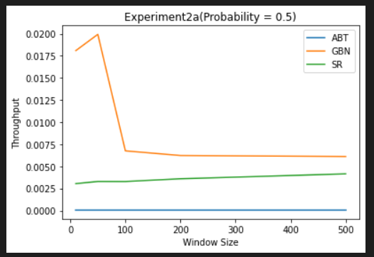

The throughput observed when the loss probability of 0.5 is that we see with the increasing window size the throughput of gbn increases till window size of approximately 75 and then it reduces drastically. This can be attributed to the fact that with increasing losses, the number of sequences that will fail to reach A will also be high and subsequent packets will also not be sent.

In case of Selective Repeat, we see that the throughput increases gradually with the window size as even if a packet fails to reach the destination, then the subsequent packets will be sent and with an increase in window size the number of packets sent will also be high in the given time period which will increase throughput.

In case of Alternating Bit protocol, the behavior will be the same as mentioned in the previous images.

c)

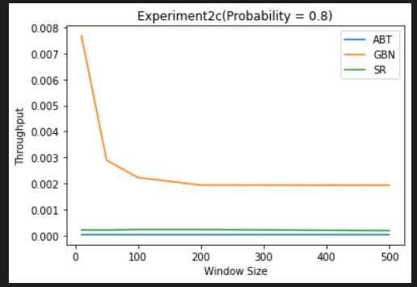

When the loss probability is 0.8, In case of GBN the throughput decreases and stays relatively constant after a certain window size. This is because most of the packets needs to be retransmitted in this case and as the window size increases the number of packets sent in that time period will become less in that window and the subsequent packets won’t be transmitted which will be higher in the case of more window size.

In the case of Selective repeat protocol the throughput is almost constant as expected because even if the packet fails, the subsequent packet will be sent and the window size will not make much difference as we can see in the above graph.

**NOTE**: In the above graphs the throughput of ABT is not zero as visible in the graph. It is in the range of (10^-4) which makes it look as if it is zero.