Lung Disease Detection and Localization of CXR Images using Deep Learning

Narayana Darapaneni  
*Director - AIML  
Great Learning/Northwestern University*Illinois, USA  
darapaneni@gmail.com

Ganesh Pradeep P V  
*Student – M. Tech - DSML*  
*PES University* Bangalore, India  
gan.410@gmail.com

Siddhartha Pandey  
*Student – M. Tech - DSML*  
*PES University* Bangalore, India  
siddhartha.pandey25@yahoo.com Sudha B G  
*Faculty & Senior Manager*  
*Great Learning*Bangalore, India  
sudha.bg@greatlearning.in

Sourabh Kumar  
*Student – M. Tech - DSML*  
*PES University* Bangalore, India  
sourabhkumar4889@gmail.com

Mathan Kumar  
*Student – M. Tech - DSML*  
*PES University* Bangalore, India  
mathan.rajeshwaran@gmail.com Anwesh Reddy Paduri  
*Research Assistant - AIML  
Great Learning*Mumbai, India  
anwesh@greatlearning.in

Sourabh Jain  
*Student – M. Tech - DSML*  
*PES University* Bangalore, India  
sourabhdarda@gmail.com

Sumanth Babu S  
*Student – M. Tech - DSML*  
*PES University* Bangalore, India  
s.sumanth.bab@gmail.com

*Abstract*—The COVID-19 crisis has caused millions of casualties worldwide and posed challenges for doctors and radiologists to differentiate it from other lung diseases due to similar symptoms. Chest X-ray diagnosis is an easily available method with less radiation exposure to detect several lung infections. Computer-aided diagnosis systems can assist in the early identification of lung diseases. Previous researches in this area have used complex deep learning models, which require significant time and resources compared to the proposed models in this study. We worked on different state-of-the-art CNN architectures such as VGG, Inception, XceptionNet, AlexNet, Mobile Net, ResNet, DenseNet and Efficient Net with their latest versions over COVID-19 Radiography Database which consists of 21165 annotated images with their corresponding masks across four different categories, one being normal and other three lung diseases. EfficientNetB5 with optimization has shown excellent results amongst others in classifying COVID-19, viral pneumonia, and lung opacity with a whopping accuracy of 99 percent. Hence, we conclude the proposed model is ready for clinical diagnosis and triaging of X-ray images. Our solution also offers efficient ways to show the presence of lung diseases using Grad-CAM technique.

Keywords— CNN architectures, Comparative Study Image Classification, Lung Diseases, Disease Localization.

# Introduction

COVID-19 is a highly infectious respiratory illness caused by the SARS-CoV-2 virus. The virus was first detected in Wuhan, China in December 2019 and quickly spread around the world, leading to a global pandemic. The COVID-19 pandemic has had a significant impact on the world, affecting people's health, the economy, and daily life. As of April 10, 2023, there have been over 532 million confirmed cases and over 6.5 million deaths worldwide. Chest X-ray diagnosis is an easily available method with less radiation exposure to detect several lung infections. Computer-aided diagnosis systems can assist in the early identification of lung diseases.

Deep CNN models have shown great promise in the field of medical image analysis, including the detection and diagnosis of lung diseases. Using a deep learning model for lung disease diagnosis can improve the accuracy of diagnoses, speed up the detection process, and ultimately lead to better patient outcomes. By leveraging the power of neural networks and advanced algorithms, deep learning models can analyze large amounts of medical data and identify patterns that may not be visible to the human eye. In this context, a deep learning model for lung disease diagnosis can potentially revolutionize the way we approach the detection and treatment of lung diseases.

Introducing our state-of-the-art AI/ML model, specifically designed to address the growing concern of lung diseases. Using advanced machine learning algorithms and deep neural networks, our model is capable of accurately predicting the presence and severity of various lung diseases with unprecedented accuracy. Whether it's Covid19, Viral Pneumonia, or Lung opacity due to other lung diseases, our model has been trained on reasonable amounts of data and is capable of providing reliable and actionable insights to healthcare professionals and patients alike. By leveraging the power of AI, we hope to revolutionize the way lung diseases are diagnosed and treated, ultimately leading to better outcomes for patients worldwide

# Materials and Methods

## Literature Survey

Chest X-rays are often used as an initial imaging test to evaluate lung diseases because they can provide a good overview of the lungs and surrounding structures. They can help identify various lung conditions such as pneumonia, lung cancer, tuberculosis, chronic obstructive pulmonary disease (COPD), and other conditions that affect the lungs and chest. A chest X-ray can show changes in the lungs, such as the presence of fluid or air, the formation of nodules or masses, and the enlargement of lymph nodes. It can also show changes in the size or shape of the heart, which can indicate certain heart conditions.

AI can play a significant role in chest X-ray analysis by assisting radiologists in identifying and diagnosing lung diseases. AI algorithms can be trained on large datasets of chest X-rays to detect abnormalities, such as pneumonia, lung opacity, or other lung diseases that may be indicative of a lung disease.

[2] This study employed a deep learning approach that utilized transfer learning to distinguish between various lung diseases using Chest X-ray images. Two different datasets were used, one with three labeled classes (pneumonia, pneumothorax, normal) and another with four labeled classes (pneumonia, pneumothorax, tuberculosis, normal). The image sizes ranged from 1024*1024 to 3000*3000, but all images were scaled down to 600*600 and converted to grayscale with three channels 600*600*3. To increase the number of samples, data augmentation was performed. The authors used EfficientNetv2 as the base model and added new layers to fine-tune it. The new layers added included a Global average pooling layer and a Dropout layer on top of the EfficientNetv2-m. The researchers found that training all the layers from scratch produced better results than training only the newly added layers. . The authors used a lookahead optimizer and trained the model for 25 epochs. The testing accuracy of normal, pneumonia, pneumothorax, and tuberculosis classes on SCH dataset was 63.60%, 82.30%, 82.80%, and 89.90%, respectively.

[3] The study aims to classify lung diseases from Chest X-ray images in the Chest X-ray14 dataset using CNN-based approaches. The authors used 5-fold resampling for training, validation, and testing, where each split had a specific allocation of data. Input images were center-cropped before being fed into the model. Batch sizes 16 and 8 were used for models based on transfer learning and for models trained from scratch with large input size. They experimented with ResNet-50 and various ResNet depths such as ResNet-101, ResNet-38 and compared models with and without non-image features. The researchers applied Adam Optimizer to optimize their model, with hyperparameters of beta1 = 0.9 and beta2 = 0.999. The learning rate was set to lr = 0.001 for transfer learning and lr = 0.01 for training from scratch. They used Sigmoid as the multilabel classification function and performed ROC analysis using AUC metric. The best performance was achieved by the ResNet-37-large-meta model, which was trained from scratch and included non-image features for 5 out of 14 pathologies.

[4] The aim of this research is to present a deep learning structure that can classify Pneumonia, Lung Cancer, tuberculosis (TB), Lung Opacity, and COVID-19 by utilizing chest X-ray images. The images were resized to 224*224*3, normalized into [0,1], and divided into 80% for training and 20% for testing. VGG19 was used as a pre-trained model, and it was followed by three convolutional neural network layers for feature extraction, and a fully connected network was used for classification. The activation function used for categorizing the images was SoftMax. Adam optimizer was applied with a learning rate of 0.000009, and the model was trained and validated for 5000 epochs with eight iterations per epoch and a batch size of 32. Their proposed VGG19 + CNN model performed very well with 96.48% accuracy, 93.75% recall, 97.56% precision, 95.62% F1 score.

[8] The study proposed different deep learning techniques using transfer learning to classify chest X-ray images based on inflammation in the lungs, and to distinguish between pneumonia, COVID-19, and normal cases, as well as identifying the disease's location on the image. To accomplish this, pre-trained convolutional networks like VGG16, ResNet50, and EfficientNetB0 were used as feature extractors. The results were promising, with high accuracy rates of 90%, 94.3%, and 96.8%, respectively. The authors also utilized a generative adversarial framework, particularly a Cycle GAN, to expand the dataset and the Gradient Class Activation Map technique to monitor disease progression. To avoid overfitting of the model, five-fold cross-validation was employed during training. The model is built on top of a pre-trained model with a fully connected network, using SoftMax activation function for classification. Adam optimizer and back propagation technique used to enhance performance. The EfficientNetB0 augmented model achieved an overall accuracy of 0.968, surpassing other pre-trained models. For COVID-19 classification, the model reported a precision accuracy of 1, while it achieved a precision of 0.96 for normal and pneumonia cases.

[11] The main focus of this study is on using the Histogram of Oriented Gradient (HOG) technique to extract key features from chest X-ray images, with a focus on the primarily affected cells. These features are then used in combination with a less complex but powerful linear Support Vector Machine (SVM) model to detect and classify diseases. The author aims to address issues related to complex algorithms, such as insufficient computing power and lack of necessary image extraction functions, which can negatively impact the accuracy of superior models. By introducing new techniques like HOG descriptors, which capture the direction of edges and intensity gradient distribution, and Linear SVM, which divides data into lines or hyper-planes, the author has achieved decent accuracy ranging from 85% to 87% using just 3000 X-ray images. However, due to inadequate computing power, the author was unable to use the complete dataset of 15000 images obtained from Kaggle event, annotations supported by VinBigData web platform, VinLab. Despite this limitation, the author believes that HOG and Linear SVM are promising techniques in this domain, with potential to outperform other popular models in terms of brevity, accuracy, reliability, and optimization with less training data. One observation was that larger HOG cell sizes showed better accuracy.

[12] This research paper focuses on using a multi-layer computer vision model with generalized regression neural network (GRNN) and Grey relational analysis (GRA) algorithms to detect lung diseases from chest X-ray images within a bounding region of interest (ROI). X-ray image texture is analyzed using two-dimensional fractional differential order convolution with a fractional parameter (v) from 0.3 to 0.5 to remove noise and enhance features. Maximum pooling is proposed for faster computations. The author combines computer vision models with a radial Bayesian network supported by gray relational analysis for disease classification, achieving promising results with evaluation metrics. Image quality is enhanced using fractional order convolution to address low-quality images in databases. This approach outperforms traditional models, providing an automatic CADM tool for disease detection and enabling clinicians to focus on treatments. Opportunities for further improvement are suggested, including parameter optimizations and additional data pre-processing or post-processing techniques.

[13] This research paper focuses on the usage of the Cov-Net computer-aided diagnosis model, which incorporates a modified residual network with asymmetric convolution and attention technique for feature extraction. The skip connected dilated convolution with different variation rates helps capture both high-level semantic and low-level detailed information. The attention technique addresses the issue of over-focusing on common symptoms in Covid-19 and other pneumonia, while avoiding information loss due to insufficient attention. The model performs well on two public Covid-19 radiography datasets, outperforming other advanced computer vision algorithms. Opportunities for optimization and integration with other data processing techniques are suggested, and training on private hospital data for clinical validity is recommended.

[16] This research paper compares data augmentation techniques, namely Affine and DCGAN (Deep Convolution Generative Adversarial Network), in terms of accuracy, recall, and AUC metrics. The study finds that DCGAN yields significantly better results compared to traditional techniques. The pneumonia dataset used contains 5863 chest X-ray images, and data augmentation techniques are employed to overcome the challenge of obtaining a large amount of data for model learning and addressing overfitting issues. The accuracy of DCGAN for the classification of lung diseases is as high as 98%, with a recall of 100% and an AUC of 0.99. DCGAN is also computationally efficient compared to other top CNN models such as VGG16, Inception V3, ResNet, DenseNet, etc.

[19] In this paper, the author proposes a deep transfer learning technique that utilizes an ensemble of GoogLeNet, ResNet-18, and DenseNet-121 to address the challenge of limited X-ray image datasets for detecting Pneumonia disease. The ensemble technique combines the weighted average probabilities of key metrics such as precision, recall, f1-score, and AUC for binary classification between Pneumonia and normal cases. Through 5-fold cross-validation, the proposed technique achieves an accuracy of 98.81% on the Kermany dataset and 86.86% on the RSNA dataset, outperforming many classical approaches and ensemble methods in terms of accuracy and robustness.

## Dataset

We have chosen a Radiography Dataset (Winner of the COVID-19 Dataset Award by Kaggle Community). It consists of both images and masks of shape 299*299*3. We have chosen to focus solely on the images for our model training. The dataset consists of annotated images as follows:

* 3616 COVID images
* 6012 Lung Opacity images
* 10192 Normal lung images
* 1345 Viral Pneumonia images

To add more variation in modelling and reduce complexity in model building, we created four equal subsets of above categories. Within each subset, we further divided the images into training (70%), testing (15%) and validation (15%) sets to facilitate the training and validation. In addition, we trained on the complete dataset as well to compare the results with other models and finally come across the best performing model for the given dataset to classify and detect the presence of lung diseases

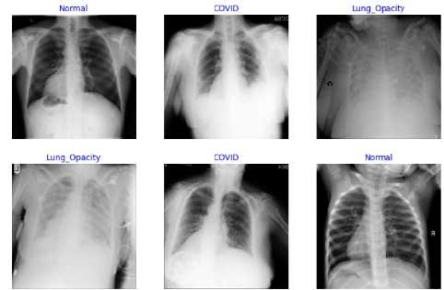Figure 1. Lung Images from COVID 19 Radiography Database

## Data Pre-processing

Data augmentation and data generation are crucial techniques in machine learning and data science as they can enhance the size and variety of a dataset, ultimately improving the performance of machine learning models. Data augmentation involves modifying existing data samples by applying transformations such as flipping, rotating, cropping, zooming, or adding noise to images or audio signals, creating new but similar samples. The model can then learn to recognize patterns in various contexts, reducing overfitting and improving its generalization ability. Data generation, on the other hand, involves creating entirely new data samples that resemble the original data but are not identical copies. This approach is particularly useful in situations where there is limited or no real-world data available, such as in the development of synthetic datasets or simulations. Generating new data samples can help train models that are robust to a wider range of scenarios, improving their accuracy and reliability. Ultimately, data augmentation and data generation are essential tools for enhancing the quality and diversity of datasets, leading to better performance and more accurate predictions from machine learning models.

In our proposed model, we have reduced the shape of the input images to 224*224*3 to meet the input shape requirement of underlying base model without compromising in quality and resolution of the image. We have split the Covid19 radiography dataset as 80% for training and 20% for test and validation. We have applied the following augmentation techniques such as horizontal flip, rescale, zoom range, shear range to add the variety in the training of the model. In addition, we rescaled the test and validation data as well. Below figures shows the Covid-19 Radiography images for each of the pathology.

## Proposed Methodology

A range of lung diseases, such as pneumonia, lung opacity, and Covid-19, can affect the human respiratory system, resulting in severe effects on the lungs. To diagnose these diseases, X-ray images are commonly used. Recently, deep learning algorithms have become increasingly important in identifying and classifying these diseases, thus saving time for healthcare providers. To address this issue, our study has proposed a multi class deep learning classification model that aims to identify the most common lung diseases, including Pneumonia, Lung Opacity, and COVID-19. The research work focuses on designing a deep learning framework to classify these diseases.

To develop the most efficient and high-performance model, we began with some of the top-performing models that have dominated the ImageNet dataset with high accuracy, while also requiring minimal computation resources. These models come with pre-trained weights that can be readily accessed using transfer learning techniques. During our literature survey, we discovered various models, but with our optimized and innovative approach, we were able to surpass some of the most renowned architectures. Our method resulted in a significant increase in accuracy and f1-score while reducing the validation loss, despite having only a few million trainable parameters and training for just 30 epochs.

To add more variation in modelling and reduce complexity in model building, we created four equal subsets of Covid-19 Radiography database and then we applied data augmentation techniques on each subset to add more variety in the original images. Later we implemented our own models based on some of the popular ImageNet pre-trained models such as VGG16, InceptionV3, XceptionNet, AlexNet, MobileNetV2, EfficientNetV2M, ResNet50, DenseNet121, DenseNet169 and ensemble stacking techniques on couple of models. In the process of customization, we unfroze few layers of the pre-trained model and added our custom new layers at the top. We trained all our models with the optimized batch size of 16.

We compiled above mentioned models with highly efficient optimizers such as Adam and SGD with a learning rate of 0.0001. We have used categorical cross entropy as our loss function. Categorical cross-entropy measures the dissimilarity between the predicted probability distribution and the true probability distribution of the classes. It penalizes the model heavily if it assigns a low probability to the true class and a high probability to other classes. We used several optimization, regularization and memory optimization technique such as ReduceLROnPlateau, Early stopping callback and Model Checkpoint respectively for faster convergence and reduce overfitting. When we applied above techniques on the subset of radiography images with limited computing resources, we were able to achieve promising results such as overall accuracy of 89% and f1-score of 99% for pneumonia, 92% for Covid-19, 90% for Normal and 89% for lung opacity.

However, we still believed to improvise the performance of our so far attempted models. We ventured another set of complex and more recent models such as ResNet152v2, ResNet101, DenseNet201, EfficientNetB5, EfficientNetV2S and EfficientNetV2L [Table2] to try on full dataset built using higher computing environment such as Google Colab. We implemented all these models by unfreezing and adding custom layers at the top followed by above mentioned optimization and regularization techniques. We found that EfficientNetB5 based optimized model outperformed rest of the models in terms of test accuracy and F1-score. We were able to achieve promising results such as overall accuracy of 99% and f1-score of 99% for Covid-19, 98% for Viral Pneumonia, 98% for Lung Opacity and 99% for Normal images.

In addition, we have implemented Gradient Class Activation Maps (Grad CAM) [53] which enables the identification of the crucial regions in an image that are responsible for predicting a specific class by a Convolutional Neural Network (CNN). Grad CAM is an advanced version of Class Activation Map (CAM), which enhances the localization of vital regions by incorporating gradient information of the anticipated class concerning the feature maps.

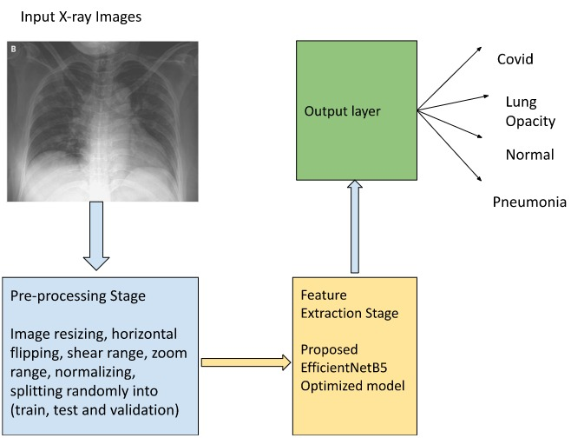

Figure 2. Proposed Deep Learning framework

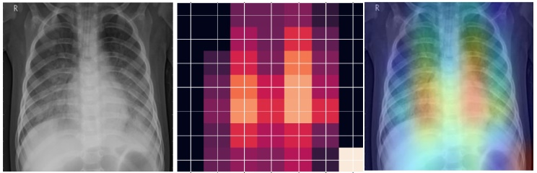

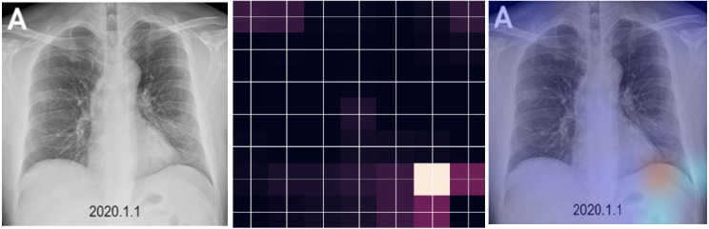

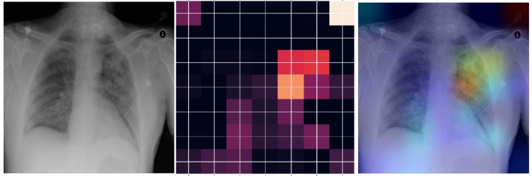

Figure 3. Covid-19, Pneumonia and Lung Opacity Grad CAMs

# Results

To create a deep learning model for classifying lung diseases, we utilized Python 3 and the Keras framework, and implemented our proposed model on Google Colab. During the pre-processing stage, we used the ImageDataGenerator class in Keras for picture scaling, normalization, and conversion to a data array. The pre-processing step's output was utilized to create the input for the suggested deep learning model for multi-classification of lung illnesses. We trained and validated the model using appropriate fit algorithms and optimizers such as Adam and R-Adam. Number of epochs our base model trained was 30. Each epoch utilized 1059 iterations and a batch size of 16. We used the R-Adam optimizer with a learning rate of 0.0001 (LR) on the EfficientNetB5 based initial model and trained for 6 epochs. We measured the model's performance using Precision, Recall, F1-Score, accuracy and validation loss metrics [Table 1].

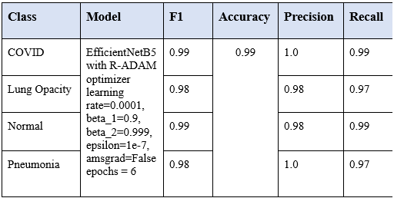

Table 1. EfficientNetB5 Optimized model performance results

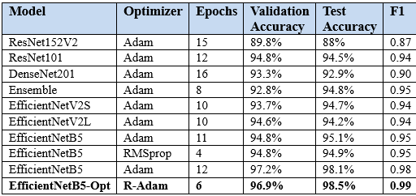

Table 2. Model Comparisons

# Discussions and conclusions

The objective of this research was to develop a deep convolutional neural network (CNN) model that could accurately distinguish between COVID-19 and non-COVID-19 diseases, such as viral pneumonia, using chest X-ray images. To achieve this, we implemented various state-of-art Computer Vision architectures, pre-trained models and ensemble techniques. Out of the whole lot, EfficientNetB5 with RAdam optimization demonstrated outstanding results with a remarkable overall accuracy of 99% and F1-scores of 99% for the COVID, 98% for the lung opacity, 99% for normal, and 98% for viral pneumonia. Grad CAM technique was implemented to visualize the infected area of the lung. In the future, we will continue the research to classify and localize more such lung diseases. Some future scope work can be as follows:

* Explore the use of other imaging modalities, such as CT scans and MRI, for lung disease detection using deep learning and compare their performance to chest X-rays
* Combine different imaging modalities to improve the accuracy and efficiency of lung disease detection
* Develop more advanced and efficient deep learning models, such as graph convolutional networks or attention-based models, for lung disease detection using chest X-rays
* Incorporate other types of data, such as clinical data or patient demographics, to improve the accuracy and reliability of the deep learning models

# References

1. P. Rajpurkar et al., “CheXNet: Radiologist-level pneumonia detection on chest X-rays with deep learning,” arXiv [cs.CV], 2017.
2. S. Kim, B. Rim, S. Choi, A. Lee, S. Min, and M. Hong, “Deep learning in multi-class lung diseases’ classification on chest X-ray images,” Diagnostics (Basel), vol. 12, no. 4, p. 915, 2022.
3. I. M. Baltruschat, H. Nickisch, M. Grass, T. Knopp, and A. Saalbach, “Comparison of deep learning approaches for multi-label chest X-ray classification,” Sci. Rep., vol. 9, no. 1, p. 6381, 2019.
4. G. M. M. Alshmrani, Q. Ni, R. Jiang, H. Pervaiz, and N. M. Elshennawy, “A deep learning architecture for multi-class lung diseases classification using chest X-ray (CXR) images,” Alex. Eng. J., vol. 64, pp. 923–935, 2023.
5. J. De Moura et al., “Deep convolutional approaches for the analysis of COVID-19 using chest X-ray images from portable devices,” IEEE Access, vol. 8, pp. 195594–195607, 2020.
6. G. Wang et al., “A deep-learning pipeline for the diagnosis and discrimination of viral, non-viral and COVID-19 pneumonia from chest X-ray images,” Nat. Biomed. Eng., vol. 5, no. 6, pp. 509–521, 2021.
7. X. Li, C. Li, and D. Zhu, “COVID-MobileXpert: On-device COVID-19 patient triage and follow-up using chest X-rays,” arXiv [eess.IV], 2020.
8. T. Zebin and S. Rezvy, “COVID-19 detection and disease progression visualization: Deep learning on chest X-rays for classification and coarse localization,” Appl. Intell., vol. 51, no. 2, pp. 1010–1021, 2021.
9. I. Allaouzi and M. Ben Ahmed, “A novel approach for multi-label chest X-ray classification of common thorax diseases,” IEEE Access, vol. 7, pp. 64279–64288, 2019.
10. M. E. Karar, E. E.-D. Hemdan, and M. A. Shouman, “Cascaded deep learning classifiers for computer-aided diagnosis of COVID-19 and pneumonia diseases in X-ray scans,” Complex Intell. Syst., vol. 7, no. 1, pp. 235–247, 2021.
11. N. Saparkhojayev, L. Zholayeva, Y. Tashkenbayev, and D. Tokseit, “Abnormality detection in chest X-ray images using uncertainty prediction algorithms,” in 2021 16th International Conference on Electronics Computer and Computation (ICECCO), 2021, pp. 1–3.
12. J.-X. Wu, P.-Y. Chen, C.-M. Li, Y.-C. Kuo, N.-S. Pai, and C.-H. Lin, “Multilayer fractional-order machine vision classifier for rapid typical lung diseases screening on digital chest X-ray images,” IEEE Access, vol. 8, pp. 105886–105902, 2020.
13. H. Li, N. Zeng, P. Wu, and K. Clawson, “Cov-Net: A computer-aided diagnosis method for recognizing COVID-19 from chest X-ray images via machine vision,” Expert Syst. Appl., vol. 207, no. 118029, p. 118029, 2022.
14. E. Schwab, A. Gooßen, H. Deshpande, and A. Saalbach, “Localization of critical findings in chest X-ray without local annotations using multi-instance learning,” arXiv [cs.LG], 2020.
15. O. Uparkar, J. Bharti, R. K. Pateriya, R. K. Gupta, and A. Sharma, “Vision transformer outperforms deep convolutional neural network-based model in classifying X-ray images,” Procedia Comput. Sci., vol. 218, pp. 2338–2349, 2023.
16. M. Bali and T. Mahara, “Comparison of affine and DCGAN-based data augmentation techniques for chest X-ray classification,” Procedia Comput. Sci., vol. 218, pp. 283–290, 2023.
17. R. Gulakala, B. Markert, and M. Stoffel, “Rapid diagnosis of Covid-19 infections by a progressively growing GAN and CNN optimisation,” Comput. Methods Programs Biomed., vol. 229, no. 107262, p. 107262, 2023.
18. S. Sheykhivand et al., “Developing an efficient deep neural network for automatic detection of COVID-19 using chest X-ray images,” Alex. Eng. J., vol. 60, no. 3, pp. 2885–2903, 2021.
19. R. Kundu, R. Das, Z. W. Geem, G.-T. Han, and R. Sarkar, “Pneumonia detection in chest X-ray images using an ensemble of deep learning models,” PLoS One, vol. 16, no. 9, p. e0256630, 2021.
20. N. Hilmizen, A. Bustamam, and D. Sarwinda, “The multimodal deep learning for diagnosing COVID-19 pneumonia from chest CT-scan and X-ray images,” in 2020 3rd International Seminar on Research of Information Technology and Intelligent Systems (ISRITI), 2020, pp. 26–31.
21. V. Acharya et al., “AI-assisted tuberculosis detection and classification from chest X-rays using a deep learning Normalization-free network model,” Comput. Intell. Neurosci., vol. 2022, p. 2399428, 2022.
22. Y. Erdaw and E. Tachbele, “Machine learning model applied on chest X-ray images enables automatic detection of COVID-19 cases with high accuracy,” Int. J. Gen. Med., vol. 14, pp. 4923–4931, 2021.
23. A. S. Pillai, “Multi-label chest X-ray classification via deep learning,” J. Intell. Learn. Syst. Appl., vol. 14, no. 04, pp. 43–56, 2022.
24. T. Rahman *et al.*, “Reliable tuberculosis detection using chest X-ray with deep learning, segmentation and visualization,” *IEEE Access*, vol. 8, pp. 191586–191601, 2020.
25. N. M. Elshennawy and D. M. Ibrahim, “Deep-pneumonia framework using deep learning models based on chest X-ray images,” *Diagnostics (Basel)*, vol. 10, no. 9, p. 649, 2020.
26. R. Jain, M. Gupta, S. Taneja, and D. J. Hemanth, “Deep learning-based detection and analysis of COVID-19 on chest X-ray images,” *Appl. Intell.*, vol. 51, no. 3, pp. 1690–1700, 2021.
27. S. Basu, S. Mitra, and N. Saha, “Deep learning for screening COVID-19 using chest X-Ray images,” *bioRxiv*, 2020.
28. S. R. Nayak, D. R. Nayak, U. Sinha, V. Arora, and R. B. Pachori, “Application of deep learning techniques for detection of COVID-19 cases using chest X-ray images: A comprehensive study,” *Biomed. Signal Process. Control*, vol. 64, no. 102365, p. 102365, 2021.
29. S. H. Yoo *et al.*, “Deep learning-based decision-tree classifier for COVID-19 diagnosis from chest X-ray imaging,” *Front. Med. (Lausanne)*, vol. 7, p. 427, 2020.
30. K. Hammoudi *et al.*, “Deep learning on chest X-ray images to detect and evaluate pneumonia cases at the era of COVID-19,” *J. Med. Syst.*, vol. 45, no. 7, p. 75, 2021.
31. I. M. Baltruschat, H. Nickisch, M. Grass, T. Knopp, and A. Saalbach, “Comparison of deep learning approaches for multi-label chest X-ray classification,” *Sci. Rep.*, vol. 9, no. 1, p. 6381, 2019.
32. J. Rasheed, A. A. Hameed, C. Djeddi, A. Jamil, and F. Al-Turjman, “A machine learning-based framework for diagnosis of COVID-19 from chest X-ray images,” *Interdiscip. Sci.*, vol. 13, no. 1, pp. 103–117, 2021.
33. S. A. Ali, N. Vallapureddy, S. Mannem, Y. Gudla, and V. Malathy, “Detection of cancer in lung CT image using 3D CNN,” in *2022 2nd International Conference on Intelligent Technologies (CONIT)*, 2022, pp. 1–4.
34. I. Shafi *et al.*, “An effective method for lung cancer diagnosis from CT scan using deep learning-based support vector network,” *Cancers (Basel)*, vol. 14, no. 21, p. 5457, 2022.
35. D. Riquelme and M. Akhloufi, “Deep learning for lung cancer nodules detection and classification in CT scans,” *AI (Basel)*, vol. 1, no. 1, pp. 28–67, 2020.
36. M. Chen, S. Huang, Z. Huang, and Z. Zhang, “Detection of lung cancer from pathological images using CNN model,” in 2021 IEEE International Conference on Computer Science, Electronic Information Engineering and Intelligent Control Technology (CEI), 2021, pp. 352–358.
37. S. Garud and S. Dhage, “Lung cancer detection using CT images and CNN algorithm,” in *2021 International Conference on Advances in Computing, Communication, and Control (ICAC3)*, 2021, pp. 1–6.
38. T. L. Chaunzwa *et al.*, “Deep learning classification of lung cancer histology using CT images,” *Sci. Rep.*, vol. 11, no. 1, p. 5471, 2021.
39. R. Sun and Y. Pang, “Efficient lung cancer image classification and segmentation algorithm based on improved Swin transformer,” *arXiv [cs.CV]*, 2022.
40. V. Deepa and P. M. Fathimal, “Lung cancer prediction and Stage classification in CT Scans Using Convolution Neural Networks -A Deep learning Model,” in *2022 International Conference on Data Science, Agents & Artificial Intelligence (ICDSAAI)*, 2022, vol. 01, pp. 1–5.
41. G. Thakral, S. Gambhir, and N. Aneja, “Proposed methodology for Early Detection of Lung Cancer with low-dose CT Scan using Machine Learning,” in 2022 International Conference on Machine Learning, Big Data, Cloud and Parallel Computing (COM-IT-CON), 2022, vol. 1, pp. 662–666.I. Abunadi A. Rehman, M. Kashif and N. Ayesha. Lung cancer detection and classification from chest ct scans using machine learning techniques. IEEE, pages pp. 101–104, doi: 10.1109/CAIDA51941.2021.9425269, 2021.
42. A. Rehman, M. Kashif, I. Abunadi, and N. Ayesha, “Lung cancer detection and classification from chest CT scans using machine learning techniques,” in 2021 1st International Conference on Artificial Intelligence and Data Analytics (CAIDA), 2021, pp. 101–104.
43. J. Hu, C. Zhang, K. Zhou, and S. Gao, “Chest X-ray diagnostic quality assessment: How much is pixel-wise supervision needed?” IEEE Trans. Med. Imaging, vol. 41, no. 7, pp. 1711–1723, 2022.
44. M. S. Alam, D. Wang, and A. Sowmya, “Bidirectional Convolutional-LSTM based Network for lung segmentation of chest X-ray images,” in 2021 IEEE 33rd International Conference on Tools with Artificial Intelligence (ICTAI), 2021, pp. 915–919.
45. T. R. Pant, R. K. Aryal, T. Panthi, M. Maharjan, and B. Joshi, “Disease Classification of Chest X-Ray using CNN,” in 2021 IEEE 6th International Conference on Computing, Communication and Automation (ICCCA), 2021, pp. 467–471.
46. R. Arora, I. Saini, and N. Sood, “Modified UNet++ model: A deep model for automatic segmentation of lungs from chest X-ray images,” in 2021 2nd International Conference on Secure Cyber Computing and Communications (ICSCCC), 2021, pp. 166–169.
47. J. Rathi, K. Talwadia, H. Jamwal, and S. Kumar, “Depth wise convolution on chest X-ray & comparative analysis with transfer learning,” in 2022 2nd International Conference on Intelligent Technologies (CONIT), 2022, pp. 1–6.
48. B. Wang, Z. Wu, Z. U. Khan, C. Liu, and M. Zhu, “Deep convolutional neural network with segmentation techniques for chest X-ray analysis,” in 2019 14th IEEE Conference on Industrial Electronics and Applications (ICIEA), 2019, pp. 1212–1216
49. G. J. Chowdary and V. Kanhangad, “A dual-branch network for diagnosis of thorax diseases from chest X-rays,” IEEE J. Biomed. Health Inform., vol. 26, no. 12, pp. 6081–6092, 2022.
50. S. Mo and M. Cai, “Deep learning based multi-label chest X-ray classification with entropy weighting loss,” in 2019 12th International Symposium on Computational Intelligence and Design (ISCID), 2019, vol. 2, pp. 124–127.
51. L. Luo et al., “Deep mining external imperfect data for Chest X-ray disease screening,” IEEE Trans. Med. Imaging, vol. 39, no. 11, pp. 3583–3594, 2020.
52. S. Lu, Y. Qin, Y. Che, and H. Guo, “Classification of chest X-ray images based on superpixels and deep learning models,” in 2022 15th International Congress on Images and Signal Processing, BioMedical Engineering and Informatics (CISP-BMEI), 2022, pp. 1-4.
53. R. R. Selvaraju, M. Cogswell, A. Das, R. Vedantam, D. Parikh, and D. Batra, “Grad-CAM: Visual explanations from deep networks via Gradient-based localization,” arXiv [cs.CV], 2016.